Business Requirement
Intelligent Financial Insight System for Claims & Commission Analytics
Author: Robotiyee
Date: October 2025

1. Executive Summary 3
2. Current Operational Process (AS-IS) 3
Operational Context 3
AS-IS Process (Policy Issued / Claim Approved) 3
AS-IS Process Flow 4
Step-by-Step Flow 4
3. TO-BE Process 5
TO-BE Process Flow 6
Step-by-Step Flow 6
FCA Reporting Template 7
4. Business Needs: 8
5. Business Objectives 8
6. Business Risks 9
7. Business Requirements 10
8. User Requirements 11
9. Stakeholders, Users, and Third Parties 12

Executive Summary
Insurance companies face increasing pressure to deliver accurate, real-time financial insights across claims, commissions, and operational KPIs.
Currently, financial reporting processes are manual, fragmented, and delayed, leading to poor decision-making and compliance risks (FCA / IFRS).
The proposed project builds an AI-augmented financial insight platform integrating data analytics, machine learning (ML), and LLM-based reporting
to automate financial intelligence delivery.
The FCA has introduced a new compliance requirement mandating that each insurance policy transaction include a 'Risk Exposure Category' parameter, recorded in CRM and passed to SAP for reporting. Each insurance policy transaction must now include a “Risk Exposure Category” parameter, recorded in CRM and passed to SAP for reporting.

Current Operational Process (AS-IS)
The organization operates an insurance ecosystem with CRM, SAP, and Data Warehouse components. Integration is partial, leading to delays in claims and reporting. The current FCA report is outdated and requires a new version.

Operational Context
• CRM: Manages policies, claims, customer data.
• SAP FI/CO: Handles accounting and compliance.
• DW: Consolidates CRM + SAP for analytics.
• Power BI: Generates executive and regulatory reports.

AS-IS Process (Policy Issued / Claim Approved)
1. Sales agent receives a customer policy request.
2. Agent enters policy information into CRM.
3. Data manually reviewed and exported to SAP for accounting posting.
4. Delays occur due to manual intervention.
5. Reporting done manually using Excel exports.

AS-IS Process Flow
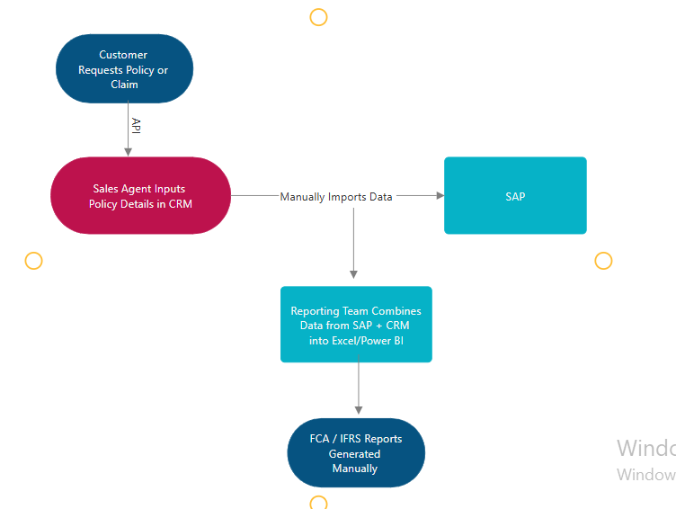

Step-by-Step Flow
Step | Actor | System/Module | Description | Issues / Pain Points
1 | Customer | Front-end Portal | Customer requests policy quotation | Manual entry; limited validation
2 | Sales Agent | CRM Policy Module | Agent inputs policy and customer details | Repetitive data entry; no auto-sync with SAP
3 | CRM System | Database | Policy saved in CRM DB | Delayed sync with SAP; inconsistent customer IDs
4 | Finance | SAP FI/CO | Manually imports policy details for posting | Manual process; error-prone
5 | Reporting Team | Excel/Power BI | Extracts data from SAP and CRM for FCA report | Fragmented data sources; report delay (1–2 days)

TO-BE Process
A new mandatory field, 'Risk Exposure Category,' will be added to CRM to meet FCA compliance. The AI-augmented Financial Insight Platform will integrate analytics, Machine Learning (ML), and Large Language Model (LLM)-based reporting to automate and enhance financial intelligence delivery.
TO-BE Process:
1. Customer requests a policy via the web portal.
2. Sales agent enters data into CRM with new mandatory 'Risk Exposure Category'.
3. CRM automatically validates and triggers integration API.
4. SAP FI/CO updates accounting entries using ABAP logic including new parameter.
5. Data warehouse synchronizes nightly with Python ETL.
6. Power BI, integrated with LLM components, auto-generates insights and compliance reports.

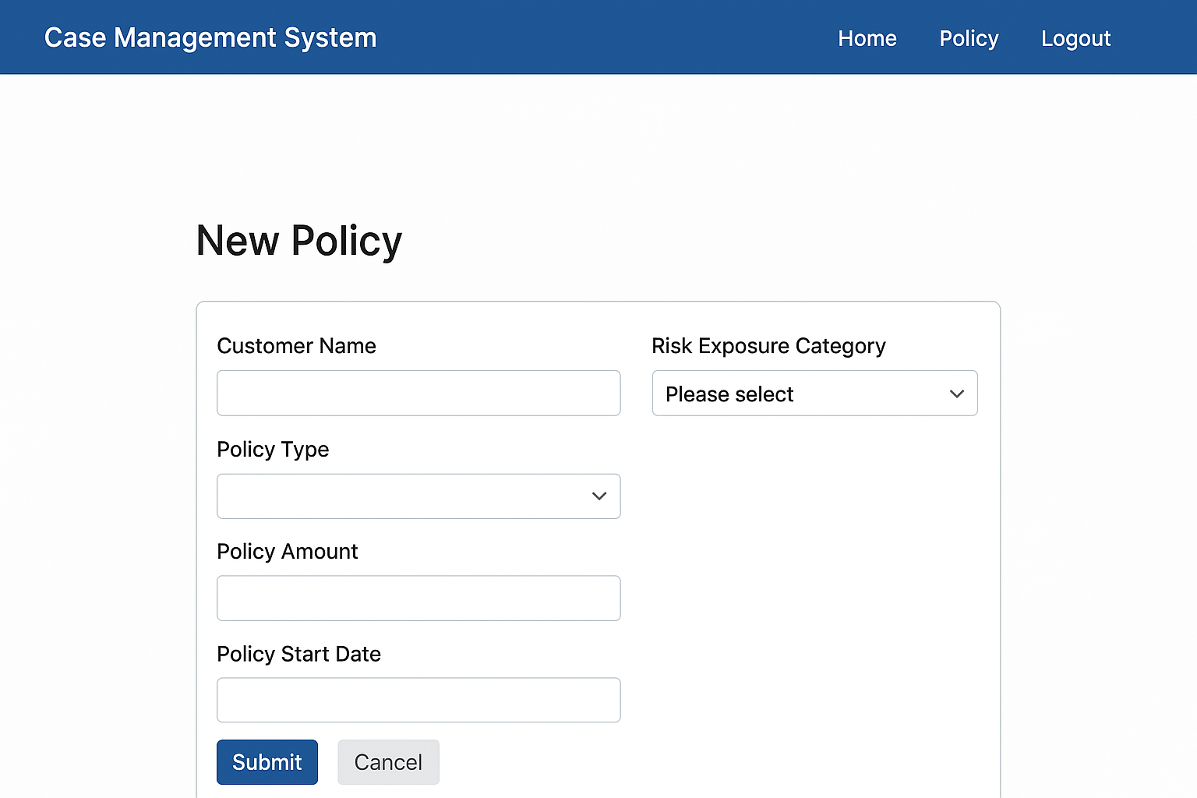

TO-BE Process Flow

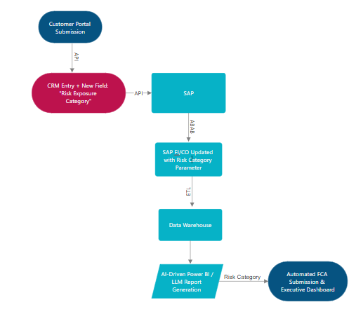

Step-by-Step Flow
Step | Actor | System | Description | Improvements
1 | Customer | Web Portal | Requests policy / claim | Validations triggered via API
2 | Sales Agent | CRM (Front-End) | Enters policy data + selects new Risk Exposure Category (mandatory) | Data completeness enforced
3 | CRM | Business Logic Layer | Validates data and sends to Integration API | Automatic checks reduce errors
4 | Integration Layer | REST API | Transmits policy data to SAP FI/CO | Real-time communication
5 | SAP FI/CO | ABAP Logic | Updates accounting entries to include Risk Exposure Category | Compliance-ready data posting
6 | ETL / Data Warehouse | Python Script | Syncs CRM + SAP nightly | Unified data schema
7 | Analytics | Power BI + LLM | Auto-generates dashboards & FCA reports | Reports generated in real-time
8 | Compliance Officer | Power BI Dashboard | Reviews compliance and performance metrics | Faster, accurate reporting

FCA Reporting Template
Field Name | Description | Source System | Data Type | Mandatory
Policy ID | Unique policy number | CRM | String | ✔
Customer ID | Policyholder identifier | CRM | String | ✔
Claim Amount | Financial claim value | SAP | Decimal | ✔
Risk Exposure Category | New compliance field | CRM | String | ✔
Policy Start Date | Coverage start date | CRM | Date | ✔
Policy End Date | Coverage end date | CRM | Date | ✔
Commission Amount | Commission paid | SAP | Decimal | ✔
Reporting Date | Report generation date | DW | Date | ✔

Business Needs:
ID | Business Need Description
BN-01 | The organization’s financial and operational data is fragmented across CRM, SAP FI/CO, and the Data Warehouse, creating delays and inconsistencies in reporting. A unified data model is required for real-time financial insight and FCA compliance.
BN-02 | The FCA now mandates that each insurance policy transaction include a “Risk Exposure Category” field. This parameter must be captured in CRM, integrated into SAP postings, and reflected in compliance and management reports.
BN-03 | Executives require real-time KPIs and “what-if” simulation capabilities for claims, commissions, and exposure analysis. Manual Excel-based reporting limits forecasting and audit traceability.
BN-04 | The organization’s transformation program seeks to leverage AI/ML/LLM to generate predictive insights and plain-language financial summaries, improving decision-making speed and quality.
BN-05 | Reporting structures must dynamically adapt to new regulatory and operational parameters (FCA, IFRS, internal KPIs) without extensive redevelopment or downtime.

Business Objectives

Objective ID | Business Objective | Category | Expected Outcome / KPI
BO-01 | Achieve end-to-end FCA/IFRS compliance by integrating “Risk Exposure Category” into all insurance policy transactions and financial postings. | Compliance | 100% FCA-compliant transactions; no audit exceptions.
BO-02 | Automate data synchronization between CRM, SAP, and Data Warehouse, reducing manual reconciliation and latency. | Efficiency | 80% faster report generation; 50% reduction in manual errors.
BO-03 | Enable AI/ML-driven predictive analytics and anomaly detection for financial performance and claims risk. | Innovation | ≥85% model accuracy on forecast validation; anomaly detection precision ≥90%.
BO-04 | Deliver real-time dashboards and LLM-based natural-language reporting for executive insights and transparency. | Decision Support | Power BI dashboard refresh ≤10 seconds; narrative generation ≤2 seconds.
BO-05 | Ensure scalability and adaptability to regulatory and business changes through modular data and analytics architecture. | Sustainability | New FCA or IFRS parameter integration within ≤2 weeks.

Business Risks

Risk Category | Description | Business Impact
Regulatory Compliance Risk | FCA’s “Risk Exposure Category” mandate not captured or transmitted correctly between systems. | High – Non-compliance may lead to financial penalties and audit findings.
Data Integrity Risk | Inconsistent or missing mappings between CRM, SAP, and Data Warehouse cause discrepancies in financial or exposure data. | High – Undermines report accuracy and decision quality.
Operational Risk (Manual Process) | Manual report generation and reconciliation slow down monthly closing and FCA submissions. | Medium – Reporting turnaround >2 days, raising compliance exposure.
Technology Integration Risk | Legacy SAP and CRM interfaces lack robust APIs for bi-directional synchronization. | Medium – Integration challenges delay automation.
AI Model Bias / Accuracy Risk | Predictive analytics or LLM summaries may generate inaccurate results if models are not periodically retrained. | Medium – Can mislead management decisions.
User Adoption Risk | End users may resist change or fail to understand AI-driven outputs. | Medium – Delays ROI realization and limits platform adoption.
Data Security & Privacy Risk | Sensitive policyholder and transaction data processed in AI workflows. | High – Non-compliance with GDPR and internal data protection standards.

Business Requirements

R ID | Business Requirement Description | Linked Business Objective (BO)
BR-01 | The system must capture and synchronize all FCA-mandated risk data (e.g., Risk Exposure Category) across CRM, SAP, and reporting layers. | BO-01 — Ensure FCA/IFRS compliance.
BR-02 | Data consolidation between CRM, SAP, and the Data Warehouse must be automated to remove manual reporting and reconciliation. | BO-02 — Improve efficiency and data accuracy.
BR-03 | The platform must generate predictive financial insights and anomaly detection using AI/ML models. | BO-03 — Enable AI-driven financial intelligence.
BR-04 | Dashboards must provide real-time KPIs and natural-language insights for executive decision-making. | BO-04 — Improve transparency and decision quality.
BR-05 | The system must maintain a full audit trail, enforce RBAC, and secure sensitive financial and customer data. | BO-01 / BO-02 — Ensure compliance and governance.
BR-06 | The platform must ensure high system performance, uptime, and automated job recovery for operational continuity. | BO-02 / BO-04 — Ensure reliable analytics delivery.

User Requirements

UR ID | User Requirement Description | Linked BR | Priority (MoSCoW)
UR-1.1 | Users must be able to enter and validate mandatory FCA fields in CRM. | BR-01 | Must Have
UR-1.2 | The system must automatically sync risk and policy data between CRM and SAP. | BR-01, BR-02 | Must Have
UR-1.3 | ETL pipelines must automatically aggregate and reconcile CRM–SAP data. | BR-02 | Must Have
UR-1.4 | AI models must produce daily KPI forecasts and detect financial anomalies. | BR-03 | Should Have
UR-1.5 | Dashboards must display real-time KPIs and generate plain-language summaries. | BR-04 | Must Have
UR-1.6 | Users must access reports filtered by compliance fields (e.g., Risk Exposure Category). | BR-01, BR-04 | Could Have
UR-1.7 | The system must log all transactions, AI outputs, and user actions for auditability. | BR-05 | Must Have
UR-1.8 | The platform must ensure uptime ≥99.5% and automated recovery ≤30 minutes. | BR-06 | Should Have

Stakeholders, Users, and Third Parties
Role / Group | Type | Responsibility / Interest | System Interaction
Project Sponsor (CFO / COO) | Internal Executive Stakeholder | Approves budget, defines business KPIs, and oversees compliance deliverables. | Consumes reports and dashboards.
Business Analyst | Internal (Core Team) | Defines scope, requirements, and manages change impact analysis. | Engages with all systems; leads BA documentation.
Compliance Officer | Internal (User / Reviewer) | Ensures FCA / IFRS compliance; validates data integrity and reports. | Reviews Power BI dashboards and audit logs.
Sales Agent / Operations User | Internal (End User) | Enters policy details including new Risk Exposure Category in CRM. | Uses CRM Front-End.
Finance & Accounting Team | Internal (End User) | Processes transactions in SAP and validates financial postings. | Uses SAP FI/CO.
Data Engineer / ETL Developer | Internal (Technical) | Build and maintain Python ETL pipelines for data consolidation. | Data Warehouse, ETL Layer.
Data Scientist / ML Engineer | Internal (Technical) | Develops ML and LLM models for financial prediction and summaries. | ML & LLM modules, APIs.
Power BI Developer | Internal (Technical) | Designs FCA and AI-driven dashboards and visual reports. | Power BI, SQL, APIs.
IT Integration Team | Internal (Technical) | Manages APIs, SAP–CRM integrations, and version control. | Integration Layer.
Third-Party Vendor (LLM API Provider) | External (Vendor) | Provides API for LLM (e.g., OpenAI, Azure Cognitive Services). | LLM Integration Layer.
Regulatory Body (FCA) | External (Authority) | Defines compliance reporting standards, audits accuracy. | Receives FCA-compliant reports.
Project Management Office (PMO) | Internal (Governance) | Monitors project delivery, resource allocation, and risk tracking. | Jira / PM tools.
Quality Assurance (QA) Team | Internal (Testing) | Executes UAT, functional testing, regression validation. | All integrated environments.

