Functional Requirement Document
Intelligent Financial Insight System for Claims & Commission Analytics
Author: Robotiyee
Date: October 2025

1. Functional Requirements 5
Business Requirements: 5
Functional Requirements 6
1.1 UC-1 - Unified Data Capture & Integration Layer 8
Main Flow 8
Alternate Flow 9
Exception Flow 9
Business Rules 9
NFRs 9
Assumptions & Dependencies 10
User Story 1 10
Acceptance Criteria 10
FCA Reporting Template 11
Use Case Diagram 11
1.2 UC-2 - Automated ETL and Data Quality Framework 12
Main Flow 12
Alternate Flow 13
Exception Flow 13
Business Rules 13
NFRs 13
Assumptions & Dependencies 13
User Story 2 14
Acceptance Criteria 14
1.3 UC-3 - AI-Driven Financial Analytics Engine 14
Main Flow 14
Alternate Flow 15
Exception Flow 15
Business Rules 15
NFRs 15
User Story 3 15
Acceptance Criteria 15
1.4 UC-4 -LLM-Augmented Narrative Intelligence 16
Main Flow 16
Alternate Flow 16
Business Rules 16
NFRs 17
User Story 4 17
Acceptance Criteria 17
1.5 UC-5- Compliance, Audit & Security Module 17
Main Flow 18
Alternate Flow 18
Business Rules 18
NFRs 18
User Story 5 18
Acceptance Criteria 18
1.6 UC-6 Performance & Continuity Management 19
Main Flow 19
Alternate Flow 19
Business Rules 19
NFRs 20
User Story 6 20
Acceptance Criteria 20
2. Traceability Matrix 20
Requirements Traceability Matrix (RTM) 20
Use Case and User Story Mapping Matrix 22
BR → UR → FR → UC → US End-to-End Mapping 22
Verification Summary Matrix 23
3. System Architecture and Technical Design 23
3.1 Front-End Applications 24
3.2 Back-End Systems and Integrations 24
3.3 Integration Flow 25
3.4 Programming Languages and Frameworks 25
3.5 Technical Integration and Impact Analysis 26
3.6 Non-Functional Requirements (NFR) Matrix 27
4. Project Sizing and Effort Estimation 27

Functional Requirements

Business Requirements:
R ID | Business Requirement Description | Linked Business Objective (BO)
BR-01 | The system must capture and synchronize all FCA-mandated risk data (e.g., Risk Exposure Category) across CRM, SAP, and reporting layers. | BO-01 — Ensure FCA/IFRS compliance.
BR-02 | Data consolidation between CRM, SAP, and the Data Warehouse must be automated to remove manual reporting and reconciliation. | BO-02 — Improve efficiency and data accuracy.
BR-03 | The platform must generate predictive financial insights and anomaly detection using AI/ML models. | BO-03 — Enable AI-driven financial intelligence.
BR-04 | Dashboards must provide real-time KPIs and natural-language insights for executive decision-making. | BO-04 — Improve transparency and decision quality.
BR-05 | The system must maintain a full audit trail, enforce RBAC, and secure sensitive financial and customer data. | BO-01 / BO-02 — Ensure compliance and governance.
BR-06 | The platform must ensure high system performance, uptime, and automated job recovery for operational continuity. | BO-02 / BO-04 — Ensure reliable analytics delivery.

Functional Requirements
FR ID | Functional Requirement Description | Derived From | Linked Business Objectives (BO) | Primary Actors / Systems | Aligned Business Risk
FR-01 | Unified Data Capture and Integration Layer• Introduce and enforce mandatory “Risk Exposure Category” field in CRM.• Validate data at both UI and API levels (FCA-approved values).• Synchronize policy, claims, and commission data between CRM and SAP FI/CO in real time.• Store and reconcile data in Data Warehouse for FCA / IFRS reporting.• Ensure all SAP postings and FCA reports include this field. | BR-01, BR-02, BR-03 | BO-01, BO-02 | CRM System, SAP FI/CO, API Gateway, Data Warehouse | Regulatory Compliance Risk; Data Integrity Risk
FR-02 | Automated ETL and Data Quality Framework• Perform nightly CRM–SAP–DWH ETL with full reconciliation.• Validate record completeness and data quality metrics.• Auto-detect and recover from failed ETL or sync jobs.• Maintain daily data snapshots for business continuity and audit comparison. | BR-02, BR-06 | BO-02 | ETL Engine, DataOps Pipeline, Data Warehouse | Operational Risk (AS-IS Manual Process)
FR-03 | AI-Driven Financial Analytics Engine• Apply ML models for claims ratio, premium trend, and commission forecasting.• Detect anomalies or deviations against baseline KPIs.• Auto-refresh KPI values in near real time using Data Warehouse input.• Maintain quarterly model retraining cycle and performance validation ≥ prior baseline accuracy. | BR-04 | BO-03 | ML Engine, Data Science Pipeline | Technology Limitation Risk; AI Model Accuracy Risk
FR-04 | LLM-Augmented Narrative Intelligence• Convert ML outputs into natural-language summaries (plain-English narratives).• Validate content accuracy ≥ 85% confidence threshold.• Display summaries within Power BI dashboards.• Flag insights with <80% model confidence as “Requires Review.” | BR-05 | BO-04 | LLM Engine, Power BI Dashboard | User Adoption / Process Inefficiency Risk
FR-05 | Compliance, Audit & Security Module• Log all policy, ETL, AI inference, and dashboard generation events with timestamps, model IDs, and user IDs.• Enforce Role-Based Access Control (RBAC) for users (Finance, Compliance, Data Science).• Ensure data encryption at rest and in transit (TLS 1.3 / AES-256).• Archive all FCA-related and AI-generated insights ≥ 12 months for audit traceability. | BR-07, BR-08, BR-09 | BO-01, BO-05 | Compliance Engine, Security Services, IAM System | Data Privacy & Security Risk; Audit Risk
FR-06 | Performance & Continuity Management• Ensure Power BI dashboard refresh ≤10 seconds for ≤1 million records.• Maintain ≥99.5% system uptime across CRM–SAP–ETL–Analytics.• Auto-recover failed ETL or sync jobs within ≤30 minutes.• Monitor system KPIs, data latency, and SLA metrics via centralized operations dashboard. | BR-06, BR-09 | BO-02, BO-04 | IT Ops, Monitoring Service, DataOps | Operational Risk; Technology Limitation Risk

UC-1 - Unified Data Capture & Integration Layer
Element | Description
Use Case ID | UC-1
Use Case Name | Policy Creation and FCA Field Synchronization
Business Objective | Ensure FCA/IFRS compliance and end-to-end traceability of the “Risk Exposure Category” field across CRM → SAP → Data Warehouse.
Primary Actor | Sales Agent
Supporting Actors | CRM System, SAP FI/CO, API Gateway, Data Warehouse
Stakeholders | Compliance Officer, Finance Department, IT Integration Team
Preconditions | User authenticated in CRM; SAP and API Gateway active; valid policy and customer data available.
Trigger | Sales Agent creates or updates a policy in CRM.

Main Flow
Step | Actor/System | Action
1 | Sales Agent | Opens “New Policy” screen in CRM.
2 | Sales Agent | Enters policy details and selects Risk Exposure Category from dropdown (Low/Medium/High).
3 | CRM System | Validates completeness (mandatory fields, value list, data type).
4 | CRM System | Saves policy and invokes API call to SAP.
5 | SAP FI/CO | Receives and stores the field; generates accounting entries.
6 | Data Warehouse (ETL) | Updates consolidated table for reporting.
7 | Power BI | Reflects updated FCA field in dashboards.

Alternate Flow
- SAP Unavailable: CRM queues transaction, retries automatically. Displays: “Policy saved; pending SAP sync.”

Exception Flow
- Invalid Risk Exposure: CRM blocks save, displays error “Please select a valid Risk Exposure Category.” Log recorded with timestamp & user ID.

Business Rules
Rule ID | Business Rule | Type
BR-01 | Risk Exposure Category must be populated and valid before save. | Constraint
BR-02 | SAP postings must include the field within 10 seconds of creation. | Performance Constraint
BR-03 | Only Finance or Compliance roles can edit exposure data. | Access Rule
BR-04 | All changes logged with timestamp, user ID, and transaction ID. | Audit Rule

NFRs
Category | Requirement | Validation
Performance | CRM–SAP sync ≤10 s | API latency logs
Availability | ≥ 99.5 % uptime | System monitoring
Usability | Error messages ≥ 85 % user clarity score | UAT feedback
Audit | 100 % field traceability | Audit reports

Assumptions & Dependencies
- SAP supports the new field via integration layer.
- CRM lookup values are FCA-approved.
- ETL mappings validated before go-live.

User Story 1
As a Sales Agent, I want to capture and synchronize the Risk Exposure Category in CRM so that financial postings and FCA reports remain compliant and traceable.

Acceptance Criteria
- Field mandatory and validated at save.
- SAP updated within ≤10 s.
- Queued transactions auto-retry when SAP online.
- FCA report includes the field within next ETL cycle.
- Logs show full CRM → SAP → DWH → Power BI lineage.

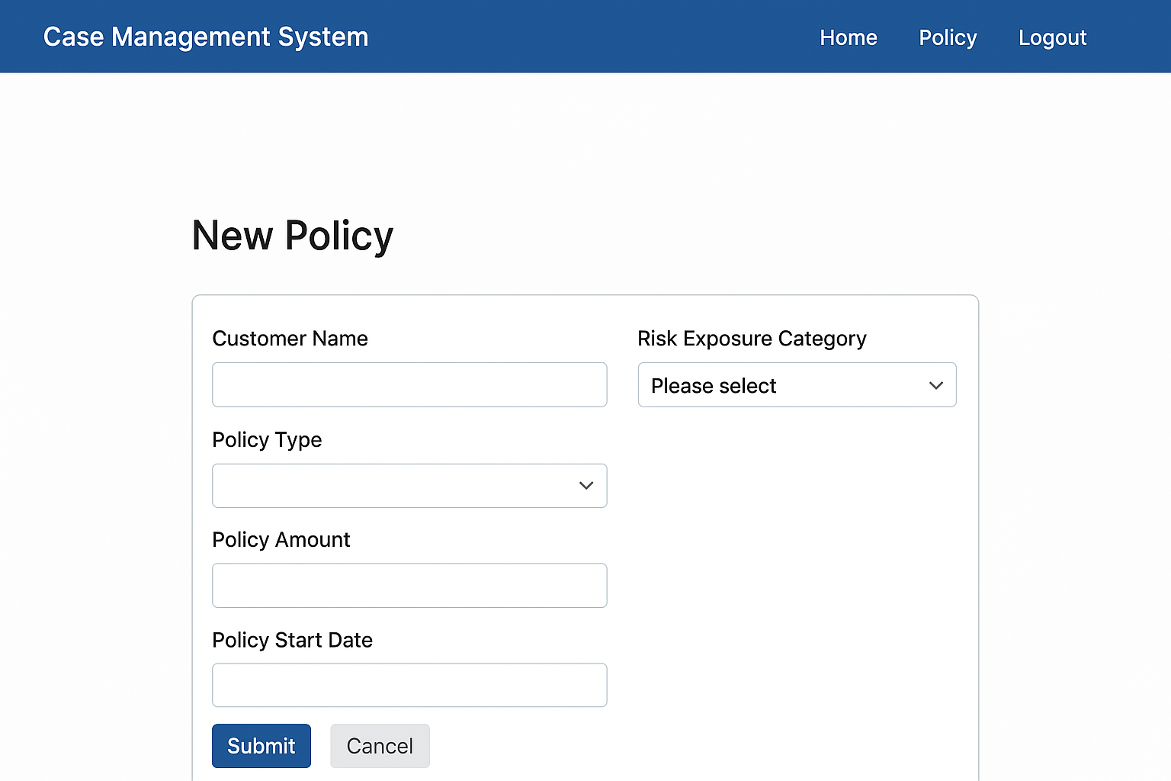

FCA Reporting Template
Field Name | Description | Source System | Data Type | Mandatory
Policy ID | Unique policy number | CRM | String | ✔
Customer ID | Policyholder identifier | CRM | String | ✔
Claim Amount | Financial claim value | SAP | Decimal | ✔
Risk Exposure Category | New compliance field | CRM | String | ✔
Policy Start Date | Coverage start date | CRM | Date | ✔
Policy End Date | Coverage end date | CRM | Date | ✔
Commission Amount | Commission paid | SAP | Decimal | ✔
Reporting Date | Report generation date | DW | Date | ✔

Use Case Diagram
Actors:
- Sales Agent inputs and submits policy data
- CRM System validates and triggers API Gateway
- API Gateway transfers to SAP FI/CO (logs and retries if needed)
- SAP FI/CO updates financial records
- ETL Process consolidates data in Data Warehouse
- Power BI dashboard displays FCA field for Compliance Officer and Finance review.
Flow:
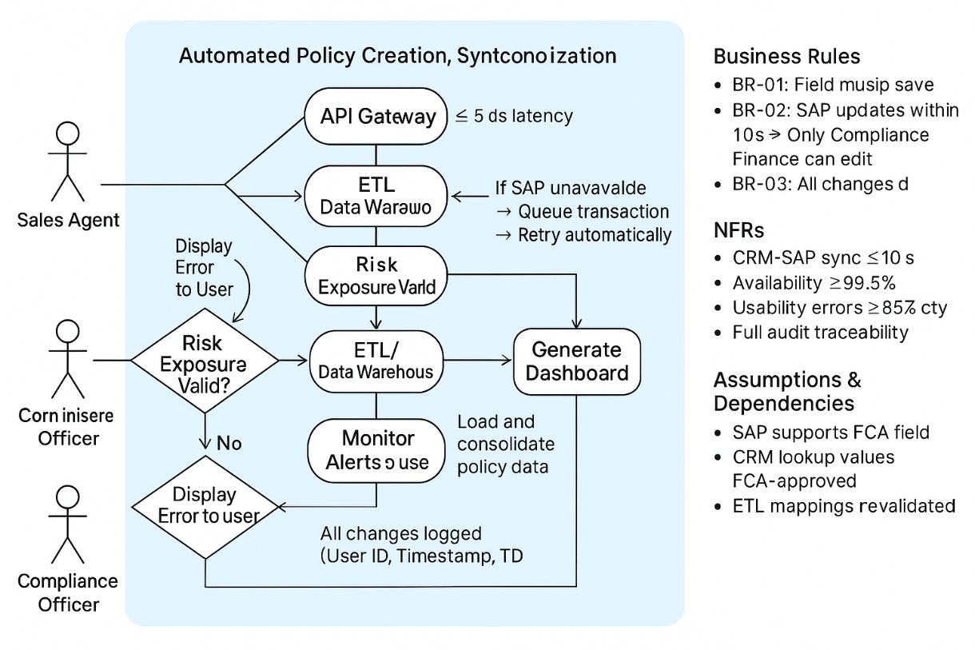

UC-2 - Automated ETL and Data Quality Framework
Element | Description
Use Case ID | UC-2
Use Case Name | Automated ETL and Data Reconciliation
Business Objective | Eliminate manual data consolidation; ensure completeness, accuracy, and recovery for nightly data synchronization.
Primary Actor | DataOps Scheduler
Supporting Actors | ETL Engine, Data Warehouse, Monitoring Service
Stakeholders | Finance Analysts, Compliance Team, IT Operations

Main Flow
- Scheduler triggers nightly ETL job.
- ETL extracts CRM and SAP datasets.
- ETL validates record counts and key fields.
- ETL loads reconciled data into Data Warehouse.
- Generates data quality report and logs results.

Alternate Flow
- Partial Failure: ETL retries failed segment automatically, sends email notification to DataOps.

Exception Flow
- Total ETL Failure: System rolls back, preserves last valid snapshot, notifies IT Ops.

Business Rules
Rule ID | Rule | Type
BR-05 | Daily ETL job must complete by 04:00 AM UTC. | Constraint
BR-06 | Reconciliation variance ≤ 0.1 %. | Quality Rule
BR-07 | Failed ETL must auto-retry ≤ 3 times before escalation. | Recovery Rule

NFRs
Category | Requirement
Reliability | Auto-recovery ≤ 30 min
Audit | ETL run logs retained ≥ 12 months
Performance | Job completion ≤ 60 min
Availability | 99.5 % pipeline uptime

Assumptions & Dependencies
- CRM/SAP accessible nightly.
- Network throughput supports full load volume.

User Story 2
As a DataOps Engineer, I want automated ETL with reconciliation and recovery so that data remains consistent and audit-ready.

Acceptance Criteria
- ETL runs successfully 95 % of nights.
- Discrepancies auto-flagged for review.
- Historical snapshots retained 30 days.

UC-3 - AI-Driven Financial Analytics Engine
Element | Description
Use Case ID | UC-3
Use Case Name | Predictive Financial Analytics
Business Objective | Provide predictive KPIs and anomaly detection for proactive decision-making
Primary Actor | Data Scientist
Supporting Actors | ML Engine, Data Warehouse
Stakeholders | CFO, Risk Officer

Main Flow
- ML Engine loads ETL-validated data.
- Calculates daily KPIs (claim ratio, forecast variance).
- Detects anomalies outside 2σ thresholds.
- Updates Power BI datasets.
- Stores model metrics and predictions.

Alternate Flow
- Model Drift Detected: ML triggers retraining workflow.

Exception Flow
- Data Incomplete: Model skips run, notifies DataOps.

Business Rules
Rule | Type
Models retrained quarterly; accuracy ≥ previous baseline. | Constraint
Forecast error ≤ 10 %. | KPI Rule
Model outputs logged with version and timestamp. | Audit Rule

NFRs
- Compute time ≤ 15 min per model.
- Accuracy ≥ 85 %.
- Model logs retained ≥ 12 months.

User Story 3
As a CFO, I want predictive analytics to anticipate claims and revenue trends so I can act early on financial risks.

Acceptance Criteria
- Forecasts auto-refresh daily.
- Anomalies flagged within dashboard.
- Retraining documented quarterly.

UC-4 -LLM-Augmented Narrative Intelligence
Element | Description
Use Case ID | UC-4
Use Case Name | Executive Narrative Generation
Business Objective | Translate complex KPIs into natural-language insights for non-technical executives
Primary Actor | LLM Engine
Supporting Actors | Power BI, ML Engine
Stakeholders | Executives, Data Analysts

Main Flow
- ML Engine sends KPI data to LLM.
- LLM generates narrative summary.
- Validates confidence ≥ 85 %.
- Displays text in Power BI dashboard.

Alternate Flow
- Confidence < 80 %: Mark as Requires Review and alert analyst.

Business Rules
Rule | Type
LLM must use approved narrative templates. | Constraint
Narratives auto-refresh every dashboard update. | Functional
Confidence score displayed beside summary. | Informational

NFRs
- Latency ≤ 2 s per summary.
- Accuracy ≥ 85 %.
- Availability ≥ 99 %.

User Story 4
As an Executive, I want plain-language KPI explanations so I can quickly understand financial performance.

Acceptance Criteria
- Summaries load within 2 s.
- Confidence < 80 % flagged.
- Template-based text verified for accuracy.

UC-5- Compliance, Audit & Security Module
Element | Description
Use Case ID | UC-5
Use Case Name | Compliance and Security Governance
Business Objective | Maintain audit trail, access control, and data security across all modules.
Primary Actor | Compliance Officer
Supporting Actors | IAM System, Security Services
Stakeholders | Compliance, IT Security, Internal Audit

Main Flow
- User logs into system via IAM.
- Role checked via RBAC policy.
- Actions (create/update/report) logged with metadata.
- Logs archived for audit.

Alternate Flow
- Unauthorized Access Attempt: System blocks and notifies Security Admin.

Business Rules
Rule | Type
RBAC enforced for all modules. | Constraint
Logs immutable and retained ≥ 12 months. | Audit
Data encrypted (TLS 1.3/AES-256). | Security

NFRs
- Authentication latency ≤ 3 s.
- Access failures logged 100 %.
- Security audit every quarter.

User Story 5
As a Compliance Officer, I want to ensure all user actions are traceable and data access is restricted by role.

Acceptance Criteria
- 100 % transactions logged.
- Unauthorized actions denied.
- Quarterly audit reports available.

UC-6 Performance & Continuity Management
Element | Description
Use Case ID | UC6
Use Case Name | System Performance and Continuity
Business Objective | Guarantee system responsiveness, uptime, and SLA monitoring across the data ecosystem
Primary Actor | IT Operations
Supporting Actors | Monitoring Service, DataOps, API Gateway
Stakeholders | CIO, DataOps Manager

Main Flow
- Monitoring Service collects uptime and performance metrics.
- Detects latency or downtime > threshold.
- Auto-trigger recovery or alert.
- Dashboard shows SLA compliance.

Alternate Flow
- ETL Delay Detected: Prioritizes recovery job and flags backlog.

Business Rules
Rule | Type
Dashboard refresh ≤ 10 s for ≤ 1 M records. | Performance
System uptime ≥ 99.5 %. | Availability
Failed jobs auto-recover ≤ 30 min. | Reliability

NFRs
- Mean Time to Recover (MTTR) ≤ 30 min.
- SLA compliance ≥ 95 %.
- Monitoring refresh every 5 min.

User Story 6
As an IT Operations Manager, I want automated monitoring and recovery so that system uptime and performance meet SLAs.

Acceptance Criteria
- SLA compliance ≥ 95 %.
- Automatic recovery verified in testing.
- Ops dashboard shows live performance metrics.

Traceability Matrix

Requirements Traceability Matrix (RTM)

BR/UR Ref ID | Business or User Requirement (from BRD) | FR Ref ID(s) | Functional Requirement Description (from FRD) | Test Case / Validation Reference
BR-01 / UR-1.1, UR-1.2 | Capture and synchronize the mandatory FCA “Risk Exposure Category” across CRM and SAP. | FR-01 | Unified Data Capture & Integration Layer — capture, validate, and sync risk category across CRM→SAP→DW→Reports. | TC-01 – TC-05 (UI validation, API sync, SAP posting, ETL check)
BR-02 / UR-1.3, UR-1.8 | Automate end-to-end data flow and reconciliation between CRM, SAP, and DW. | FR-02 | Automated ETL and Data Quality Framework — nightly ETL, validation, reconciliation, and failure recovery. | TC-06 – TC-09 (ETL job logs, recovery test, record match)
BR-03 / UR-1.5, UR-1.6 | Generate FCA-compliant reports containing mandatory fields for traceability. | FR-03 | FCA-Compliant Reporting Layer — generate, validates, and store FCA and IFRS reports with audit fields. | TC-10 – TC-13 (Report completeness, field validation)
BR-04 / UR-1.4 | Deliver predictive financial analytics and anomaly detection via AI. | FR-04 | AI-Driven Financial Analytics Engine — run ML/AI models for forecasting, anomaly detection, and KPI simulation. | TC-14 – TC-17 (Model accuracy, forecast validity)
BR-05 / UR-1.5, UR-1.6 | Produce real-time natural-language insights for executives. | FR-05 | LLM-Augmented Narrative Intelligence — translate KPIs to plain-language summaries in Power BI dashboards. | TC-18 – TC-20 (Narrative accuracy, generation latency ≤2s)
BR-06 / UR-1.7, UR-1.8 | Ensure system reliability, performance, auditability, and recovery. | FR-06 | Compliance, Audit & Continuity Management — uptime ≥99.5%, auto-recovery ≤30min, and full audit logging. | TC-21 – TC-25 (Failover, performance, SLA verification)

Use Case and User Story Mapping Matrix
FR ID | Use Case ID | Use Case Name | User Story ID | User Story Summary | Primary Actor
FR-01 | UC-1.1 | Policy Creation & Risk Exposure Capture | US-1.1 | As a Sales Agent, I want to capture and validate the Risk Exposure Category so policies comply with FCA rules. | Sales Agent
FR-02 | UC-1.2 | ETL Automation & Data Synchronization | US-1.2 | As a Data Engineer, I want automated CRM–SAP–DW data flow so reconciliation is error-free and traceable. | Data Engineer
FR-03 | UC-1.3 | FCA Report Generation & Validation | US-1.3 | As a Compliance Officer, I want FCA reports with all mandatory fields for regulatory submission. | Compliance Officer
FR-04 | UC-1.4 | AI-Augmented Financial Insights | US-1.4 | As a CFO, I want predictive and anomaly-based insights to identify revenue or compliance risks earlier. | CFO
FR-05 | UC-1.5 | Natural-Language KPI Narratives | US-1.5 | As an Executive, I want to see AI-generated summaries explaining KPI changes in real time. | Executive
FR-06 | UC-1.6 | Audit, Recovery & Performance Monitoring | US-1.6 | As an IT Operator, I want real-time system health checks, SLA dashboards, and auto-recovery workflows. | IT Operations

BR → UR → FR → UC → US End-to-End Mapping
BR ID | Business Requirement / Goal | Linked UR(s) | Functional Requirement(s) | Use Case | User Story
BR-01 | Capture and synchronize Risk Exposure Category for FCA compliance. | UR-1.1, UR-1.2 | FR-01 | UC-1.1 | US-1.1
BR-02 | Automate data flow and reconciliation across systems. | UR-1.3, UR-1.8 | FR-02 | UC-1.2 | US-1.2
BR-03 | Generate FCA reports with complete traceability. | UR-1.5, UR-1.6 | FR-03 | UC-1.3 | US-1.3
BR-04 | Enable predictive analytics and anomaly detection. | UR-1.4 | FR-04 | UC-1.4 | US-1.4
BR-05 | Provide AI-generated KPI narratives. | UR-1.5, UR-1.6 | FR-05 | UC-1.5 | US-1.5
BR-06 | Ensure uptime, audit logging, and recovery. | UR-1.7, UR-1.8 | FR-06 | UC-1.6 | US-1.6

Verification Summary Matrix
Layer | Verification Method | Tool / Owner | Validation Metric
FR-01 | Unit + Integration Test | QA + Integration | API sync time ≤10s
FR-02 | ETL Job Log Validation | DataOps | 100% record match
FR-03 | UAT Report Validation | Compliance | FCA fields complete
FR-04 | Model Test (MSE, Recall) | Data Science | ≥85% accuracy
FR-05 | UX Validation | BI Team | Summary latency ≤2s
FR-06 | Performance & SLA Monitoring | IT Ops | Uptime ≥99.5%, recovery ≤30min

System Architecture and Technical Design

The AI-Augmented Financial Insight Platform integrates front-end business systems (CRM, SAP, Power BI) with back-end data processing, AI, and reporting layers.
It ensures end-to-end traceability from policy creation → financial posting → data consolidation → AI insight generation → FCA-compliant reporting.

3.1 Front-End Applications
System | Technology | Primary Users | Core Function
CRM (Insurance Core) | ASP.NET (C#), JavaScript | Sales & Operations Teams | Manage policies, customers, and claims; capture and validate Risk Exposure Category
🔹 Enable Azure AD SSO
SAP FI/CO | SAP HANA, ABAP | Finance Department | Record financial postings and commissions, linked by Risk Category

3.2 Back-End Systems and Integrations
Component | Technology | Integration Type | Purpose
CRM Database | SQL Server | REST API / Direct SQL | Master data store for customers, policies, and risk metadata
SAP ERP | HANA / ABAP | RFC / BAPI / REST API | Financial postings, commission, settlements
Data Warehouse (DW) | MS SQL + Airflow | ETL / Python / SSIS | Consolidates CRM + SAP + external data
AI Analytics Layer | Python (ML) + TensorFlow | REST / SDK | Predict KPIs, detect anomalies
LLM Layer | LangChain + OpenAI API | REST | Generate natural-language financial summaries
Reporting Layer | Power BI + Python scripts | ODBC / REST | Generate FCA reports and narratives

3.3 Integration Flow
- CRM → SAP: New policies and claims transmitted via REST API with Risk Exposure Category.
- SAP → DW: Nightly ETL extracts postings and merges with CRM data.
- DW → ML Engine: Consolidated dataset processed for KPI predictions (claims ratio, variance).
- ML → LLM Layer: LLM converts KPIs into narratives.
- DW / AI → Power BI: Dashboards show metrics, trends, and insights.
- Scheduler: Archives outputs and refreshes pipelines with full audit trail.

3.4 Programming Languages and Frameworks

Layer | Technology / Framework | Purpose | Recommendation / Enhancement
Front-End | ASP.NET, C#, JavaScript | CRM UI, validation | Add client validation + localization support
Integration & ETL | Python, Airflow, REST APIs | Orchestration, transformation | Implement containerized Airflow for scalability
Back-End / Core | SQL, ABAP | Data persistence & posting | Use stored procedures for validation
Analytics / BI | Power BI, DAX, Python | KPI analytics & dashboards | Optimize DAX queries; enable caching
ML / AI | Python (pandas, scikit-learn, TensorFlow) | Predictive KPI analytics | Version model artifacts; automate retraining
LLM / NLP | LangChain, OpenAI API | Narrative summaries | Add prompt versioning + fallback templates
Monitoring / Logging | Grafana, ELK, CloudWatch | SLA monitoring & audit | Add real-time error dashboards
Security | Azure AD, RBAC, MFA | Access control & authentication | Implement quarterly RBAC review

3.5 Technical Integration and Impact Analysis

FR | Component | Technology | Technical Impact | Mitigation Strategy
FR-01 | CRM Front-End | ASP.NET / React | Schema + UI update for new Risk field | Regression + UAT testing; user training
FR-02 | Integration API | REST / JSON | API schema expansion | Versioned API; backward compatibility
FR-03 | SAP Posting | ABAP / HANA | ABAP logic update | Sandbox testing + controlled rollout
FR-04 | Data Warehouse / ETL | Python / Airflow | New data lineage + job dependencies | Automated validation; snapshot fallback
FR-05 | AI & LLM | TensorFlow / OpenAI | API latency, drift, and semantic errors | Caching, retraining pipeline, confidence scoring
FR-06 | Power BI & Security | Power BI, Azure AD | Performance degradation or access risks | SLA monitoring; incremental refresh; MFA enforcement

3.6 Non-Functional Requirements (NFR) Matrix
Category | Metric / Requirement | Target / Threshold
Performance | Dashboard load time | ≤ 10 seconds for 1M records
Availability | System uptime | ≥ 99.5%
Data Latency | ETL completion | ≤ 30 minutes
Accuracy | ML model prediction accuracy | ≥ 90%
Narrative Confidence | LLM output accuracy | ≥ 85% semantic match
Audit Retention | Transaction & AI logs | ≥ 12 months
Security | MFA, RBAC | Enforced for all roles
Scalability | Concurrent sessions | ≥ 500 users supported
Recovery Time Objective (RTO) | ETL or API failure | ≤ 30 minutes
Compliance | FCA/IFRS adherence | 100% validated before release

Project Sizing and Effort Estimation
FR / Module | Description | Complexity | Estimated Effort (Person-Days) | Dependencies | Priority (MoSCoW)
FR-01: Unified Data Capture & Integration Layer | Capture Risk Exposure Category, sync CRM ↔ SAP ↔ DW | Medium | 18 | CRM UI, SAP API | Must Have
FR-02: Automated ETL & Data Quality Framework | Nightly ETL + validation + recovery | High | 20 | Data Warehouse, Airflow | Must Have
FR-03: AI-Driven Financial Analytics Engine | ML-based KPI forecasting and anomaly detection | High | 25 | Data Science Models, DW | Should Have
FR-04: LLM-Augmented Narrative Intelligence | Generate and embed natural-language summaries | Medium | 18 | ML Engine, Power BI | Should Have
FR-05: Compliance, Audit & Security Module | RBAC, audit trail, FCA field validation | Medium | 12 | Azure AD, Security Logs | Must Have
FR-06: Performance & Continuity Management | SLA monitoring, ETL recovery, uptime | Medium | 12 | DataOps, Grafana | Could Have
Total Effort |  |  | ≈ 105 Person-Days

