Robot Setup user’s guide

Index

1 Introduction 4
2 RobotCloud 4
2.1 Data Structure 4
2.1.1 Main structure 5
2.1.2 Project structure 5
3 Users management 6
3.1 RobotCloud permissions 6
3.2 RobotSetup roles 7
4 User Manual 7
4.1 Common elements 7
4.2 Users 8
4.2.1 List 8
4.2.2 Create 9
4.2.3 Edit 11
4.2.4 Projects access 11
4.3 Organizations 12
4.3.1 List 12
4.3.2 Create 13
4.3.3 Edit 14
4.4 Projects 15
4.4.1 List 15
4.4.2 Create 16
4.4.3 Edit 17
4.4.4 Project configuration 18
4.5 Project tags 19
4.5.1 List 19
4.5.2 Create 20
4.5.3 Edit 20
4.6 Project subsystems 20
4.6.1 List 21
4.6.2 Create 21
4.6.3 Edit 21
4.7 Project locations 22
4.7.1 List 22
4.7.2 Create 22
4.7.3 Edit 23
4.8 Project devices 23
4.8.1 List 23
4.8.2 Create 23
4.8.3 Edit 24
4.9 Project services 24
4.9.1 List 24
4.9.2 Create 25
4.9.3 Edit 26
4.9.4 Configure instances devices 26
4.9.5 Instances management 27
4.10 Project export/import 32
4.10.1 CSV file format 32
4.10.2 CSV file format: Advanced 35
4.10.3 Run loaded file 37
4.11 User profile 39
4.11.1 User profile: Personal data 40
4.11.2 User profile: Organizations 40
4.11.3 User profile: Project access request 41

Introduction
RobotSetup is the application used to interact with RobotCloud. Its main utility is handle the installations of an organization, concretely, it allows to define and manage the installation structure and configure all its services.
This document contains the user manual of the platform and is structured by two main sections. Section 2 introduces the three RobotCloud elements managed: The users and its roles in the platform, the installations structure and the services that can be configured. Section three is the user manual itself.

RobotCloud
It’s essential to know RobotCloud to use RobotSetup platform. So, this section aim is to introduce it and explain the RobotSetup most relevant elements.
RobotCloud is the software and infrastructure used to manage the devices installed over the SiSLink buses. Next image shows how all elements are related, RobotCloud is the central element, it communicates with the installations with SiSLink to get installation data, and in the other hand applications like RobotSetup and RobotDesk query to it data about those installations.
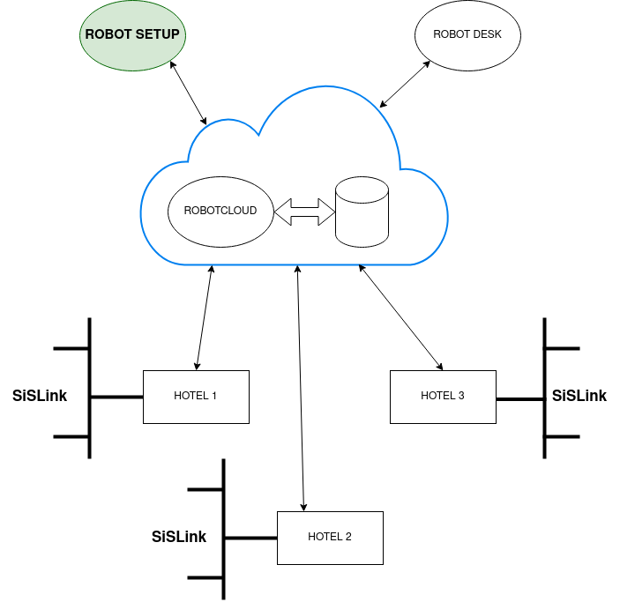

Data Structure
As already stated the main usage of RobotSetup is to define and handle the installations structure. In this section we introduce all the RobotCloud elements required to register a project, handle its structure and configure its services.
organizations
users
projects

projects

locations
services
instances
data
configuration
alert

devices

subsystems
tags
tags
tags
...

Main structure
There are three main elements that define the projects context:
- Organizations: It contains a set of users and projects and it is used to manage the relations between them.
- Users: Represents a user of the platform. Each user must belong to an organization and will have a specific permission on it and access permissions to some projects.
- Projects: It represents a ROBOTBAS installation. It contains information about the installed devices on it and the functionality they provide (called services). Each project is composed of a set of elements that define its structure, those elements are defined on the next section.

Project structure
An installation structure on RobotCloud is defined by the next elements:
- location: Represents a physical location inside an installation. Some examples would be: an hotel room, a machine room, the kitchen, etc. Each location can contain services instances and devices.
- device: Represents a device installed on the installation.
- Subsystem, Tag: Elements used to label some elements inside the project to ease its classification and filtering.
The functionality provided by the devices are defined by the following elements:
- service: Defines a set of data logically related to each other. For example, the service RoomClime_1 defines a set of data related to the clime control of a room (temperature, humidity, setpoint, etc.). There are a predefined set of services, each with a corresponding predefined data structure.
- instance: It provides access to the concrete values of a service. For example, an instance of the service RoomClime_1 will exist for the room 101 for an hotel, and another instance will exists at room 102, and so on for all the hotel rooms. To get the clime values for a given room you have to access to its own instance. The values provided by an instance are split in three groups:
  - data (read-only): Data provided by an instance.
  - configuration (read-write): Instance configuration data.
  - alert (read-only): Instance possible related alerts status.

Users management
Users in RobotCloud has a configurable access to the system. They have a concrete access level to his organization, split in five levels: “MASTER”, “SUPERUSER”, “ADMIN” and “STANDARD”, “STAFF”. Moreover, an access level to any project can be defined to each user. The project access levels are: “ADVANCED”, “BASIC”, “RESTRICTED” and “BLOCKED”.
To ease the different access level combinations in RobotSetup, there are a predefined set of roles which has a fixed organization access level and a default access level to his organization projects.

RobotCloud permissions
The organization access level defines how the user can interact with the system. Next table describes each platform access level permissions:
 | MASTER | SUPERUSER | ADMIN | STANDARD | STAFF
R Organization | X | X | X (*) | X (*) | X (*)
C Organization | X | X
D Organization | X | X
E Organization | X | X | X (*)
R User M/S | X
R User NORMAL | X | X | X (**) | Himself | Himself
C User M/S | X
C User NORMAL | X | X | X (*)
D User M/S | X
D User NORMAL | X | X | X (*)
E User M/S | X
E User NORMAL | X | X | X (*) | Himself partially | Himself partially
R Project | X | X | X (*) | His projects | His projects
C Project | X | X | X (*)
D Project | X | X | X (*)
E Project | X | X | X (*)
Legend:
- (*): Only affect elements from the user organization.
- (**): Users from the user organization or with access to any project.
- R: Read
- E: Edit
- C: Create
- D: Delete
- M/S: MASTER and SUPERUSER
- NORMAL: Neither MASTER nor SUPERUSER
RobotCloud also defines a set of access levels to a project. Those access levels are defined in the next table:
 | ADVANCED | BASIC | RESTRICTED | BLOCKED
L Project structure | X | X | X
E Project structure  (creation, edit and delete) | X
L Project configuration* | X | X | X
E Project configuration* | X | X
L Project data and alerts* | X | X | X
The previous table concepts are:
- Project structure: Locations, tags, subsystems, devices, services instances and historical.
- Project configuration: Services instances configurations.
- Project data and alerts: Services instances data, alerts and historical data.

RobotSetup roles
RobotSetup manage RobotCloud access levels assigning a role to each user. That roles are a combination of an organization access level and the default access level to its organization projects. So, a role is defined with this two values as defined in the next table:
ROBOTSETUP role | Organization access in RobotCloud Server | Default project access in RobotCloud Server
Super Robot | MASTER | ADVANCED
Robot | SUPERUSER | ADVANCED
Partner | ADMIN | ADVANCED
Advanced technician | STANDARD | ADVANCED
Basic technician | STANDARD | BASIC
Supervisor | STANDARD | RESTRICTED
Staff | STAFF | RESTRICTED

This roles are divided in two natural groups: administration roles and tech roles. The administrator roles are: “Super Robot”, “Robot” and “Partner”, tech roles are the others. “Super Robot” and “Robot” roles are platform administrators while “Partner” are the administrator of his organization. The non administrator roles may not have access to all his organization projects.
We can define each of the roles individually as follows:
- “Super Robot”: User with full access to the platform. This role is only used internally by the platform managers.
- “Robot”: User with full access to the platform. There are only a slightly difference with “Super Robot”, this role cannot edit or delete other “Super Robot” and “Robot” users. This role is only used internally by the platform managers.
- “Partner”: User that manage an organization. It has full access on all his organization projects. This role can manage users with access to any organization project.
- “Advanced Technician”: User of an organization that can manage his projects.
- “Basic Technician”: User of an organization that cannot modify the project structure.
- “Supervisor”: User of an organization that cannot modify the project structure neither modify the instances service configuration.
- “Staff”: User of an organization that only can see projects information.

User Manual
This section contains the user manual for each RobotSetup page.

Common elements
All lists in the platform has a set of common elements that has been remarked in the next image:
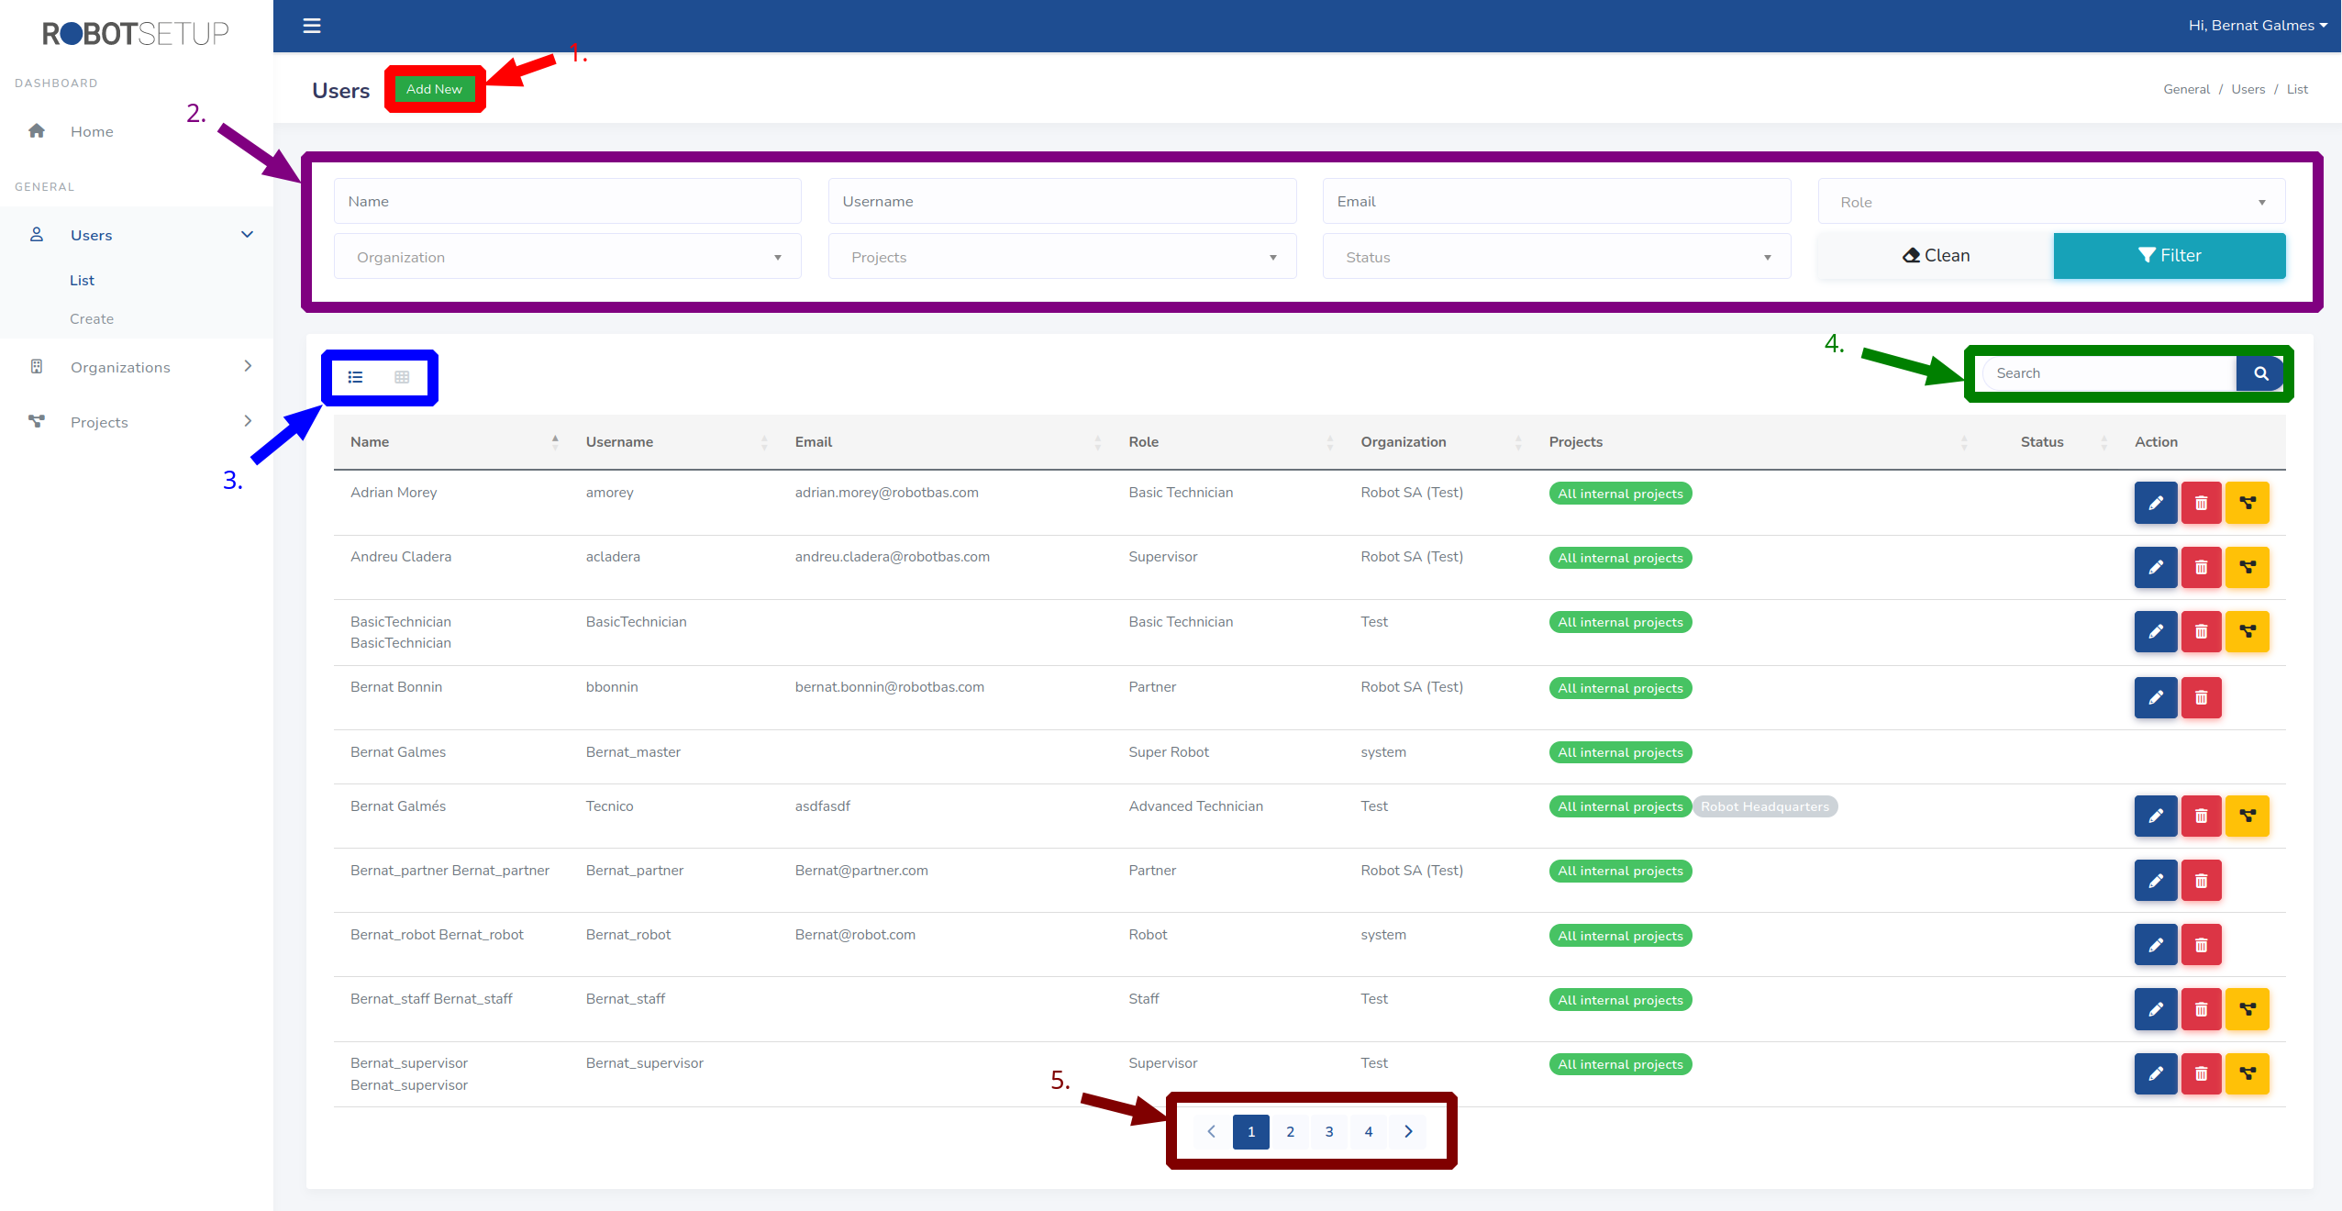
This common elements are enumerated in the image and has the next behavior.
- Button to create a new element.
- Form to filter the list by a field value.
- Change between table and targets views.
- Input to search registers by a text.
- Navigate between list pages.

Users
This module is only visible by admin roles: SuperRobot, Robot y Partner. That three roles has access to the whole module, the difference fall on the users they can manage.
Role | Manage “partner” users | Manage non admin users | Manage “superrobot” or “robot” users
SuperRobot | ✓ | ✓ | ✓
Robot | ✓ | ✓
Partner |  | ✓ (Only from his organization)
Furthermore, partner users only can create users for his organization..

List
This is the main page of the module, where you can find all the users accessible by the logged in user. Through this page you can access the pages to create a new user and edit, delete and manage project access from an existing user. The next image shows where you can find the buttons to access to that functionality in the table tagged with a number:
- Button to edit the user
- Button to delete the user
- Button to edit the user projects access. This button is only accessible for non admin users (roles: Advanced Technician, Basic Technician, Supervisor and Staff)
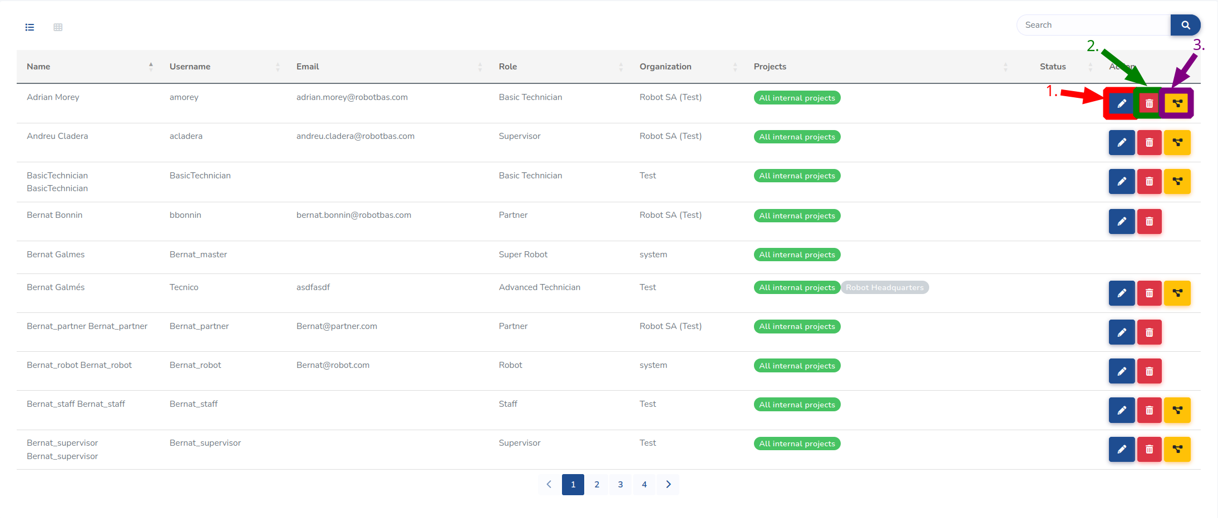
This buttons are not visible for the current logged in user neither for the system administrator user.

Create
This page is for creating a new user from scratch. Partner users only can view his organization, so only can create users for his organization.
You can access this page from the left context menu (See next image) or from the users list view with the button to add a new register common in all list views (See section 3.1).
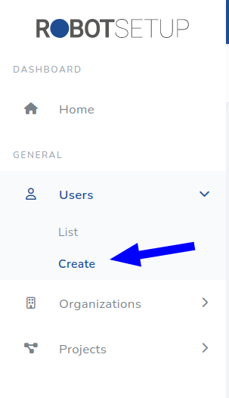
The page form is split in three sections to ease the data input. First section contain the account fields, second the role and third the profile fields. The profile section fields are dynamically generated according to the selected role.
Next image, contain the main page of the view:

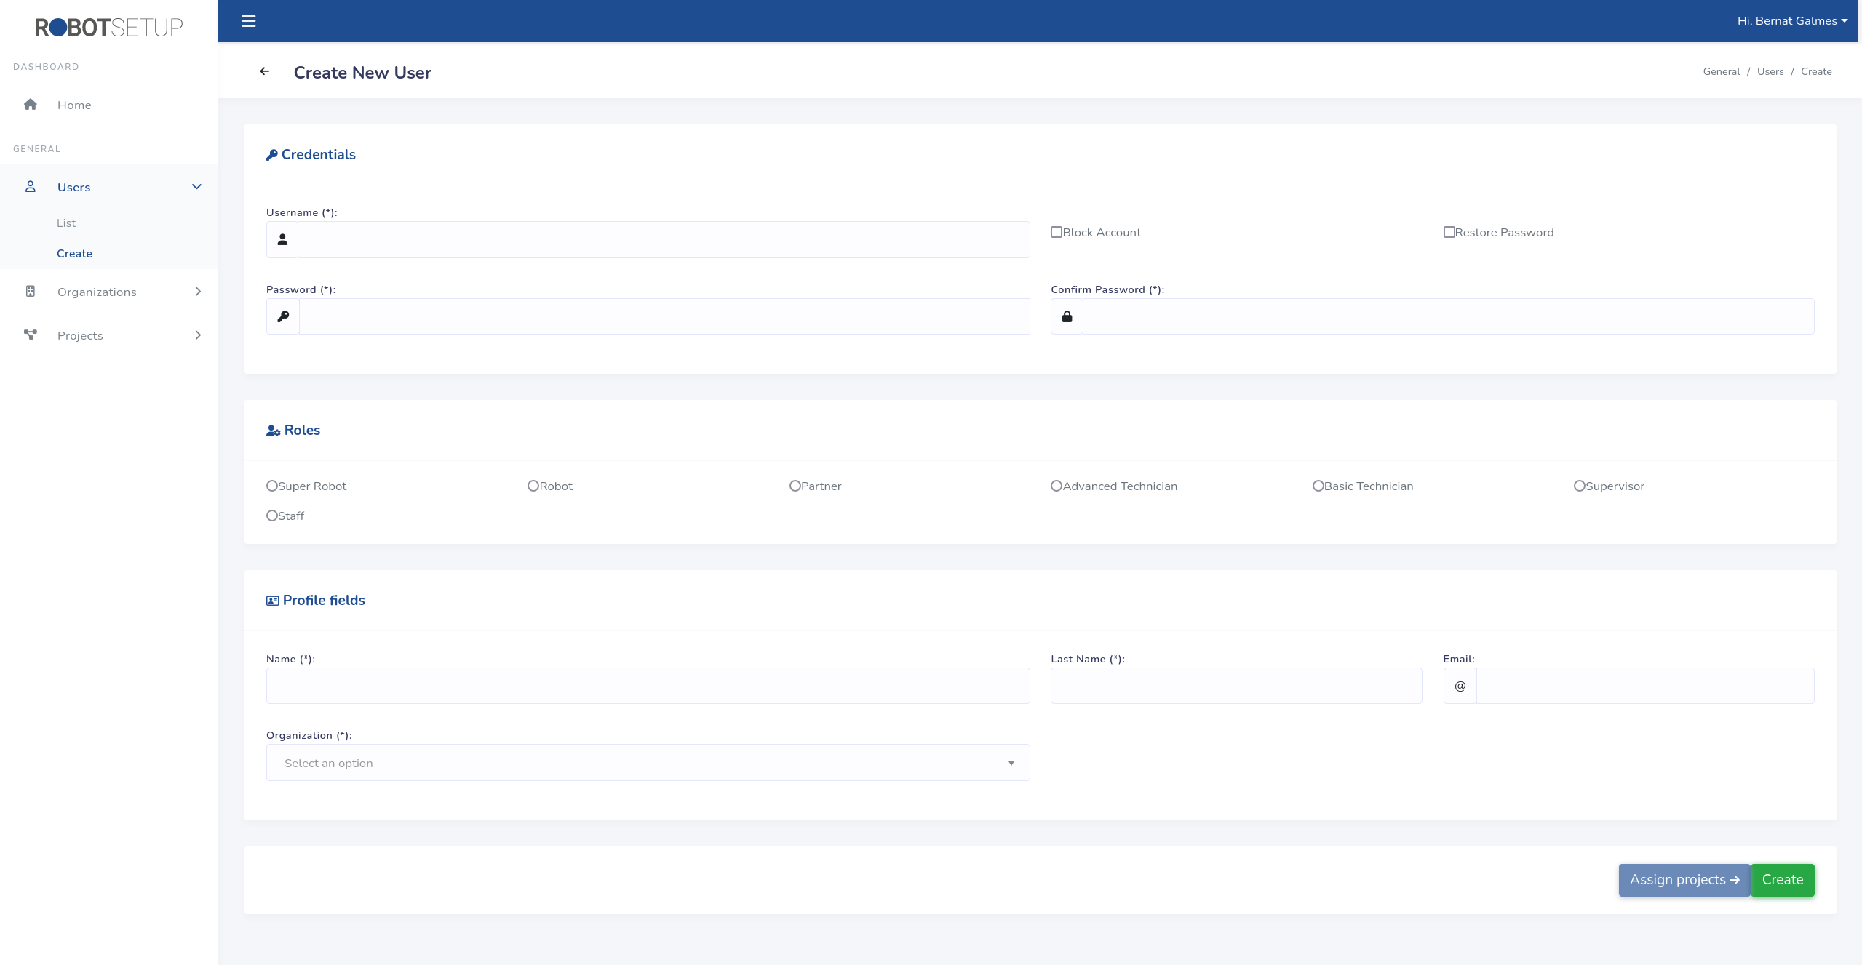
Credentials section
In this section of the form you have to indicate the credentials with which the user will access to the application.
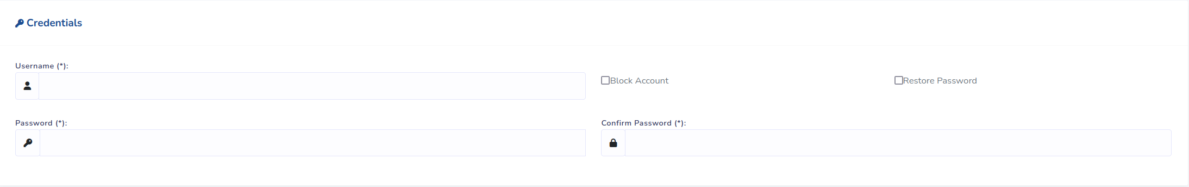
In this section you also have two check boxes:
- Checkbox “Block account”: if is active the created user will have the account blocked. Which means that the user won’t be able to access to the platform. Only “Super Robot” users can block users with role “Super Robot” and “Robot”.
- Checkbox “Restore password”: If is active it force the user to restore the password in the next login. While the user does not change the password he can’t access the platform. The checkbox functionality is not implemented yet.

Roles section
Section to select the role of the user:
- Partner user: Cannot create “Super Robot” and “Robot” users.

Profile section
This section vary according to the role selected in the previous section. For all roles except SuperRobot and robot you will see the next fields:
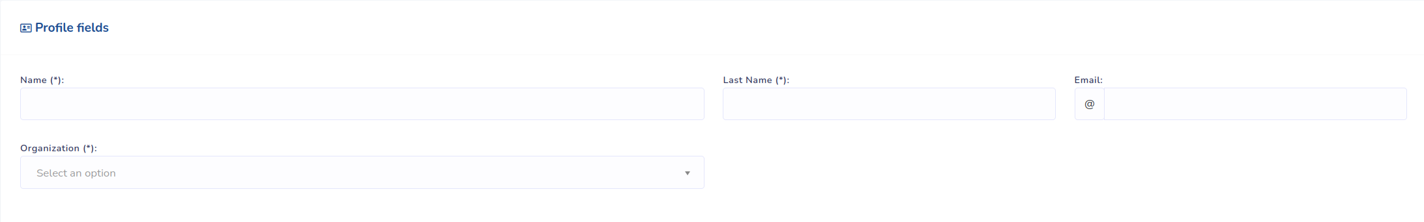
The organization field is mandatory for all roles except for the roles without organization (Super Robot and Robot) in which case the field will not be visible.
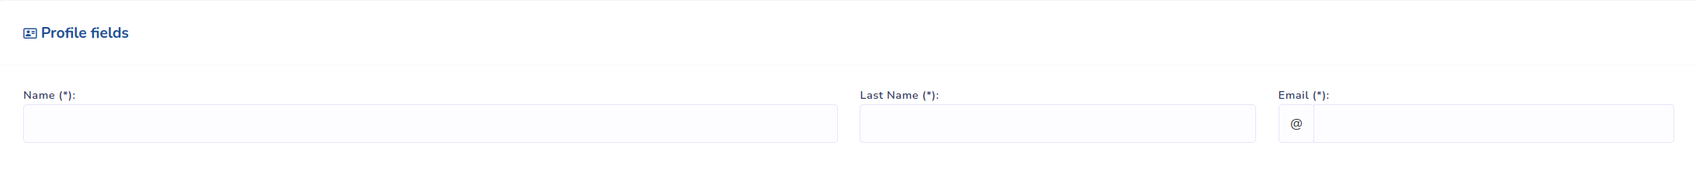
The email field is only mandatory for Admin roles (Super Robot, Robot and Partner).
- Partner user: The organization field is not editable and the organization selected by default is the one from the logged in user

Project assignation
When you are creating a non admin user (roles: Advanced Technician, Basic Technician, Supervisor and Staff) and you have selected an organization the project assignation page is available with the a button at the bottom of the page, otherwise this button is disabled.
When you access this page you will see an empty form to grant projects access. We refer to section 4.2.4. for more details about this form.

Edit
This view is equals as the creation one, but without access to project access management page. The form is filled with the data of the editing user, except for the password fields. We refer to previous section for more details of the view.

Projects access
To grant or revoke project access to a given user we must access this view. This view is accessible both from the user create form and from the users list view to edit an existing user permissions. Only Super Robot users can manage external projects accesses. The content of this view is filled with all the projects with permissions for the selected user.
In the project assignation page you can manage the user projects access. The current software version only allow to grant or revoke permissions for project for external organizations. All users always have access to all his organization projects with its default role permission.
The view initially look as follows:
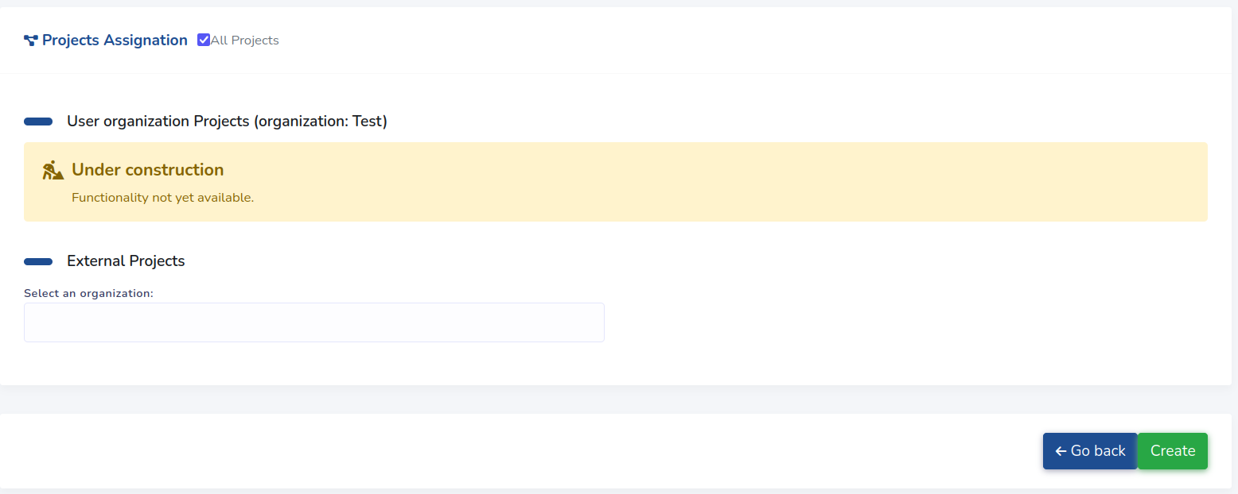
When you select an organization, a table with all the projects of the organization appears. This table allow you to grant an access level for any of the organization projects. The next image show this section with the main elements remarked:
- In blue there is remarked the input to select the external organizations to grant projects access.
- In Green there is the input to specify a concrete access level for the project.
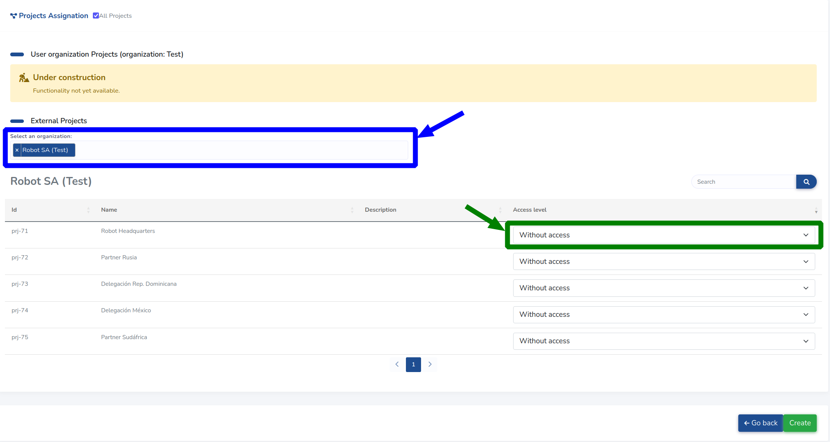
Available project access levels permissions are detailed in section XXX

Organizations
This module is only accessible by “Super Robot” and “Robot” users, then all organizations will be always visible in the module.

List
This view is accessible from the left sidebar main menu. From this you can manage all the organizations in the platform. It has all the common elements in all list pages (See Section 3.1.).
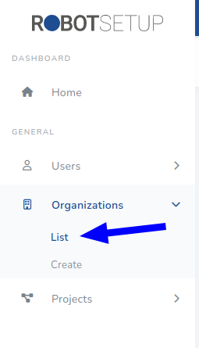
For each organization there are four functionality accessible with the buttons tagged with a number in the next screen image:
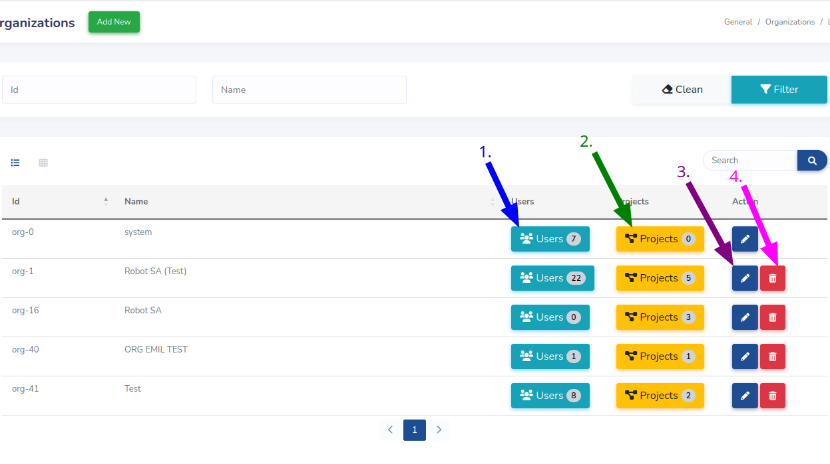
The four buttons tagged in the previous capture has the next functionality:
- Show a List of all users that has access to any of the organization projects.
- Show a list of all the organization projects.
- Access to the organization edit page.
- Delete the organization.
The system organization, cannot be deleted for any user.

Create
This view is accessible from the left sidebar main menu and from a button in the organization list.
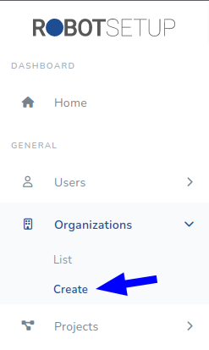
When you access this view you will see an empty form as follows. The three fields you will see are mandatory:
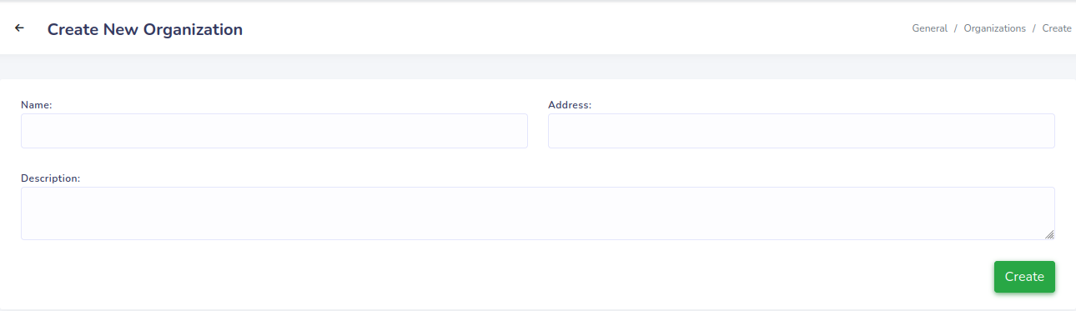

Edit
This view contains the same form as for creation filled with the editing organization data. You can access this form with the proper button in the organization list.
The view also offer information details about the project and users related with the organization. Next image contains the elements in this view labeled: Elements labeled in blue are organization projects information, elements labeled in purple are users information and red one is information about external users.
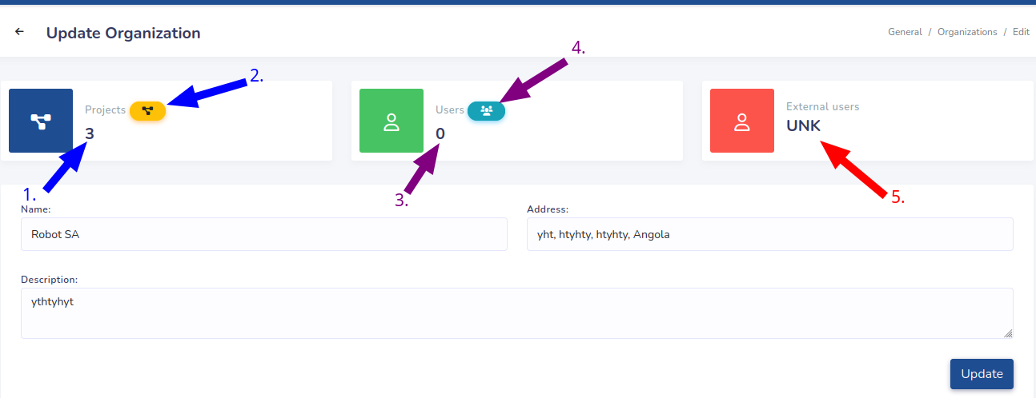
The previous labeled elements with a number are the next:
- Number of organization projects
- Button to show the list of all organization projects.
- Number of organization users (internal and external).
- Button to show a list of all user projects.
- Number of organization external users.

Projects
This module is the access point of the platform, so it is accessible for all users.

List
This is the main page of the module where a list of all the projects accessible from the logged in user are shown.
- “Super Robot” and “Robot” users see all the projects in the platform.
- “Partner” role see all the projects in this organization.
- Other roles see his organization projects and the external projects with access.
This view has all the common elements in list views shown in Section 3.1. The elements shown in this view vary according to the logged in user role and its projects access.
Next image shows the table shown in this view. The buttons labeled by a number has the next functionality:
- Access to edit project view. Only visible by admin roles.
- Delete the projects. Only visible by admin roles.
- Access to project configuration view.
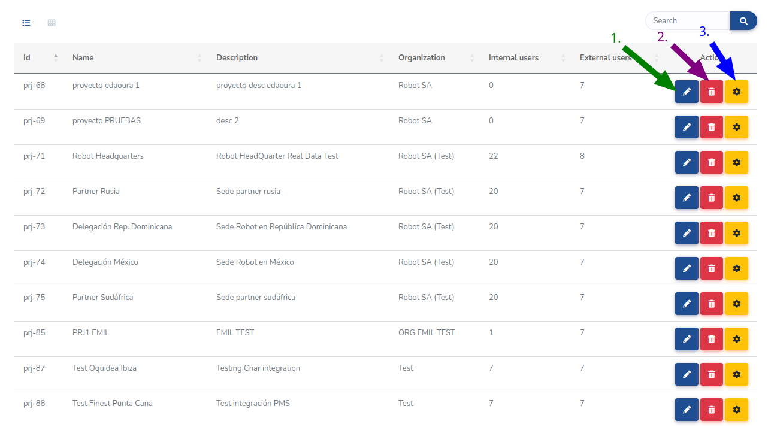

Create
The unique roles that can create projects are admin roles, so, this view is only accessible by “Super Robot”, “Robot” and “Partner” users. To access this view you can do it by the left sidebar or with the button in the projects list page, both buttons are hidden for users without access to this view.
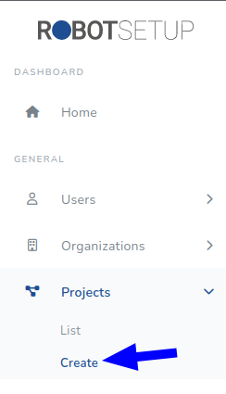
This view contains the next form with all the fields required to create a new project.
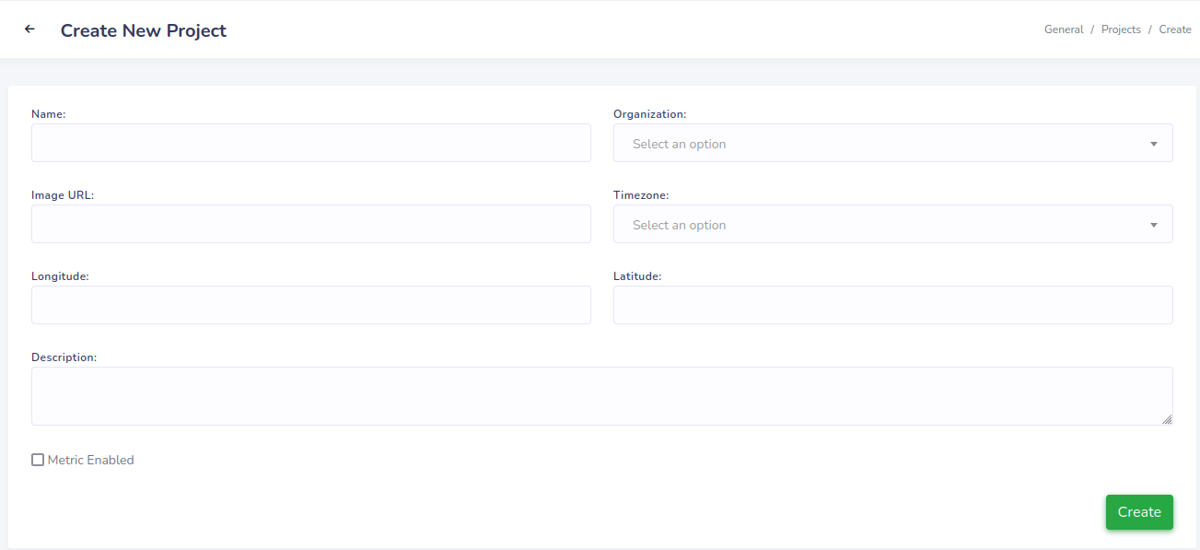
Next table summarize the form fields:
Field | Mandatory | Default value | Details
Name | ✓
Organization | ✓ | Partner user: User organization | Partner user: Disabled and not editable.
Image URL |  |  | Specify a URL with an image to describe the project.
Timezone | ✓ |  | Project location timezone.
Longitude |  |  | Project location longitude coordinate.
Latitude |  |  | Project location latitude coordinate.
Description
Metric enabled |  |  | Enable access to metric app.

Edit
Just like creation view this is only accessible by admin roles. This contains the same form as creation with the same restrictions (See section 3.4.2) filled with the editing user data.
Next image show the editing view. The difference with creation view is that at top you have information about the number of users with access to the project (internal and externals)
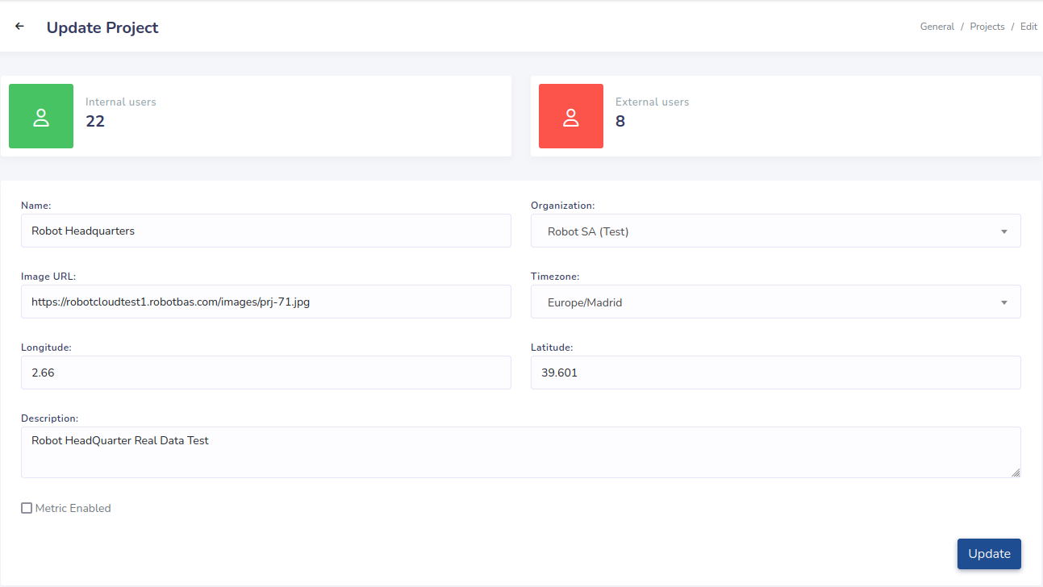
Note: After modify the project organization the relations between the project and this users are not modified, so the users from the old organization become external. And the users from the new organization become internal.

Project configuration
From this view you have access to the project scheme management and project configuration. As this is the main functionality of the app it is accessible for all roles in a different measure.
This view is the access point for all modules related with a projects, which are explained in the next sections: project tags, project subsystems, project locations, projects devices, project services and project export. When you access the view the left sidebar context menu changes to give access to all this modules for the selected project:

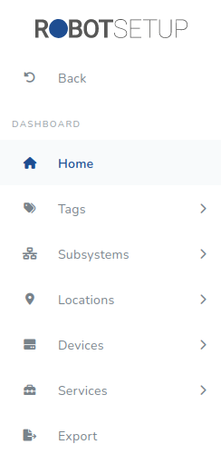
The non admin roles cannot modify the project structure, so they see all the modules but only can consult its record lists.
The main page of this view contains a summary of the project scheme elements and its configuration. Next image contains this page:
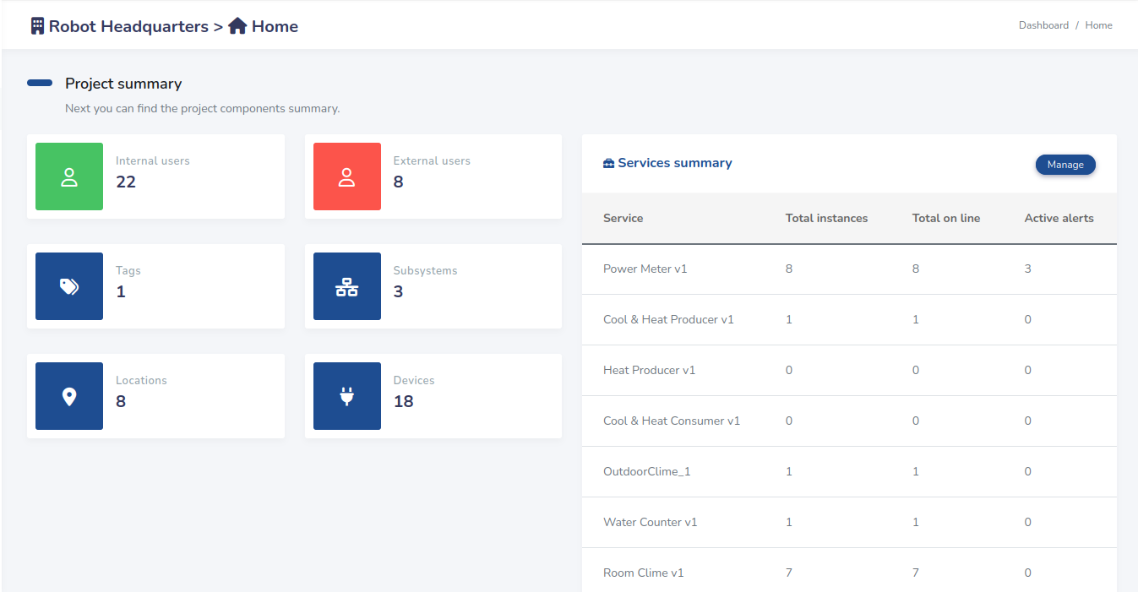
On the page left side you can see a summary of the project scheme elements. On the other side there are a list with a summary of all services configured in the project ant its status.

Project tags
This module is the responsible to manage the tags in a project. It’s accessible for all user, but users without “ADVANCED” access to the project can only view the tags.

List
In this view you can see a list of all tags registered in the project with its hierarchy. The users with an “ADVANCED” project also has also access to the views to manage the tags.
Next image contains the view. Users that can modify the project scheme see the three buttons in the rightest column:
- Button to create a child tag of the respective tag.
- Button to go to the tag edit view.
- Button to delete the tag.
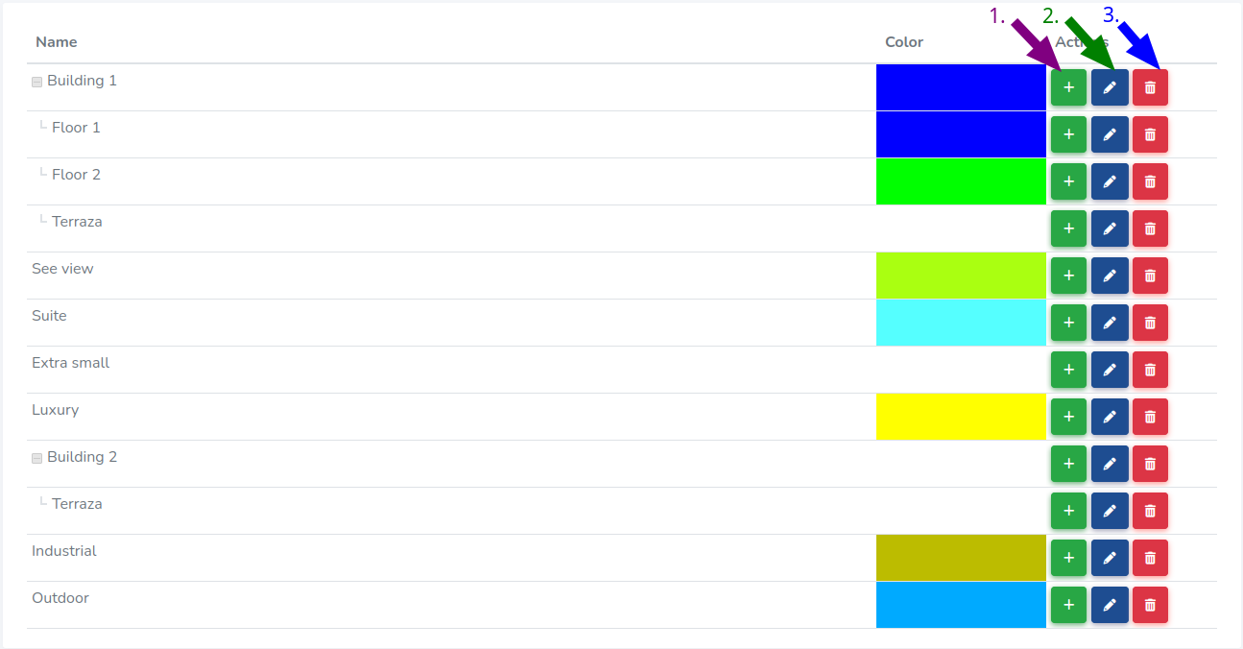

Create
View only accessible for users with “ADVANCED” access to the project. You can access this view from two sides:
- The button at the top of the page common in all app lists (See Section 3.1): to create a tag without parent.
- Green buttons in the list view table: to create a child tag for a specific element.
The form for creating a new tag is as shown in next image. When the form is open to create a child tag for a specific element the parent field is filled by default.
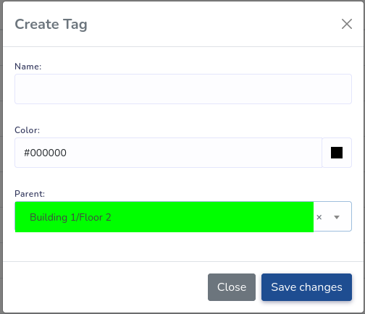

Edit
This view is the same as create but the form is filled with the editing element data.

Project subsystems
This module is for manage project subsystem records. Users without “ADVANCED” project access only can see the project subsystems.

List
This view shows all project subsystems details. Next image contains the view, with the buttons on the right you can access to a subsystem edit view and delete a subsystem.
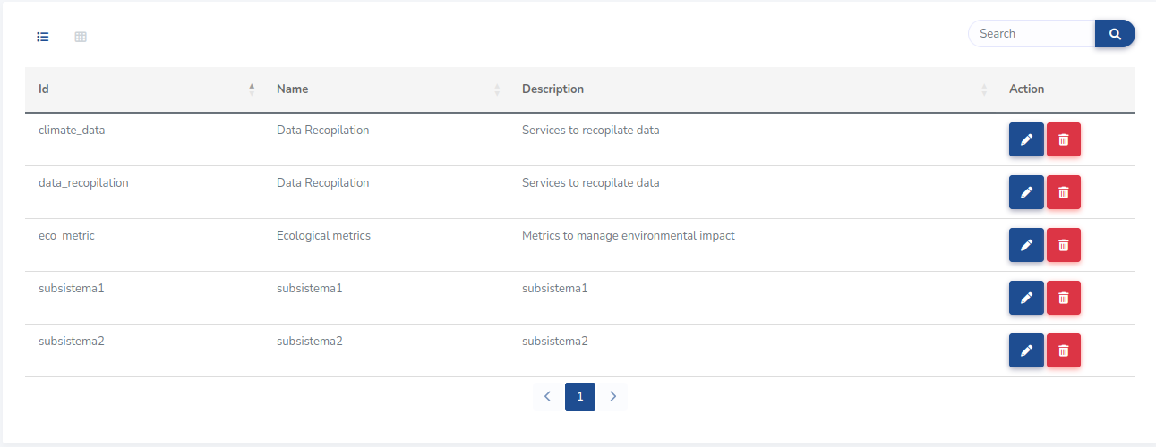

Create
You can access this view from the subsystem list view with the common button in all pages (See section 3.1).

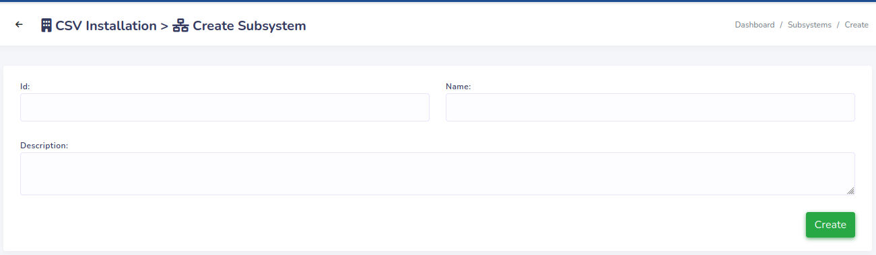
Next table contains the form fields details
 | Type | Mandatory | Unique in the project | Details
Id | String | ✓ | ✓
Name | String | ✓
Description | String

Edit
This view is accessible with the buttons in the table of the list view. Only users with “ADVANCED” access to the project can access it.
The content is the same form in the create view but with the fields filled with the editing subsystem values.

Project locations
All users with access to the project can access this module, but only the users with “ADVANCED” access can create, edit or delete locations.

List
This view is accessible for all users, but users without “ADVANCED” access to it only can see the list without any button.
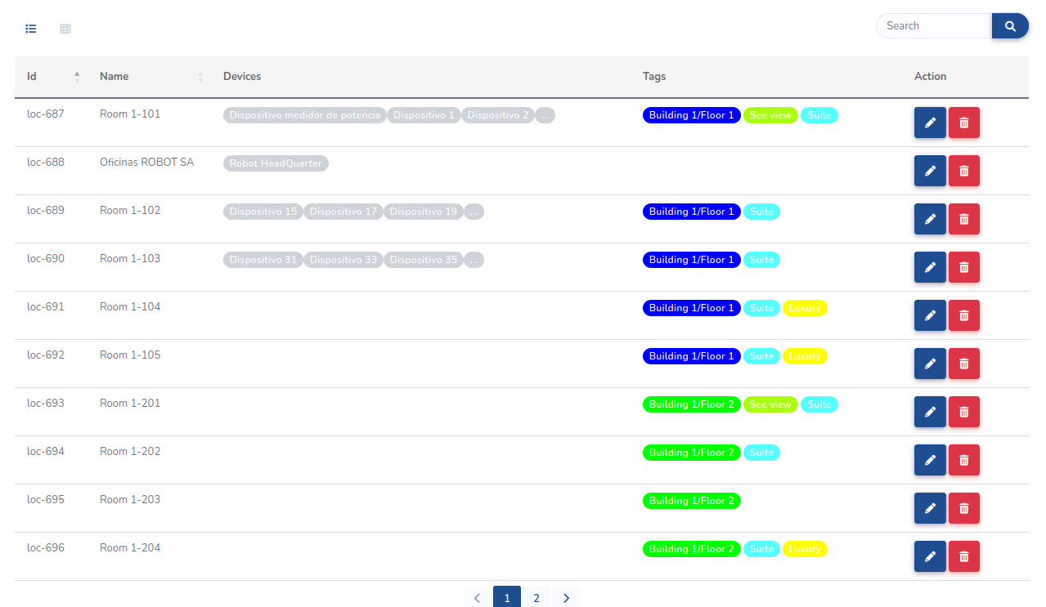

Create
This view is only accessible by users with “ADVANCED” access to the project. Next image shows the view.
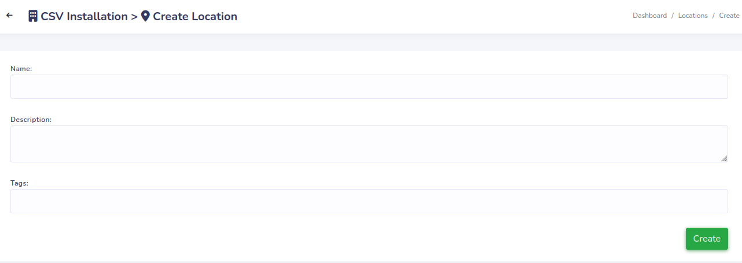
The fields in the form are described next:
 | Type | Mandatory | Unique in the project | Details
Name | String | ✓ | ✓
Description | String
Tags | Tags list |  |  | List of tasks related with the location

Edit
The edit view contains the same form as create view with the fields filled with the values of the editing location. Remember that only can be accessed by users with “ADVANCED” project access.

Project devices
Module to manage the project devices. Like the other project scheme modules this can be accessed by any user but only users with “ADVANCED” project access can create/edit/delete elements, in this case devices.

List
This view contains the list of all devices in the project. Users with “ADVANCED” project access will find the edit and remove devices buttons here, other users will only see the devices information.

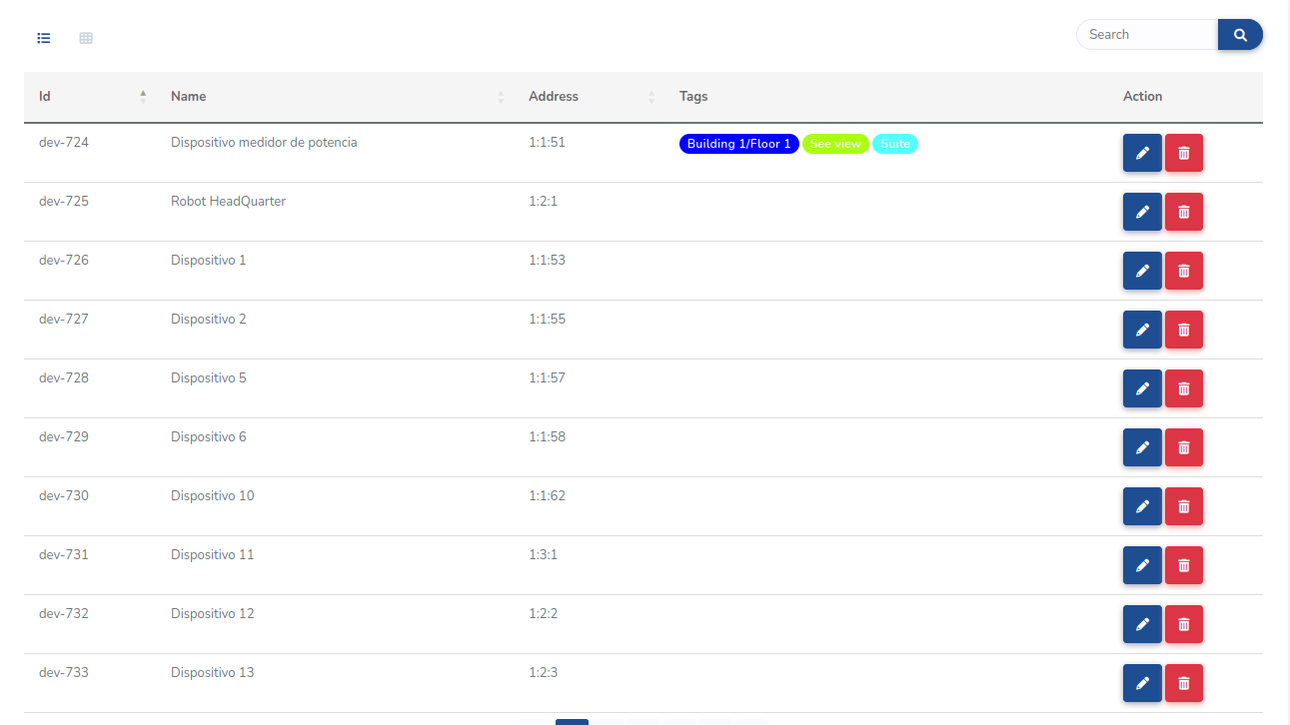
Create
View with the form for register new devices in the project. It is only accessible for users with “ADVANCED” project access.
Next image contains the screen of this view, where you can see a form with two section. In the first section you must specify the location data, and the second section is for specify its direction in the SiSLink bus.
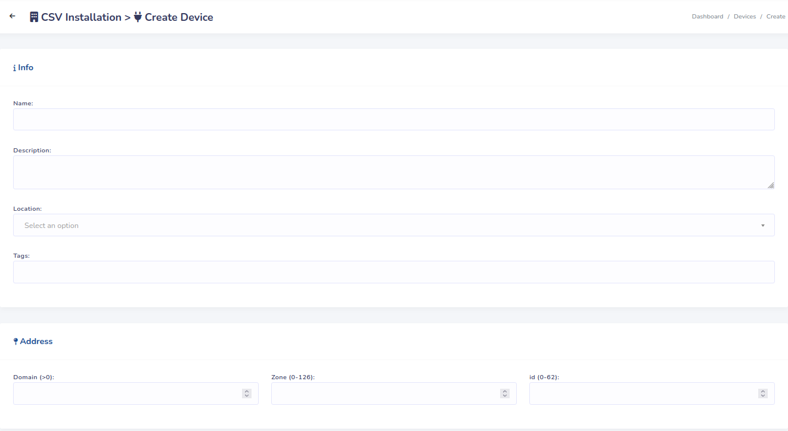
Next table describes the form fields:
 |  | Type | Mandatory | Unique in the project | Restrictions | Details
Name |  | String | ✓ | ✓
Description |  | String
Location |  | Location | ✓
Tags |  | Tags list |  |  |  | List of tags related with the device.
Address | Domain Id | Integer | ✓ |  | > 0 | The combination of the three values must be unique.
Address | Zone Id | Integer | ✓ |  | [0-126] | The combination of the three values must be unique.
Address | Device Id | Integer | ✓ |  | [0-62] | The combination of the three values must be unique.

Edit
View with the form for edit existing devices. It is only accessible for users with “ADVANCED” project access.
This view contain the same form as in the creation view filled with the values of the editing location. So, we refer to the previous for more details.

Project services
This is the main module of a project, with this module we can define, manage and configure all the services in the projects defined by the devices.
The data shown in this module can be read by any project access. Services can only be created/edited and deleted by a user with an administrator role or by an “Advanced Technician” project access. “Supervisor” and “Staff” roles cannot modify services configuration.

List
This view is accessible by any user. It shows all services registered in the project and its status.
The services in the list are grouped by his type. Next image shows the view where you can see all services types with at least one service instance in the project. The most remarkable thing is that if there are active alarms the service types of the affected instances appear marked with a yellow bell as shown in the next image.
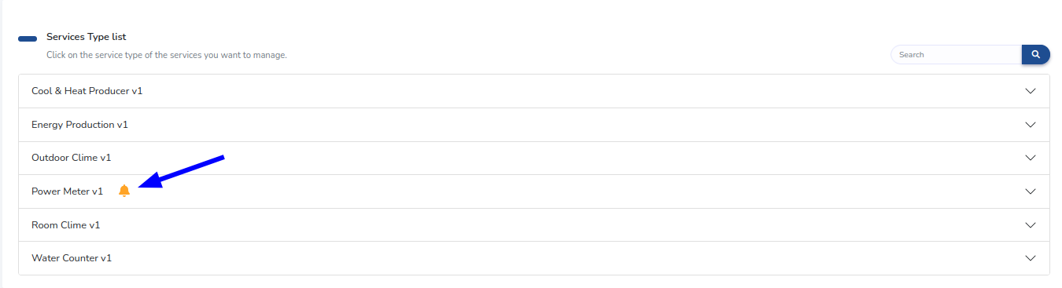
When you click on a service type in the previous image view, a table with all registered service instances of this type appear. Next image contain this table with its most relevant things labeled. In blue there are enumerated all action buttons:
- Button to refresh the table
- Button to access to the selected service instance management page. This button is disabled when there are not any row selected.
- Button with a direct access to all service instances with an active alarms, alarm instances view. This button is only visible if the service type has alerts. This button is disabled when there are not any service with active alarms.
- Button to access to the form to configure the devices of the service instance.
- Button to edit the fields of the service instance.
- Button to delete the service instance.
With green there are all the table columns that may require an explanation:
- Checkbox to select rows.
- Inform if the service instance is currently sending data.
- Inform if the service instance has any alarm active.
- Information about the configured devices on the service instance.3
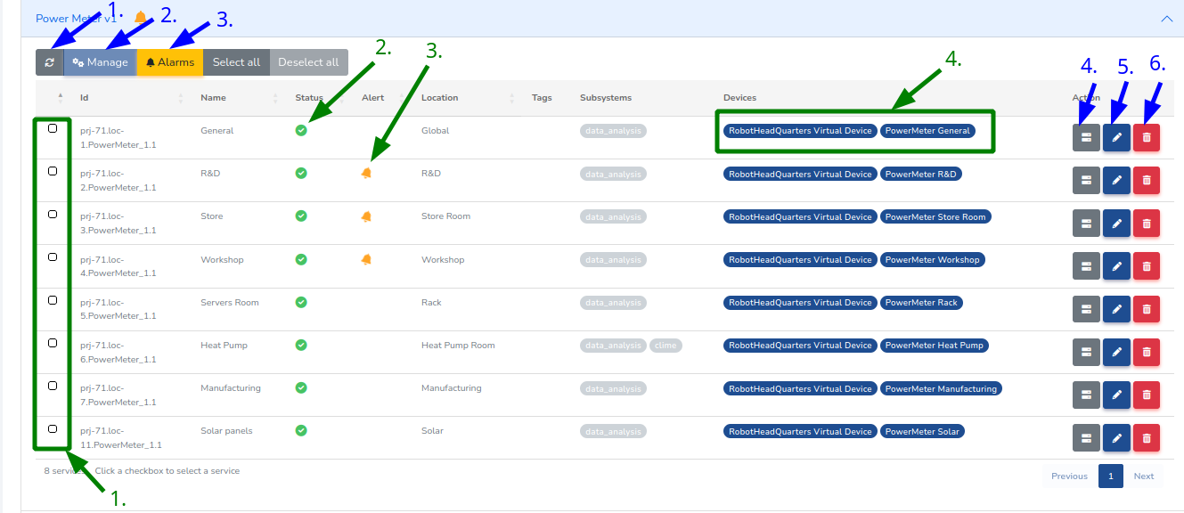

Create
To register new services instances you can access this view with the creation button in the same position than in the other list pages (See section 4.1).
Next image contains the form of this view:
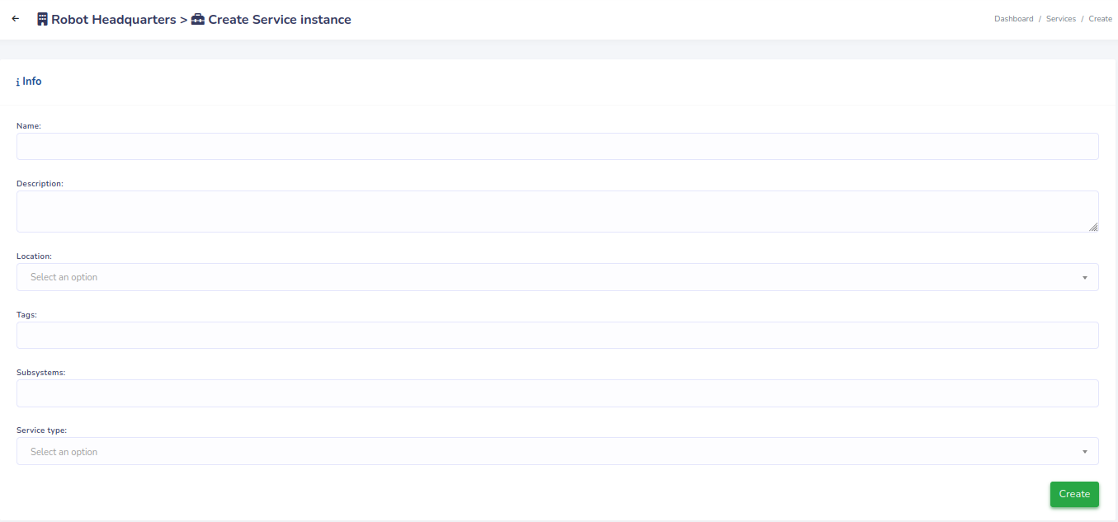
The description of the form fields are as follows:
 | Type | Mandatory | Unique in the project | Details
Name | String | ✓ | ✓
Description | String
Location | Location | ✓
Tags | Tags list |  |  | List of tags used to classify the service instances
Subsystems | Subsystem list |  |  | List of subsystems of the service instance
Service Type | Service Type | ✓

Edit
The edit view contains the same form as the create view without the service type (which is not editable), so we refer to the create view section for more information (Section 4.9.2). The form fields are filled by default with the editing instance values.

Configure instances devices
This view is accessible for any user with permissions to edit services instances, which are users with admin roles or “Advanced Technician” access to the project.
Next image contains an example of the form used to configure the device of a service instance. That form is dynamically generated according to the service type because each has a different device configuration: different number of device fields and for some device fields there are to configure an analogical input index. To configure a service instance correctly all fields are mandatory.
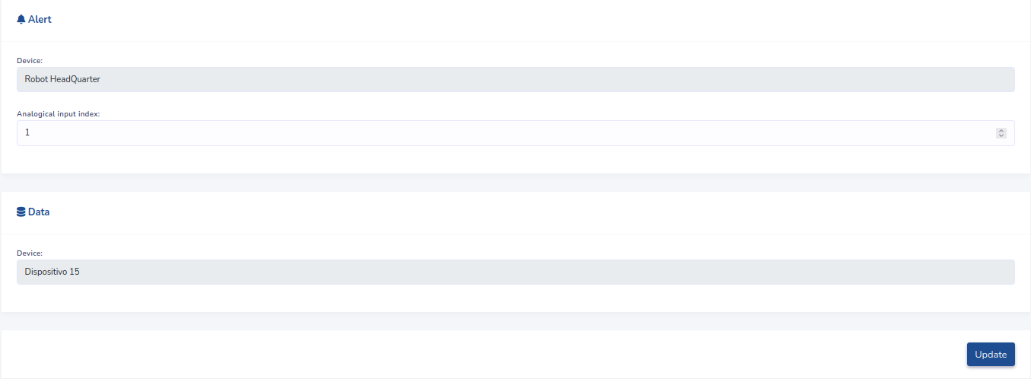
When you click on the device field a modal containing a table with all the project devices will be shown. In a project with a lot of devices might be difficult to find the desired device, consequently the modal contain some filtering elements to help this task.
Next image contain the modal with the devices table. In green there are labeled the filtering elements, with fields in “1.” you can find a device by a specific field value, with the element “2.” you can search for a device with a random text. To select a device you just have to click button with the blue arrow.
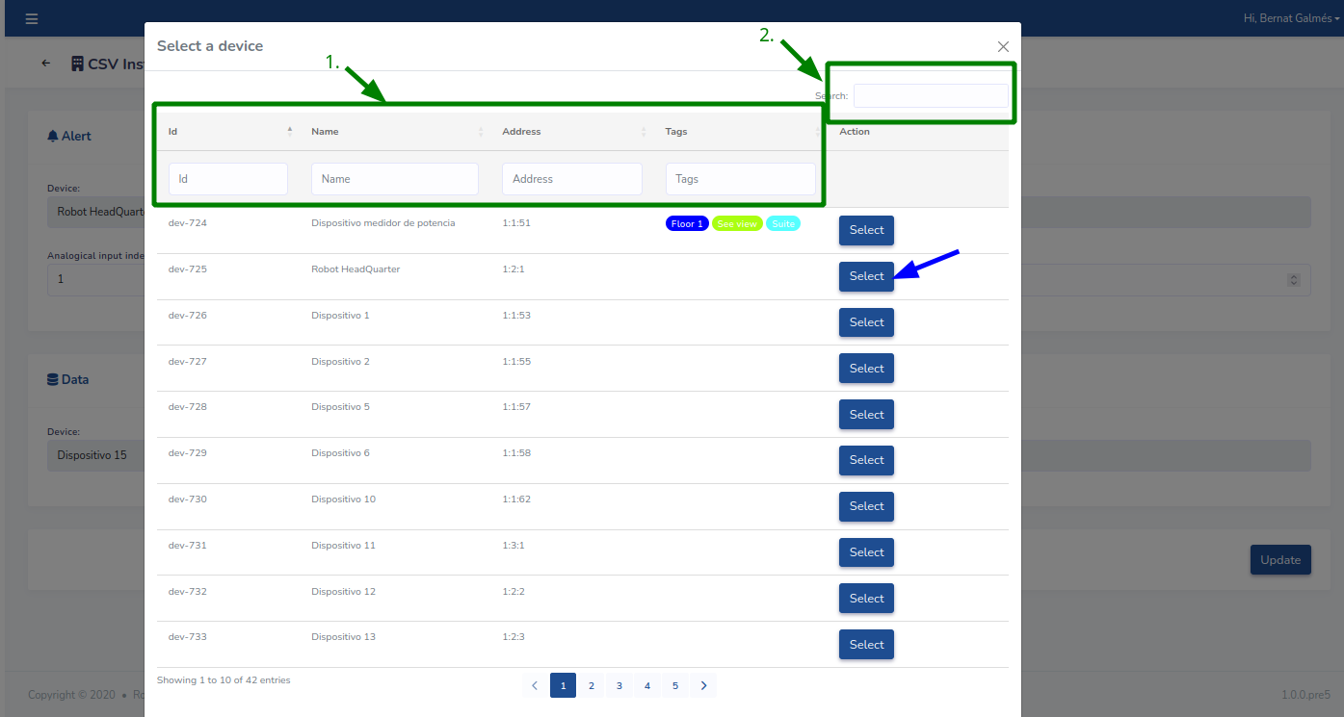

Instances management
The service instances registered in the project offer information about configuration, alarms and data. From this module you can visualize that information of a set of selected service instances.
To access the instances management you have to select a set of services instances using the checkbox in the first table row. Once the service instances are selected you can access the instances management view using the manage button on top of the table. (See image in Section 4.9.1 to find those elements)
When you access to instances management with a selection the left side menu changes with the following elements. In which each element correspond with the next four subsections:
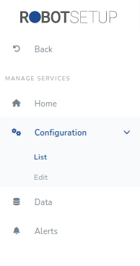
The header of all pages in instances management give information about the selected instances. Next image show that header with the elements enumerated:
- Number of selected instances.
- Button to show more information about the selection.
When the button to show more information about the selection is pressed the next header is shown, where you can see the values of the filters applied on the selection.
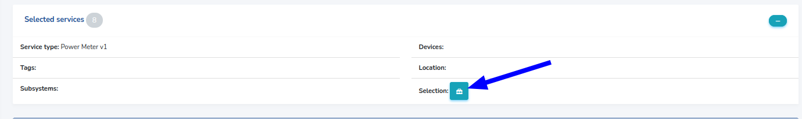
The button remarked with a blue arrow in the previous image open a modal with the list of all the selected services:
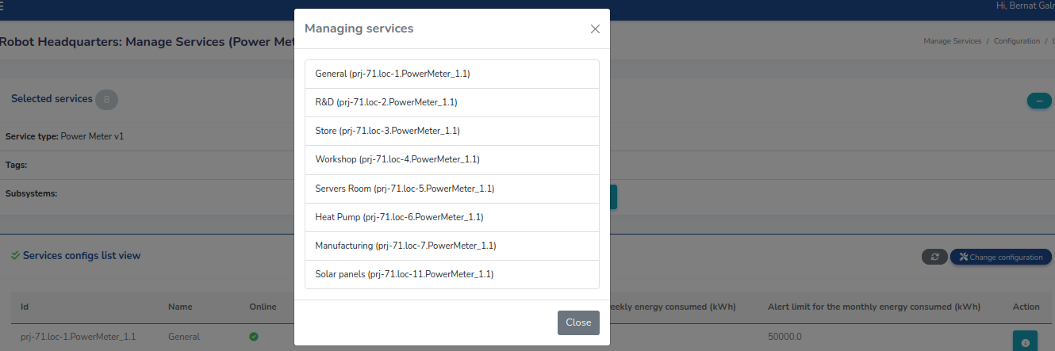
Most of the views shown in this section has several common elements, which are enumerated in the following image:
- Icon indicating if all managing services are online.
- Table column indicating the identifier of the service.
- Table column indicating the name of the service.
- Table column indicating if the service is online.
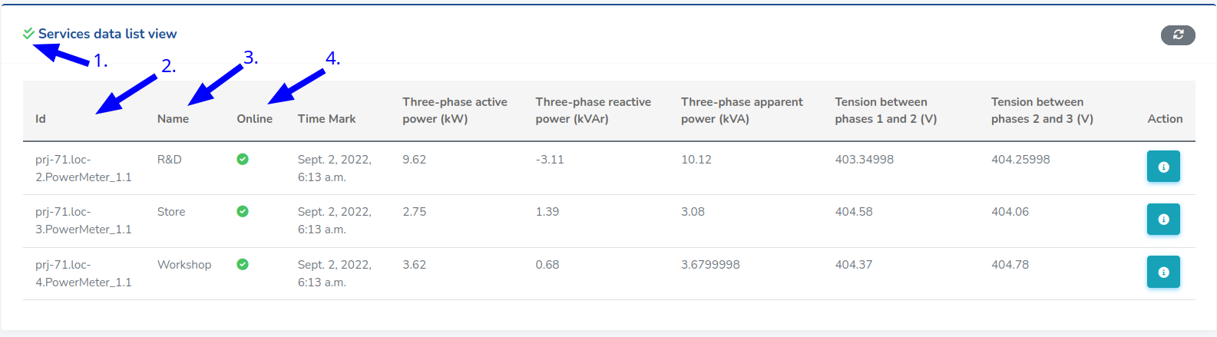

Configuration
The configuration values of the services selected can be seen in this page. Some service types can have a large number of configurable parameters, for example power meters has 13 configurable parameters. Showing all this parameters for all the selected instances in a pretty way is not feasible, so the view is adapted to solve that only showing three configuration values.
The view is composed by a table with the selected services configuration values. Next image shows that view, with the main elements tagged with a number:
- Button to refresh the table.
- Button to access to edit configuration view.
- Buttons to show all the configurable parameters values of the service instance.
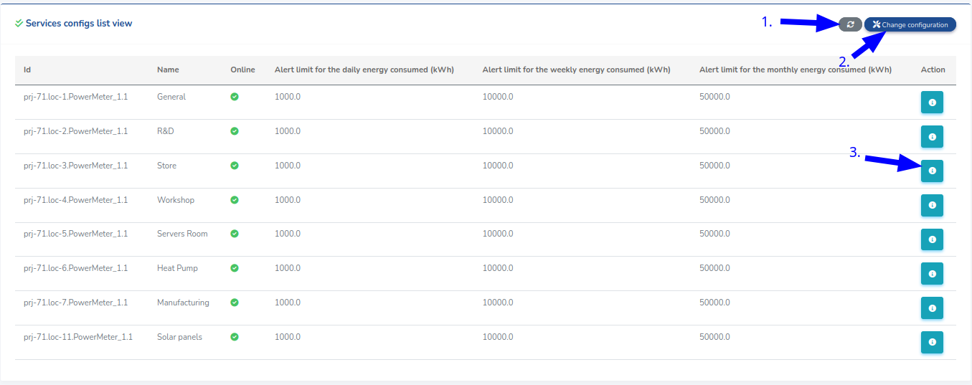

Edit configuration
With this view you can set the configuration parameters values for all the selected instances at the same time. Users with “Supervisor” or “Staff” access level to the project cannot modify services configuration.
When the configuration values of all selected services coincide the view looks as follows:
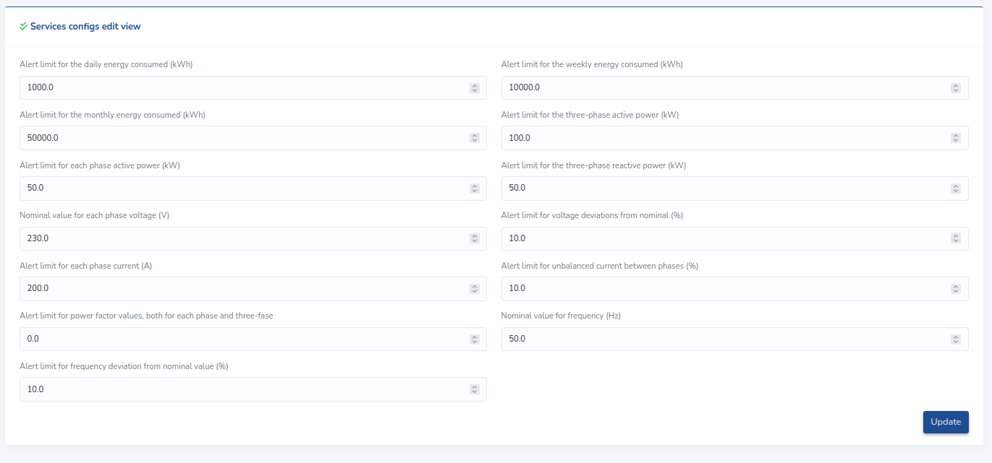
When a value of a field has different values between instances or does not appear in some instance the field appear remarked with a warning message. The next image shows the form for a set of Room Clime Services where there are three problematic fields. The fields remarked with a warning can mean:
- The value of the field do not match between services.
- There are any of the selected instances that does not provide the field.
- There are offline instances selected, all fields appear with a warning (The value of the configuration can’t be read).
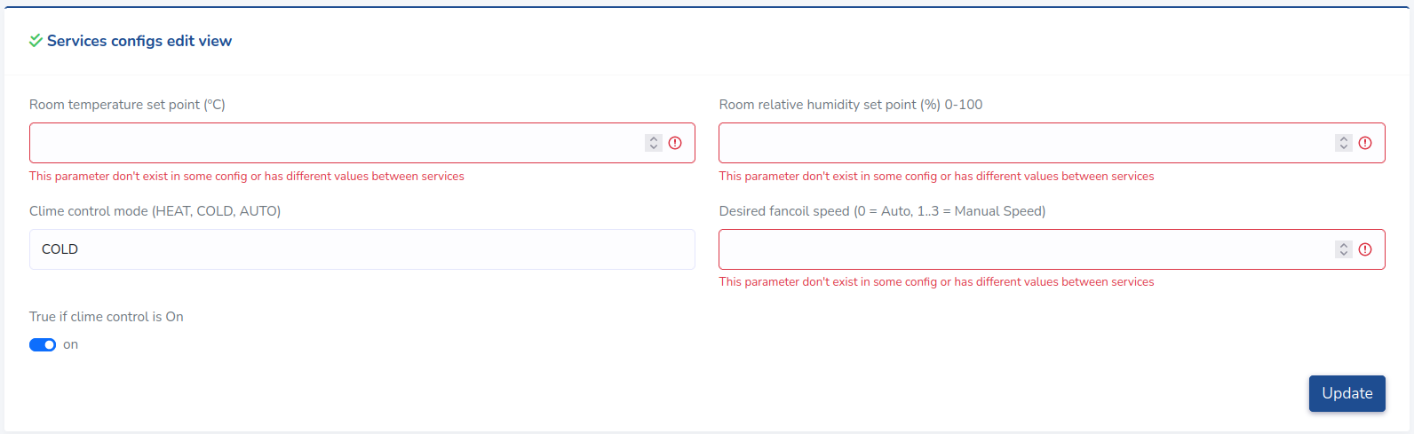
When there are fields with a warning it is recommended to review the selected services configurations list, to see what happen. The image below shows the configuration of the services of the previous form, where can be appreciated that the “Room temperature set point” has different values between services, and that the “Room relative humidity set point” does not exist in any of the service instances.
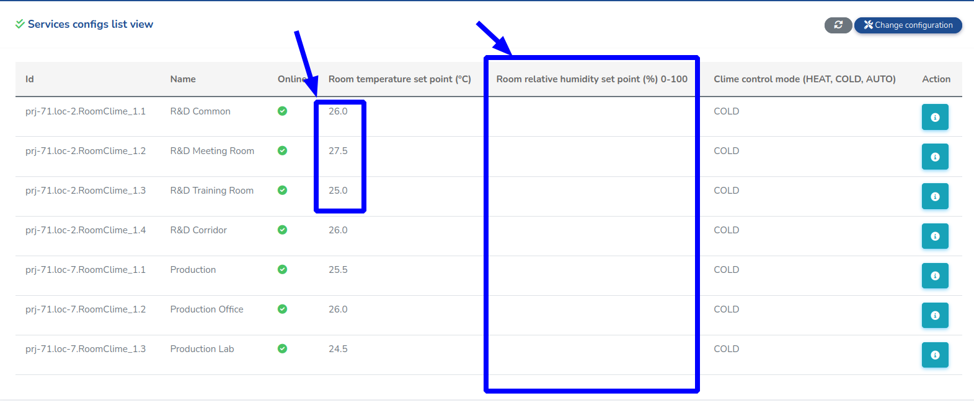
If you process the previous form with a values for all configurable parameters you will unify the values for “Room Temperature set point”, but the value of “Room relative humidity set point” will not apply any change on the system as this does not exist in any of the selected service instances.

Alarms
This view is only accessible for services instances type with alarms. All users with permissions on the project can access it.
Next image shows the view for three power meter services with active alarms. With a red bell you have the active alarms remarked.
Some service types has a large quantity of alarm fields, for example power meters has 19 alarms. Show those values in a single table shown in a laptop screen is impossible, so the alarm table can be scrolled horizontally with the bar pointed with a blue arrow under the table.
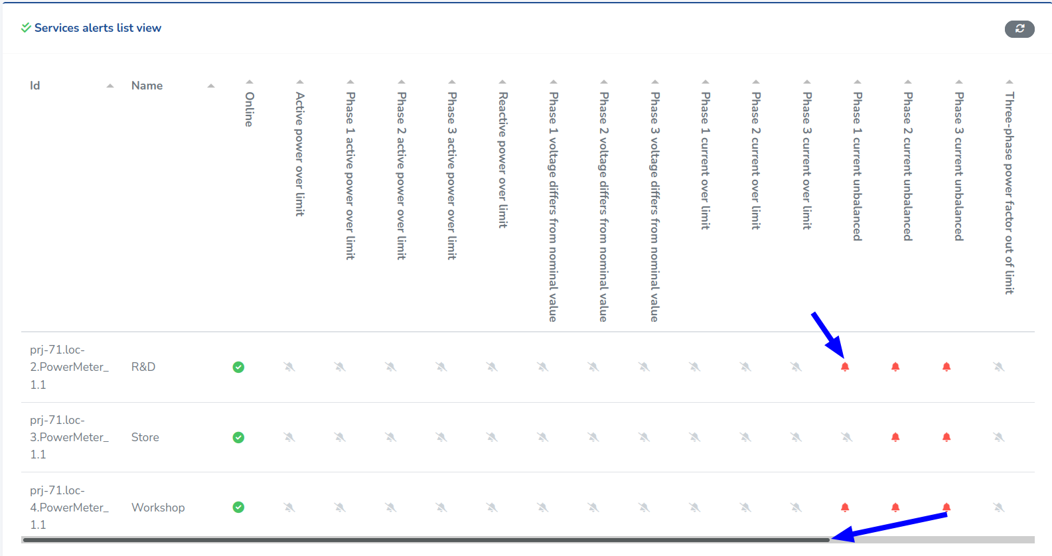

Data
This view is only informative, it gives information about the status of the services and the values of its last read data.
Next image shows the view, as with configuration table there are too much fields to show directly on the table, so there is a button on the rightest column to open a modal which contain all the service values.
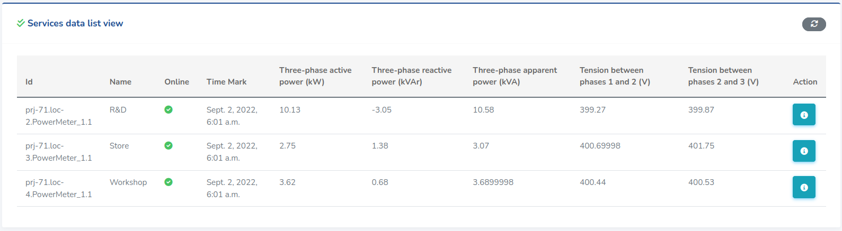

Project export/import
The aim of this module is allow to import a project structure from a CSV file. So, this module is only accessible by users with permissions to manage the project structure, those who have “ADVANCED” access to the project (admin roles and Advanced Technician).
The view of the module is split in the two parts that appear in the image below. The top section is to load a CSV file into the platform, on the other section when a file is loaded appear the data from the loaded CSV file.
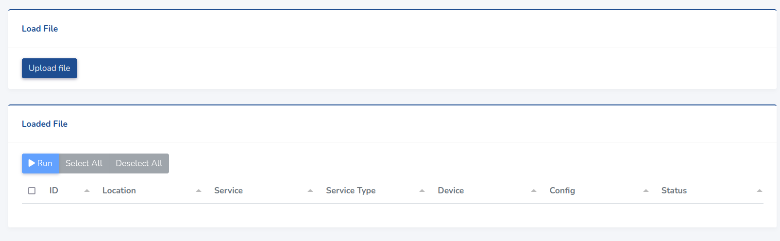
To load a file you must click the button in the top section and fill the form that will appear in a modal as one below. At the first field you should specify the delimiter character used in the file, currently the platform only allow to use “,”, “;” and “TAB” characters, by default “,” character is selected. The second field to fill is the CSV file that you want to upload, in section 4.10.1. you will find the required file format.

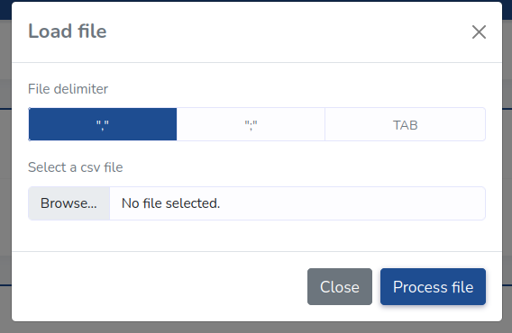
Once a file is loaded the table of the view is filled with the information of the CSV file. Then, you can inspect the rows loaded in the table and select and run the desired rows. In Section 4.10.2 you will find the details of this table and how to run the file rows.

CSV file format
The CSV file should define the structure of the installation you want to load in the platform. That file must contain the configuration of all services with all its associated tags, subsystems, devices and locations.
NOTE: No field in the CSV file can contain the delimiter character.
In order to be understandable for the platform this files must have a very concrete format and structure. That structure consists in each file row defining a device configuration on a service. Those rows must have the next fields with its values separated by the configured delimiter character in exact the next order:
Column | Name | Description | Value details
1 | Row type | Identifier of the type of row | Must have the constant value “CONF” on all rows.
2 | Service local identifier | Unique identifier of the service instance. Used to identify other occurrences of the same service instance in the file. | String
3 | Service location local identifier | Location unique identifier. Used to identify other occurrences of the same location in the file. | String
4 | Location name | Name of the service instance location. | String
5 | Location description | Description of the service instance location. | String
6 | Location tags | Tags of the service instance location. | See Tags format section
7 | Service type | Type of the service we are configuring. | String
8 | Service name | Name of the service instance | String
9 | Service description | Description of the service instance | String
10 | Service subsystems | Subsystems of the service instance | See Subsystems format section
11 | Service tags | Tags of the service instance | See Tags format section
12 | Service Classifier | Classifier of the service instance | See Classifier format section
13 | Device Address | Configuring device address on SiSLink bus | See Device address format section
14 | Device location | Device location identifier. | If is kept blank the same location of the service instance is used
15 | Device name | Name of the device | String
16 | Device description | Description of the device | String
17 | Device tags | Tags of the device | See Tags format section
18 | Service configuration | Value of the service instance device field where configure the device. | See Device config format section

Next table show an example with the two required rows in the CSV file to configure the two devices of a power meter. To understand the format of the fields see the following sections.

Tags format
The rows that provide information about the tags associated with a concrete element must have a very specific format.
Remember that a tag is a hierarchical element, a tag can have a parent tag and successively. To define a tag in a cell you must specify all the tag hierarchy using the next format:
ancestor:parent:child
That is you must write the full tag path separating each element with the “:” character. The previous character string is used to identify a specific tag in the file, so if your file have the same tag path multiple times all of them refer to the same tag.
To assign multiple tags to a single element you should use the “+” character to separate them as follows:
ancestor:parent:child1+ancestor:parent:child2+single
If you observe the previous definition of multiple tags there are some shared ancestors between them, so the tag hierarchy created will be the following:
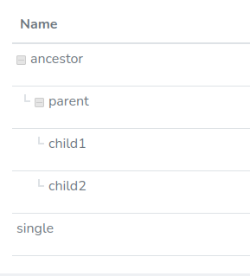
This format implies that you are not allowed to use the “:” and “+” characters in a tag name.
The tags created directly like this will have white color by default, if you want to specify a color for the tag see the respective subsection in section 4.10.2

Subsystems format
Subsystems are similar as tags, but without hierarchy. You can assign one or more subsystems to a service instance writing its subsystem id separated by “+” character as follows:
subsystem1+subsystem2
This format implies that you are not allowed to use the “+” characters in the subsystem id.
The subsystems created this way will have the same identifier and name, the character string identifier, and en empty description. If you want to create subsystems with a custom name and description see the respective subsection in section 4.10.2.

Classifiers format
Classifiers are similar as locations, but they are not mandatory. You can only assign one classifier to a service instance writing its classifier id:
cls-*
Where * is a certain number you specified in the CSV.For information on creating classifiers, refer to the corresponding subsection in section 4.10.2.

Device address format
The device address is the location of a device in a SiSLink bus. That address is defined by three elements:
- Domain: An integer greater than 0.
- Zone: An integer between 0 and 126.
- Id: An integer between 0 and 62.
The specification of this three elements in a single cell must be done by specifying the previous three elements in the same order separated with the “-” character as follows:
domain-zone-id --> 1-2-5

Device configuration format
The device configuration is the slot where to configure a device in a service instance. The slots to configure are defined by the service type. To know the slots to configure in a service type you have to look up RobotCloud documentation.
For example to configure a power meter we have to set a device for the slots “data” and “alert”. The alert slot also require to indicate an index. In the device configuration cell we must specify the slot name string, for example “data”. When the slot require to define an index we must introduce it indicating the slot name and the index number separated with the “-” character, so, to configure the alert slot with the index “1” will be as follows: “alert-1”

CSV file format: Advanced
The previous section provide the basic knowledge to set up a full installation structure, but with a lot of limitations.
Sometimes we will reuse a location in several services or configure a service with a device in a different location than the service. We can want to define details about the tags and subsystems used in the configuration rows. Those details cannot be specified with the simple format specified in the previous section.
To solve that problem we have other type of rows which allow to specify additional data in the file.

Location row
Sometimes there are locations which has a lot of services, other times you want to configure devices in a different location of the service, and other combinations.
To allow more flexibility you can specify the locations in a specific rows and then associate them to the different services and devices using the location local identifiers.
Next table detail the required columns in a location row specification:

Column | Name | Description | Value details
1 | Row type | Identifier of the type of row | Must have the constant value “LOC” on all rows.
2 | Service location local identifier | Location unique identifier. Used to identify other occurrences of the same location in the file. | String
3 | Location name | Name of the service instance location. | String
4 | Location description | Description of the service instance location. | String
5 | Location tags | Tags of the service instance location. | See Tags format section

Below there is an example of a row defining a location:
The defined locations can be used now to be assigned to a service instance or to a device using its local id (Second column value).
Bonus: Defining the locations separately of device configuration rows allow us to simplify configuration rows, so that we can omit columns 4, 5, and 6 because they will contain redundant information. That way we can specify configuration rows with 15 columns instead of 18. You can combine configuration rows of 15 and 18 columns in a same file as its content is identified by the same platform.

Config row
Sometimes you can configure shorter service rows only if you previously defined locations rows(defined above), only then you can define services as shown in the next table.

Column | Name | Description | Value details
1 | Row type | Identifier of the type of row | Must have the constant value “CONF” on all rows.
2 | Service location local identifier | Location unique identifier. Used to identify other occurrences of the same location in the file. | String
3 | Service location local identifier | Location unique identifier. Used to identify other occurrences of the same location in the file. | String – Must be already defined in his specific row
4 | Service type | Type of the service we are configuring. | String
5 | Service name | Name of the service instance | String
6 | Service description | Description of the service instance | String
7 | Service subsystems | Subsystems of the service instance | See Subsystems format section
8 | Service tags | Tags of the service instance | See Tags format section
9 | Service Classifier | Classifier of the service instance | See Classifier format section
10 | Device Address | Configuring device address on SiSLink bus | See Device address format section
11 | Device location | Device location identifier. | If is kept blank the same location of the service instance is used
12 | Device name | Name of the device | String
13 | Device description | Description of the device | String
14 | Device tags | Tags of the device | See Tags format section
15 | Service configuration | Value of the service instance device field where configure the device. | See Device config format section

Below there is an example of a row defining a configuration:

Tag row
Declaring tags directly on configuration rows does not allow to customize its color. For this purpose you can define tags in a special rows with the next format:
Column | Name | Description | Value details
1 | Row type | Identifier of the type of row | Must have the constant value “TAG” on all rows.
2 | Tag | Single tag string | Use the format defined in tag format section
3 | Color | Color associated with the tag | Color as hexadecimal string (“#00FF00”)
Next there is a tag row example:

Classifier row
You are not able to directly declare classifier on configuration rows, thats why you define all your classifiers in specials rows with this format:

Column | Name | Description | Value details
1 | Row type | Identifier of the type of row. | Must have the constant value “CLASSIFIER” on all rows.
2 | Classifier Identifier | Classifier unique identifier in the project. | String. Must be unique in the project.
3 | Classifier name | Name of the classifier. | String
4 | Classifier description | Description of the classifier. | String

Next there is a classifier row example:

Subsystem row
As with tags declaring subsystems directly on configuration rows has several limitations. You may want to use a different subsystem name and identifier and you may also want to specify a subsystem description. To include this additional information in the CSV file you can specify a special type of rows with the subsystems information.

Column | Name | Description | Value details
1 | Row type | Identifier of the type of row | Must have the constant value “SUBSYSTEM  ” on all rows.
2 | Subsystem identifier | Subsystem unique identifier in the project | String. Must be unique in the project.
3 | Subsystem name | Name of the subsystem. | String
4 | Subsystem description | Description of the subsystem. | String

Next there is a subsystem row example:

Shared elements between rows (Local identifiers usage)
There are a lot of elements that appear several times in the file. All these elements are identified in the file by a unique identifier, some elements has a natural identifier in his data (a device address is unique in a project) and for others we have to use a local identifier which is only used in the CSV file. The next list expose the list of identifiers for each element:
- Service instance: Uses the value of the service local identifier.
- Location: Uses the value of the location local identifier.
- Device: Uses his address in the SiSLink bus.
- Tag: Uses the string that describes the tag path.
- Subsystem: Uses the subsystem identifier.
- Classifier: Uses the value of the classifier local identifier.
When an element appear in several rows the data used in the first processed row is used to create the element, while the other data associate with the same unique identifier is ignored.
Then is important to know that the file first process the tag, subsystem and location especial rows and finally execute the configuration rows. All rows are processed sequentially as appear in the file, so the topmost row of each element definition is the used. If you create two service instances with the same local identifier with different locations and names the second row service instance data is ignored.

Run loaded file
Once you have loaded a file, a table with the csv rows data will appear in the view. The next image shows that table, with the three more relevant elements remarked:
- Selected rows checkbox.
- Buttons to apply actions to the selected rows.
- Status of the rows.
- Rows data.

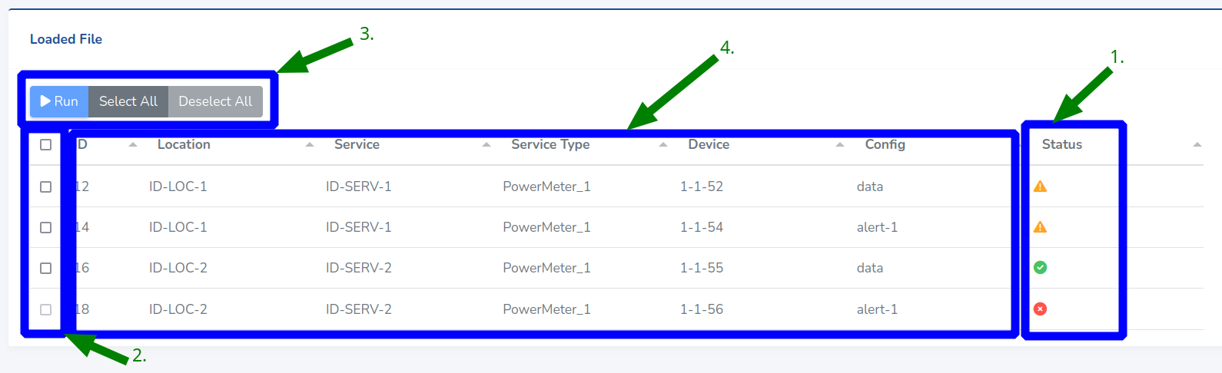

Row status
First thing you have to look when you have loaded a file is the status of the loaded rows. It indicates the problems that each row can have and if the row can be executed. There are three types of status:
- Success (Green icon): The row can be executed, and all the associated data is correctly defined.
- Warning (Orange icon): The row can be executed, but there are some data related to it that can be problematic.
- Error (Red icon): The row can’t be executed. There are some mistakes on the row data that does not allow to execute it.
You can get more details about the causes of the status clicking onto the row status icon. Next image contain the modal shown when you click on the warning status of a row, in this case it indicates that the row device has a related tag which is not inside the database and is not explicitly defined in the file, so it will be defined with default values (Color white)
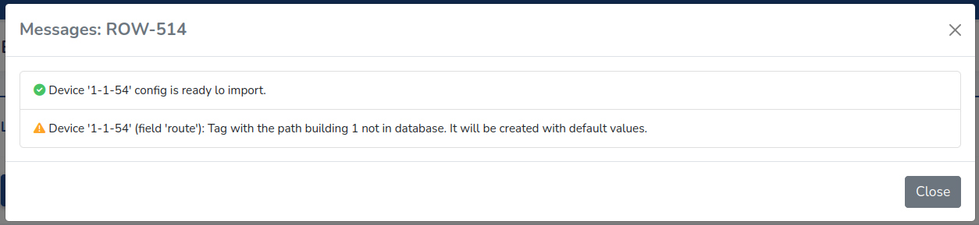
The rows with error status also provide information about his error. The following modal shows the error messages of a row with error status. It indicate that the row can’t be executed because the “name” of the device can’t be blank.
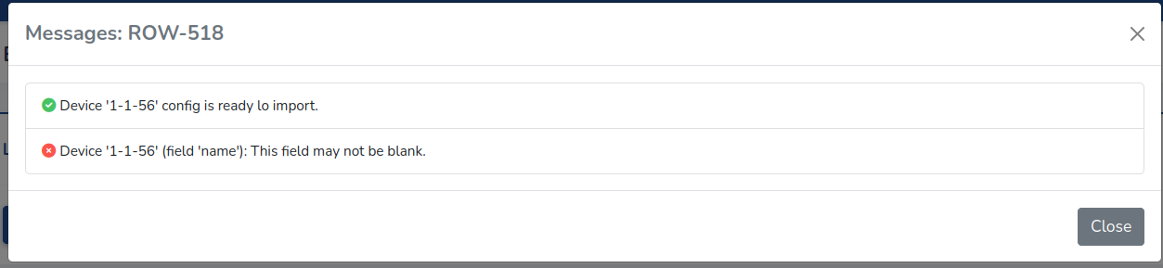

Selected rows checkbox
The first column of the table allow you to select and deselect rows. It allows you to select/deselect individual rows and you can select all the selectable rows with the checkbox in the header row.
Only rows without error status are selectable.

Table buttons
On the top of the table there are three buttons to manage the rows selection.
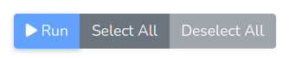
- The leftmost button is to run the selected rows. It is disabled when there are not any row selected.
- The button in the middle is to select all selectable rows.
- The rightmost button is to deselect all the selected rows.

Row data
The content of the body of the table shows the data that will be loaded into the project when the row is executed. It provides information about the location data, the service instance data and the device data.
If you click onto a cell with the identifier of a location, a service or a device the details of the data of the item referenced will be shown:

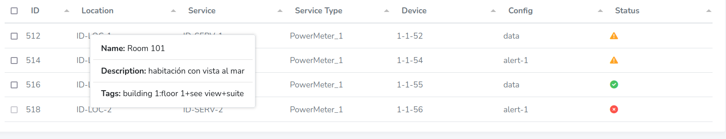
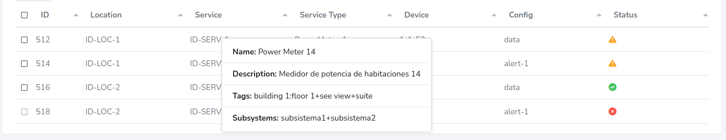
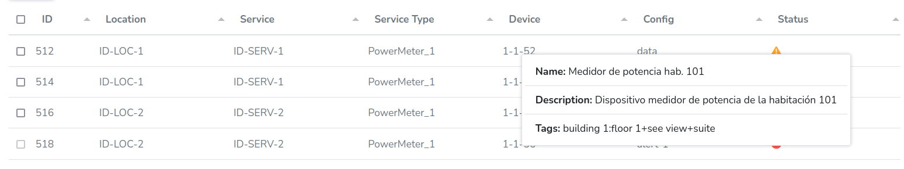

Run rows
When you have a set of rows selected and you click the button to run the selected rows the data included on the selected rows are imported into the project.
The tags and subsystems referenced in a row are created with the details defined in its definition csv rows if exists, otherwise are created with default values.
After running the rows a set of messages informing about the results of the import are shown on the screen:

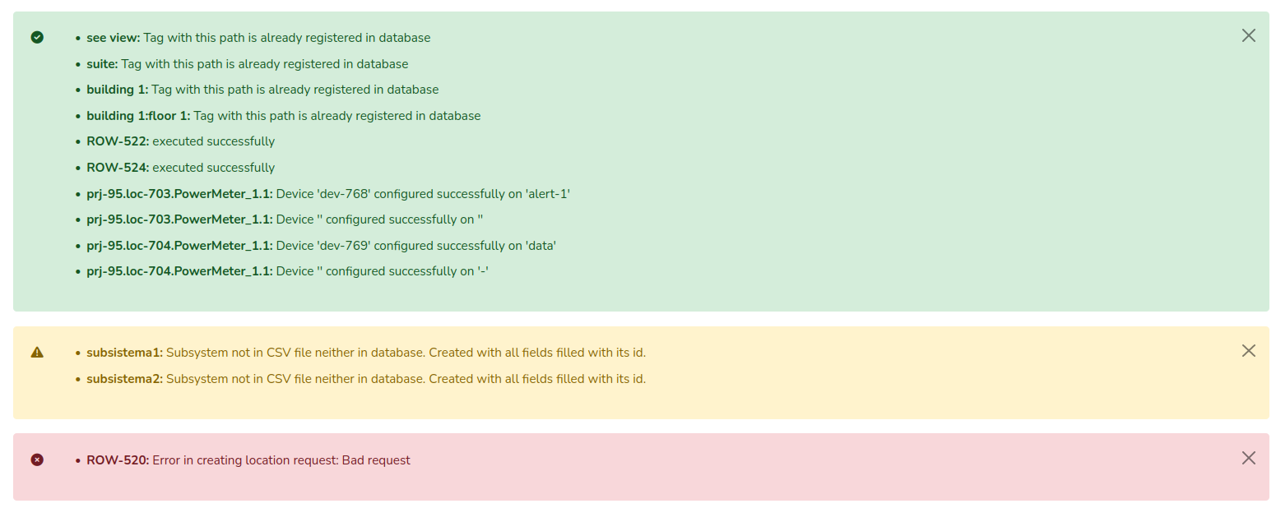
User profile
All the platform users has access to its profile. From it they can see and edit his user data or see which organizations can access.
The user profile is accessible from the top right menu. The image below show that menu, which is split in three parts:
- Information about the user role and organization.
- Profile views access.
- Log out button.
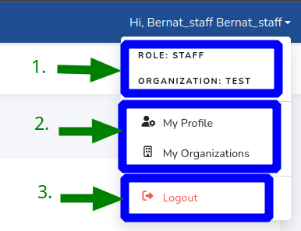

User profile: Personal data
View accessible from the “My profile” button in the profile views access in the profile menu. This view is available for all the platform users. From it the user can see and edit his personal information. The form in this view is the same for all the users in the platform, the main usage of this page is to change the personal password.
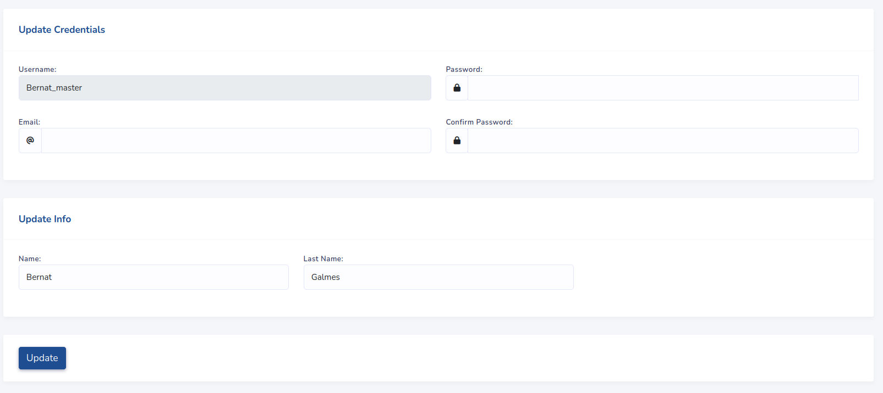
Non admin roles has an additional section in this view from which they can send project access request to an admin user. We refer to Section 4.11.3 to more information.

User profile: Organizations
From this view the users can see which organizations can access. This view is accessible from all users except roles “Super Robot” and “Robot” who has access to all platform organizations.
Next image shows the table of this view. The two main elements are remarked:
- Icon indicating that this is the user organization.
- Button which opens a modal with the organization projects that the user has access.
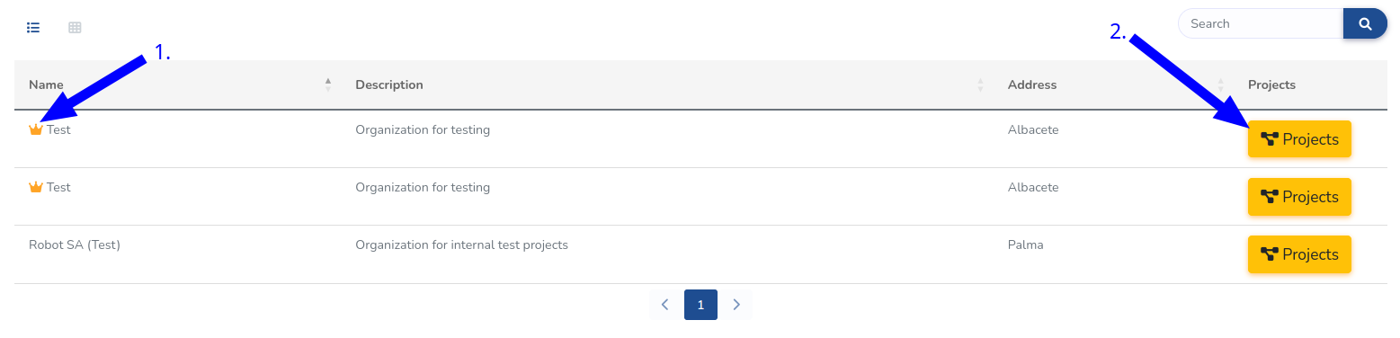
Partner users only see his organization in this view. They, instead of see the button to see projects they have a button to edit the organization.

User profile: Project access request
Users without an admin role can request access to a project from a different organization. This requests only can be addressed to a partner user. The form to perform a request is accessible from the “My profile” view for all non admin users. That form looks as follows:
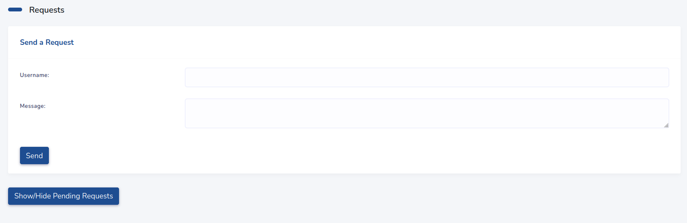
The form has two fields, one to indicate the partner username to whom we address, and the other to write a message to that user. The username is not validated at all, so if you write an erroneous username you will not have any feedback.
Once you have made a request at the top of the modal you can see the pending requests as follows:

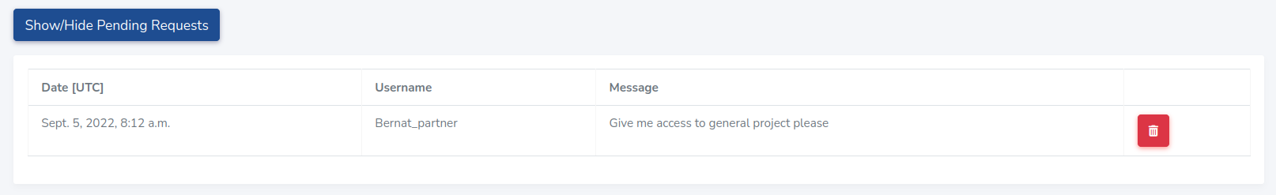
Partner users
After sending a request, the partner user to whom we address will have an alert message on his top platform menu.
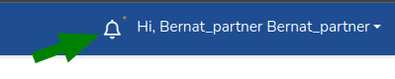
From this alert icon he can access to the process requests views. That view contain a section for each user that performed a request. The section of a user looks as follows and is split in two parts:
- List of all messages that the user has sent.
- Buttons to process the request or to discard it.
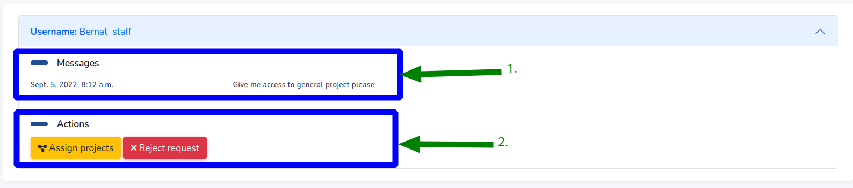
When you click the button to assign projects to the user a modal with a table with all the partner organization projects are shown. From this table you can assign different permissions to any organization project. This table is similar as the one appearing in section 4.2.4. for external projects, so we refer that section for more details. Remember to press the button “Save changes” on the bottom of the modal to process the changes.
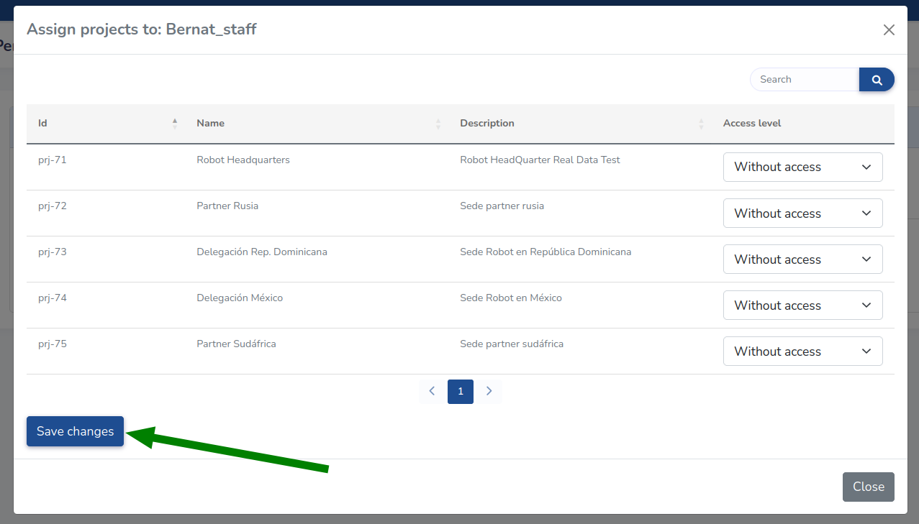
Once the changes are saved the user request disappear of the view. If you click the “Reject request” button the saved user request also disappear without giving any project access to the user.

