Building the RobotCub’s head kinematics model.
Version 1.0. June 2004.

Let,
c = cos(angle)
s = sin(angle)
t = 1 – c

[R] =
  t*x*x + c | t*x*y - z*s | t*x*z + y*s
  t*x*y + z*s | t*y*y + c | t*y*z - x*s
  t*x*z - y*s | t*y*z + x*s | t*z*z + c

This is the axis/angle to rotation matrix conversion.

Then the translation of the end-point assuming a spring of length “length” is:

neck(1,4) = -(length/phi * cos(phi) - length/phi) * cos(theta);
neck(2,4) = -(length/phi * cos(phi) - length/phi) * sin(theta);
neck(3,4) = length/phi * sin(phi);

and the matrix R becomes:

neck(1,1) = (1-cos(phi)) * sin(theta)^2 + cos(phi);
neck(1,2) = -(1-cos(phi)) * sin(theta) * cos(theta);
neck(1,3) = cos(theta) * sin(phi);
neck(2,1) = neck(1,2);
neck(2,2) = (1-cos(phi)) * cos(theta)^2 + cos(phi);
neck(2,3) = sin(theta) * sin(phi);
neck(3,1) = -cos(theta) * sin(phi);
neck(3,2) = -sin(theta) * sin(phi);
neck(3,3) = cos(phi);

Kinematics:

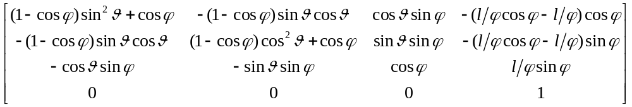
Derivation of the Jacobian of the neck-spring:

For the linear part, just take the derivative of the translation vector with respect to theta and phi.

For the rotational part use the formula:

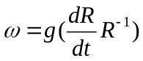
and g is:

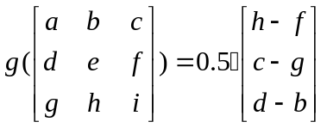

then decomposing the temporal derivative of R gives:

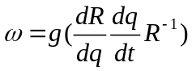

which allows recovering the Jacobian of the rotation:

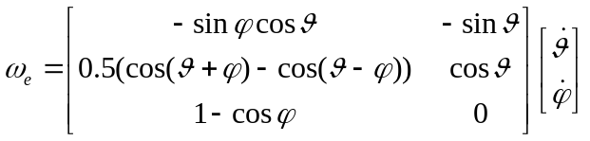

and for the linear part:

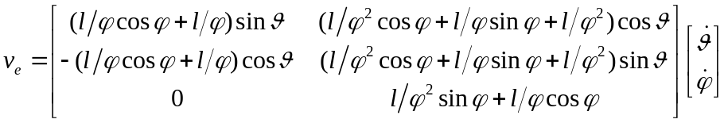

The wrench applied to the end point can be computed as a function of the torques generated by the motors:

Say:
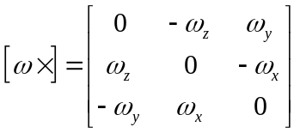

then from the kinematics:
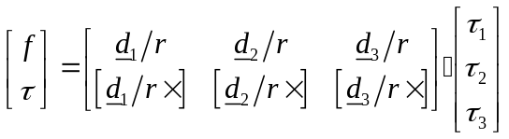
with d’s of the form (calling K(l) the robot kinematics function):

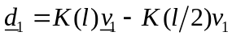

which represents the direction of the force applied to the top platform and v’s are the distances of the application point from the center of the spring. Thus:

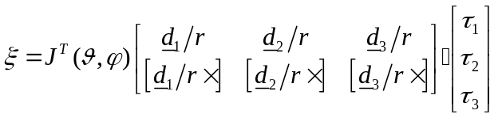
and at equilibrium:

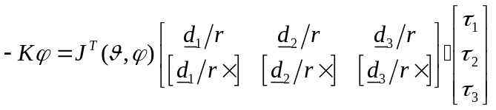

This is a non-linear equation of the neck dynamics with input tau’s and output the two state variables theta and phi. Starting from this equation we can:

Use some geometry to compute theta given the torques tau. Given that we know tau we can substitute its value.

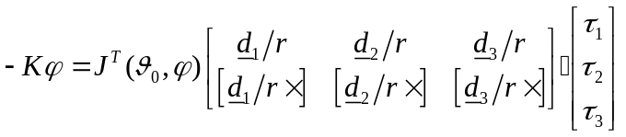

and for the rest then by using the implicit function theorem (if the derivative in not zero):

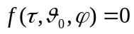 and theta can be dropped in the following discussion.

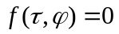

and 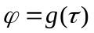

and thus:

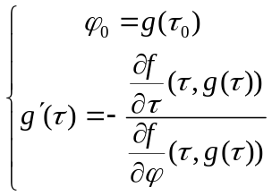

which is a differential equation in g and can be integrated starting from some known point.

This provides the solution of theta and phi given the input torques.

