Toolchain for DSP56F807 embedded FLASH programming

It is described in here how to set up the toolchain used to program flash of DSP56F807(Freescale). It is used the Code Warrior IDE plus USB TAP or Can Loader.

Approval History
Version | Author |  | Date | Approved |  | Date
0.1 | V.Gaggero | RBCS | 30 Jun 11 |  |  | TBD

Revision History

Version | Date | Author | Comments
0.1 | 30 Jun 11 | V.Gaggero | First version of the document.

Table of Contents
1 Introduction 1
2 Toolchain for BIN installation 1
2.1 BIN installation using programmer 1
2.2 BIN installation using CAN Loader 2
3 Reference to other documents 2

Introduction
It is here described how to program flash of DSP56f807 mounted in some boards of iCub

y.x using the Code Warrior suite by Freescale or Can Loader application provided by iCub group.

Toolchain for BIN installation
Applications that run on Dsp56f807-boards, like every board mounted on iCub, have a loader and an application.

There are two methods to install application on board:
- using programmer
- using Can Loader
If you would like to flash application on board not mounted on robot, you can choose which method you prefer; otherwise you must use Can Loader application.
If you choose the first method, you must know that programmer erase the flash, so application burnt before (among which Loader Dsp56f807 ) will be deleted.

In the following chapters we detail each method.

BIN installation using programmer
With this method you need to install Code Warrior Suite (the same for compiling, see [1] ) and the programmer shown in this figure:

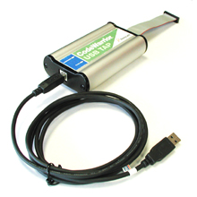

Actually, used programmers have a custom connector from USB TAP to board; it has some wires cut off.

In order to flash application, you need to:
- Connect USB TAP with board and your pc
- Compile application by CodeWarrior
- Flash application by Debug button. If you aren’t interesting in debugging, you can press stop debug button, so the application keeps on run, but your debugger is unconnected.

BIN installation using CAN Loader

If you would like to install your application by CanLoader, you must be sure that the Boot loader application is already installed on used board.
If boot loader is not present, you must program it by using ICD3 programmer. Boot loader’s executable file is:
https://robotcub.svn.sourceforge.net/svnroot/robotcub/trunk/iCub/firmware/build/56F807_bootloader.S
Note that this boot loader is suitable only to boards with Dsp56f807.

Since CanLoader communicates with Boot loader by can bus, you need eCAN device (see following figure) and must install its driver:
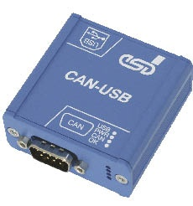

For more information on this device: see
http://www.esd-electronics-usa.com/CAN%20CANopen%20J1939%20USB%202.0%20-%20CAN-USB-2.html

CanLoader application is an iCub module, so you must get YARP and iCub’s source code and must compile them.
For more information, see http://eris.liralab.it/wiki/Manual#Six._Software.2C_Compiling_YARP_and_iCub and http://eris.liralab.it/wiki/CanLoader.

Reference to other documents
- RBCS-TOOL-SRC-001-firmware-dsp56f807.odt explains how to compile application for Dspic30f4013 microcontrollers. (....\firmware\documents\Dsp56f807\).

