Toolchain for DSPIC30f4013 FLASH programming

It is described in here how to set up the toolchain used to program the FLASH of dspic30f microcontrollers.

Approval History
Version | Author |  | Date | Approved |  | Date
0.1 | V.Gaggero | RBCS | 30 Jun 11 |  | RBCS | TBD

Revision History

Version | Date | Author | Comments
0.1 | 30 Jun 11 | V.Gaggero | First version of the document.

Table of Contents
1 Introduction 1
2 Toolchain for BIN installation 1
2.1 Bin installation using programmer 1
2.2 Bin installation using CanLoader 2
3 Reference to other documents 3

Introduction
It is here described how to program the FLASH of DSPIC30f4013. This microcontroller is mounted on Mais and Strain boards of iCub.

Toolchain for BIN installation
There are two methods to install sensor reader applications on boards:
- using programmer
- using CanLoader application
If you would like to flash an application on board not mounted on robot, you can choose which method you prefer; otherwise you must use CanLoader application.

Bin installation using programmer
If you choose the first method, you must know that programmer erases the flash, so application burnt before will be deleted.
Moreover, you must have a board with connector suitable for the programmer.

With this method you need to install MPLAB IDE ( the same development tool for compiling, see [1] ) and the programmer shown in this figure:

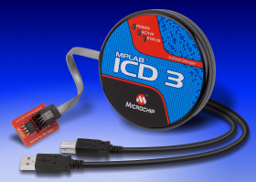

In order to flash the application you need to:
- connect ICD 3 to your laptop and to the board.
- if you want burn application in flash and debug it, do the following operation:
  - verify that you have compiled your application in “Debug configuration”. See following figure:

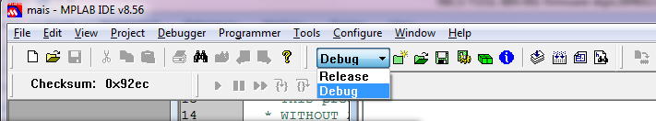

  - from “Debug” menu : select “Select tool” →MPLAB ICD3
  - from “Debug” menu : select “Connect” . In output windows you may see:
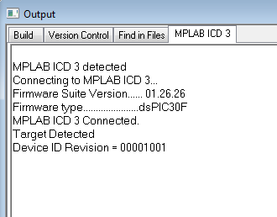

  - from “Debug” menu : select “Program”
  - from “Debug” menu : select “run”

- If you want to burn application in flash, do the following operation:
  - Verify that you have compiled your application in “Release configuration”. See figure 2.a(previous point).
  - from “Programmer” menu: select “Select tool” →MPLAB ICD3
  - from “Programmer” menu: select “Connect”. In output window you can see something like shown in figure on 2.c (previous point)
  - from “Programmer” menu: select “program”

Bin installation using CanLoader
If you would like to install your application by CanLoader, you must be sure that the Boot loader application is already installed on used board.
If boot loader is not present, you must program it by using ICD3 programmer. Boot loader’s executable file is:
https://robotcub.svn.sourceforge.net/svnroot/robotcub/trunk/iCub/firmware/loaderDspic30f4013/Bootloader.hex
Note that this boot loader is suitable only to boards with Dspic30f4013.

Since CanLoader communicates with Boot loader by can bus, you need eCAN device (see following figure) and must install its driver:
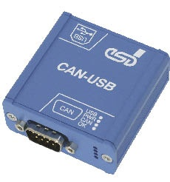

For more information on this device: see
http://www.esd-electronics-usa.com/CAN%20CANopen%20J1939%20USB%202.0%20-%20CAN-USB-2.html

CanLoader application is an iCub module, so you must get YARP and iCub’s source code and must compile them.
For more information, see http://eris.liralab.it/wiki/Manual#Six._Software.2C_Compiling_YARP_and_iCub and http://eris.liralab.it/wiki/CanLoader.

Reference to other documents
- RBCS-TOOL-SRC-001-firmware-dspic30f4013.odt explains how to compile application for Dspic30f4013 microcontrollers. (....\firmware\documents\Dspic30f4013).

