DSPIC HAL library
This document is the start point to operate with DSPic30f Hardware Abstraction Layer library.

Approval History
Version | Author |  | Date | Approved |  | Date
0.1 | V.Gaggero | RBCS | 30 Jun 11 |  | RBCS | TBD

Revision History

Version | Date | Author | Comments
0.1 | 30 Jun 11 | V.Gaggero | First version of the document.

Table of Contents
1 Introduction 1
2 Provided services 1
3 Source code 1
3.1 Code retrieval 1
3.2 Code compilation 1
3.2.1 Dependences 1
3.2.2 Order of compilation 1
3.2.3 Compilation settings 2
3.2.4 How to compile 2
4 Binary 2
5 Reference to other documents 2

Introduction
This document gives you very briefly overview of DSPIC HAL library and provides you links to documents with detailed information.

- Provided services
DSPIC HAL library is a module for hardware abstraction layer.
It is complaints with other hardware abstraction layer libraries used in iCub firmware; so it provides services to configure peripherals (such as CAN, ADC, etc), to read/write non volatile information on EEPROM/FALSH, etc.
Actually a part of library is depending on boards: so you can find a library for each board with dspic30f microcontroller mounted; these libraries provide common services plus board specific services.
If you are interested in library header files, check
- .....\ libDspic30f4013-HAL\source_code\common\include: API for common services
- .....\libDspic30f4013-HAL\source_code\mais\include: API for Mais services
- libDspic30f4013-HAL\source_code\strain\include: API for Strain services

- Source code
Library source code is written in C language.

Code retrieval
Library source code can be retrieved from following folders in:
https://robotcub.svn.sourceforge.net/svnroot/robotcub/trunk/iCub/firmware/libDspic30f4013-HAL

Code compilation
To compile library it is necessary use MPLAB IDE. (see [1])

Dependences
The library depends on peripheral library provided by Microchip IDE. (you can find it in <Installation_directory>\Microchip\MPLAB C30\lib\dsPIC30F), but you can compile it by yourself using <Installation_directory>\Microchip\MPLAB C30\src\peripheral_30F_24H_33F\src\makeplib.bat script provided by Microchip.
For details, see Microchip documentation.

Order of compilation
None

Compilation settings
You must be sure you are compiling with –finline option.
Actually, libraries are compiled without optimizations. If you need some optimizations you can add –O1, -o2, -o3 in the field “Use Alternate Settings” in the windows “Build option”, as this figure shows:

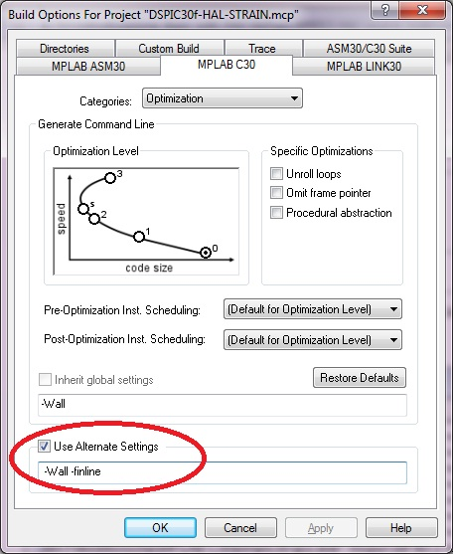

For more information see “Option for controlling optimization” paragraph in C30 user manual in MPLAB help.

How to compile
Open the workspace file DSPIC30f-HAL.mcw. it is composed by 2 projects: one for HAL-MAIS and other for HAL-STRAIN.
To obtain for HAL-MAIS library, set the project active(“Project” menu →”Set Active project”) and then compile it.
To obtain for HAL-STRAIN library, set the project active(“Project” menu →”Set Active progect”) and then compile it.
See [1] form more information how to compile in MPLAB.

Binary
The output of compilation is in “output” folder.
If you want use your library file in application, it is necessary install it on board application folder by libDspic30f4013-HAL\install_scripts\install_lib.bat script.
Note that the script copies library and all interface files (header file) in application folder (MAIS and STRAIN).

Reference to other documents
- RBCS-TOOL-SRC-001-firmware-dspic30f4013.odt : explains how to set up the source code toolchain. https://robotcub.svn.sourceforge.net/svnroot/robotcub/trunk/iCub/firmware/Documents
- RBCS-TOOL-BIN-001-firmware-dspic30f4013.odt : explains how to flash executable file
https://robotcub.svn.sourceforge.net/svnroot/robotcub/trunk/iCub/firmware/Documents

