Test specification:
Head V2

Rev. | Prepared by |  | Date | Approved |  | Date
0.0 | RBCS | M.M | 27/10/2010

Revision history

Rev. | Date | Revision description
0.0 | 27/10/2010 | Preliminary emission

Summary
1 Revision history 1
2 Summary 2
3 General description 3
4 Motor Test 3
4.1 Testing of the motors 3
5 Wiring Test 3
Test equipment 3
5.1 CAN line connections test 3
5.2 AEA sensors connections test 3
5.3 Encoder connections test 3
5.4 Motor connections test 4
5.5 PC104 test 4
6 Firmware 4
Test equipment 4
6.1 CAN programming test 4
7 Software 4
7.1 Check 5
7.2 Calibration 5
7.3 LED test 6
7.4 FAN test 6
7.5 Labeling and warehousing 6
7.6 Test Report 6

General description
The document described the procedure for testing the iCubHead version 2.0. In the following paragraph are described the mechanical, the electronic and the software tests to curry on.

Motor Test

Testing of the motors
The head has six motors. The test of the motors must be done after mounting each single joint and before wiring the iron cables. The test consists of applying a certain voltage to the leads Motor+ and Motor- of the motor, that it must be sufficient to make the motor moves smoothly (without stacking in any position). Before doing the measurements it is necessary to move freely the motors for at least 5 minutes CW and CCW with a voltage. In the case of the motors 1B2 and 1B3 it is not possible to move the motor freely (because of the mechanics of the joint), it is sufficient to make at least 20 cycles of movements along the whole range of the joint. The table reports the values of the voltage that must be apply to the motors. In the last column must be written the exact value applied to the motor in order to make it move smoothly.

iCubHead V2.0 |  | S/N: 002 (il prototipo e’ il numero 000)
Motor Name | Motor description | Voltage | Tested value
0M0 | Neck pitch/roll Bottom | 2.0V ±0.5 | 1.7
0M1 | Neck pitch/roll Top | 2.0V ±0.5 | 1.75
1M0 | Neck yaw | 1.8V±0.5 | 1.9
1M1 | Eye tilt | Not necessary any test
1M2 | Left Eye | 7V±1 | 7.4
1M3 | Right Eye | 7V±1 | 6.25

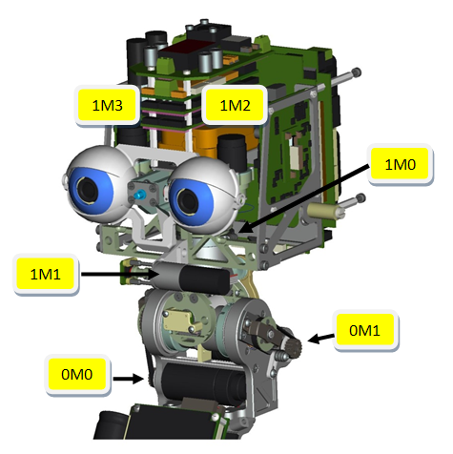

Wiring Test

Test equipment
Digital multimeter 1% or better precision.

CAN line connections test

WRITE THE PROCEDURE

AEA sensors connections test

Multimeter in diode check mode.
Put the black terminal of the multimeter on the pin 1 of the connector (red lead). With the red one touch the pin 2,3,5,6 and 8. If the connections are ok the multimiter should do a single “bip”.

Note: if none of the connections are ok. Put the red terminal to pin 8 (big black lead) and check it to pin 2,3,5 and 6. If in this way the multimeter does a bip, it means that the red lead is not connected.

Encoder connections test

WRITE THE PROCEDURE

Motor connections test

Check resistance between Motor+ and Motor-. The value you should read are :

iCubHead V2.0 |  | S/N:
Motor Name | Motor description | Resistance | Tested value
0M0 | Neck pitch/roll Bottom | 1.9
0M1 | Neck pitch/roll Top | 1.9
1M0 | Neck yaw | 8.71
1M1 | Eye tilt | 19.8
1M2 | Left Eye | 17.1
1M3 | Right Eye | 17.1

PC104 test

WRITE THE PROCEDURE

Firmware

Test equipment
- PC with WIN XP OS.
- Dual channel Power Supply 0-48V (10A).
- CAN bus interface ESD USB-CAN 2264 and relative device drivers.
- CAN Loader for DSP56F807 uControllers (canLoader20.exe, ACE.dll, ACEd.dll, GTK2-Runtime-Environment.exe, Visual Studio Runtime on machines with visual studio installed),
- FW for boards (2BLLDC.1.62.out.S, 4DC.2.15.out.S ).

CAN programming test
Launch CANLoader2.6.exe, within the first 5 seconds from board reset (5 seconds from switching on the power supply) press ‘connect’. You should see three boards, 2 MC4 (ID 2 and 4) and one BLL (ID 1).
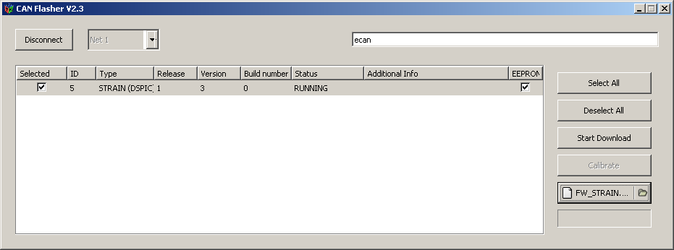
Open the file 2BLLDC.1.62.out.S select the board with ID=1 and then press start download; verify the absence of programming errors.
Open the file 4DC.2.15.out.S select the board with ID=2 and 4 and then press start download; verify the absence of programming errors.

Software

Test Equipment

- PC with Linux configured as described in http://eris.liralab.it/wiki/ICub_laptop_installation_instructions.
- Dual channel Power Supply 0-48V (10A).
- YARP at SVN revision NUMBER (http://eris.liralab.it/wiki/Manual#Six._Software.2C_Compiling_YARP_and_iCub)
- iCub Software at SVN revision NUMBER
(http://eris.liralab.it/wiki/Manual#Six._Software.2C_Compiling_YARP_and_iCub)

Check and Calibration
- Press the red button (fault button).
- Switch on the boards (12V and 24/42V ).
- Create a folder in ICUB_ROOT\app\ named iCub<CityName><Number> where ICUB_ROOT is the place where the folder icub is in the PC, CityName is the name of the city where the robot will be sent and Number is a progressive number starting from “01” (it depends on how many robots are in the same city).
- Copy the file ICUB_ROOT\app\iCubHeadV2_0\conf\calibration\kinematics\iCub_Calibration_V2_0_CityName_Number.xls to the folder ICUB_ROOT\app\iCub<CityName><Number>\conf\calibration\kinematics\ and rename it as : iCub_Calibration_V2_0_<CityName>_<Number>.xls where CityName is the name of the city where the robot will be sent and Number is a progressive number starting from “01” (it depends on how many robots are in the same city).
- Open the .xls file and enable the macros.
- In the first page change the path to the folder ICUB_ROOT\app\iCub<CityName><Number>\conf\
- Open a shell and type:
yarp server
- Open another shell and type:
iCubInterface –config ICUB_ROOT\app\iCubHeadV2_0\conf\ecan\iCubRawHead.ini

- Open another shell and type:
robotmotorgui --from ICUB_ROOT\app\iCubHeadV2_0\conf\ecan\robotmotorgui.ini

- Put the head in the initial position (see Figure 1) by hand for the first 4 joints. The last two joints do not require such a calibration, leave them as they are.
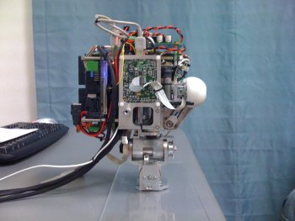
Figure 1. Initial position of the head.
- Open the file iCub_Calibration_V2_0_<CityName>_<Number>.xls and copy the numbers read in the robotmotorGui for the first 4 joints in the column value_read_at_zero.
- Press the button Generate Head Files and Generate robotmotorgui.
- Press Ctrl_C in the shell where is running iCubInterface and robotMotorgui
- Restart iCubInterface and robotMotorgui
- In the robotmotorgui window press calib to all the joints before pressing run.
- Release the red button (fault button) and put it very close to your hand.
- Press run to all the joints.
- Move each joints of ±10 degree with a velocity set to 10% and fill the table below.
iCubHead V2.0 |  | S/N:
Motor Name | Motor description | CW Motion | CCW Motion | Encoder
0M0 | Neck pitch/roll Bottom | YES □ NO □ | YES □ NO □ | YES □ NO □
0M1 | Neck pitch/roll Top | YES □ NO □ | YES □ NO □ | YES □ NO □
1M0 | Neck yaw | YES □ NO □ | YES □ NO □ | YES □ NO □
1M1 | Eye tilt | YES □ NO □ | YES □ NO □ | YES □ NO □
1M2 | Left Eye | YES □ NO □ | YES □ NO □ | YES □ NO □
1M3 | Right Eye | YES □ NO □ | YES □ NO □ | YES □ NO □
- Press Ctrl_C in the shell where is running iCubInterface and robotMotorgui
- In shell where iCubInterface where running type:
iCubInterface –config ICUB_ROOT\app\iCub<CityName><Number>\conf\iCubHead.ini

- You should see the head moving to the initial position (see Figure 1).
- Restart robotmotorgui with the following sintax and verify that all the joints are in position 0.
robotmotorgui --from ICUB_ROOT\app\iCub<CityName><Number>\conf\robotmotorgui.ini
- Move each joint for in the whole range of motion and check that it reach the end points.
- If steps 1 to 23 are OK, press in the robotmotorgui Open Sequence and browse for the file:

Calibration

Set DC power supply to 12V and current limit to 6A, connect supply cable to connector P1. Connect the resistor on P2 and switch on the power supply.
(For cable connections, see photo below)

Labeling and warehousing
Apply a serial number on the board.

Test Report
(Compilare in stampatello)

Informazioni generali

Data del test GG/MM/AA: __/__/__
Collaudatore (nome, cognome): _______________________________

Nome scheda: PS_CPU_001
S/N:____________________________________

Note: ___________________________________________________________________ ________________________________________________________________________________
________________________________________________________________________________

Risultati del collaudo
(Indicare l’esito della prova con una crocetta nei campi “passed” o “failed”

Item | Descrizione prova | Passed | Failed | Note
1 | Controllo visivo preliminare
2 | Controllo tensione su P2
3 | Controllo tensione su P4
4 | Controllo tensione su P3
5 | Controllo leds
6 | Controllo FUN
7 | Etichettatura con S/N

