<https://fr.farnell.com/stmicroelectronics/stspin830/driver-de-moteur-40-a-150-c/dp/2987063>

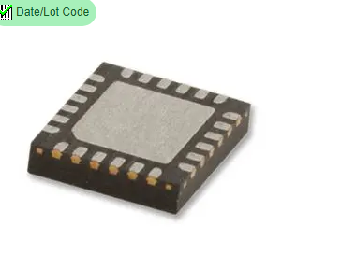

STSPIN830

L6235 : <https://fr.farnell.com/stmicroelectronics/l6235d/driver-de-moteur-dc-triphase-cms/dp/1271007>

L6229 : <https://www.farnell.com/datasheets/1815536.pdf>

A3930 and A3931: <https://datasheet.lcsc.com/lcsc/2005181002_Allegro-MicroSystems--LLC-A3930KJPTR-T_C459252.pdf>

