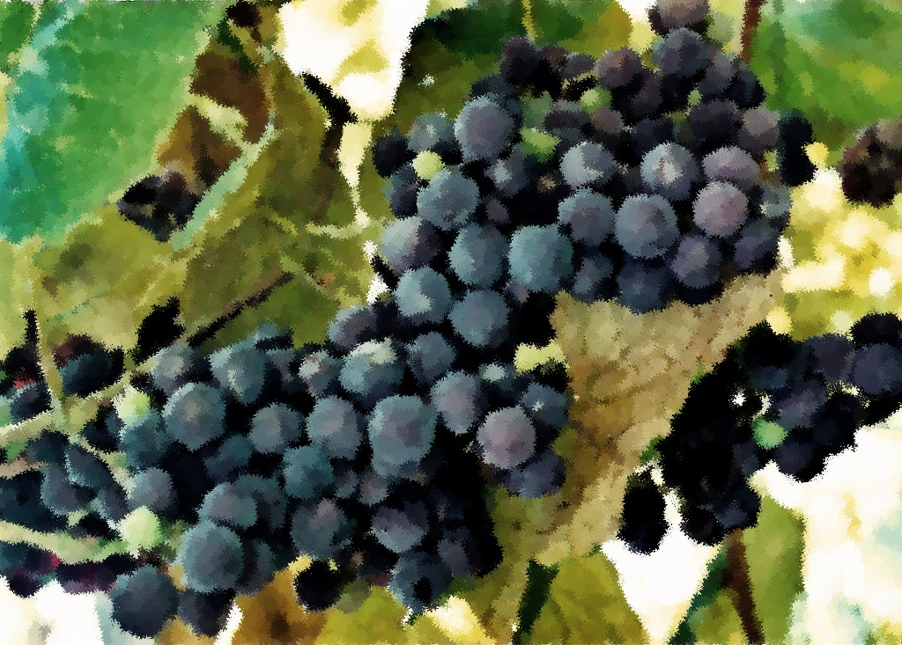

Prayer and Mission List

Conference and Local

Indiana-Michigan Conference, especially Dan Miller (conference minister) and the Missional Leadership Team (executive committee).

Kalamazoo Loaves and Fishes.

Campus Ministries at Western Michigan University and Kalamazoo College

Friends Far and Wide

David and Hilary Ker, Wycliffe Bible Translators in southern Africa.

Joe and Sharon Rosa, Dakar Academy, Senegal, Africa

JC and Lois Ebersole (and Andrea and Kyle), Eastern Mennonite Missions in Ghana.

Carlos and Rebecca Pinto, Latin American Missions.

Michael Ayuen Kuany and Rebuild Sudan.

Readings

June 19, 2011

*Trinity Sunday*

Genesis 1:1-2:4a

Psalm 8

2 Corinthians 13:11-13

Matthew 28:16-20

June 26, 2011

*Second Sunday after Pentecost*

Genesis 22:1-14

Psalm 13

Romans 6:12-23

Matthew 10:40-42

Readings

June 5, 2011

*Ascension of the Lord*

Acts 1:1-11

Psalm 47

Ephesians 1:15-23

Luke 24:44-53

June 12, 2011

*Day of Pentecost*

Acts 2:1-21

Psalm 104:24-34, 35b

1 Corinthians 12:3b-13

John 20:19-23

* Welcome
* Opening prayer and song
* Centering Silence and confession
* Prayer and announcement of forgiveness
* Readings and Songs of Worship: Address one another in psalms and hymns
* and spiritual songs
* Teaching & Reactions
* Joys and Concerns with Prayer
* Offering and Other Announcements
* Benediction and closing song

Kalamazoo Mennonite Fellowship

Simplicity. Service. Peace. Worship. Community. Jesus.

Order of Worship, June 2011