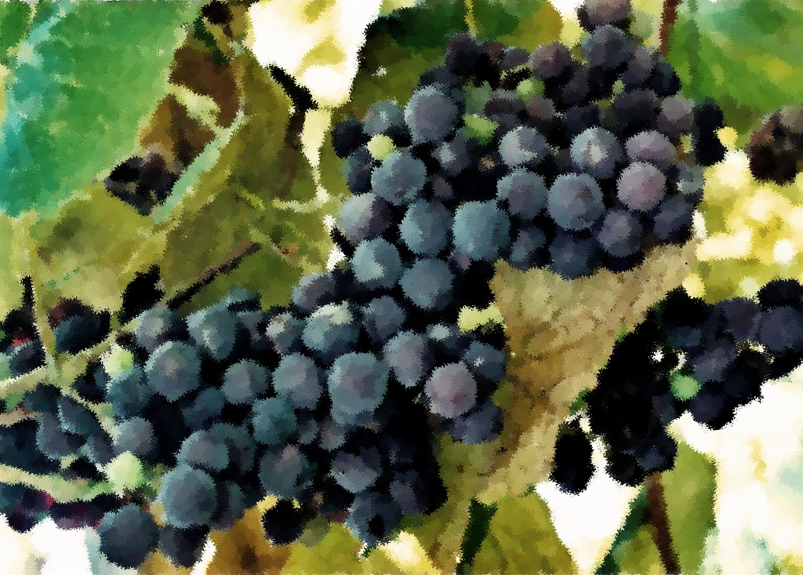

Readings

July 24, 2011

Genesis 29:15-28

Psalm 105:1-11, 45b

Romans 8:26-39

Matthew 13:31-33, 44-52

July 31, 2011

Genesis 32:22-31

Psalm 17:1-7, 15

Romans 9:1-5

Matthew 14:13-21

Readings

July 3, 2011

Genesis 24:34-38, 42-49, 58-67

Psalm 45:10-17

Romans 7:15-25a

Matthew 11:16-19, 25-30

July 10, 2011

Genesis 25:19-34

Psalm 119:105-112

Romans 8:1-11

Matthew 13:1-9, 18-23

July 17, 2011

Genesis 28:10-19a

Psalm 139:1-12, 23-24

Romans 8:12-25

Matthew 13:24-30, 36-43

Prayer and Mission List

Conference and Local

Indiana-Michigan Conference, especially Dan Miller (conference minister) and the Missional Leadership Team (executive committee).

Kalamazoo Loaves and Fishes.

Campus Ministries at Western Michigan University and Kalamazoo College

Friends Far and Wide

David and Hilary Ker, Wycliffe Bible Translators in southern Africa.

Joe and Sharon Rosa, Dakar Academy, Senegal, Africa

JC and Lois Ebersole (and Andrea and Kyle), Eastern Mennonite Missions in Ghana.

Carlos and Rebecca Pinto, Latin American Missions.

Michael Ayuen Kuany and Rebuild Sudan.

Rachel and Jesus Reyes, Dayspring Outreach Ministries, Soyaltepec, Oaxaca, Mexico.

* Welcome
* Opening prayer and song
* Centering Silence and confession
* Prayer and announcement of forgiveness
* Readings and Songs of Worship: Address one another in psalms and hymns
* and spiritual songs
* Teaching & Reactions
* Joys and Concerns with Prayer
* Offering and Other Announcements
* Benediction and closing song

Kalamazoo Mennonite Fellowship

Simplicity. Service. Peace. Worship. Community. Jesus.

Order of Worship, July 2011