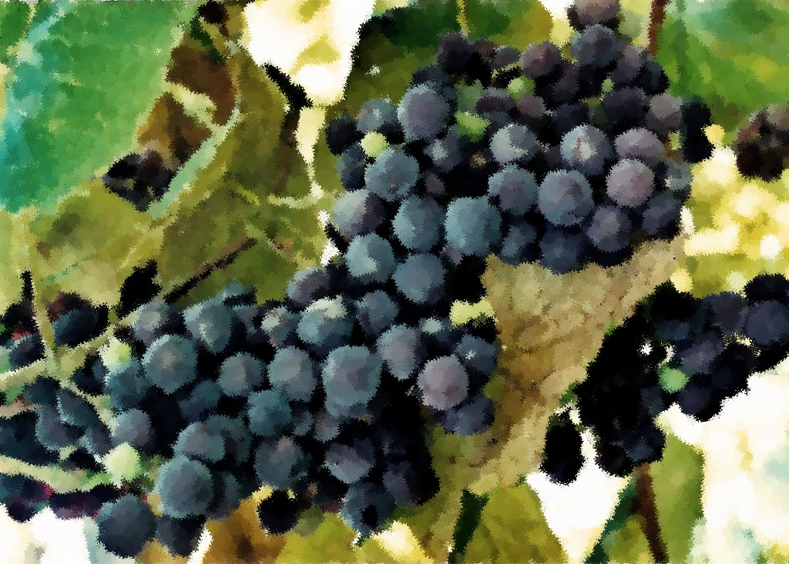

Readings

August 21, 2011

Exodus 1:8-2:10

Psalm 124

Romans 12:1-8

Matthew 16:13-20

August 28, 2011

Exodus 3:1-15

Psalm 105:1-6, 23-26, 45b  
Romans 12:9-21

Matthew 16:21-28

Readings

August 7, 2011

Genesis 37:1-4, 12-28

Psalm 85:8-13

Romans 10:5-15

Matthew 14:22-33

August 14, 2011

Genesis 45:1-15

Psalm 133

Romans 11:1-2a, 29-32

Matthew 15:10-28

Prayer and Mission List

Conference and Local

Indiana-Michigan Conference, especially Dan Miller (conference minister) and the Missional Leadership Team (executive committee).

Kalamazoo Loaves and Fishes.

Campus Ministries at Western Michigan University and Kalamazoo College

Friends Far and Wide

David and Hilary Ker, Wycliffe Bible Translators in southern Africa.

Joe and Sharon Rosa, Dakar Academy, Senegal, Africa

JC and Lois Ebersole (and Andrea and Kyle), Eastern Mennonite Missions in Ghana.

Carlos and Rebecca Pinto, Latin American Missions.

Michael Ayuen Kuany and Rebuild Sudan.

Rachel and Jesus Reyes, Dayspring Outreach Ministries, Soyaltepec, Oaxaca, Mexico.

* Welcome
* Opening prayer and song
* Centering Silence and confession
* Prayer and announcement of forgiveness
* Readings and Songs of Worship: Address one another in psalms and hymns
* and spiritual songs
* Teaching & Reactions
* Joys and Concerns with Prayer
* Offering and Other Announcements
* Benediction and closing song

Kalamazoo Mennonite Fellowship

Simplicity. Service. Peace. Worship. Community. Jesus.

Order of Worship, August 2011