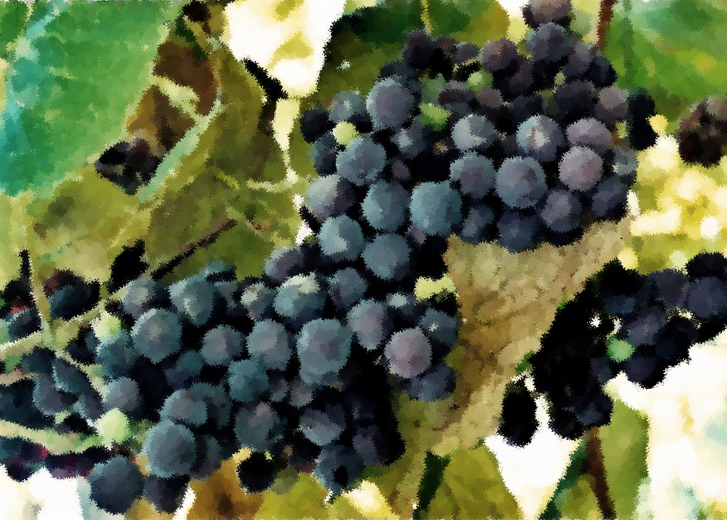

Readings

Proper 20 (25)

Fourteenth Sunday after Pentecost

September 18, 2011

Exodus 16:2-15

Psalm 105:1-6, 37-45

Philippians 1:21-30

Matthew 20:1-16

Proper 21 (26)

Fifteenth Sunday after Pentecost

September 25, 2011

Exodus 17:1-7

Psalm 78:1-4, 12-16

Philippians 2:1-13

Matthew 21:23-32

Readings

Proper 18 (23)

Twelfth Sunday after Pentecost

September 4, 2011

Exodus 12:1-14

Psalm 149

Romans 13:8-14

Matthew 18:15-20

Proper 19 (24)

Thirteenth Sunday after Pentecost

September 11, 2011

Exodus 14:19-31

Psalm 114

Romans 14:1-12

Matthew 18:21-35

Prayer and Mission List

Conference and Local

Indiana-Michigan Conference, especially Dan Miller (conference minister) and the Missional Leadership Team (executive committee).

Kalamazoo Loaves and Fishes.

Campus Ministries at Western Michigan University and Kalamazoo College

Friends Far and Wide

David and Hilary Ker, Wycliffe Bible Translators in southern Africa.

Joe and Sharon Rosa, Dakar Academy, Senegal, Africa

JC and Lois Ebersole (and Andrea and Kyle), Eastern Mennonite Missions in Ghana.

Carlos and Rebecca Pinto, Latin American Missions.

Michael Ayuen Kuany and Rebuild Sudan.

Rachel and Jesus Reyes, Dayspring Outreach Ministries, Soyaltepec, Oaxaca, Mexico.

* Welcome
* Opening prayer and song
* Centering Silence and confession
* Prayer and announcement of forgiveness
* Readings and Songs of Worship: Address one another in psalms and hymns
* and spiritual songs
* Teaching & Reactions
* Joys and Concerns with Prayer
* Offering and Other Announcements
* Benediction and closing song

Kalamazoo Mennonite Fellowship

Simplicity. Service. Peace. Worship. Community. Jesus.

Order of Worship, September 2011