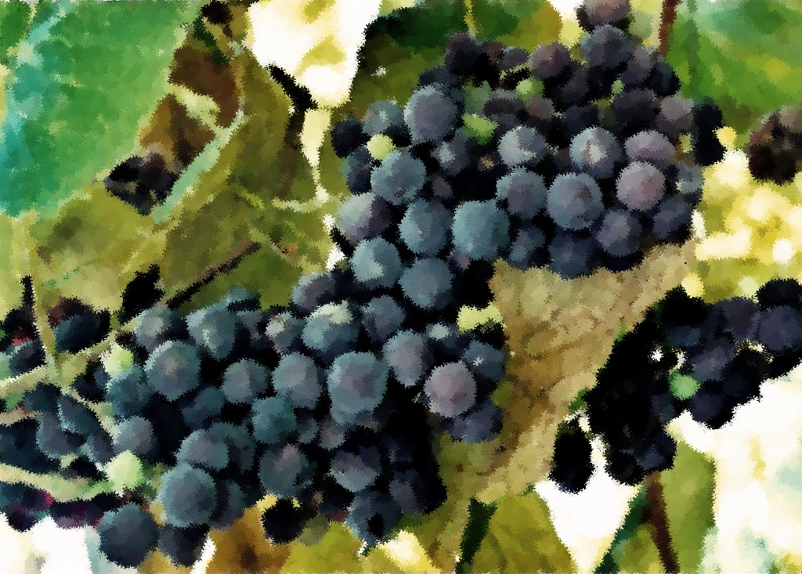

October 23, 2011

Deuteronomy 34:1-12

Psalm 90:1-6, 13-17

1 Thessalonians 2:1-8

Matthew 22:34-46

October 30, 2011

Joshua 3:7-17

Psalm 107:1-7, 33-37

1 Thessalonians 2:9-13

Matthew 23:1-12

Readings

October 2, 2011

Exodus 20:1-4, 7-9, 12-20

Psalm 19

Philippians 3:4b-14

Matthew 21:33-46

October 9, 2011

Exodus 32:1-14

Psalm 106:1-6, 19-23

Philippians 4:1-9

Matthew 22:1-14

October 16, 2011

Exodus 33:12-23

Psalm 99

1 Thessalonians 1:1-10

Matthew 22:15-22

Prayer and Mission List

Conference and Local

Indiana-Michigan Conference, especially Dan Miller (conference minister) and the Missional Leadership Team (executive committee).

Kalamazoo Loaves and Fishes.

Campus Ministries at Western Michigan University and Kalamazoo College

Friends Far and Wide

David and Hilary Ker, Wycliffe Bible Translators in southern Africa.

Joe and Sharon Rosa, Dakar Academy, Senegal, Africa

JC and Lois Ebersole (and Andrea and Kyle), Eastern Mennonite Missions in Ghana.

Carlos and Rebecca Pinto, Latin American Missions.

Michael Ayuen Kuany and Rebuild Sudan.

Rachel and Jesus Reyes, Dayspring Outreach Ministries, Soyaltepec, Oaxaca, Mexico.

* Welcome
* Opening prayer and song
* Centering Silence and confession
* Prayer and announcement of forgiveness
* Readings and Songs of Worship: Address one another in psalms and hymns
* and spiritual songs
* Teaching & Reactions
* Joys and Concerns with Prayer
* Offering and Other Announcements
* Benediction and closing song

Kalamazoo Mennonite Fellowship

Simplicity. Service. Peace. Worship. Community. Jesus.

Order of Worship, October 2011