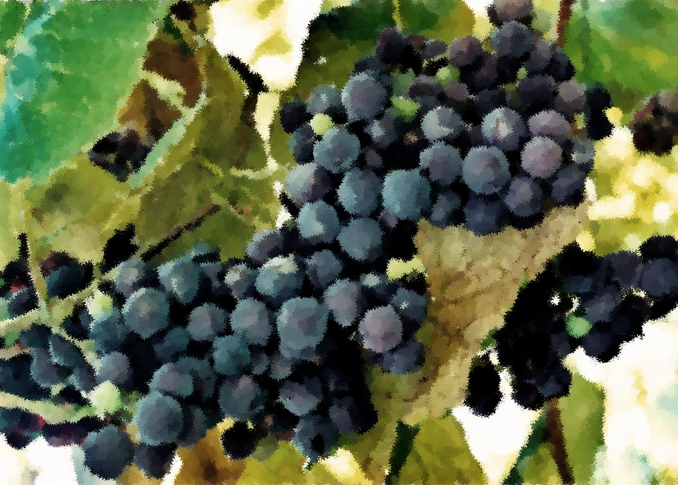

*Reign of Christ*

Twenty-Third Sunday after Pentecost

November 20, 2011

Ezekiel 34:11-16, 20-24

Psalm 100

Ephesians 1:15-23

Matthew 25:31-46

*First Sunday of Advent*

November 27, 2011

Isaiah 64:1-9

Psalm 80:1-7, 17-19

1 Corinthians 1:3-9

Mark 13:24-37

Readings

Twenty-First Sunday after Pentecost

November 6, 2011

Joshua 24:1-3a, 14-25

Psalm 78:1-7

1 Thessalonians 4:13-18

Matthew 25:1-13

Twenty-Second Sunday after Pentecost

November 13, 2011

Judges 4:1-7

Psalm 123

1 Thessalonians 5:1-11

Matthew 25:14-30

Prayer and Mission List

Conference and Local

Indiana-Michigan Conference, especially Dan Miller (conference minister) and the Missional Leadership Team (executive committee).

Kalamazoo Loaves and Fishes.

Campus Ministries at Western Michigan University and Kalamazoo College

Friends Far and Wide

David and Hilary Ker, Wycliffe Bible Translators in southern Africa.

Joe and Sharon Rosa, Dakar Academy, Senegal, Africa

JC and Lois Ebersole (and Andrea and Kyle), Eastern Mennonite Missions in Ghana.

Carlos and Rebecca Pinto, Latin American Missions.

Michael Ayuen Kuany and Rebuild Sudan.

Rachel and Jesus Reyes, Dayspring Outreach Ministries, Soyaltepec, Oaxaca, Mexico.

* Welcome
* Opening prayer and song
* Centering Silence and confession
* Prayer and announcement of forgiveness
* Readings and Songs of Worship: Address one another in psalms and hymns
* and spiritual songs
* Teaching & Reactions
* Joys and Concerns with Prayer
* Offering and Other Announcements
* Benediction and closing song

Kalamazoo Mennonite Fellowship

Simplicity. Service. Peace. Worship. Community. Jesus.

Order of Worship, November 2011