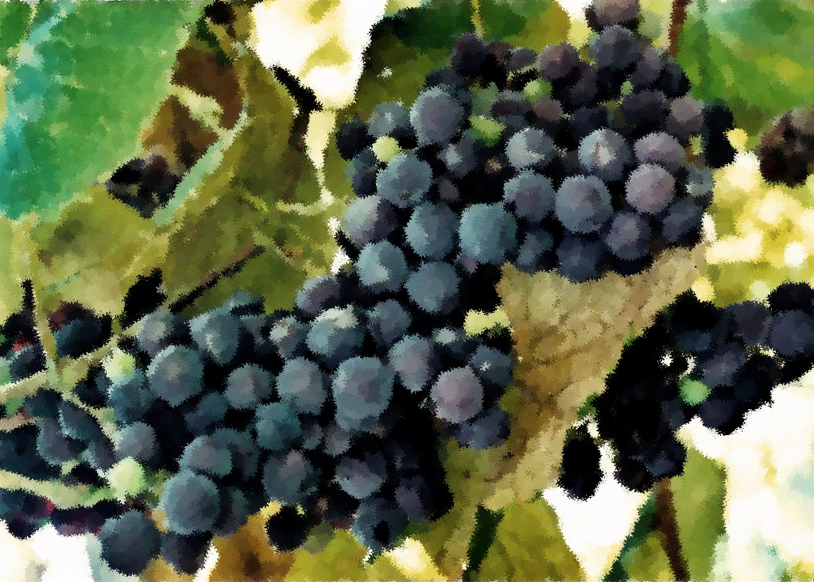

Fourth Sunday of Advent

December 18, 2011

2 Samuel 7:1-11, 16

Luke 1:46b-55

Romans 16:25-27

Luke 1:26-38

Christmas

December 25, 2010

Isaiah 9:2-7

Psalm 96

Titus 2:11-14

Luke 2

Readings

Second Sunday of Advent

December 4, 2011

Isaiah 40:1-11

Psalm 85:1-2, 8-13

2 Peter 3:8-15a

Mark 1:1-8

Third Sunday of Advent

December 11, 2011

Isaiah 61:1-4, 8-11

Psalm 126

1 Thessalonians 5:16-24

John 1:6-8, 19-28

Prayer and Mission List

Conference and Local

Indiana-Michigan Conference, especially Dan Miller (conference minister) and the Missional Leadership Team (executive committee).

Kalamazoo Loaves and Fishes.

Campus Ministries at Western Michigan University and Kalamazoo College

Friends Far and Wide

David and Hilary Ker, Wycliffe Bible Translators in southern Africa.

Joe and Sharon Rosa, Dakar Academy, Senegal, Africa

JC and Lois Ebersole (and Andrea and Kyle), Eastern Mennonite Missions in Ghana.

Carlos and Rebecca Pinto, Latin American Missions.

Michael Ayuen Kuany and Rebuild Sudan.

Rachel and Jesus Reyes, Dayspring Outreach Ministries, Soyaltepec, Oaxaca, Mexico.

Germantown Mennonite Historic Trust

* Welcome
* Opening prayer and song
* Centering Silence and confession
* Prayer and announcement of forgiveness
* Readings and Songs of Worship: Address one another in psalms and hymns
* and spiritual songs
* Teaching & Reactions
* Joys and Concerns with Prayer
* Offering and Other Announcements
* Benediction and closing song

Kalamazoo Mennonite Fellowship

Simplicity. Service. Peace. Worship. Community. Jesus.

Order of Worship, December 2011