**I will try to answer your questions.**

**1. Cement**

**In Georgia, there are several plants producing cement (including in the city where we plan to locate the plant), but we do not produce white cement. We mainly import it from Turkey,Rusia,Ukraine and Armenia.**

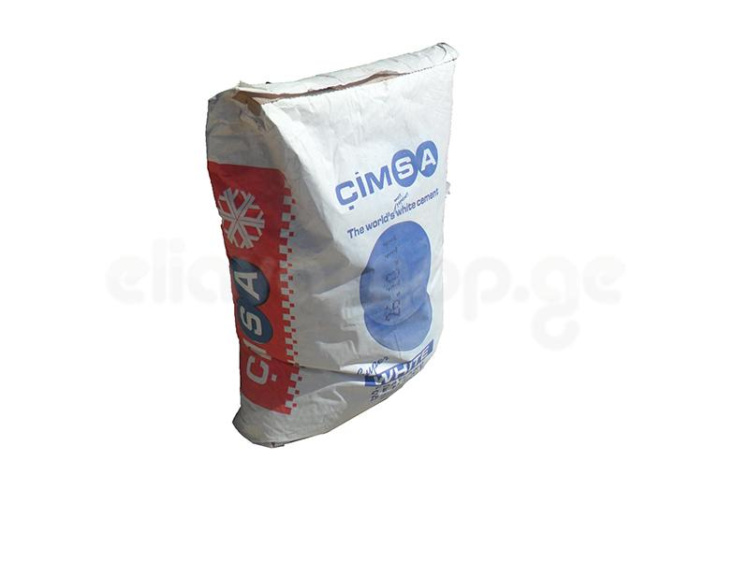

**For example, in June, I bought 50 kg of this cement in a store (not in wholesale) for $ 8.6. According to rumors, white cement should rise in price; therefore, based on our calculations, it is better to put import by our own forces.**

**If the rumors are not confirmed the price will remain the same (8.6 $ 50kg) and if in our market the cement becomes more expensive we can think about importing (together with you) of white cement for both - sale on the wholesale and for our own consumption. Our company has good opportunity to enter our market with white cement.**

**2. Crushed Stone**

**Our company has the following opportunities**

**1 gray granite**

**2 gray basalt**

**3-green granite and diabase**

**4-black granite and diabase**

**5-light beige marble**

**These are the quarrys of our partners who are ready to provide waste suitable for crushing for a nominal fee. Crushing of a stone of 10-15 mm does not represent any problems**

**In addition, white dolomite, white and red marble are mined in Georgia. market price of finished crashed stone is around 50-70$ per ton**

**If we can polish the stone, we will be very helpful to owners of quarrys and we will be able to get crushed stone at very low prices**

**3- Plant Area and climate**

**My company will ensure that the area and size of the plant will be suitable for production.**

**Сlimate**

**Georgia has a good climate**

**360 days a year you can work without problems**

**4- Other plants**

**There are no tile plants in Georgia**

**There are small semi artisan workshops**

**5- Electricity, Industry state**

**There are no problems with highly qualified specialists in Georgia.**

**6- The capacity**

**We** **have a lot of different stones. Their processing is a super urgent matter of national importance.**

**7- Company Type**

**Allow to discuss this issue later. In any case, it should be a joint venture.**