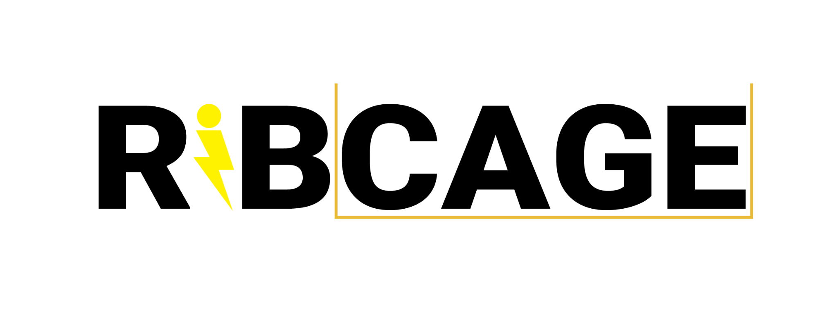

Ribcage Solutions is the only provider of portable lightning protection system kits for workplace safety that allow labor to continue under various lightning severity conditions.Our patent-pending ARCANGEL kit is specially designed for the motion picture industry.

**The Problem**

Every year lightning storms cause safety related workplace shutdowns in outdoor work environments. When using external power sources such as portable generators, these shutdowns apply to indoor workplaces as well. The motion picture industry almost always works indoors on location while running off of external power and lightning storms cause production companies to shut down temporarily 100% of the time.

While on set of a major motion picture in 2021, our co-founder, Isaac, discovered that this is because, due to liability issues, the studios only rent generators and rentals cannot be modified via attaching lightning protection systems, resulting in lightning-vulnerable generators.

Without this vulnerability, production companies would be able to continue working indoors during lightning storms, saving studios industry-wide millions of dollars per year.

**The Opportunity**

* Over half of all Hollywood production takes place in Georgia.
* Georgia is a high lightning ground flash density state, experiencing over 50 thunder days and 100 rain days per year.
* TV Pilot season is in March; March is the beginning of thunderstorm season in Georgia.
* Any week with a forecasted rain day is a week with a potential lightning shutdown.
* Each set of 30 minute increments of potential lightning shutdown time has a cost of at least 0.8% of the below-the-line crew’s weekly pay rate, not including equipment. On a major budget motion picture with a $200MM budget, the weekly crew cost can be over $1.5MM, making 0.8% = $12,000. The loss of time may in some cases necessitate an additional day of production.
* Above-the-line costs are usually similar or slightly more, bringing the total shutdown cost to ~$25k/ea.
* In 2021, a large studio film production in a state with similar flash density to GA accumulated 6 additional days due to lightning shutdowns in the summer at a total cost of over $2MM.
* Accordingly, this $2MM in losses due to lightning shutdowns over 20 weeks means they could have spent any amount less than $100,000/wk on lightning protection to avoid these shutdowns and saved money.
* In order to avoid a shutdown, each generator and HVAC unit required for continued work also requires lightning protection.
* Since studios do not purchase generators, they cannot modify them, and since they cannot modify them, the only way they can put an LPS on them is with a portable, kitted system.
* It is not uncommon for productions to use make-shift stages or converted warehouses. These seldom have enough house power for production. **Any show shooting in Georgia, on a warehouse stage, during any time other than winter, is our MVP avatar.**

= OPPORTUNITY

**The Solution** 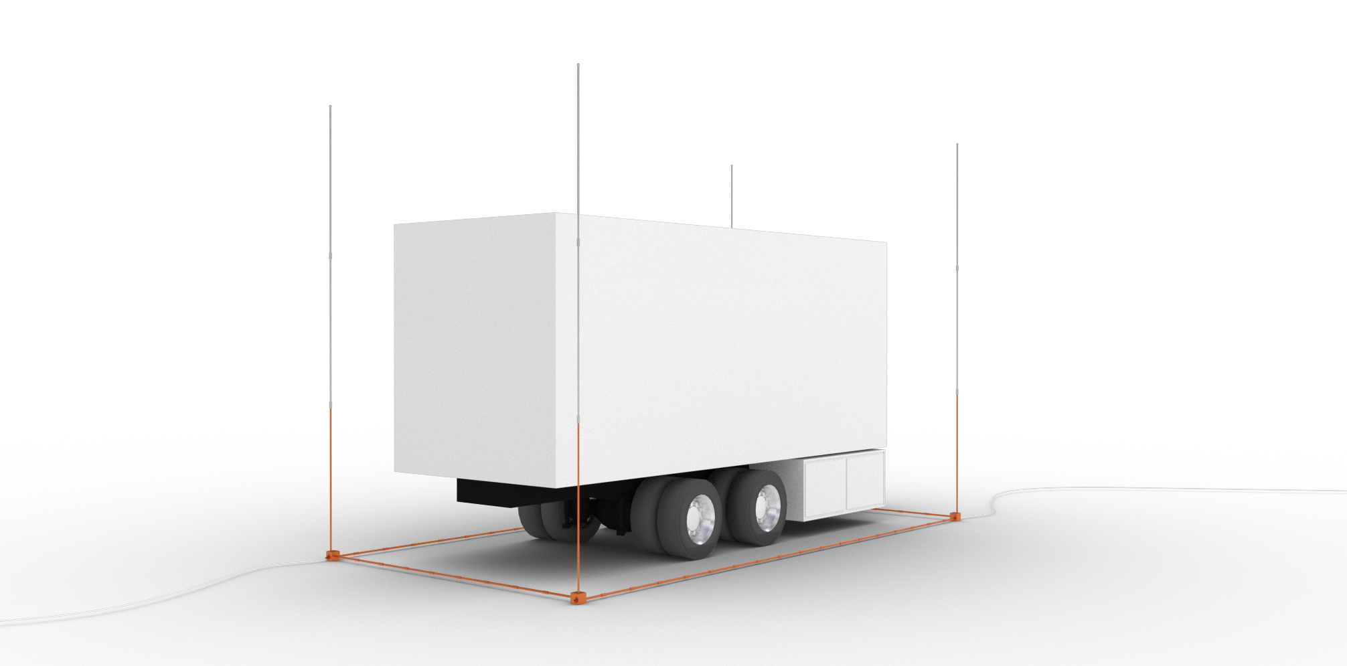

We offer the ARCANGEL kit: an easily assembled, portable lightning protection system kit rental for: $15k/Run Of Show rate per kit and $2500 weekly.   
  
The average show needs two kits for Run of Show.

**The Design**

Designed according to Lightning Protection Institute (LPI) standards, following all NFPA/NEC, OSHA, NOAA standards, and with Underwriter’s Laboratories (UL) listed parts, by Isaac and Wesley. The designs were inspected and qualified as LPS by Intercept Lightning LLC, an LPI licensed lightning protection solutions provider and systems inspector. The ARCANGEL kit is a full and complete lightning protection system when earthed, and a light Faraday cage when not. Ribcage Solutions currently uses American manufacturers and suppliers, exclusively, giving us a Made in the USA label along with more reliable supply chains.

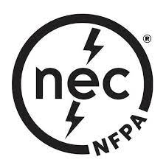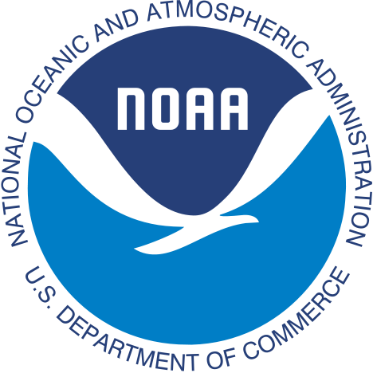

**The Financials**

On average, one generator and one HVAC per location set-up means two ARCANGEL kits per production per show-under-lightning-threat in a high ground flash density state (GA, NM, FL, VA).

The cost of manufacturing one ARCANGEL kit depends on the quantity and ranges from $1100-$1400 depending on supply chain shortages, lead times, and quantity. In 2022, total direct production budget spending in Georgia topped $4B+.

We are proud to have a revshare agreement with MBS Equipment Company, a powerhouse in Lighting Rentals, which services over 40 shows per year in Atlanta.

Terms: In return for 20% profit share and exclusive distribution,

1. MBS handles all billing, fulfillment, L&D
2. MBS provides word-of-mouth to their clients
3. MBS provides a credit line for manufacturing new inventory (25 units/inventory run)
   1. When we have debt on this line, we revshare at 80% to MBS until it’s repaid

There are no traditional competitors in our niche since regular lightning protection companies are not usually contracted to do lightning protection on films as they do not have a kitted solution like an ARCANGEL kit.

TAM+SAM+SOM:

~280 total productions in Georgia/year (2022 data ~30 features, ~250 TV shows)

~1/10 stages are warehouse stages

~28 productions in GA/yr shooting on warehouse stages (TAM)

~⅕ Locations need external power (conservative, no way to estimate)

~56 productions in GA/yr shooting on locations without enough power

= ~84 productions in GA/yr that need lightning protection

= 84 productions * $30k RoS

= $2.52m

Our TAM is $2.5MM in GA.

Our SAM is a year one goal of 20 RoS rentals in GA (20x $30k=$600k) through establishing vendor relationships with the major studios and streaming service production arms, direct outreach to UPMs, word-of-mouth via networking and MBS.

**BLOCKERS:**  
The single issue we are having is that CSATF has not released the pending update for Inclement Weather Safety Bulletin #38. They provided the new draft to us and also assured us that we could still deploy our solution. We were able to soft launch and secure our first client, but the strike began right after that.

We have been in contact with CSATF throughout this process and have been assured:

1) it’s no problem to service productions now

2) the bulletin revision is forthcoming.

**OUR FIRST CLIENT**

In 2023 we got our first client, Outer Range Season 2 (Amazon). The production was in Santa Fe, NM. We were unsure of our pricing, so we offered them a Run of Show package for $21k. There was no conversation and the rental was immediately executed. We made two separate technician visits to them, at a cost of $2k. The total profit was $17.5k, at a margin of 83%.

**The Team**

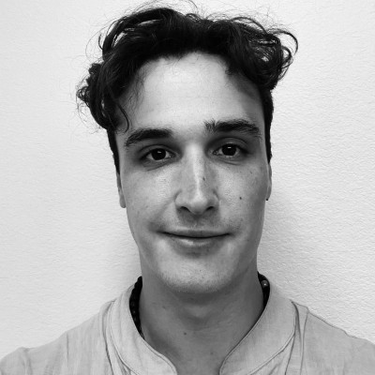

**Isaac Wostrel-Rubin, Co-Founder**

Isaac co-founded Ribcage Solutions in 2021, after working in film and television as a coordinator for 4 years. Before that he was Product Manager at Dreamium Labs, working on blockchain platform product development and feature engineering. Isaac holds a Bachelor of Arts degree in Philosophy of Aesthetics from Bennington College.

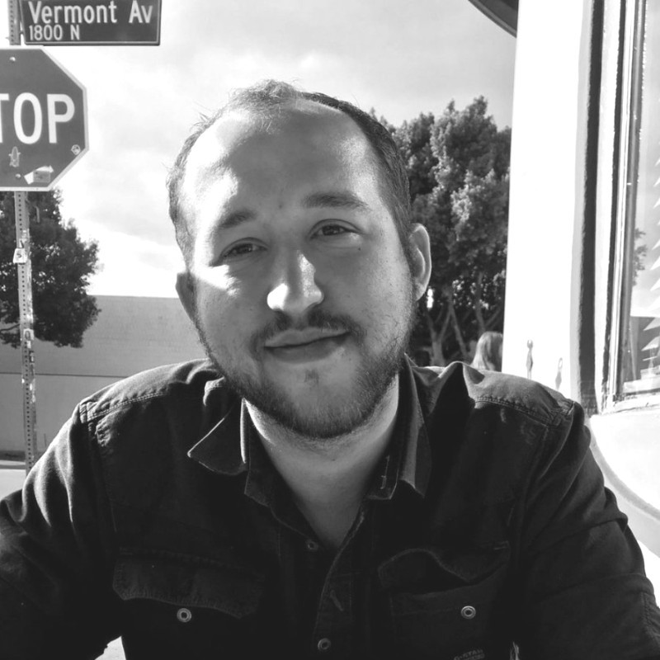

**Wesley Evans, Co-Founder**

Wesley co-founded Ribcage Solutions in 2021, after studying and working in the architecture industry for 6 years, applying the practice and knowledge base of architectural design to the LPS invention process. His most recent role was as the Design Development Lead on a new state-of-the-art private medical office campus in Fort Worth, TX. Wesley holds a Bachelor of Arts degree in Art & Architecture from Bennington College and a Masters in Architecture from the Southern California Institute of Architecture.

**Partnership:**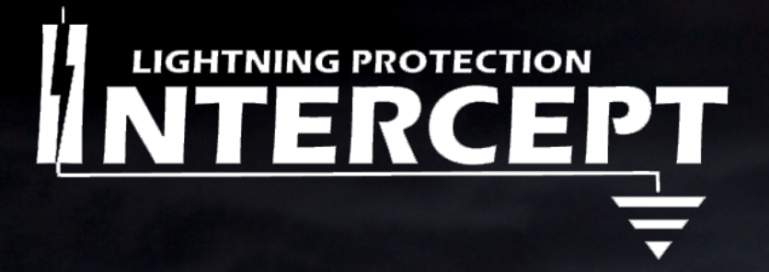

**Intercept Lightning Protection**

Ribcage Solutions has a partnership with Intercept LP, LPI master installer contractors able to design and certify class I and class II lightning protection systems as well as LPS for munitions and non-ordinary structures. Intercept LP contracts for organizations such as ConocoPhillips and the Oklahoma State Department. Intercept LP has designed a protocol for remote inspection of ARCANGEL kits, and will be providing remote inspections (assembly oversight) and working with electricians to resolve any installation issues.

**ASK:**

We are looking to raise $250k with a $2.5m valuation to fund operations for the next year to bring us into profitability.

**PLAY:**

1. Find and network with all warehouse stages in lightning dense states.
   1. Permanent installations with revshare increase their stage value.
2. Establish validated acquisition channels (ie warming and nurture channels for UPMs, Rigging Gaffes, etc).
3. Establish new affiliate partnerships with other rental houses (cinelease, united, herc, etc).
4. Present to production safety departments on the dangers of lightning.
5. Remove productivity blocking obstacles like necessity for self-funding.
   1. The strike put us in a difficult position. We had already been delayed by the CSATF bulletin postponement and our first client put us barely above water. The strike hitting right after put us in the red. If we don’t receive an injection, it will necessitate thousands of hours of unrelated work being done to fund the operation.

**GOAL:**

Establish Ribcage as the industry go-to for lightning protection AND establish lightning protection as a necessary cost for production safety when shooting in certain places.

Info:

Current Equity Distribution: Co-Founders 100% (50/50)