
2028-08-29 Mitsue

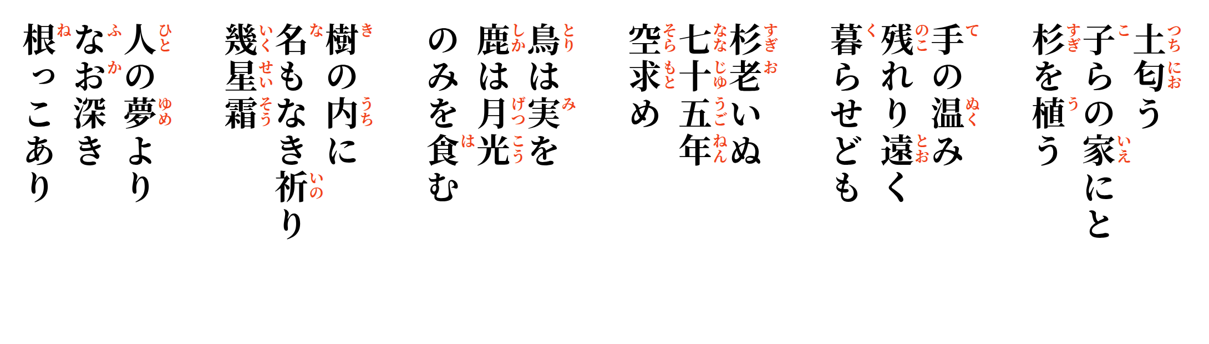

For their children's homes,
sugi saplings enter the earth
in the spring.
For lives far away,
the warmth of human hands
remains.
Seventy-five years—
the sugi reach toward heaven
and grow old.
The birds wait for fruit;
the deer eat only moonlight.
Within the wood,
a nameless prayer
crosses the years.
Deeper than human dreams,
there are roots.

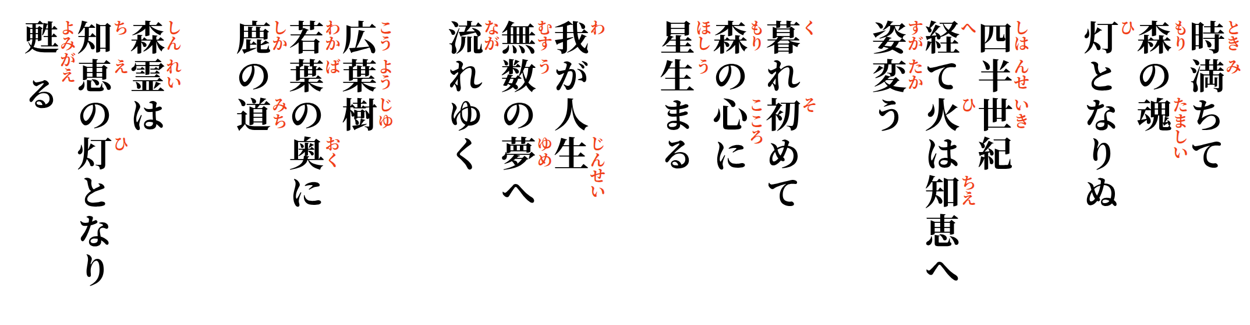
The time has ripened;
the soul of the forest
becomes fire.
Twenty-five years—
the fire changes its form
into wisdom.
In the house of night,
stars are born
within the heart of the forest.
One life
flows onward
into countless dreams.
Broadleaf forest—
beyond the young leaves
lies the deer's path.
The heart of the forest
becomes the light of knowledge,
and returns to life.

