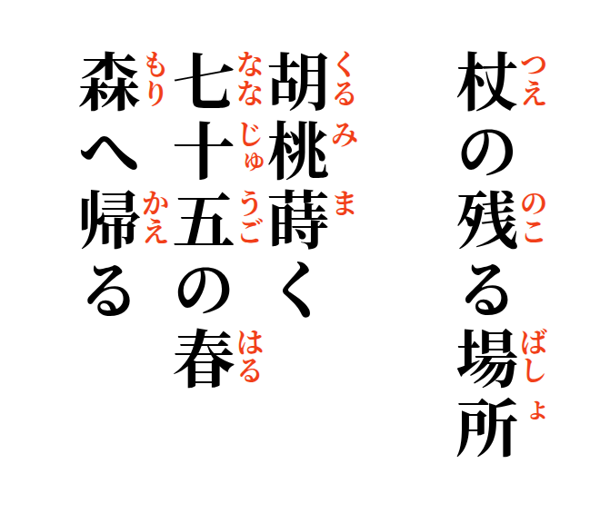

2026-09-11
Where the Staff Remains
One walnut, sown—
seventy-five springs
return to the forest.

