Университет ИТМО

Вычислительная математика
Лабораторная работа №4
«Аппроксимация функции методом наименьших квадратов»

Работу выполнил:
Бавыкин Роман
Группа: Р3210
Вариант 2

Санкт-Петербург
2022 г.
Цель работы:
найти функцию, являющуюся наилучшим приближением заданной табличной функции по методу наименьших квадратов.
Порядок выполнения работы:

0 | 0,2 | 0,4 | 0,6 | 0,8 | 1 | 1,2 | 1,4 | 1,6 | 1,8 | 2
0 | 0,60 | 1,17 | 1,59 | 1,70 | 1,50 | 1,17 | 0,87 | 0,64 | 0,47 | 0,35
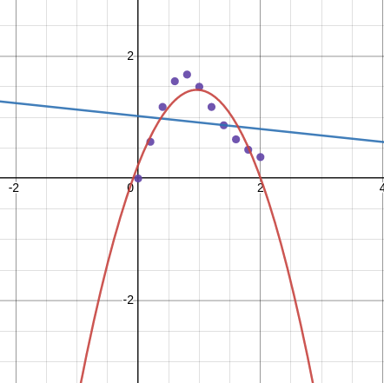
Рабочие формулы:

Листинг программы:

1  2  3  4  5  6  7  8  9  10  11  12  13  14  15  16  17  18  19  20  21  22  23  24  25  26  27  28  29  30  31  32  33  34  35  36  37  38  39  40  41  42  43 | @Component  public class LinearApproximation implements Approximation{  private ApproximationAnalyzer approximationAnalyzer;  @Autowired  public LinearApproximation(ApproximationAnalyzer approximationAnalyzer) {  this.approximationAnalyzer = approximationAnalyzer;  }  @Override  public ApproximationResults approximate(double[] xValues, double[] yValues) {  double x = 0;  double x2 = 0;  double y = 0;  double xy = 0;  int n = Math.min(xValues.length, yValues.length);  for (int i = 0; i < n; i++) {  x += xValues[i];  x2 += Math.pow(xValues[i], 2);  y += yValues[i];  xy += xValues[i] * yValues[i];  }  double[][] left = new double[][] {  {x2, x},  {x, n}};  double[] right = new double[]{  xy, y  };  DecompositionSolver solver = new LUDecomposition(new Array2DRowRealMatrix(left)).getSolver();  double[] solution = solver.solve(new ArrayRealVector(right)).toArray();  LinearFunction function = new LinearFunction();  function.setA(solution[0]);  function.setB(solution[1]);  return ApproximationResults  .builder()  .function(function)  .deviation(approximationAnalyzer.calculateDeviation(xValues, yValues, function))  .r2(approximationAnalyzer.calculateR2(xValues, yValues, function))  .correlation(approximationAnalyzer.calculateCorrelation(xValues, yValues))  .build();  }  }
1  2  3  4  5  6  7  8  9  10  11  12  13  14  15  16  17  18  19  20  21  22  23  24  25  26  27  28  29  30  31  32  33  34  35  36  37  38  39  40  41  42  43  44  45  46  47  48  49  50  51  52 | @Component  public class Polynomial2Approximation implements Approximation{  private ApproximationAnalyzer approximationAnalyzer;  @Autowired  public Polynomial2Approximation(ApproximationAnalyzer approximationAnalyzer) {  this.approximationAnalyzer = approximationAnalyzer;  }  @Override  public ApproximationResults approximate(double[] xValues, double[] yValues) {  double x = 0;  double x2 = 0;  double x3 = 0;  double x4 = 0;  double y = 0;  double xy = 0;  double x2y = 0;  int n = Math.min(xValues.length, yValues.length);  for (int i = 0; i < n; i++) {  x += xValues[i];  x2 += Math.pow(xValues[i], 2);  x3 += Math.pow(xValues[i], 3);  x4 += Math.pow(xValues[i], 4);  y += yValues[i];  xy += xValues[i] * yValues[i];  x2y += Math.pow(xValues[i], 2) * yValues[i];  }  double[][] left = new double[][]{  {n, x, x2},  {x, x2, x3},  {x2, x3, x4}  };  double[] right = new double[]{  y, xy, x2y  };  DecompositionSolver solver = new LUDecomposition(new Array2DRowRealMatrix(left)).getSolver();  double[] solution = solver.solve(new ArrayRealVector(right)).toArray();  Polynomial2Function function = new Polynomial2Function();  function.setA0(solution[0]);  function.setA1(solution[1]);  function.setA2(solution[2]);  return ApproximationResults  .builder()  .function(function)  .deviation(approximationAnalyzer.calculateDeviation(xValues, yValues, function))  .r2(approximationAnalyzer.calculateR2(xValues, yValues, function))  .correlation(null)  .build();  }  }

1  2  3  4  5  6  7  8  9  10  11  12  13  14  15  16  17  18  19  20  21  22  23  24  25  26  27  28  29  30  31  32  33  34  35  36  37  38  39  40  41  42  43  44  45  46  47  48  49  50  51  52  53  54  55  56  57  58  59 | @Component  public class Polynomial3Approximation implements Approximation{  private ApproximationAnalyzer approximationAnalyzer;  @Autowired  public Polynomial3Approximation(ApproximationAnalyzer approximationAnalyzer) {  this.approximationAnalyzer = approximationAnalyzer;  }  @Override  public ApproximationResults approximate(double[] xValues, double[] yValues) {  double x = 0;  double x2 = 0;  double x3 = 0;  double x4 = 0;  double x5 = 0;  double x6 = 0;  double y = 0;  double xy = 0;  double x2y = 0;  double x3y = 0;  int n = Math.min(xValues.length, yValues.length);  for (int i = 0; i < n; i++) {  x += xValues[i];  x2 += Math.pow(xValues[i], 2);  x3 += Math.pow(xValues[i], 3);  x4 += Math.pow(xValues[i], 4);  x5 += Math.pow(xValues[i], 5);  x6 += Math.pow(xValues[i], 6);  y += yValues[i];  xy += xValues[i] * yValues[i];  x2y += Math.pow(xValues[i], 2) * yValues[i];  x3y += Math.pow(xValues[i], 3) * yValues[i];  }  double[][] left = new double[][]{  {n, x, x2, x3},  {x, x2, x3, x4},  {x2, x3, x4, x5},  {x3, x4, x5, x6}  };  double[] right = new double[]{  y, xy, x2y, x3y  };  DecompositionSolver solver = new LUDecomposition(new Array2DRowRealMatrix(left)).getSolver();  double[] solution = solver.solve(new ArrayRealVector(right)).toArray();  Polynomial3Function function = new Polynomial3Function();  function.setA0(solution[0]);  function.setA1(solution[1]);  function.setA2(solution[2]);  function.setA3(solution[3]);  return ApproximationResults  .builder()  .function(function)  .deviation(approximationAnalyzer.calculateDeviation(xValues, yValues, function))  .r2(approximationAnalyzer.calculateR2(xValues, yValues, function))  .correlation(null)  .build();  }  }

1  2  3  4  5  6  7  8  9  10  11  12  13  14  15  16  17  18  19  20  21  22  23  24  25  26  27  28  29  30  31 | @Component  public class ExponentialApproximation implements Approximation{  private LinearApproximation linearApproximation;  private ApproximationAnalyzer approximationAnalyzer;  @Autowired  public ExponentialApproximation(LinearApproximation linearApproximation, ApproximationAnalyzer approximationAnalyzer) {  this.linearApproximation = linearApproximation;  this.approximationAnalyzer = approximationAnalyzer;  }  @Override  public ApproximationResults approximate(double[] xValues, double[] yValues) {  int n = Math.min(xValues.length, yValues.length);  double[] xValuesNew = new double[n];  double[] yValuesNew = new double[n];  for (int i = 0; i < n; i++) {  yValuesNew[i] = yValues[i] > 0 ? Math.log(yValues[i]) : yValues[i];  xValuesNew[i] = xValues[i];  }  ApproximationResults results = linearApproximation.approximate(xValuesNew, yValuesNew);  LinearFunction linearFunction = (LinearFunction) results.getFunction();  ExponentialFunction exponentialFunction = new ExponentialFunction();  exponentialFunction.setA(Math.exp(linearFunction.getB()));  exponentialFunction.setB(linearFunction.getA());  results.setFunction(exponentialFunction);  results.setDeviation(approximationAnalyzer.calculateDeviation(xValues, yValues, exponentialFunction));  results.setR2(approximationAnalyzer.calculateR2(xValues, yValues, exponentialFunction));  results.setCorrelation(null);  return results;  }  }
1  2  3  4  5  6  7  8  9  10  11  12  13  14  15  16  17  18  19  20  21  22  23  24  25  26  27  28  29  30  31  32 | @Component  public class LogarithmicApproximation implements Approximation {  private LinearApproximation linearApproximation;  private ApproximationAnalyzer approximationAnalyzer;  @Autowired  public LogarithmicApproximation(LinearApproximation linearApproximation, ApproximationAnalyzer approximationAnalyzer) {  this.linearApproximation = linearApproximation;  this.approximationAnalyzer = approximationAnalyzer;  }  @Override  public ApproximationResults approximate(double[] xValues, double[] yValues) {  int n = Math.min(xValues.length, yValues.length);  double[] xValuesNew = new double[n];  double[] yValuesNew = new double[n];  for (int i = 0; i < n; i++) {  xValuesNew[i] = xValues[i] > 0 ? Math.log(xValues[i]) : xValues[i];  yValuesNew[i] = yValues[i];  }  ApproximationResults results = linearApproximation.approximate(xValuesNew, yValuesNew);  LinearFunction linearFunction = (LinearFunction) results.getFunction();  LogarithmicFunction logarithmicFunction = new LogarithmicFunction();  logarithmicFunction.setA(linearFunction.getA());  logarithmicFunction.setB(linearFunction.getB());  results.setFunction(logarithmicFunction);  results.setDeviation(approximationAnalyzer.calculateDeviation(xValues, yValues, logarithmicFunction));  results.setR2(approximationAnalyzer.calculateR2(xValues, yValues, logarithmicFunction));  results.setCorrelation(null);  return results;  }  }

1  2  3  4  5  6  7  8  9  10  11  12  13  14  15  16  17  18  19  20  21  22  23  24  25  26  27  28  29  30  31  32  33  34  35  36 | @Component  public class PowerApproximation implements Approximation{  private LinearApproximation linearApproximation;  private ApproximationAnalyzer approximationAnalyzer;  @Autowired  public PowerApproximation(LinearApproximation linearApproximation, ApproximationAnalyzer approximationAnalyzer) {  this.linearApproximation = linearApproximation;  this.approximationAnalyzer = approximationAnalyzer;  }  @Override  public ApproximationResults approximate(double[] xValues, double[] yValues) {  int n = Math.min(xValues.length, yValues.length);  double[] xValuesNew = new double[n];  double[] yValuesNew = new double[n];  for (int i = 0; i < n; i++) {  if (yValues[i] > 0 && xValues[i] > 0) {  xValuesNew[i] = Math.log(xValues[i]);  yValuesNew[i] = Math.log(yValues[i]);  } else {  xValuesNew[i] = xValues[i];  yValuesNew[i] = yValues[i];  }  }  ApproximationResults results = linearApproximation.approximate(xValuesNew, yValuesNew);  LinearFunction linearFunction = (LinearFunction) results.getFunction();  PowerFunction powerFunction = new PowerFunction();  powerFunction.setA(Math.exp(linearFunction.getB()));  powerFunction.setB(linearFunction.getA());  results.setFunction(powerFunction);  results.setDeviation(approximationAnalyzer.calculateDeviation(xValues, yValues, powerFunction));  results.setR2(approximationAnalyzer.calculateR2(xValues, yValues, powerFunction));  results.setCorrelation(null);  return results;  }  }

1  2  3  4  5  6  7  8  9  10  11  12  13  14  15  16  17  18  19  20  21  22  23  24  25  26  27  28  29  30  31  32  33  34  35  36  37  38  39  40  41  42  43  44  45  46  47  48  49 | @Component  public class ApproximationAnalyzer {  public double calculateR2 (double[] xValues, double[] yValues, Function function) {  int n = Math.min(xValues.length, yValues.length);  double upper = 0;  double lowerLeft = 0;  double lowerRight = 0;  for (int i = 0; i < n; i++) {  upper += Math.pow(yValues[i] - function.apply(xValues[i]), 2);  lowerLeft += Math.pow(function.apply(xValues[i]), 2);  lowerRight += function.apply(xValues[i]);  }  double result = 1 - upper / (lowerLeft - Math.pow(lowerRight, 2) / n);  if (Double.isNaN(result)) {  result = 0;  }  return result;  }  public double calculateCorrelation(double[] xValues, double[] yValues) {  int n = Math.min(xValues.length, yValues.length);  double averageX = 0;  double averageY = 0;  for (int i = 0; i < n; i++) {  averageX += xValues[i];  averageY += yValues[i];  }  averageX /= n;  averageY /= n;  double upper = 0;  double lowerLeft = 0;  double lowerRight = 0;  for (int i = 0; i < n; i++) {  upper += (xValues[i] - averageX) * (yValues[i] - averageY);  lowerLeft += Math.pow(xValues[i] - averageX, 2);  lowerRight += Math.pow(yValues[i] - averageY, 2);  }  return upper / Math.sqrt(lowerLeft * lowerRight);  }  public double calculateDeviation(double[] xValues, double[] yValues, Function function) {  int n = Math.min(xValues.length, yValues.length);  double sum = 0;  for (int i = 0; i < n; i++) {  sum += Math.pow(function.apply(xValues[i]) - yValues[i], 2);  }  return Math.sqrt(sum / n);  }  }

Результаты выполнения программы:

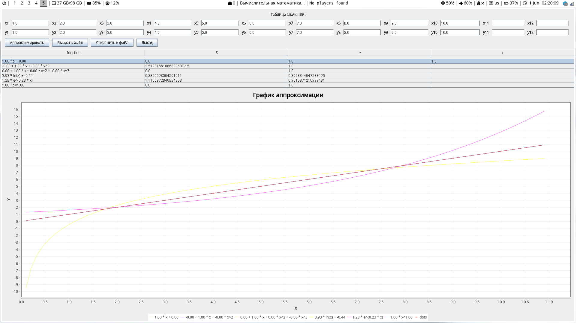

Выводы: во время выполнения лабораторной работы ознакомился с видами аппроксимации функций (линейная, квадратичная, кубическая, логарифмическая, экспоненциальная, степенная), а также методами оценки аппроксимации (метод наименьших квадратов, коэффициент корреляции, коэффициент достоверности), все методы аппроксимации и оценки реализовал программно, а также вручную произвел линейную и квадратичную аппроксимации для заданной функции, а также оценил полученные аппроксимации с помощью метода наименьших квадратов.й

