**Computer Lab – SimBiology 1 ___________________________**

**Goal**: The purpose of this lab is to become familiar with SimBiology by modeling a simple ligand binding reaction.

**Introduction**

Consider a binding reaction where ligand (L) binds to a protein receptor (R) to form a loosely bound encounter complex (L∙R), and finally a tightly bound product (P).[1]

L + R ⥂ L∙R → P

The SimBiology model of this receptor-ligand reaction looks like this (in MATLAB 2012a):

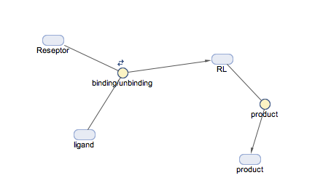

Let’s walk through the steps of how to build this model in SimBiology.

**Procedure**

1. Open Matlab and type simbiology at command window.
2. Go to Model tap in SimBiology window.
3. Home > add model > create new blank model
4. Model > Full > diagram
5. Rename window’s name to Receptor-Ligand reaction by double clicking on window.
6. Open Tools> Block Library Browser, Drag and drop three species and one reaction to the window.
7. Double click the name of the species and rename species to Ligand, Receptor and ligand-receptor respectively.
8. Rename reaction_1 to binding/unbinding
9. Hold down control key and draw an arrow from Ligand and Receptor to binding/unbinding
10. Draw an arrow from binding/unbinding to ligand-receptor
11. Double click on Ligand and set initial amount to 10.0
12. Double click on Receptor and set initial amount to 5.0
13. Double click on binding/unbinding
    1. and check “reversible”
    2. select “MassAction” for KineticLaw
       1. set “Forward Rate Parameter” value to 0.02
       2. set “Reverse Rate Parameter” value to 0.01
14. Run the simulation and save the graph.
15. Add another “species” and “reaction”. Name the species product and reaction as k-prod.
16. Connect ligand-receptor to k-prod and k-prod to product.
17. Select MassAction for kinetic law of k-prod and set value to 0.05.
18. Run simulation.
    1. Does the reaction reach a steady state?
    2. If not, increase simulation time to 100 by going to “simulation setting” (ask your TA if you can’t find it)
19. Repeat simulation for following values:
    1. “Forward Rate Parameter” : 0.01 , “Reverse Rate Parameter” : 0.02 , “k-prod” : 0.05
    2. “Forward Rate Parameter” : 0.02, “Reverse Rate Parameter” : 0.01 , “k-prod” : 0.5

**Bonus**

This same reaction can be used to describe Michaelis-Menten enzyme kinetics, in which substrate (S) binds a protein enzyme (E) to form an encounter complex (E∙S), and then chemically converts to product (E + P).

*k*1  *k*cat

E + S ⥂ E∙S → E + P

*k*-1

Suppose an enzyme has *k*1 = 107 s-1, *k*-1 = 106 s-1 and *k*cat = 104 s-1. By adjusting parameters in SimBiology, which of these rates constants would you say most sensitively controls the overall rate of catalysis?

1. Note that this last kinetic step is “one-way”, which violates thermodynamics (!). Don’t worry about this yet (we’re getting to kinetics soon in the lecture). For now, suffice it to say that here we invoke the assumption that the back rate is very small compared to forward rate.