**Computer Lab – SimBiology 2 ___________________________**

**Goal**: The purpose of this lab is to compare two- and three-state models of protein folding kinetics using the steady-state approximation

**Introduction**

This exercise is based on the following paper:

Teilum, K., Maki, K., Kragelund, B. B., Poulsen, F. M., & Roder, H. (2002). Early kinetic intermediate in the folding of acyl-CoA binding protein detected by fluorescence labeling and ultrarapid mixing. Proceedings of the National Academy of Sciences of the United States of America, 99(15), 9807–9812. doi:10.1073/pnas.152321499

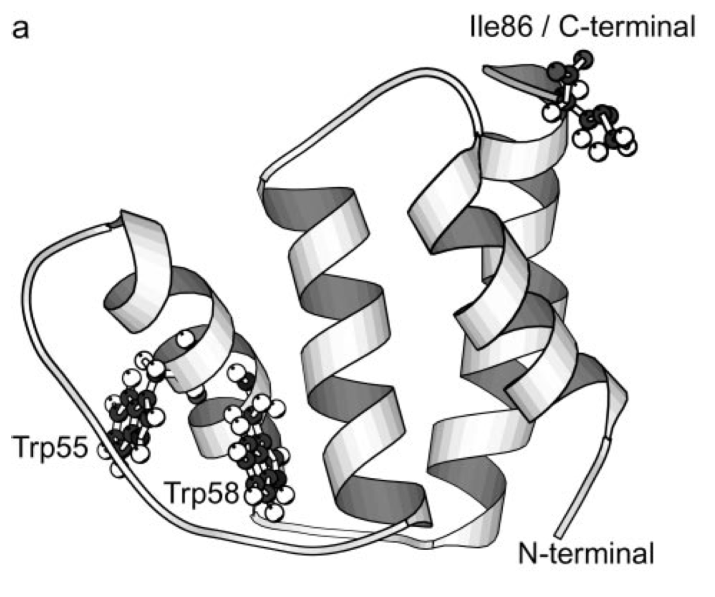

In this work, the folding kinetics of an 86-residue four helix-bundle protein called ACBP (acyl-CoA binding protein) was measured using time-resolved fluorescence spectroscopy (monitoring UV tryptophan fluorescence at 280 nm), after fast dilution from chemical denaturant (guanidinium hydrochloride, GuHCl) in a capillary mixer. The authors find that their data can be fit to the following kinetic model,

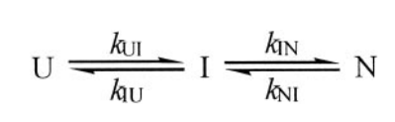

where U is a highly fluorescent unfolded state, I is a partially folded intermediate, and N is the folded state.

**Procedure**

*Modeling the three-state mechanism*

Use SimBiology to construct a model of the three-state folding kinetics, using the following kinetic rate parameters determined by the authors at 299 K:

*k*UI = 11000 s-1 *k*IN = 650 s-1

⇌ ⇌

*k*IU = 7000 s-1*k*NI = 0.07 s-1

Here is some experimental data that might be helpful in validating your model

|  |  |
| --- | --- |
| Time (ms) | Fluorescence intensity for the U state  High concentration = more intensity |
| 0.2 | 1.1 |
| 0.4 | 1.0 |
| 0.6 | 0.98 |
| 0.8 | 0.96 |
| 1 | 0.91 |
| 2 | 0.6 |
| 20 | 0.33 |
| 40 | 0.32 |
| 60 | 0.31 |
| 80 | 0.29 |

Using initial concentrations of [U] = 10.0, [I] = 0.0, and [N] = 10.0, visualize the concentrations of each species over time. **Draw or print/plot the results below**.

**Using the results of your SimBiology model, estimate the populations of U and N at equilibrium.**

**Estimate from this the equilibrium constant *K* = [Nequilibrium]/[Uequilibrium] and the free energy of folding.**

*Modeling the two-state mechanism*

Let’s now apply the steady-state approximation to this three-state model. This approximation is a simplification saying that the concentration of the intermediate [I] is constant throughout the reaction. Since the formation of the intermediate is fast compared to the slower, rate-limiting step of folding to the native state N, the steady-state approximation is still fairly accurate.

To find the steady-state approximation, we go through the following steps:

1. Write down an expression for *d*[I]/*dt* :

*d*[I]/*dt = -k*IU[I] *- k*IN[I]+ *k*UI[U] + *k*NI[I]

1. Solve *d*[I]/*dt* = 0 (i.e. steady-state conditions) to get [I] as a function of [U] and [N] :

0 =  *-k*IU[I] *- k*IN[I]+ *k*UI[U] + *k*NI[N]

[I](*k*IU + *k*IN) = *k*UI[U] + *k*NI[N]

[I] = (*k*UI[U] + *k*NI[N])/(*k*IU + *k*IN)

1. Next, we plug this expression for [I] into the rate laws for [U] and [N]:

*d*[U]/*dt*  = *-k*UI[U] + *k*IU[I]

= *-k*UI[U] + *k*IU (*k*UI[U] + *k*NI[N])/(*k*IU + *k*IN)

*d*[N]/*dt*  = *-k*NI[N] + *k*IN[I]

= *-k*NI[N] + *k*IN (*k*UI[U] + *k*NI[N])/(*k*IU + *k*IN)

1. Finally, to get rates for a two-state U ⇌ N model of folding, consider that at equilibrium, *d*[U]/*dt* = *d*[N]/*dt* = 0. **Set the two expressions for *d*[U]/*dt* and *d*[N]/*dt* above to be equal to each other, and rearrange the equation to get it in the following form:**

*k*forward [U] = *k*backward[N]

**What are your computed values of for *k*forward and *k*backward?** (*Hint*: They should be close to the values of *k*IN and *k*NI, since I → N is the rate-limiting step.)

**Estimate from *k*forward and *k*backward the equilibrium constant (K = *k*f/*k*b) and free energy of folding.**

**Answer key:**

*k*forward = kIN [kUI /(*k*IU + *k*IN) ]

*k*backward = kNI [kIU /(*k*IU + *k*IN)]

**NOTE: it takes some simplification to get this**