Computer Lab – Chimera 2 ___________________________

Goal: The purpose of this lab is to get familiar analyzing protein-protein interfaces, and examine some of the energetic factors that contribute to favorable binding.

Introduction

Recall our friend from the last exercise, the MDM2-p53 complex (PDB ID: 1YCR).

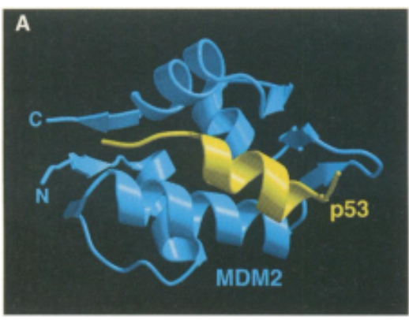
The X-ray crystal structure of MDM2-p53 (PDB ID: 1YCR)

Let’s investigate how the p53 helix interacts with the MDM2 receptor.

Finding interacting residues

- Load the structure using File > Fetch by ID … The ribbon structure of the protein complex should be shown
- Select the p53 helix by Control-clicking (holding the CNTL key and clicking with the mouse) on p53, then press the up-arrow key to select the entire chain.
- Find the receptor residues interacting with p53 using Tools > Surface/Binding Analysis.
  - In the “Atoms to Check” panel, click on the “Designate” buttons with the correct options so as to calculate interactions between the p53 helix (selected) and other atoms in the model.
  - In the “Clash/Contact Parameters” panel, click on “Contact” (not “Clash”). Then click on “Apply” below.
  - You should see a number of atoms in the helix and receptor selected. To select the residues involved, press the up-arrow key.
  - Visualize these residues using Actions > Atoms/Bonds > show. It may be helpful to Actions > Color > by element. (rendering as wire with a width of 4 works well too)

Questions

Which residues of p53 have the most interactions with the MDM2 receptor?

Which residues would you say are making hydrophobic interactions, and which have polar interactions?

Measuring surface area changes upon binding

- Select the entire complex by control-clicking on any residue, and pressing the up-arrow key until the entire structure is selected.
- Show the entire surface using Actions > Surface > show.
- Calculate the total volume and surface area using Tools > Surface/Binding Analysis > Measure Volume and Area. The values are reported in units of Å³ and Å², respectively. Write down these values in the table below.

Repeat these calculations for …
- … the MDM2 receptor by itself (select the p53 helix and delete it using Actions > Atoms/Bonds > delete.), and
- … the p53 helix by itself (reload 1YCR, select MDM2 only and delete it)

 | 1YCR (entire complex) | MDM2 | p53
Volume (Å³) | 13.07e3 | 11.11e3 | 1531
Surface Area (Å²) | 4556 | 4354 | 1092

Questions

What is the total change in surface area upon binding of the p53 helix to MDM2?

>>> 4354 + 1092 – 4556 = 890 Å²

Using the data from Figure 1a of Chen et al. (2013) below, make a rough estimate of the binding affinity of p53 helix (i.e. its dissociation constant K_{d}). Ask your TA for the actual answer

>>> Guangfeng -- the experimental K_{d} is 410 nM.

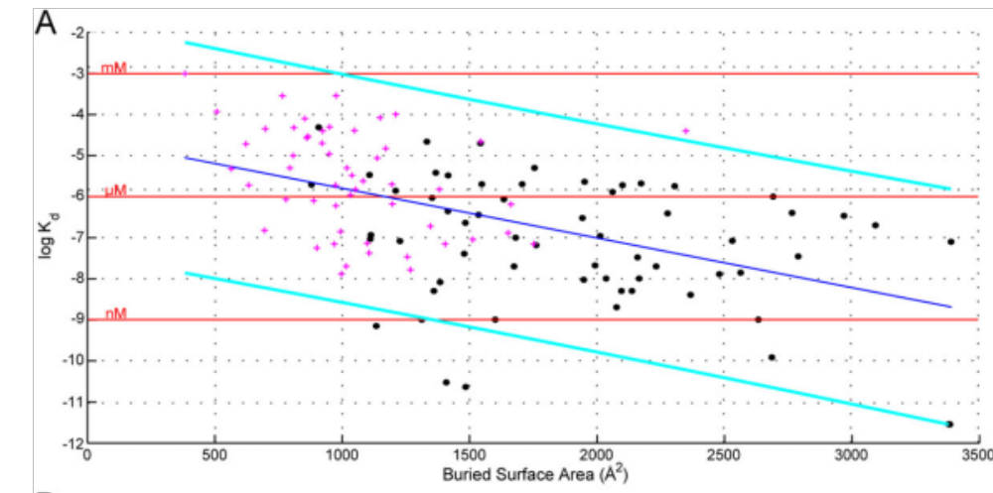
Figure 1a from Chen et al. (2013)

Chen, J., Sawyer, N., & Regan, L. (2013). Protein-protein interactions: General trends in the relationship between binding affinity and interfacial buried surface area. Protein Science, 22(4), 510–515. doi:10.1002/pro.2230

