**Artifacts:-**

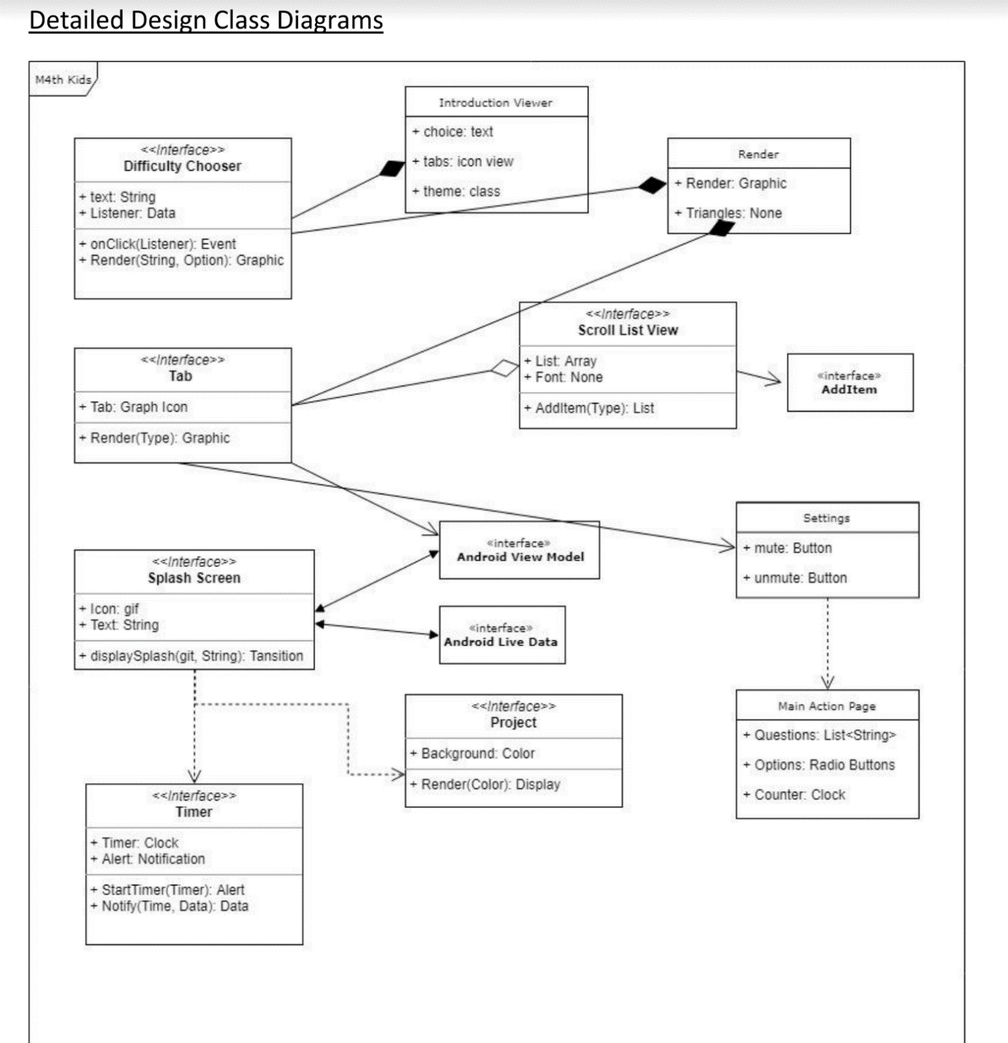

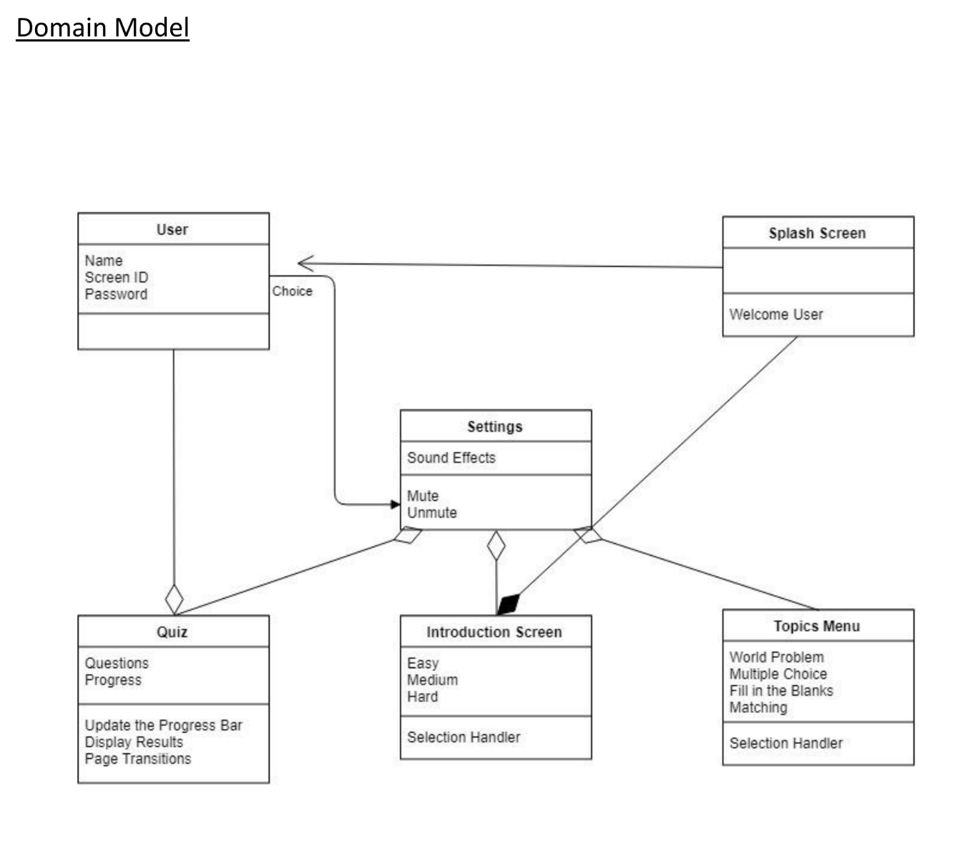

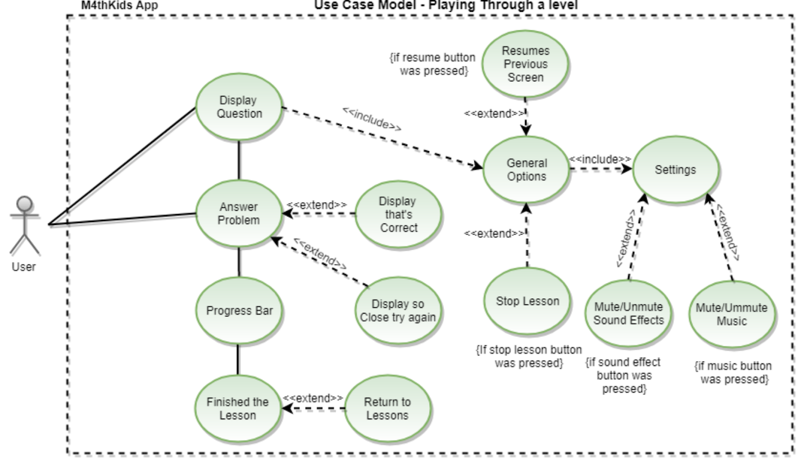

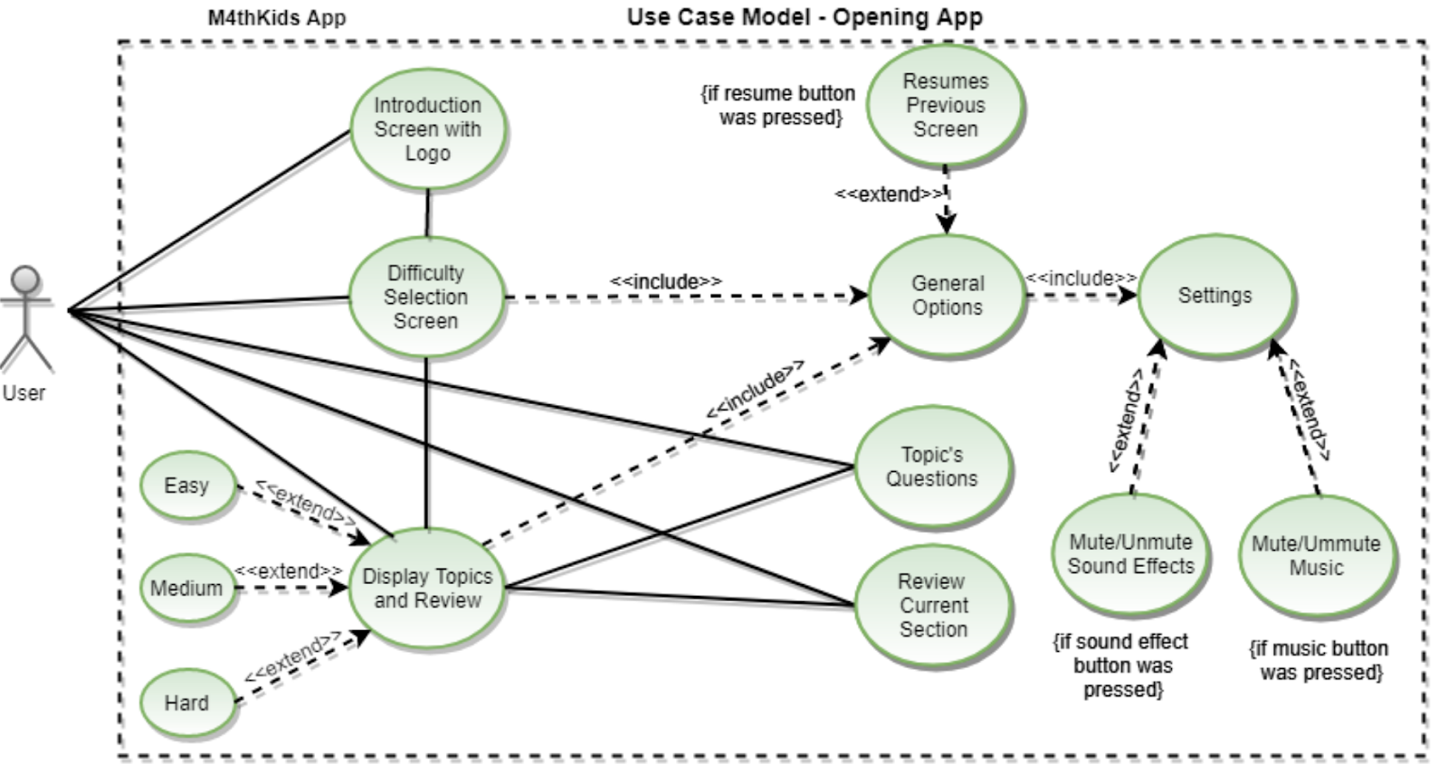

**Permission forms :-**

Date(MM/DD/YYYY): _02_/10_/_2018___

I _____Mayank___________ hereby give Math4Kids the right to use the information provided and agree to become an audience or a participant to help Math4Kids in making their app. They can/can’t (circle one) record me while conducting the Usability test. They can take notes of what I will suggest them or what I point out during the Usability test. If Math4Kids would like to use my name for information purposes, they’re more than welcome to do so.

Sign:________Mayank Loyalka___________________

Date(MM/DD/YYYY): _02_/_09_/_2018___

I ______Hemant__________ hereby give Math4Kids the right to use the information provided and agree to become an audience or a participant to help Math4Kids in making their app. They can/can’t (circle one) record me while conducting the Usability test. They can take notes of what I will suggest them or what I point out during the Usability test. If Math4Kids would like to use my name for information purposes, they’re more than welcome to do so.

Sign:_________Hemant Sharma__________________

Date(MM/DD/YYYY): _02_/_11_/_2018___

I ______Aarti__________ hereby give Math4Kids the right to use the information provided and agree to become an audience or a participant to help Math4Kids in making their app. They can/can’t (circle one) record me while conducting the Usability test. They can take notes of what I will suggest them or what I point out during the Usability test. If Math4Kids would like to use my name for information purposes, they’re more than welcome to do so.

Sign:_______Aarti Thapar____________________

**Scripts:-**

**·**      In your own words, what is your initial thought on the main page.

When I opened the app I thought that this app is more like a educational app which is going to give me something to read with a timer right after I clicked on a button. I thought of learning something when I was on the main page.

·      In your own words what do you think about the questions/ format of the questions?

I loved the fact that the numbers kept on changing every time I exited the problem so I could work with different numbers every time.

·      What type of questions would you have liked to see that were not included?

(If applicable)

I would like to see more of a imagery type of questions so more shapes. Rubrik’s cube or Puzzles.

·      Is the app easy to Navigate?

o   Yes

o   No

·      Would you share this application to a friend?

o   Yes

o   No

o   Maybe

·      Do you think the application is user friendly?

o   Yes

o   No

·      What would you rate the application on a five-scale rating?

o   1

o   2

o   3

o   4

o   5

     Any other additional comments/input; if applicable

As a new user, I want to see an introduction screen before set up.

As a user, I was an account which is simple to use and can be operated without a significant amount of adult help.

As a user, I want to have more control over my app.

As a user, I want to be able to select the math topic I want to practice on.

As a user, I want to choose a difficulty level before I choose the math topics.

As a visual learning user, I want to be able to see a lot of different colors which can help me distinguish things.

As a user, I want to be able to exit out of a topic I accidently entered in.

As a user, I want to be able to practice the same problems with different numbers every time I select a topic.

As a frequent user, I want the app to be interesting so that I can come back every time I leave it.

As a young user, I want to have as much fun as I can while I play this app.

As a parent of a young user, I want the app to be age appropriate.

As a parent of a young user, I want the app to actually teach my kid something.

**Results:-**

All the participants reported that we need to work more on our graphics and more topic menus should be available as our app is still under construction. Some of our participants also gave a suggestion to include puzzles if possible as that makes kids really interested in finding out the image behind it. Another popular suggestion was to have a rubik's cube in the app. One of the participants also wanted to see some animation besides the question or in the background of it. Overall feedback from our participants was positive and the only thing we need to work on is finishing the app, improving the graphics and have different questions.