Introduction to the Audacity Interface

Technical Requirements
The following lesson is made available in web format which includes both audio and video enhancements using the Adobe Flash plug-in. Before proceeding, it is recommended that the latest version of the plug-in be installed. An alternative format is provided for users who wish to bypass the video instruction or desire a printed set of instructions.

Users are encouraged to listen to the presentation using either speakers or headphones. Text instructions are provided for users who are not able to listen to the material. Additional hardware recommendations are at least 64 MB of RAM and a 300 MHz processor or greater.

Intended Audience
This module is designed for novice users who lack familiarity with Audacity and audio editing. Individuals familiar with audio editing may also use this orientation to quickly familiarize themselves with the Audacity graphical user interface.

Length of Module
This lesson may be viewed in the order presented which lasts approximately 10 to 15 minutes. The participant is also given the ability to pause, rewind, fast forward, and navigate to specific sections so learning may occur at their desired pace.

What to Expect
The material contained within this module will identify components of the Audacity interface, such as Tools and Menu sets. Similar items will be group and a knowledge check will be presented to assess comprehension. At the end of the lesson a short quiz will be given. This lesson does not discuss the use of Audacity and its various components.

Key Terms
Items that will be discussed and identified in this module are:
- Menu Bar
- Mixer
- Track
- Tool Bar
- WAV
- Waveform

Recommended Resources
An excellent primer for users unfamiliar with audio editing is the book by Bruce and Marty Fries, Digital Audio: A Comprehensive Guide to Creating, Recording, Editing, and Sharing Music and Other Audio available through O'Reilly Media (ISBN# 0-596-00856-2). For more information visit: http://www.teamcombooks.com/mp3handbook/index.htm.

Objective
Upon completion of this lesson you will be able to identify the major components of the Audacity interface with 100 percent accuracy.

Purpose
This module prepares users for further instruction in the use of Audacity by familiarizing them with the interface layout, tools, and controls. Upon completion, users should be able to recognize and select the appropriate parts of the interface when asked.

The Lesson

Background
Audacity is a robust open-source audio editing application available for Windows 98 and greater, Mac OS X, and Linux/Unix operating systems. Audacity was developed originally at Carnegie Mellon University and released to the public in 2000. This program may be downloaded from the project homepage (http://audacity.sourceforge.net/).

Audacity is truly a community-developed application with contributors from around the world.

Audacity uses a series of tracks to record and display each audio component such as drums, guitar, vocals, etc. These are isolated on their own track and displayed as a waveform. A waveform is a means of visually representing the shape of the sound.

The Interface an Overview
There are three main components that make up the Audacity interface. These are the Menu Bar, Toolbars, and Tracks. Other components are the Title Bar, Status Bar, and Workspace (refer to Figure 1).

The Title Bar contains the application name or working file name along with the Minimize, Maximize and Close buttons. The Status Bar displays information about the project. The workspace contains the Tracks.

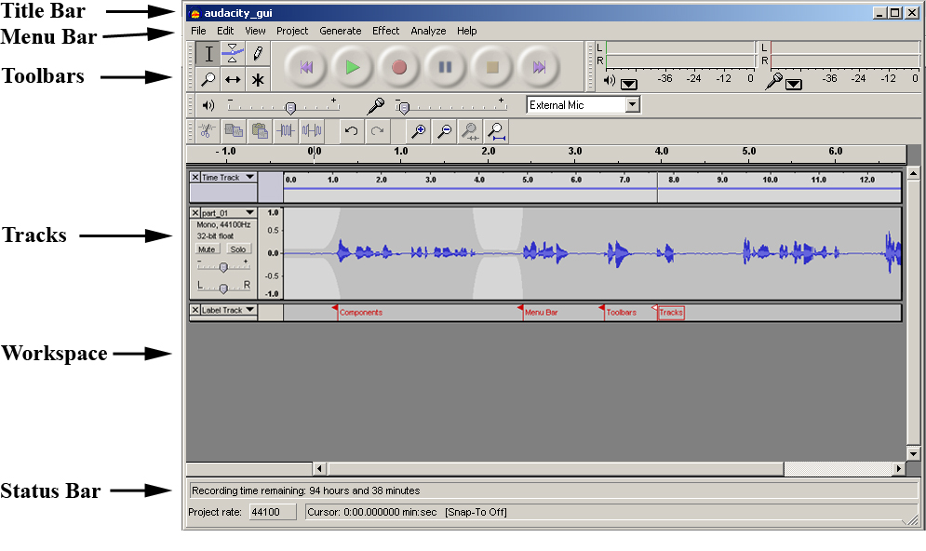
Figure 1
Components of the Audacity Interface

The Menu Bar contains links to a variety of functions. Under the Windows Operating System, the Menu Bar follows the Title Bar. On the Mac OS X, platform it follows the Apple Menu and is contained within the Application Menu.

Figure 2
The Menu Bar as viewed under the Windows Operating System

Menu Bar Components
The Menu Bar contains the following options: File, Edit, View, Project, Generate, Effect, Analyze and Help (see Figure 2). The File menu allows users to Open, Close, Save and Export their work. The workspace may be saved as a working file so that future edits and manipulations may be performed. The export feature allows the file to be saved in an uncompressed WAV format or in the compressed MP3 and Ogg Vorbis formats.

The Edit option allows users to adjust preferences and manipulate the audio.

The View menu controls how the audio is visually presented to the user. It allows for the magnification of selected areas of the waveform. The view option also provides the ability to adjust the waveform so that it is contained within the viewable workspace, omitting the need for scrolling. There is also a log or History of every action performed within Audacity so that undesirable changes can be reversed. Last, but not least, the View menu provides access to the Toolbars.

The Project menu is designed for managing the Workspace. Users can import materials, add new tracks and position tracks.

The Generate option allows for the insertion of Silence or other packaged Sounds. This is handy for controlling the tempo and beats or adding extra silence.

The Effect menu item provides a series of filters and manipulation controls that can be applied to the selected waveform. Some examples are the ability to manipulate the pitch and bass or even add reverb so that there is an echo.

The Analyze option assists with locating information about the waveform such as silence or frequency display.

The Help menu item serves as a resource about the application, providing useful tips and other information.

The Toolbars
There are four Toolbars: Control, Edit, Meter, and Mixer. These allow the user to record and manipulate audio. Each of the Toolbars contain a series of icons or buttons that perform a specific action when selected. Placing the cursor over one of the icons for approximately 2 seconds will display its name. This display popup is called a tooltip.

Each Toolbar contains a raised section known as a handle. Selecting this area with the mouse, left clicking and dragging will “tear it off” and allow it to float. This is convenient when working in other applications as the Toolbar can float on top allowing for easy recording. |  | Figure 3  Toolbar Handle

The Control Toolbar is the first Toolbar the user is presented with and it contains two parts: Editing and Audio Control buttons (refer to Figure 4).

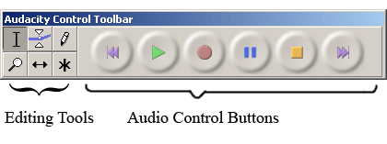 | Figure 4  The Control Toolbar

Editing Tools:

Selection Tool lets users highlight a section of the waveform which can then be manipulated.
Envelope Tool adjusts the sound intensity (e.g. increase or decrease the volume).
Draw Tool allows the user to manipulate individual points on the waveform (note: selection must be fully magnified, or zoomed in).
Zoom Tool magnifies the selected region of the waveform.
Timeshift Tool allows the user to move the waveform along a timeline thereby adjusting its starting point.
Multi-Tool activates each of these tools based on the location of the cursor and which keys are depressed. This saves the user from having to leave the waveform to select each tool every time an edit is desired.

Audio Control Buttons

 | Skip to Start icon resets the cursor to the beginning of the timeline.
 | Play button starts the playback of audio beginning where the cursor is located on the timeline.
 | Loop icon is activated by depressing the Shift key on your keyboard. This will allow the selection to continuously repeat until otherwise stopped.
 | Record button inserts a new track at the current cursor position and commences recording the audio.
 | Pause icon ceases the playback or recording process when depressed.
 | Stop button terminates the playback or recording process.
 | Skip to End icon positions the cursor at the end of the final track.

The Edit Toolbar is the last Toolbar the user is presented with (see Figure 5). It provides shortcuts to the Edit Menu items.

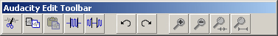 | Figure 5  The Edit Toolbar when undocked

Edit Toolbar

Cut removes the selection and places it in the clipboard.
Copy duplicates the selection storing it in the clipboard.
Paste appends or inserts the Cut or Copied selection to either a new track or just after the cursor.
Trim Outside Selection removes any component of the waveform that is not selected.
Silence Selection discards any content within a selection and replaces it with silence.
Undo discards the previous action.
Redo repeats the previous action.
Zoom In magnifies the selected area of the waveform.
Zoom Out reduces the selected area of the waveform.
Fit Selection in Window adjusts the highlighted area of the waveform so that it is within the viewable area of the workspace.
Fit Project in Widow adjusts the waveform so that it is within the viewable area of the workspace.

The Meter Toolbar
The Meter Toolbar displays the microphone or line-in input and speaker or headset output audio levels.

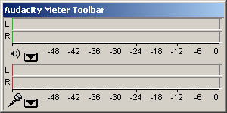 |  | 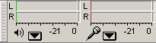
Figure 6  The Meter Toolbar when undocked |  | Figure 7  The Meter Toolbar when docked
The Mixer Toolbar
The Mixer Toolbar allows the user to select the input source such as a microphone or line-in. The Toolbar also permits the recording sensitivity to be adjusted along with the playback volume.

Figure 8
The Mixer Toolbar when undocked

Tracks Overview
The recorded or imported audio is displayed in digital format on a track. Audacity allows the user to manipulate multiple tracks to combine a variety of sounds such as vocals, guitar, drums, and keyboard. The track may be displayed as a waveform, timeline, or other format.

Tracks
Audacity provides several tracks that help organize your project. Some of these are the Audio, Label, and Time tracks (see figure 9). Audio Tracks display the waveform.

Label Tracks are used to annotate an audio file. This is useful for identifying specific parts of the track and calculating precisely when they occur.

The Time Track permits the adjusting of the playback rate.

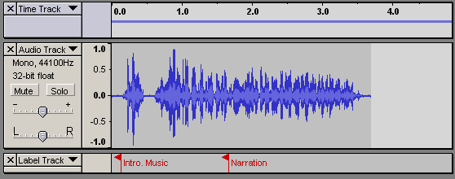 | Figure 9  A Time, Audio, and Label track

Summary
Audacity is an open-source audio editing application that may be used to produce professional quality recordings. The three main components to its interface are the Menu Bar, Toolbars, and Tracks. There are also three minor components that are primarily for displaying information. These are the Status Bar, Title Bar, and Workspace.

