Horizon Thin Client

# Start the Virtual Machine

1. Start App "Horizon Clinet"
2. Login with your h_da account

Domain:"H-DA"

3. Select your Virtual Machine by double Click on the room No.

# Use an USB-Flash Drive

USB Port

USB Drive appears as an Network Drive in "This PC"

# Use an other USB-Device

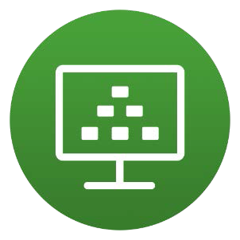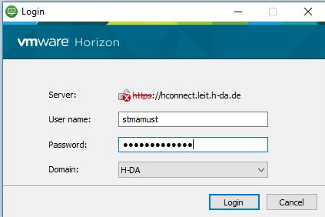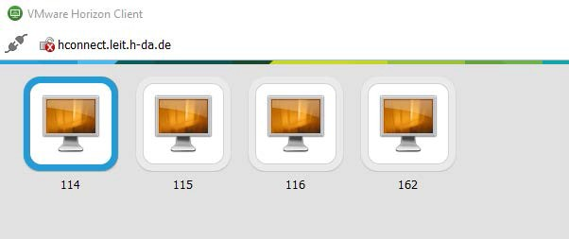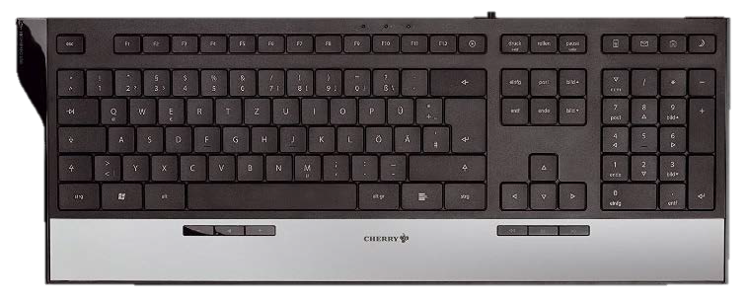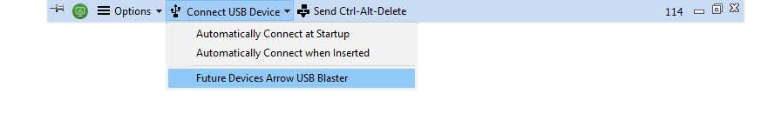

Mount the USB-Device like in Virtual Box