LOGICAL ANALYSER FOR PC

THE PEP LEGAIS

User’s Manual

The PEP Legais
Luiz Eduardo Bueno Minioli
Marcos Paulo José
Rafael Abolafio
Robson de Sousa Martins

Liceu de Artes e Ofícios de São Paulo
4° R Eletronics
1997

Contents:
03
05
06
06
07
07
09
10
12
13
14
15
24
24
26
28
30
39
41
1. Introduction..................................................................
2. Specifications...............................................................
2.1. List of Contents...............................................
2.2. System Requeriments......................................
2.3. Basic Specifications.........................................
2.4. Software Ressources........................................
3. Installation....................................................................
3.1. Physical Installation.........................................
3.2. Software Installation........................................
4. Operation.....................................................................
4.1. Panel Description.............................................
4.2. Software Configuration....................................
4.3. PEPSoftware Operation...................................
4.3.1. ALOGIC.............................................
4.3.2. DISPLAY...........................................
4.3.3. COMPARA........................................
4.3.4. MAKEOSC........................................
4.3.5. DIAG.................................................
5. Troubleshooting / Error Messages................................

LOGICAL ANALYSER FOR PC

1. INTRODUCTION

The Logical Analyser for PC was developed to give assistance to the technician in the measurement of frequency and to verify waveforms in digital circuits. Before using this equipament, read carefully every chapters of this manual that contains the description of all the resource offered, how to install and operate besides indispensable informations to this equipament be used in this maximum.

LOGICAL ANALYSER FOR PC

2. SPECIFICATIONS

2.1-List of Contents:

*Interface - Used to receive the signals to be measured from the probe and to the communication with the computer.

*Parallel Cables - Used to realize the connection between interface and microcomputer (Never utilize similar cables like: parallel cables for ZipDrive, ParallelTape or LapLink).

*Probes - Used to transfer a part of a signal to be measured in the Logical Analyser.

*Installation Disk (1.44MB) - Allows the PEPSoftware installation to the Logical Analyser in the computer hard disk.
2.2-System Requeriments:

Itens | Minimum Requeriment¹: | Recomendable²:
Microcomputer | IBM PC XT/AT or compatible | 486
Display | EGA or above | VGA colourful
Ports | 1 Parallel | 1 Parallel
Operational System | MS-DOS 5.0 or above | MS-DOS 6.XX
Drives | 1 HD and 1 FLOPPY 1.44MB | 1HD and 1 FLOPPY 1.44MB
Hard Disk Free Space | ≥1MB | >1MB

1-Minimum requeriment provides a slow operation of PEPSoftware.
2-Recomended for powerfull performance of PEPSoftware.

2.3-Basic Specifications:

Logical Analyser for PC
Power Supply: | 110V or 220V - AC 60Hz
Number of input channels: | 8
Synchronism External Input: | TTL active in high level
Voltage levels: | TTL 0-5V/CMOS 0-12V
Input Impedance: | 1MΩ
Maximum frequency in sample: | 10MHz
Maximum visible frequency in Software: | 5MHz

2.4-Software Resources:

*Setup (CONFIG.EXE) - Allows the configuration of the other modules of the PEPSoftware, in providing the address of the parallel port to be used by the interface.

*Logical Analyser (ALOGIC.EXE) - Allows the visualization of the waveforms in the microcomputer display. Beside of this, the Logical Analyser provide the resources listed below:
-Selection of horizontal scale (sample frequency);
-Zoom (1X,2X,5X or 10X);
-Selection of the base of synchronism channel;
-Paralyse waveforms in screen;
-Turn off the channels wish you don’t need for a while;
-Saving of the waveforms in file.

*Data viewer (DISPLAY.EXE) - Allows the visualization of the data apphed to the inputs, in binary, decimal and hexadecimal. Principals resources:
-Display data position in hexadecimal and decimal form;
-Import waveforms saved in files;
-Data saving in three possible formats: waveforms, binary or hexadecimal.

*Waveforms Comparator (COMPARA.EXE) - View waveforms saved in files providing resources to make comparision between the waveforms. Resources:
-Zoom (1X,2X,5X or 10X);
-Logical operation OR, AND and XOR between the waveforms;
-Screen export to BitMap form to Windows pattern - 16 colors.

*Waveforms Producer (MAKEOSC.EXE) - Produce files with standard waveforms (with frequency and duty cicle especifieds). This files is used as reference, wich will be comparedes with the waveforms measureds.

*Interface Diagnostic (DIAG. EXE) - Make the interface detection in order to indicate if exist any problem locking the communication between microcomputer and the Logical Analyser Interface.

Note: The PEPSoftware has no good performance inside of Windows environment. If you are inside of Windows 3.XX, exit for the MS-DOS before run any program. If your system is Windows 95, restart the computer in MS-DOS mode (for more informations, see your Operational System manual).

LOGICAL ANALYSER FOR PC

3. INSTALLATION

3.1-Physical Installation:

The Interface should be working in a no vibration place and protected of radiation as well as healting sources.

First, turn off your computer.

After that, connected the power cord in a outlet.

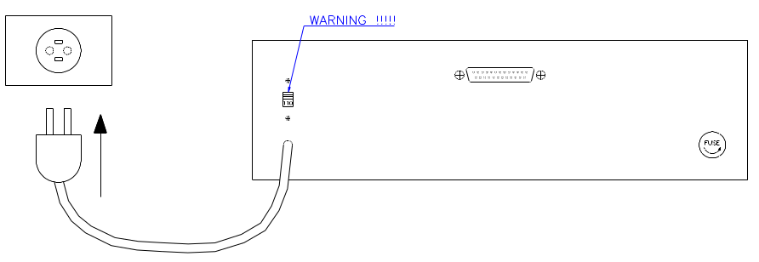

WARNING!

Before of connect the interface power supply, verify the voltage selector if in the correct position for the place voltage (110V or 220V).

After the connection, connect the communication parallel cable. One side is interconnected in the DB-25 connector locality in the Interface back panel. The other DB-25 is interconnected in microcomputer parallel port connector - LPT - (See the microcomputer manual to localize this port).

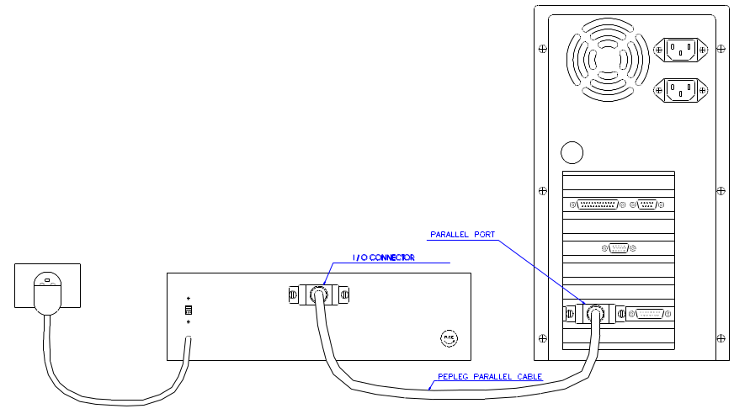

When the connection are done, turn on the Interface and turn on the microcomputer.

3.2-Software Installation:

Insert the PEPSoftware Installation Disk in the 1.44MB drive.

In the prompt A:\> type DIAG [ENTER] and follow the instructions showed in the screen.

If the message “A Interface está conectada corretamente!” appear, type INSTALL [ENTER] to start the PEPSoftware installation and follows the instructions showed in the screen. Otherwise, read the referring chapter the troubleshooting contain in this manual.

Notes:

Install the PEPSoftware in the recommended default directoty (\PEPLEG). Otherwise, at every step of the chapter operation to replace the command CD\PEPLEG by CD\ (Directory where the PEPSoftware was installed).

If the drive no by C: at every step of the operation chapter, replace the command C: for the corresponding drive letter followed for (:).

LOGICAL ANALYSER FOR PC

4. OPERATION

4.1. Panel description:

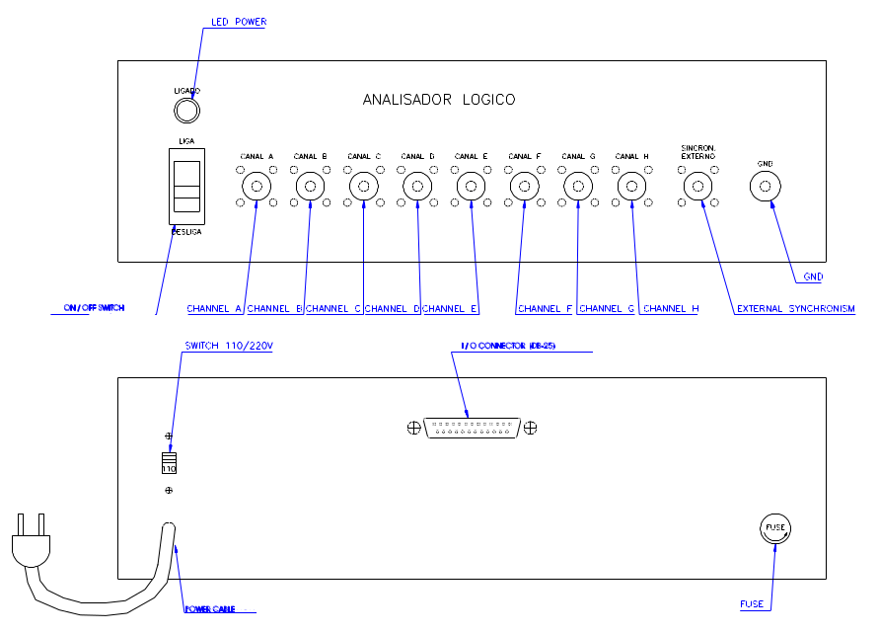

4.2- Software configuration:

After the PEPSoftware installation, run the CONFIG to determine paramenters user by other Software modules.

This procedure to be used only one time, but if that the PEPSoftware be install again or modification in the parallel port address to be used by Logical Analyser.
In the prompt, type:

C: [ENTER]

CD\PEPLEG [ENTER]

CONFIG [ENTER]

Follow the presented intructions in screen. Below is demonstrated the screen this program with the options that need chooses.

The screens present one dialog box, in the which to be indicate the used operation status line (screen last line) appear the available options in current screen, besides actual date.

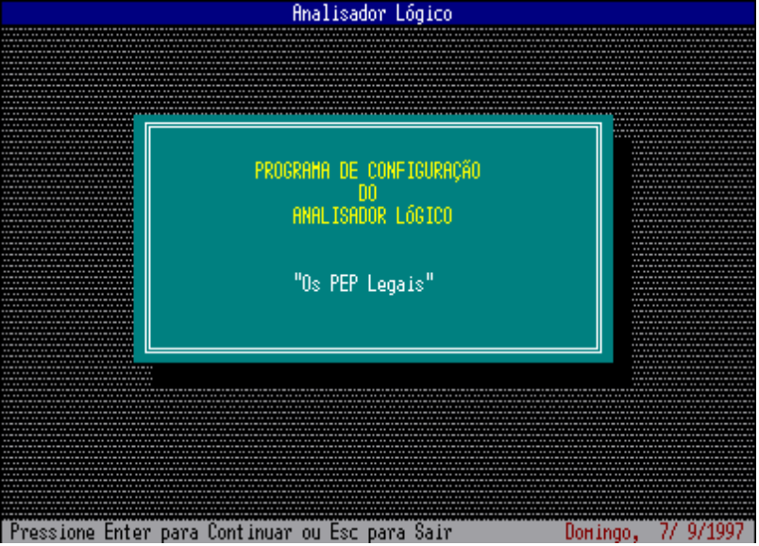

Program Presentation: Press ENTER to configure the PEPSoftware.

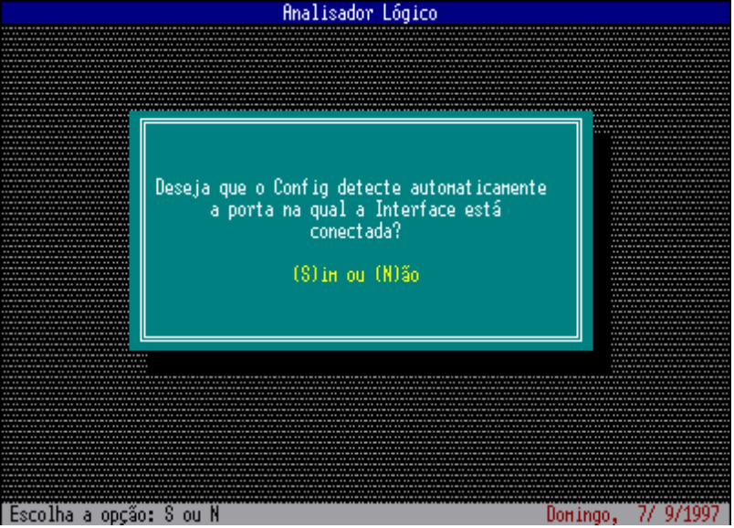

If the interface is conected at the microcomputer and ON, choose the option SIM. With this, the Config will automaticly detection the port address to be used. But, if wish specify the address manualy, choose the option NÃO.

* If the answer was NÃO, will appear the next screen

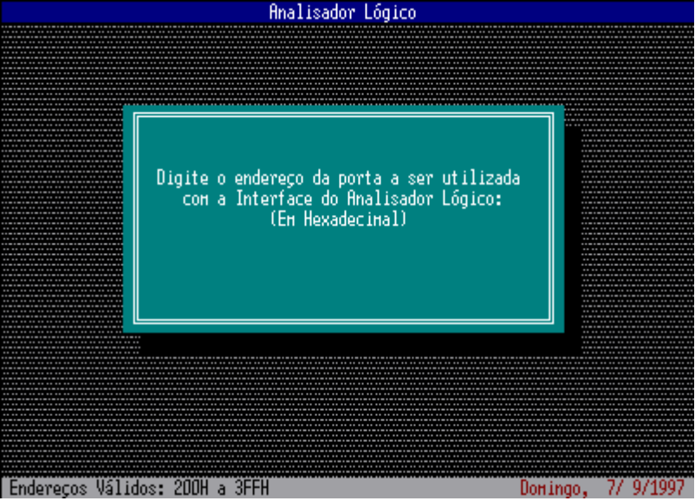

Type the port address value hexadecimal (200H to 3FFH).

* If the answer was SIM, will appear the next screen.

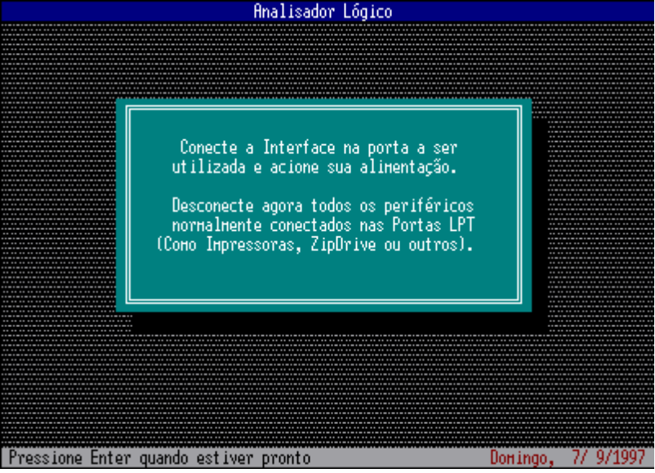

If the interface isn't conected or powered, make this now. Is recommend desconection all the peripherics that used parallel ports, for no fault the CONFIG. Press [ENTER].

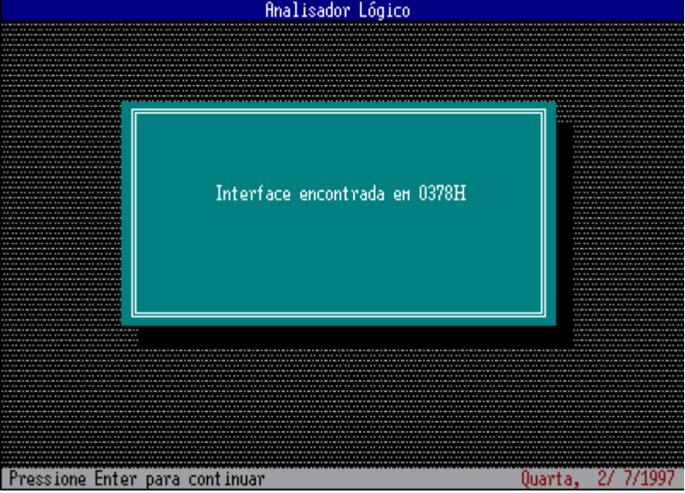

Will appear in screen the message with address of the parallel port conecteded in the Interface (ex: 0378H) Press [ENTER].

Note: Case no appear this screen, see the chapter referring the troubeshooting contains in this manual.

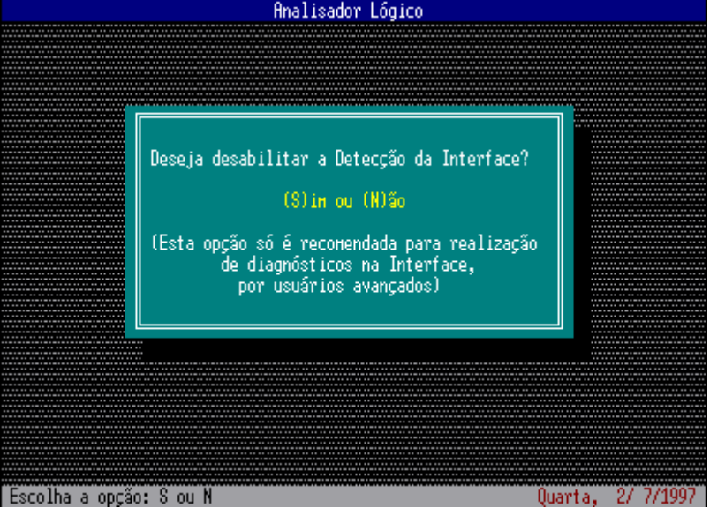

Choose the option NÃO.

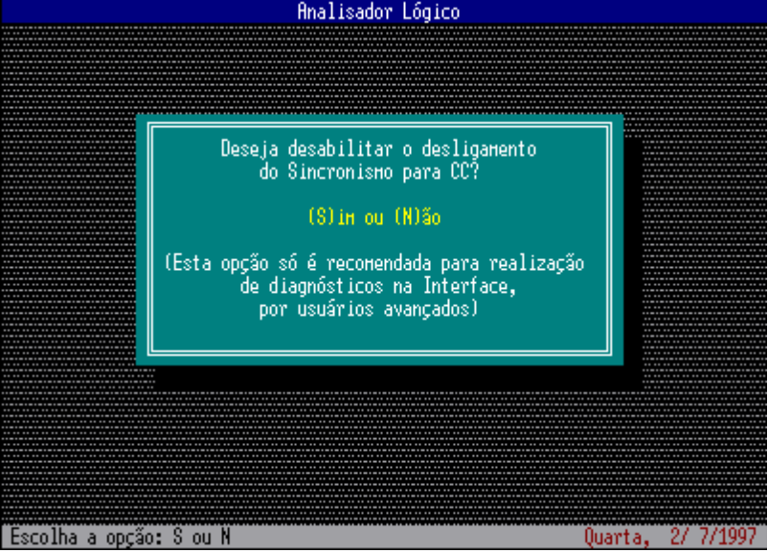

Choose the option NÃO.

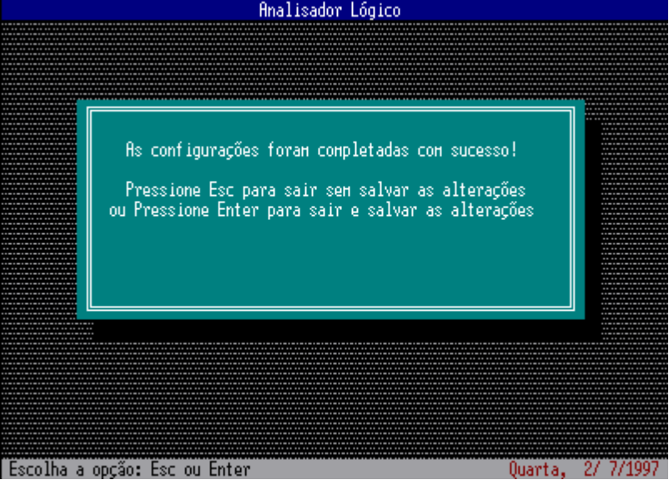

If every the option was chooses correctly, press [ENTER]. Otherwise, press ESC and execute again the CONFIG.

4.3 - PEPSoftware Operation

4.3.1 - Logical Analyser - ALOGIC:

The program ALOGIC.EXE allows the Logical Analyser utilization in the usual form, showing the waveform present in any channel.

To run the ALOGIC, type in the prompt:

C: [ENTER]

CD\PEPLEG [ENTER]

ALOGIC

Below is showed the ALOGIC main screen:

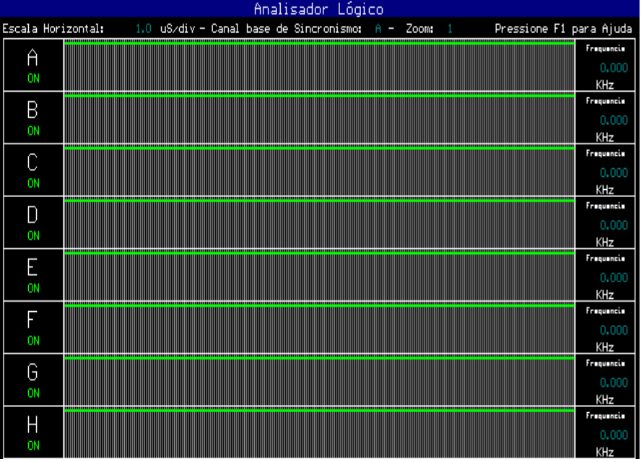

ALOGIC commands:

ESC: Exit program, come back at MS-DOS prompt;
A,B,C,D,E,F,G,H: Turn ON or Turn OFF any channels;
F1: ALOGIC commands help;
F2: Selection the horizontal scale - 1µs to 10,000 µs or external synchronism;
F3: Change the horizontal zoom - waveforms factor amplification - 1X to10X;
F4: Selection the base of synchronism channel - A to H;
F5: Paralyse the used screen;
F6: Save waveforms in file.

To save waveforms in file:

When the waveforms to be present in the screen, press F5. This will provide the paralyse of the screen (the probes wich will be disconnected). After that, press F6 and follow the instructions showed in the screen. The file saved will have a description for waveforms groups and a description for every channel. The file extension is always .OSC.

4.3.2 - Data viewer - DISPLAY

The program DISPLAY.EXE allows the visualization of the signals apphed in the probe in data form, in hexadecimal, decimal and binary. This application only works with external synchronism. One application to the DISPLAY is the read a memory contents (eight bits in the maximum) don’t need take out of the circuit. To this, connect the Logical Analyser external synchronism input in the memory Chip Select and the probes at data bus. After that, run the program DISPLAY.

To run the DISPLAY, type in the prompt:

C: [ENTER]

CD\PEPLEG [ENTER]

DISPLAY [ENTER]

Below is showed the DISPLAY main screen:

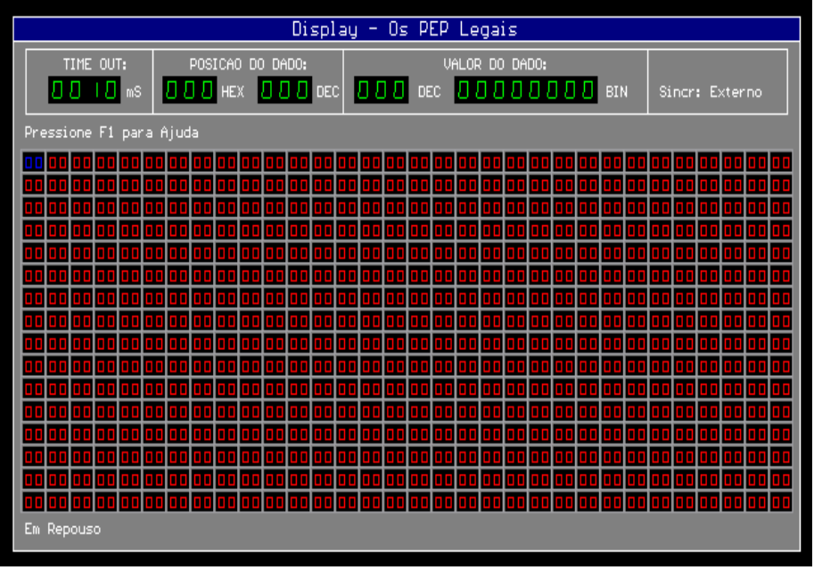

DISPLAY commands:

ESC: Exit program, come back at MS-DOS prompt;
Directional Arrows: Move cursor (display in blue), whose value is showed in the decimal and binary forms in the display called "Valor do Dado";
F1: Display commands help;
F2: Change the Timeout value - limit time that the program wait by last data - data 511;
F3: Start the data acquisition;
F4: Import data into files .OSC - display a wavefoms file in data form;
F5: Save data in file.

The saving of data in file wich will be making in three possible formats:

- (.OSC) Waveforms files that wich will be opens by COMPARA.EXE and visualized.
- (.BIN) Binarys files whose code is corresponding at saving data. Wich will be used by EPROM recorders to that your content will be keeping in no volatile memory
- (.HEX) Hexadecimals text files every line provide the data position and your value in hexadecimal

4.3.3 - Waveforms Comparator - COMPARA:

The program COMPARA allows the visualization of two waveform files (extension .OSC) at the same time of mode that wich will be make comparision between the waveforms. The files .OSC is showed in screen in different colors, to be showed too the description of every channel and the saving scale used in the files.

To run COMPARA, type in the prompt:

C: [ENTER]

CD\PEPLEG [ENTER]

COMPARA [ENTER]

Below is showed the COMPARA main screen:

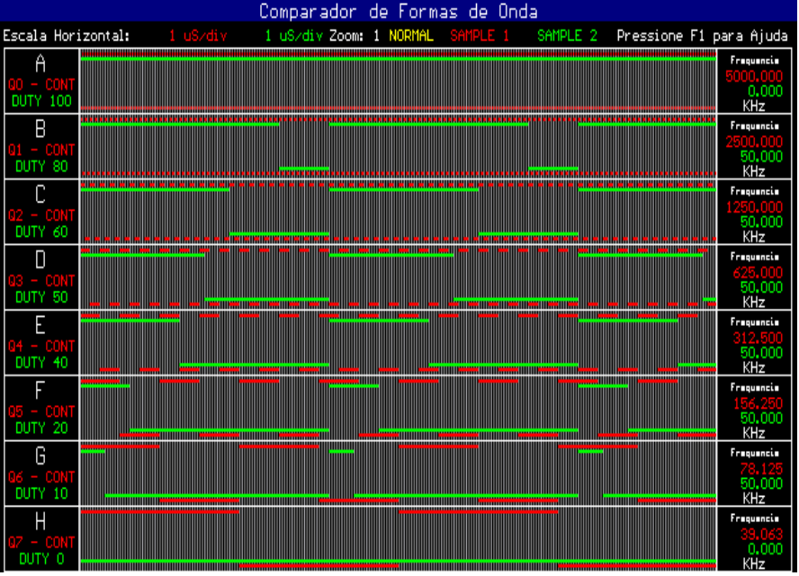

COMPARA commands:

ESC: Exit program, come back at MS-DOS prompt;
F1: COMPARA commands help;
F2: Change the horizontal zoom factor amplification - 1X to 10X;
F3: Show files information;
F4: Come back the begin screen, allows the choose agains files;
F5: Alternate mode
Normal: the two waveforms is showed individualy;
AND: is realized the operation AND between the waveforms;
OR: operation OR between the waveforms;
XOR: operation EXCLUSIVE OR between the waveforms;
F6: Screen export to BITMAP - picture with BMP extension that wich will be open by graphics programs, how windows.

4.3.4- Waveforms Producer (MAKEOSC)

The program MAKEOSC allows make waveforms files - .OSC with the frequency and duty-cicle of the every channel specifieds. The files already saved can be a pattern to be compared with the waveforms come from ALOGIC.

To run MAKEOSC, type in the prompt:

C: [ENTER]

CD \ PEPLEG [ENTER]

MAKEOSC [ENTER]

Below is showed the MAKEOSC screen:

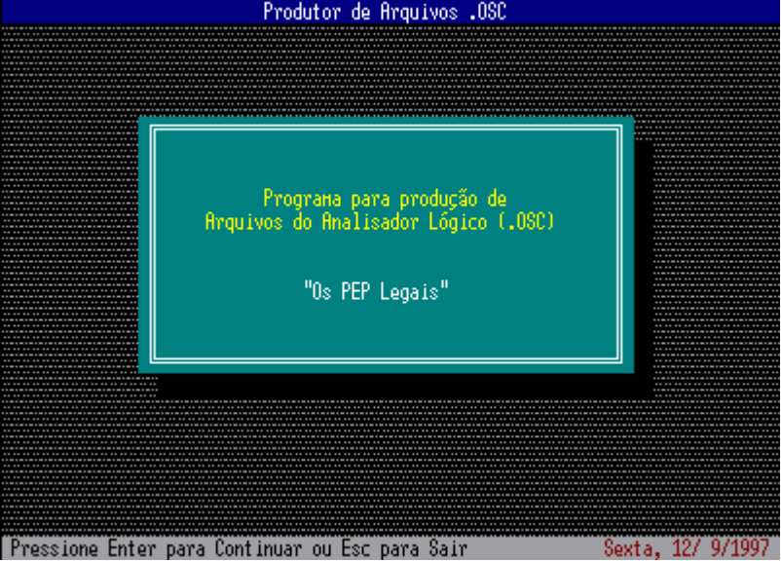

MAKEOSC presentation screen . Press ENTER.

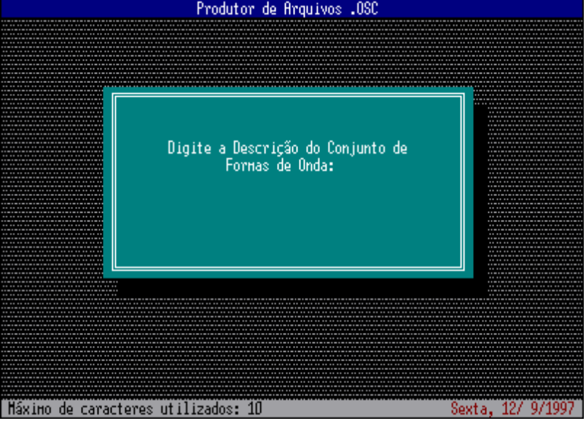

Type description to waveforms group (ex: Counter). Only 10 caracteres in the maximum will be used by MAKEOSC.

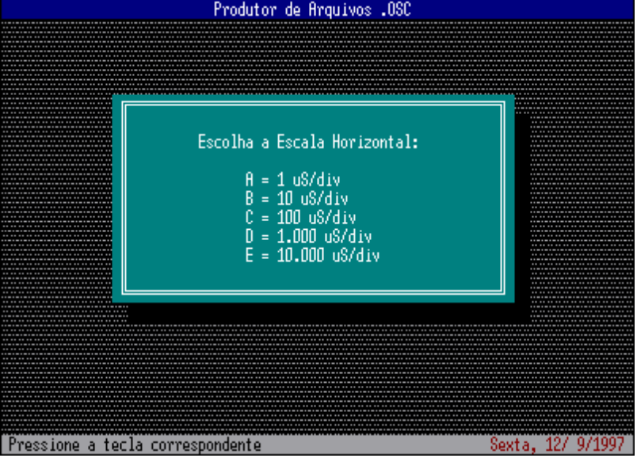

Choose the horizontal scale that wich will be used by MAKEOSC in the waveforms production.

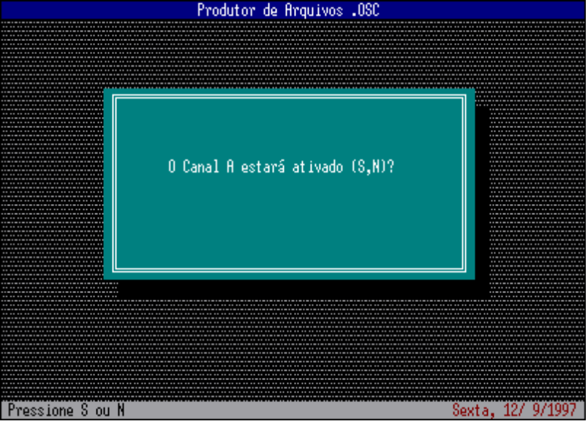

Choose:
Channel A - ON or
Channel A - OFF
(this choose too will must be making to all the other channels).

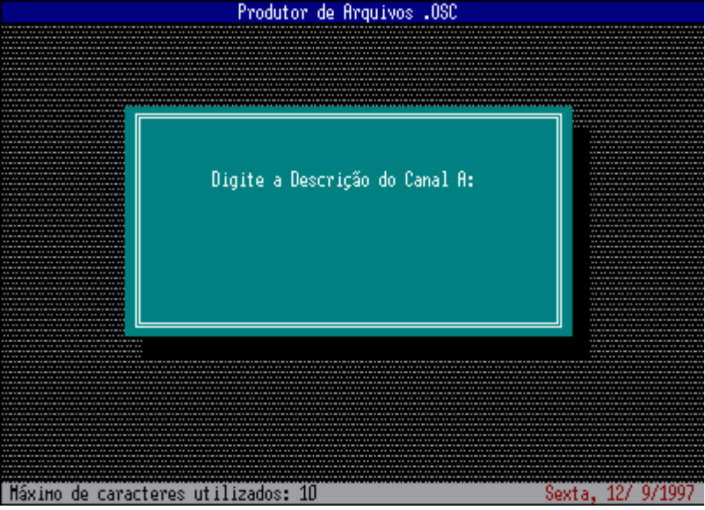

Type a description to the Channel A (Ex: Pin 5). Only 10 caracteres in the maximum will be used by MAKEOSC. This operation will must be repeat to all the channels on.

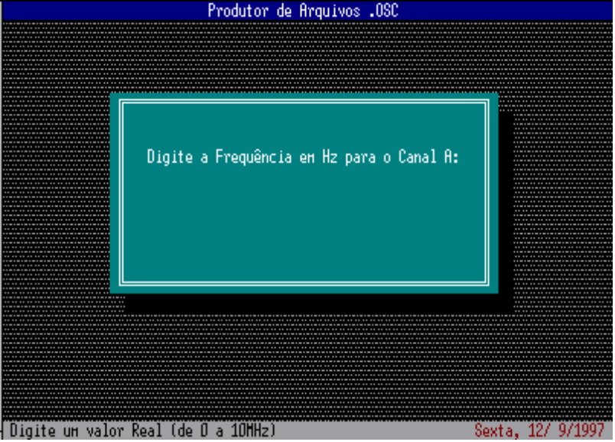

Type the frequency will wish to the channel A ( 0 to 10,000,000 Hz). This operation will must be repeat to all the channels on.

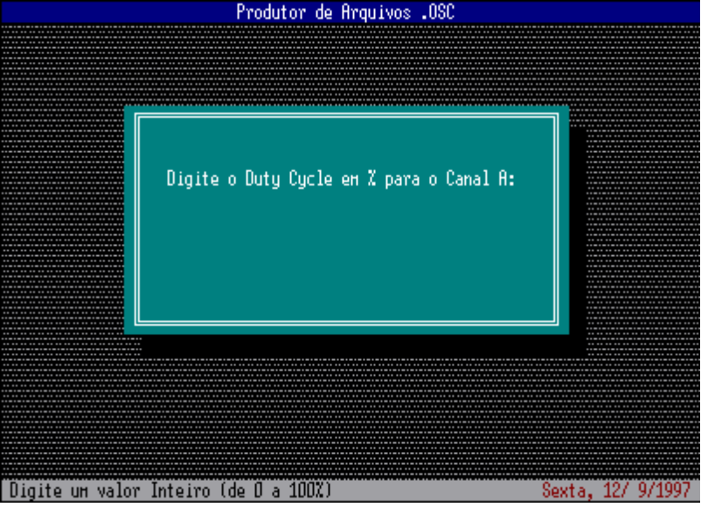

Type the duty-cicle will wish to the channel A (0 to 100%). This operation will must be repeat all the channels on.

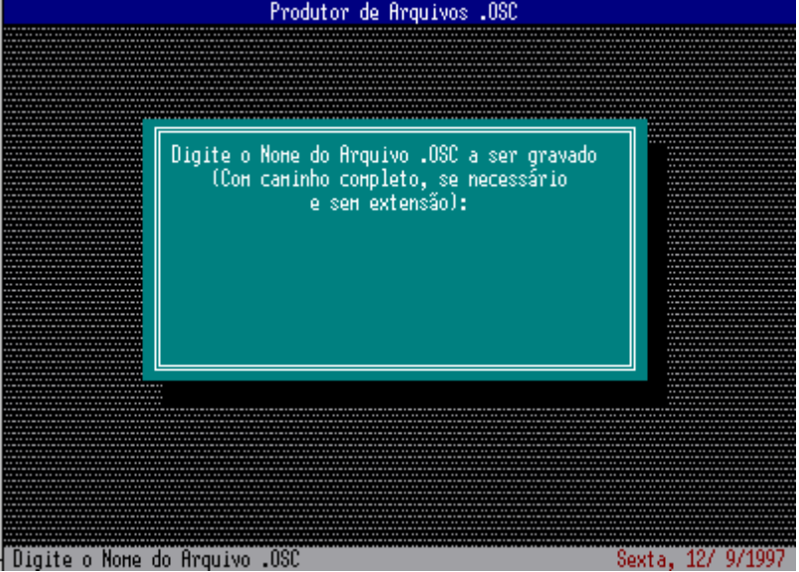

Specified the name to the file will be saving (without extension).

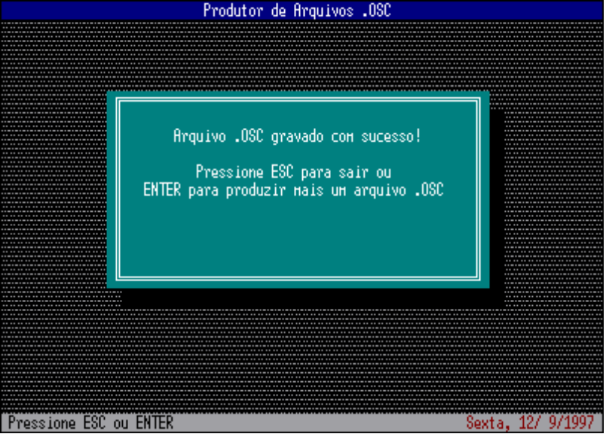

Press ENTER if will wish making other waveform file, or ESC to exit MAKEOSC and come back at MS-DOS.

4.3.5- Logical Analyser Diagnostic -DIAG:

The program provide the communication test between the microcomputer and the Interface, indicating if the connections is corrected and if the parallel port is compatible with the Logical Analyser for PC.

To run DIAG, type in the prompt:

C: [ENTER]

CD\PEPLEG [ENTER]

DIAG [ENTER]

At to be ran, the DIAG, showed the following message:

“OS PEPLEGAIS”

Certifique-se de que a interface está conectada e alimentada!

Pressione Enter quando estiver pronto...

If the interface don’t connected or powered, this make now and press ENTER. The following message is showed:

Verificando a Interface...

After any seconds the DIAG showed the test result. If had communication sucess then appear message :

A interface está conectada corretamente!

Encontrada no endereço ....H

Note: ...H is the parallel port address connected in the Interface.

If had any problem in the communication between the microcomputer and the Interface , showed following message:

A interface não foi detectada pelo DIAG!

If this happen, see the chapter refering the troubleshooting in this User’s Manual.

LOGICAL ANALYSER FOR PC

5. TROUBLESHOOTING / ERROR MESSAGES

Messages | Possibles Causes | Possible Solution
Arquivo ..... não encontrado!  or  Não existe o arquivo .... neste diretório! | Don’t is in the directory used by PEPSoftware  The file no exist (was removed) | Change to the PEPSoftware directory  Reinstall the PEPSoftware or get a new copy
A Interface não foi detectada pelo DIAG!  or  A Interface não foi encontrada!  or  A Interface não está conectada corretamente! | Don’t is the Interface powered  The communication cable is wrong connected or defective  The PEPSoftware configuration is incorrect  Don’t is a bidirectional parallel port  The parallel port is defective  The Interface is defective | Connect the Interface power cord in a outlet and turn on  Connect firmly the cable in the Interface communication connector and in the microcomputer parallel port or replace the cable  Run the CONFIG (see the chapter reffering the PEPSoftware Configuration )  The LPT is incompatible with the Logical Analyser. Get a bidirectional parallel port  Consult the microcomputer technical assistance  Contact “The PEP Legais”-LAO-4ªR Electronics
Ocorreu um Erro Fatal de Leitura/Gravação na unidade corrente  or  Houve um Erro Fatal de Gravação no Disco de Destino!  or  Disco está protegido contra gravação! | Disk is write protected  Exist lost clusters or defectives sectors in the disk | Remove the protection and repeat the operation  Run a disk reparation utility (how Scandisk or Norton Disk Doctor)
O Arquivo especificado já existe! | Already exist a file with this name | Specified other file name or replace the existent
Houve um erro na inicialização do modo Gráfico! | Don’t is in the directory used by PEPSoftware  The graphic mode files no exist (was removed)  The Hardware graphics is incompatible with the Logical Analyser | Change to the PEPSoftware directory  Reinstall the PEPSoftware or get a new copy  Verify the microcomputer manual and the system requeriments list (chapter 2)
Houve um erro na abertura do arquivo!  or  Houve um erro na gravação do arquivo! | Don’t is the file name specified valid  Exist lost clusters or defectives sectors in the disk | Specified a valid file name (for more information, see MS-DOS manual)  Run a disk reparation utility (how Scandisk or Norton Disk Doctor)
O formato do arquivo não é válido! | The file specified no have the correct format | Specified other file name
Unkown characters in the screen when run the PEPSoftware | The active Code Page isn’t brazilian (PC 850) | For more informations, see the MS-DOS manual
Runtime error # .... | Unkown Error | Reinstall the PEPSoftware or get a new copy

