

USB Flash / EPROM Programmer

https://usbflashprog.robsonmartins.com

Specifications

Version 0.1 - Revision E

Author: Robson Martins (https://www.robsonmartins.com)
History

Revision | Date | Changes
E | Apr. 23, 2022 | CPU changed to Raspberry Pi Pico. Updated diagrams. Removed PT_BR translation.
D | Feb. 02, 2001 | Added firmware project.
C | Dec. 27, 2010 | Added adapter connectors pin-out.
B | Mar. 03, 2010 | New Block Diagram.
A | Jan. 28, 2010 | Initial Version.

Contents
1. Introduction 4
2. Requirements 4
3. Hardware Platform 5
3.1. Block Diagram 5
3.2. Functional Description 6
3.2.1. Main CPU 6
3.2.2. Power Supplies 6
3.2.3. Programmer Busses 6
3.2.4. Busses Interfaces 7
3.3. Adapter Connector Pin-Out 7
3.3.1. Parallel Adapter Connector 7
3.3.2. Serial Adapter Connector 9
4. Firmware Project 10
4.1. Block Diagram 10
Appendix A – Development Environment 11

Introduction
The purpose of this board is to allow the programming, reading and verification of writable/rewritable memory devices, such as EPROM, EEPROM, Flash, SRAM, NVRAM – those with parallel bus as well as serial ones (I2C, SPI, Microwire, LPC).
In a future release, programming of some microcontroller families (eg. Microchip PIC, or 8051) may also be supported, via firmware and software upgrade.

Requirements
- Allow write, read, delete, get ID and information about supported chips.
- Support parallel and serial devices (no microcontrollers in initial version).
- Support SRAM, EPROM, E2PROM, Flash, NVRAM, Hub/LPC devices (parallel and serial, including Microwire, I2C, SPI).
- Provide two sources of programming voltage: VDD (low voltage) and VPP/VEE (high voltage for write/erase), in the range between 3.3 V and 6.8 V (VDD), and between 12V and 25V (VPP/VEE).
- Automatic control for VDD and VPP/VEE voltages, according to the chip to be programmed.
- Allow jumperless chip configuration (by software chip selection).
- Socket for adapters – for each package or family of supported chips (no ZIF socket on the programmer board).
- Algorithms for chip read/write operations must be loaded on the main board of the programmer through ‘scripts’, avoiding the use of processing by software running on the PC.
- Connection with PC via USB port, using a specific software for communication.
- Multi-platform software, compatible with Microsoft Windows® or GNU/Linux® operating systems, under 32 or 64 bits (if possible, Apple MacOSX® and FreeBSD versions can be available).
- Some compatibility with existing programmers adapters:
  - EzoFlash+ (http://www.ezoflash.com/).
  - MPSP (https://mpsp.robsonmartins.com).

Hardware Platform

Block Diagram
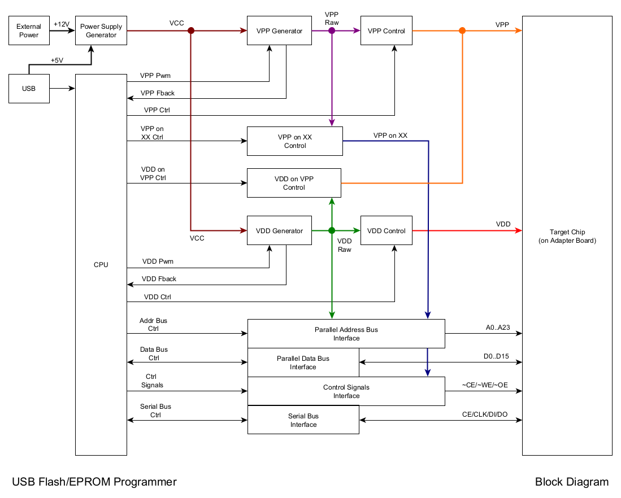

Functional Description

Main CPU
The CPU used in this programmer will be a Raspberry Pi Pico Module (with a RP2040 processor and USB support). This module has a dual core ARM Cortex-M0+ running at 133MHz, 256KB of SRAM and 2MB of storage, a USB port, required for communication between the programmer and the PC, plus one A/D converter with 3 inputs and 16 PWM channels (that can be used to generate the programming voltages). Moreover, there is a serial communication port (SPI / Microwire / I2C) that can be used for programming of serial devices, and GPIO pins to control parallel bus and signals.

Power Supplies
To generate the programming voltages (VDD and VPP/VEE), the programmer must have two DC/DC converters, driven by the PWM outputs of the CPU and monitored through of the ADC inputs.
Both the CPU and the two DC/DC converters will be powered by voltage supplied by USB port (5V), and/or by external power supply connector.
The CPU can turn on or off the VDD / VPP / VEE outputs, or supply VDD voltage on VPP line (via the “VDD on VPP” signal).

Programmer Busses
For handle parallel devices, the programmer must provide the following busses and signals to the target chip:
- Address Bus (A0..A23) – A addressing bus with 24 bits wide, allowing access up to 16777216 positions (16M).
- Data Bus (D0..D7 / D8..D15) – A data bus with 8 or 16 bits wide, allowing access for one byte (8 bits) or one word (16 bits), according to the memory width.
- Control Lines (~CE / ~WE / ~OE) – Chip Enable, Write Enable e Output Enable.
- Power and Programming Voltages (VDD / VPP / VEE) - Voltages used to power-up (VDD), program (VPP) or erase (VEE) the memory.
For handle serial devices, the programmer must provide the following signals to the target chip:
- Clock (CLK) – Clock line for synchronize the communication with the target memory.
- Data Input (DIN) – For read data from target memory.
- Data Output (DOUT) – For write data to target memory.
- Control Lines (~CE / ~WE / ~OE) – Chip Enable, Write Enable e Output Enable.
- Power and Programming Voltages (VDD / VPP / VEE) - Voltages used to power-up (VDD), program (VPP) or erase (VEE) the memory.

Busses Interfaces
To connect the microcontroller busses to target chip, is necessary adapt the voltage levels of the CPU (5V) and the voltage levels of the target chip (3.3V <= VDD <= 6.8V), using an interface circuitry.

Adapter Connector Pin-Out

Parallel Adapter Connector
Female (Top Side)

1 | 3 | 5 | 7 | 9 | 11 | 13 | 15 | 17 | 19 | 21 | 23 | 25 | 27 | 29 | 31 | 33 | 35 | 37 | 39 | 41 | 43 | 45 | 47
2 | 4 | 6 | 8 | 10 | 12 | 14 | 16 | 18 | 20 | 22 | 24 | 26 | 28 | 30 | 32 | 34 | 36 | 38 | 40 | 42 | 44 | 46 | 48

Pin | Function | Description
1 | D0 | DATA BUS – BIT 0
2 | D1 | DATA BUS – BIT 1
3 | D2 | DATA BUS – BIT 2
4 | GND | GROUND
5 | D3 | DATA BUS – BIT 3
6 | D4 | DATA BUS – BIT 4
7 | D5 | DATA BUS – BIT 5
8 | D6 | DATA BUS – BIT 6
9 | D7 | DATA BUS – BIT 7
10 | CE | CHIP ENABLE
11 | A10 | ADDRESS BUS – BIT 10
12 | OE | OUTPUT ENABLE
13 | A11 | ADDRESS BUS – BIT 11
14 | A9 | ADDRESS BUS – BIT 9
15 | A8 | ADDRESS BUS – BIT 8
16 | A13 | ADDRESS BUS – BIT 13
17 | A14 | ADDRESS BUS – BIT 14
18 | A17 | ADDRESS BUS – BIT 17
19 | WE | WRITE ENABLE
20 | VDD | VDD VOLTAGE
21 | A18 | ADDRESS BUS – BIT 18
22 | A16 | ADDRESS BUS – BIT 16
23 | A15 | ADDRESS BUS – BIT 15
24 | A12 | ADDRESS BUS – BIT 12
25 | A7 | ADDRESS BUS – BIT 7
26 | A6 | ADDRESS BUS – BIT 6
27 | A5 | ADDRESS BUS – BIT 5
28 | A4 | ADDRESS BUS – BIT 4
29 | A3 | ADDRESS BUS – BIT 3
30 | A2 | ADDRESS BUS – BIT 2
31 | A1 | ADDRESS BUS – BIT 1
32 | A0 | ADDRESS BUS – BIT 0
33 | KEY | KEY TO AVOID CONNECTOR INVERSION
34 | VPP | VPP PROGRAMMING VOLTAGE
35 | A19 | ADDRESS BUS – BIT 19
36 | A20 | ADDRESS BUS – BIT 20
37 | A21 | ADDRESS BUS – BIT 21
38 | A22 | ADDRESS BUS – BIT 22
39 | A23 | ADDRESS BUS – BIT 23
40 | KEY | KEY TO AVOID CONNECTOR INVERSION
41 | D8 | DATA BUS – BIT 8
42 | D9 | DATA BUS – BIT 9
43 | D10 | DATA BUS – BIT 10
44 | D11 | DATA BUS – BIT 11
45 | D12 | DATA BUS – BIT 12
46 | D13 | DATA BUS – BIT 13
47 | D14 | DATA BUS – BIT 14
48 | D15 | DATA BUS – BIT 15

Serial Adapter Connector
Female (Top Side)

1 | 3 | 5 | 7 | 9 | 11 | 13 | 15 | 17 | 19
2 | 4 | 6 | 8 | 10 | 12 | 14 | 16 | 18 | 20

Pin | Function | Description
1 | VPP13 | VPP PROGRAMMING VOLTAGE (13V)
2 | VPP13 | VPP PROGRAMMING VOLTAGE (13V)
3 | VDD5 | VDD VOLTAGE (5V)
4 | VDD5 | VDD VOLTAGE (5V)
5 | GND | GROUND
6 | GND | GROUND
7 | SCK | SERIAL CLOCK
8 | SCK | SERIAL CLOCK
9 | GND | GROUND
10 | GND | GROUND
11 | SDO | SERIAL DATA OUT (TO TARGET SDI)
12 | SDI | SERIAL DATA IN (FROM TARGET SDO)
13 | GND | GROUND
14 | GND | GROUND
15 | VCC | VCC SUPPLY (5V – ALWAYS ON)
16 | VCC | VCC SUPPLY (5V – ALWAYS ON)
17 | WE | CHIP SELECT (WE PROGRAMMER PIN)
18 | WE | CHIP SELECT (WE PROGRAMMER PIN)
19 | GND | GROUND
20 | KEY | KEY TO AVOID CONNECTOR INVERSION

Firmware Project

Block Diagram
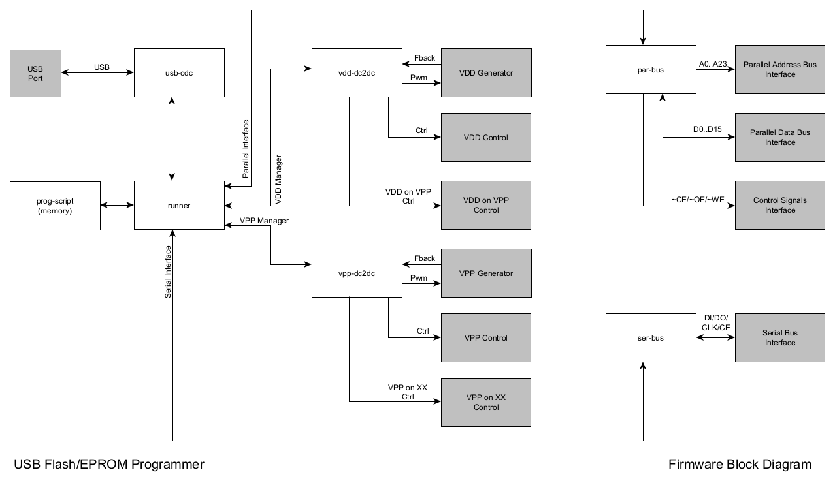
Appendix A – Development Environment
To develop the programmer, should be used only open source and freeware software:
- Operating System:
  - GNU/Linux (https://distrowatch.com/)
- Documentation:
  - LibreOffice (https://www.libreoffice.org/)
  - yEd Graph Editor (https://www.yworks.com/products/yed)
- Hardware Development:
  - CAD:
    - Kicad (https://www.kicad.org)
- Firmware Development:
  - Raspberry Pi Pico Module:
    - Raspberry Pi Pico (https://www.raspberrypi.com/products/raspberry-pi-pico/)
- Software Development:
  - C/C++ Compiler:
    - GCC (https://gcc.gnu.org/)
  - GUI Framework:
    - Qt (https://www.qt.io)
  - IDE:
    - Qt Creator (https://www.qt.io/product/development-tools)
    - Microsoft Visual Studio Code (https://code.visualstudio.com/)
  - Code Documentation:
    - Doxygen (https://www.doxygen.org/)
  - Software Modeling:
    - Umbrello (https://umbrello.kde.org/)
- Version Control System:
  - Git (https://git-scm.com/)

