>> main_Dolichobrachistochrone

Determine sparsity structure

Formatting matrices for the hermite-simpson approximation

Generate finite-difference pertubation vectors

Warning: Error encountered when evaluating const function

> In directCollocation (line 253)

In constraintFunction (line 42)

In checkDynamics (line 29)

In transcribeOCP_eachPhase (line 1604)

In transcribeOCP (line 44)

In solveMyProblem (line 390)

In main_Dolichobrachistochrone (line 31)

约束函数估计出错? No

代码中的  
cosalph = -1/sqrt(lambda_1.^2+1);

写错了，应该是

cosalph = -1./sqrt(lambda_1.^2+1);

x_1 = x(:,1);x_2 = x(:,2);lambda_1 = x(:,3);

beta = u(:,1);

cosalph = -1./sqrt(lambda_1.^2+1);

sinalph = -lambda_1./sqrt(lambda_1.^2+1);

dx(:,1) = sqrt(x_2) .* cosalph + (beta + 1)./2;

dx(:,2) = sqrt(x_2) .* sinalph + (beta - 1)./2;

dx(:,3) = -(cosalph+lambda_1.*sinalph)./(2.*sqrt(x_2));

% Initial conditions for system

problem.states.x0=[1.5 1.5 -2];

% Initial conditions for system. Bounds if x0 is free s.t. x0l=< x0 <=x0u

problem.states.x0l=[1.5 1.5 -10 ];

problem.states.x0u=[1.5 1.5 10];

%------------- BEGIN CODE --------------

boundaryCost = -tf;

%------------- END OF CODE --------------

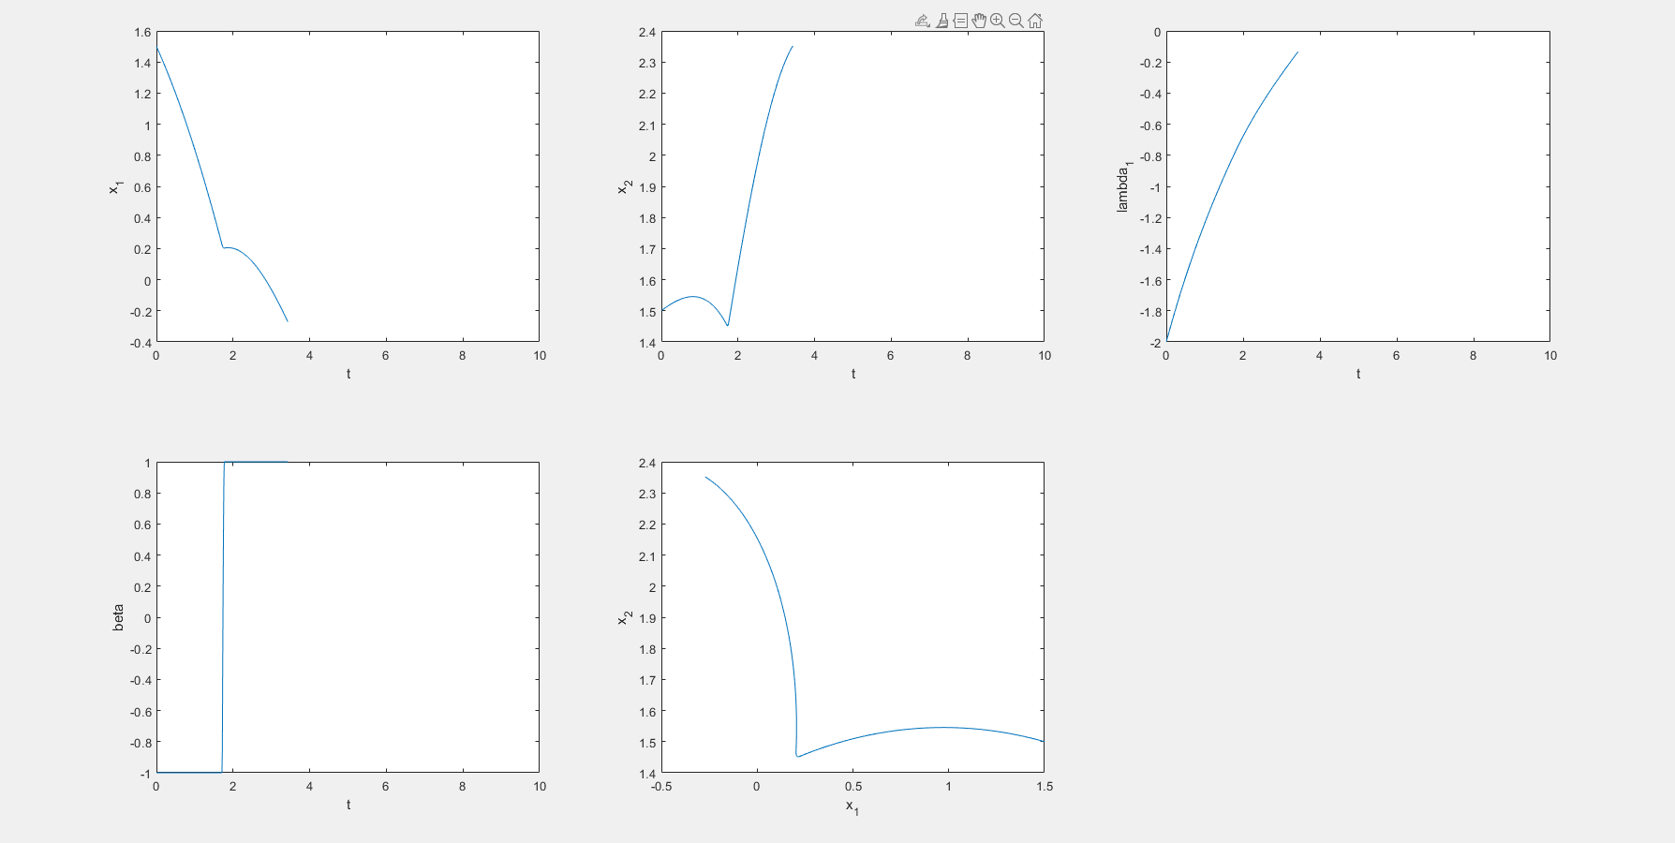

成了，lambda_x1就是大于零的常数。

为什么呢？

% Initial conditions for system

problem.states.x0=[3.5 1.5 -3];

% Initial conditions for system. Bounds if x0 is free s.t. x0l=< x0 <=x0u

problem.states.x0l=[3.5 1.5 -10 ];

problem.states.x0u=[3.5 1.5 10];

%------------- BEGIN CODE --------------

boundaryCost = -tf;

%------------- END OF CODE --------------

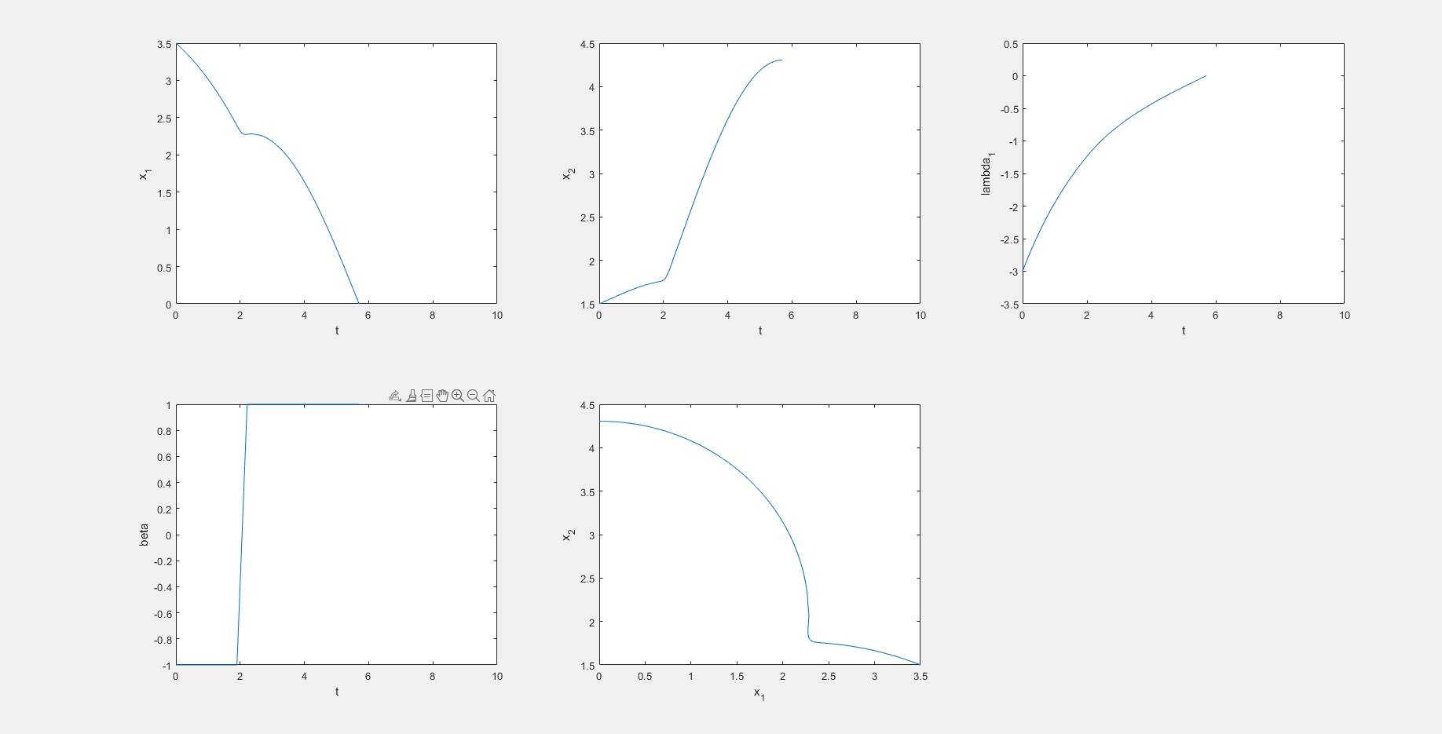

文件保存文 3.mat

% Initial conditions for system

problem.states.x0=[1.5 1.5 -1.5];

% Initial conditions for system. Bounds if x0 is free s.t. x0l=< x0 <=x0u

problem.states.x0l=[1.5 1.5 -10 ];

problem.states.x0u=[1.5 1.5 10];

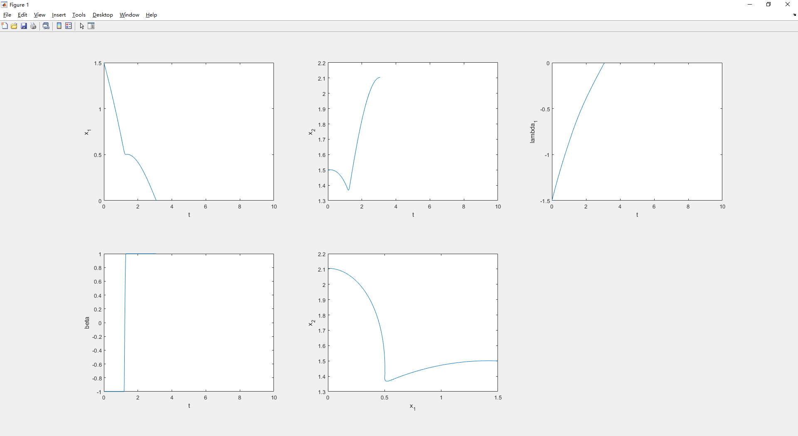

保存文件 2.mat

% Initial conditions for system

problem.states.x0=[0.5 1.5 -1];

% Initial conditions for system. Bounds if x0 is free s.t. x0l=< x0 <=x0u

problem.states.x0l=[0.5 1.5 -10 ];

problem.states.x0u=[0.5 1.5 10];

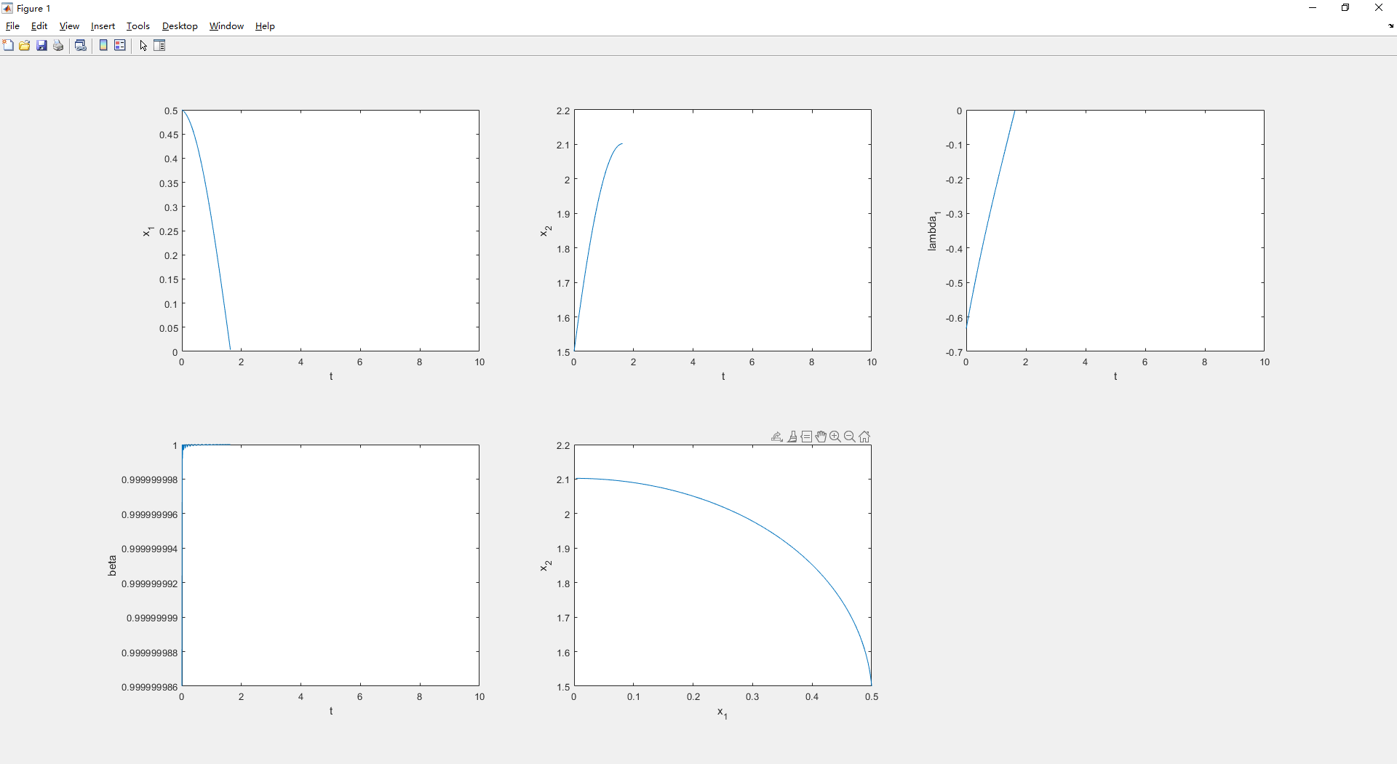

保存工作取 1.mat

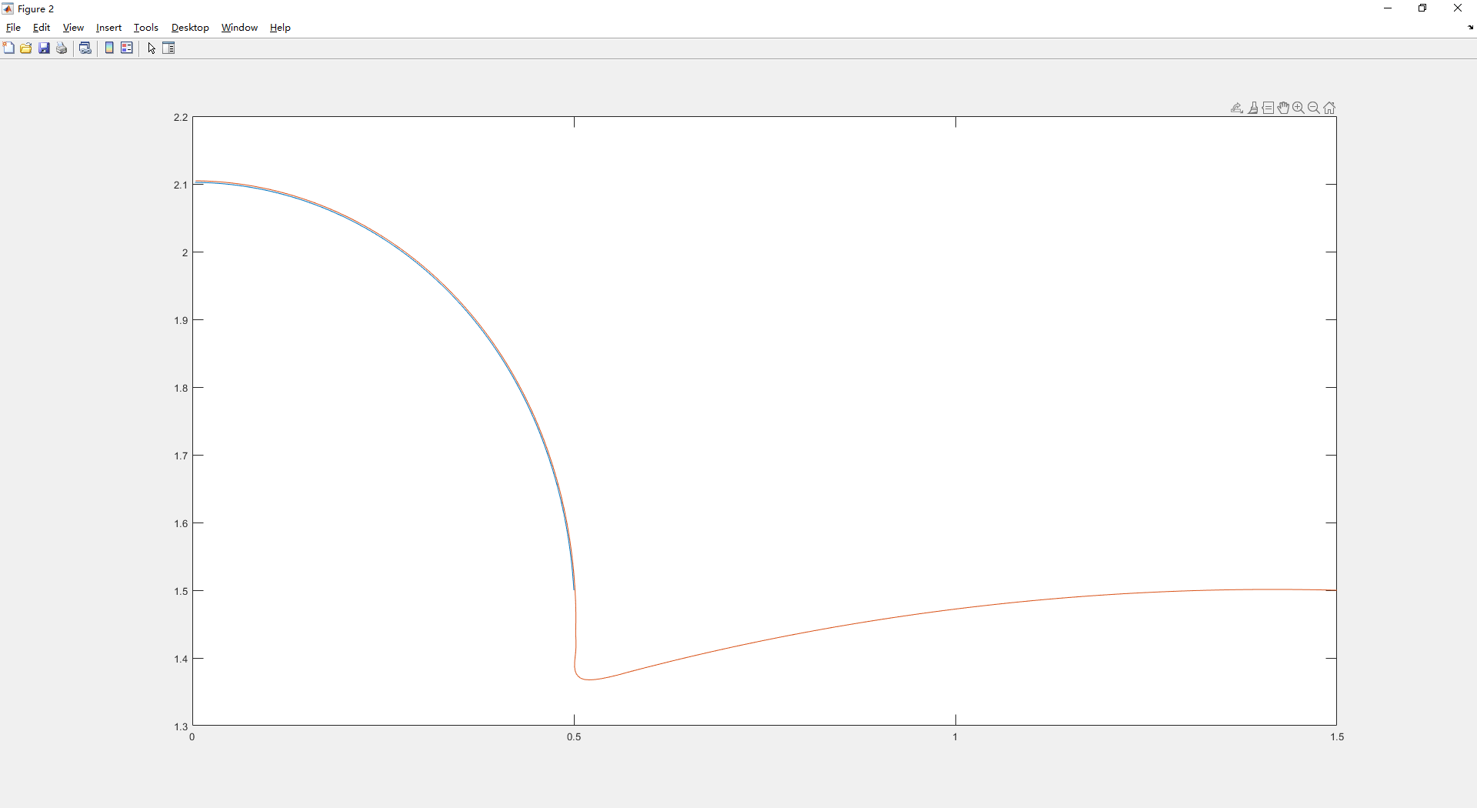

(0.5,1.5) (1.5,1.5)的轨迹发生了重叠

？？？？

修改协态变量解决

% Initial conditions for system

problem.states.x0=[1.5 1.5 -1.25];

% Initial conditions for system. Bounds if x0 is free s.t. x0l=< x0 <=x0u

problem.states.x0l=[1.5 1.5 -10 ];

problem.states.x0u=[1.5 1.5 10];

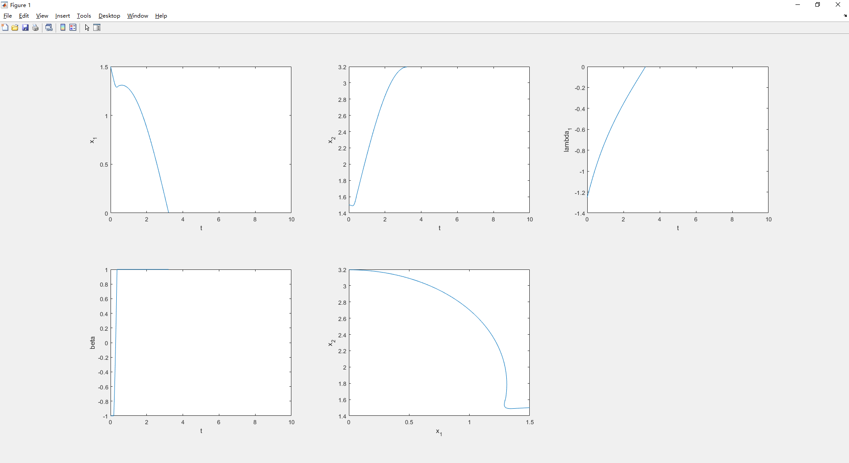

保存workspace 2.mat

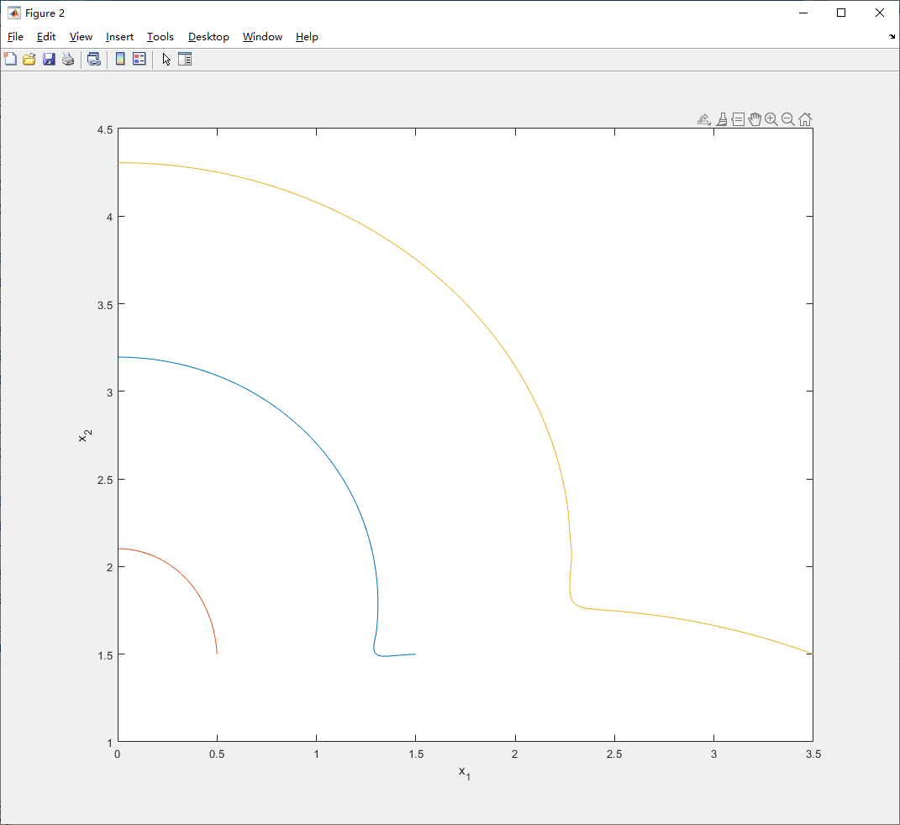

三个图形绘制在一起有。