Grooming Card Interface

Overview and Purpose
The animal grooming business requires one to keep track of a large amount of information. This information includes information for the client that cares for the animal, such as client name, phone number, and preferred veterinarian information, as well as things about the animal itself, such as animal name, rabies shot confirmation, breed, and age, among many other items. In addition to this large quantity of rudimentary information that needs to be kept for bookkeeping purposes, which could reasonably be stored in a spreadsheet, there is also a need to store descriptive or non-discrete information, such as appointment notes (which services are desired per appointment) and notes of a given animal’s behavior during an appointment. This information needs to be more easily readable by an individual groomer at any given time, a contrast to some of the previous set of information. Commonly, all of this previously mentioned information is stored on small individual paper grooming appointment cards, which can then be physically filed away and accessed later. These cards are handier for quick reference for groomers, but are difficult to manage and cumbersome to store.
Thus, we created a digital web application solution named the Grooming Card Interface (GCI). GCI is a simple web application that allows animal groomers to store and view grooming card information in a variety of ways without having to worry about the drawbacks of accessing and managing physical cards. Our application will be lightweight and will work on most modern web browsers, allowing for easy deployment and use by small grooming businesses. It will also include a database back end for long term storage of all the information entered, as well as interface options for viewing the grooming appointment information in a spreadsheet-like format or as a mock grooming card view, satisfying both of the needs of the information previously discussed. The main interface consists of a single page application (SPA) using JavaScript, HTML, CSS, and Bootstrap which calls to a back end Spring Boot application. The back end consists of a variety of REST endpoints that can create new PostgreSQL database information entries, for clients, pets, or appointments, and also retrieve said information. In our finished version, we were able to make a main page for clients, which displays client information in a table format. There are buttons to view pet and appointment information for clients in a modal view card, which also allows one to create pet and appointment information for the client. There is also a grooming card button that allows viewing of the explained card overview of all client, pet, and appointment information, similar to physical paper grooming cards that are often used at grooming shops. We were unable to finish capabilities to update or delete the information, display the information on separate pages, and view vet information.

Requirements
Note: The requirements that were able to be met by the submission of the project are denoted in bold text.
- The interface must be able to display client, animal, and appointment information in tables on separate pages per information set.
- The interface must be able to display client, animal, and appointment information as one modal card that displays in front of the current page view.
- The interface must persist all displayed information in a PostgreSQL database.
- The interface must allow for creating, reading, updating, and deleting client, animal, and appointment information.
- The interface must be able to perform all functions except for database persisting in real-time (within 500 milliseconds).
- The interface must be able to perform any database persisting within 5 seconds.
- The interface front end must be able to run on any modern web browser at the time of the project being released (Firefox, Chrome, Safari).
- The interface must be able to run on Windows or Ubuntu.
- The interface back end web services must use Java Spring Framework.
- The interface back end database must use PostgreSQL.
- The interface back end database must be able to permanently store all persisted information when the application is terminated.
- The interface must include a console log separate from the web browser front end to display descriptions of currently running functions that can be persisted and accessed after the application is terminated.
- The interface front end must use HTML, CSS, JavaScript, and Bootstrap.
- The interface must be able to display and manage the following information:
  - Client Page
    - Name
    - Phone Number
    - Phone Number Alt
    - Vet Name
    - Vet Address
    - Vet Phone
  - Pet Page
    - Client (ID)
    - Name
    - Rabies Shot Up-to-date
    - Breed
    - Age
    - Health Issues
    - Notes
    - Deceased Status
  - Appointment Page
    - Client (ID)
    - Pet (ID)
    - Date
    - Time
    - Notes/Description

What We Learned

Jackie Morrison
I learned a lot about front end web design during this project. I was able to successfully implement a single page application front end view that used modals in front of the view to display information dynamically without having to reload the page. I also learned how to efficiently modify the DOM using JavaScript to create new page elements using event listeners and actions. I also learned how to gather form data using actions from buttons. I was able to use Bootstrap and CSS to style and format web page components. I also learned how to use HTTP request to retrieve information from REST endpoints in an asynchronous manner. I learned how to design wireframes for websites.

Robert Stonner
I learned how to start a Spring Boot project from scratch. I learned how to set up a CRUD repository using Spring JDBC, and how to connect a DAO to an actual database one the same system. I learned how to serialize and deserialize JSON data into objects in Java and vice versa in order to effectively utilize said data in either JavaScript or Java parts of the application. I was able to make an application interface that allowed for a database to be added to and queried from using only a set of custom endpoints. I also learned how to manage front end web page content to be displayed from within Spring Boot using configuration classes. I also learned general project management skills.

Site Wireframes

Main Page (Client Table)
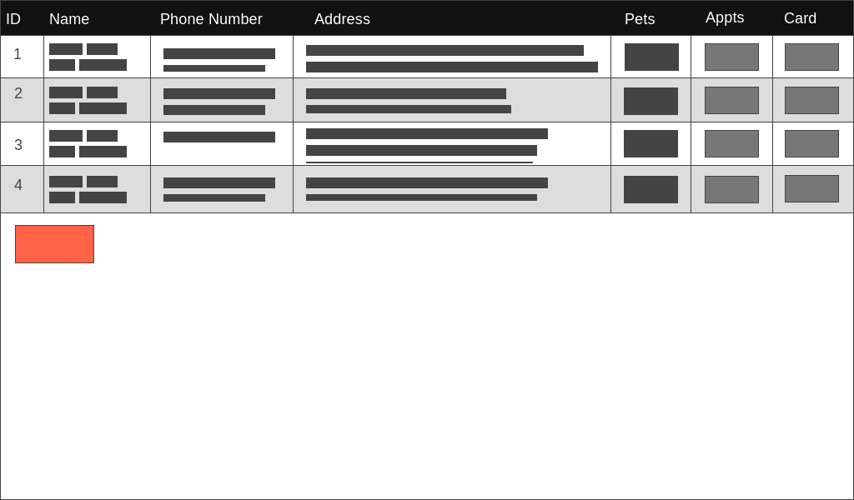

Grooming Card View
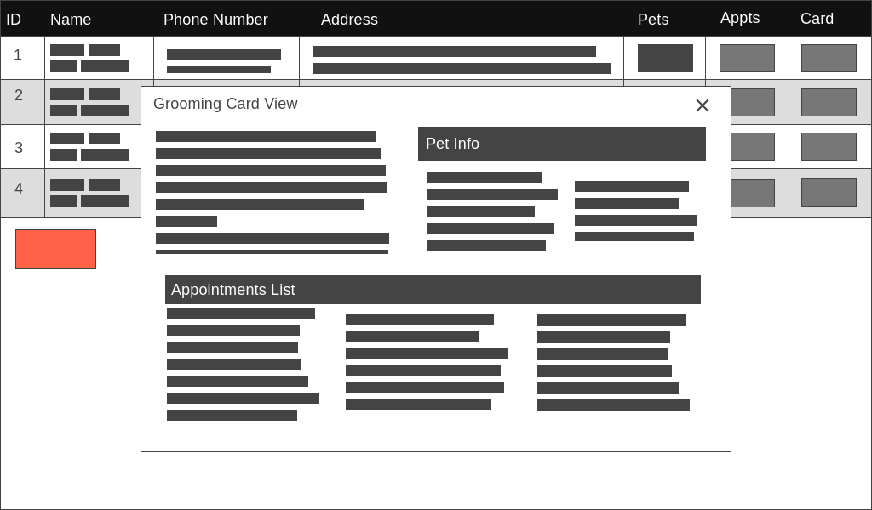

Add Pet/View Pet View
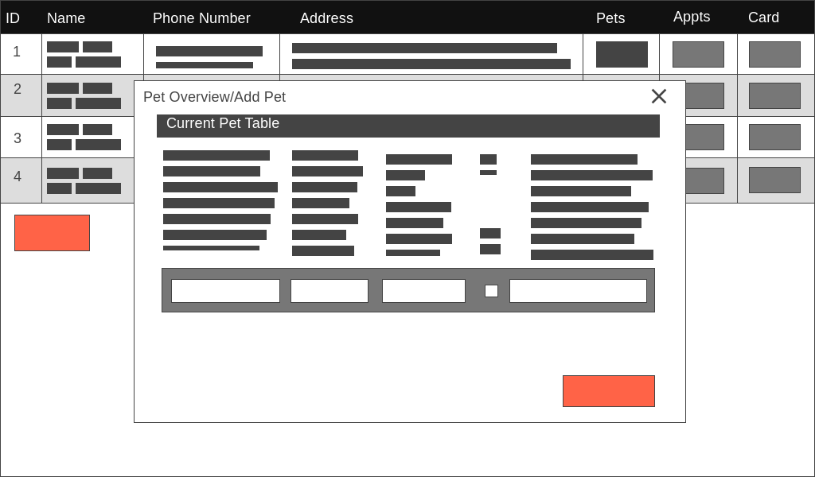

Add Appointment/View Appointment View
