***Directions:* *Provide Snippets of your code below and the interface based off the problem given to you.***

1. Create an application that allows the user to select one deck from a form, one truck assembly from a form, and one wheel set from a form. The application should also have a form that allows the user to select any miscellaneous product, using check boxes. The application should display the subtotal, the amount of sales tax (at 6%), and the total of the order. Do not apply sales tax to assembly.

Have a button that can clear the miscellaneous information, a reset button that clears everything, and an exit button to exit the program

**Details:**

The skateboard shop sells the following skateboard products:

|  |  |
| --- | --- |
| *Decks:*  The Master Thrasher = $60.00  The Dictator of Grind = $45.00  The Street King = $50.00 | *Truck Assemblies:*  7.75 axle = $35.00  8 axle = $40.00  8.5 axle = $45.00 |
| *Wheel Sets:*  51 mm= $20.00  55 mm = $22.00  58 mm = $24.00  61 mm = $28.00 | *Miscellaneous Products:*  Grip Tape = $10.00  Bearings = $30.00  Riser pads = $2.00  Nuts & bolts kit = $3.00  Assembly = $10.00 |

**User Interface:**

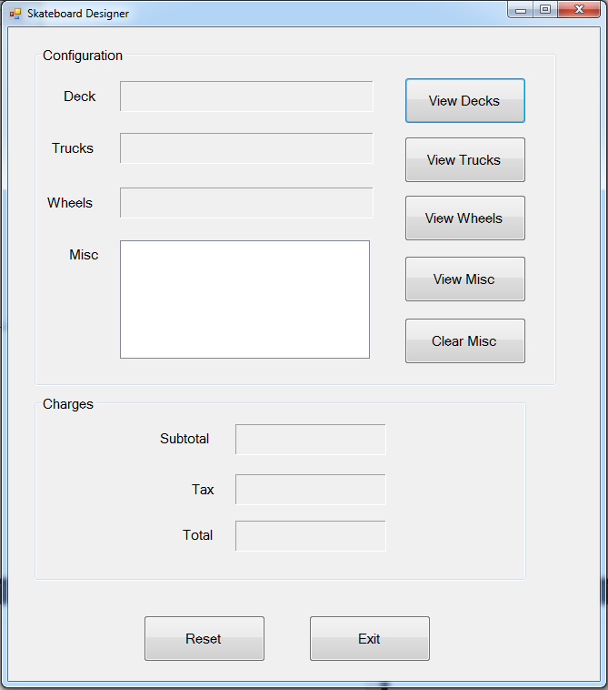

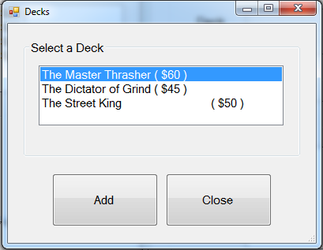 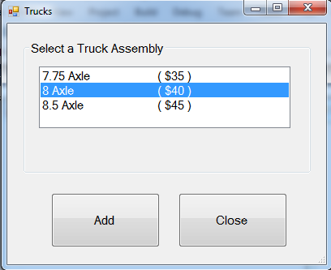

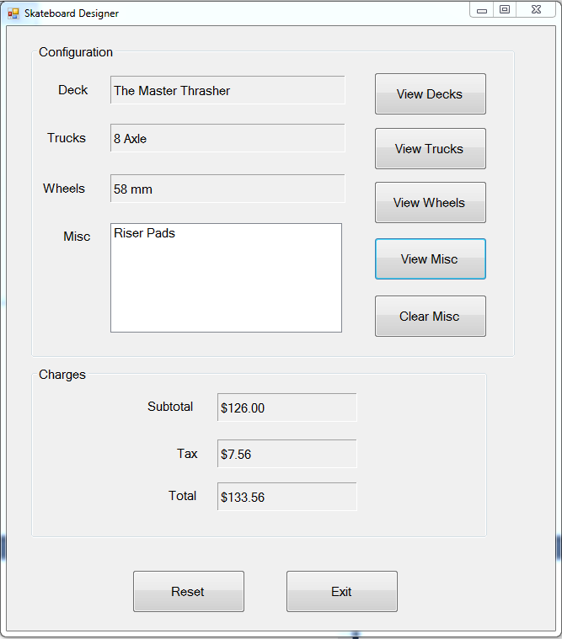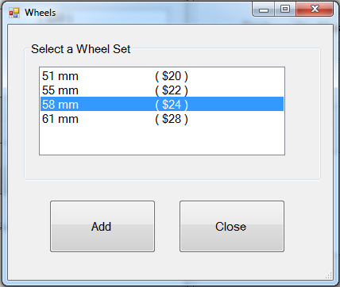 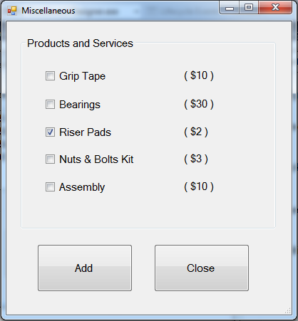

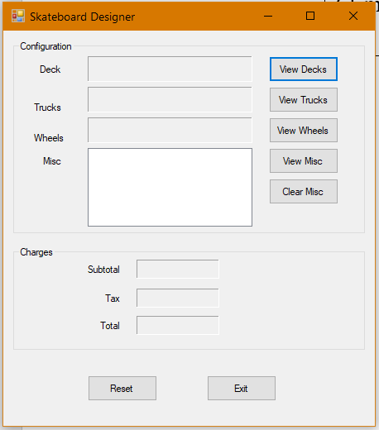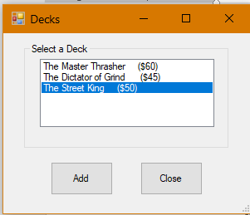

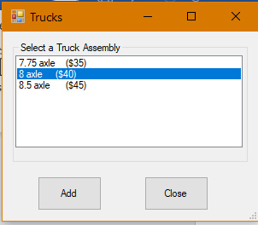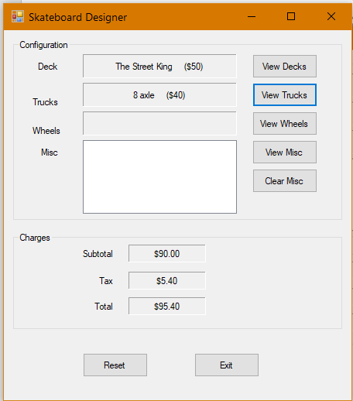

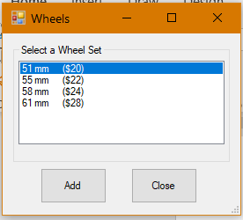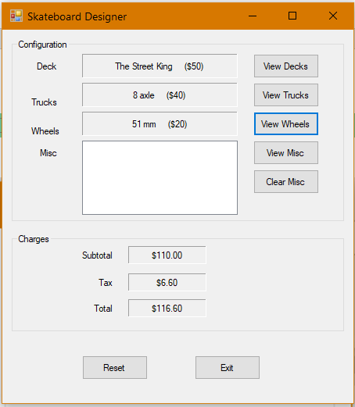

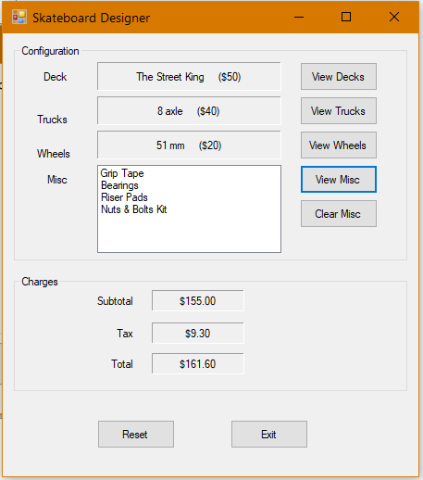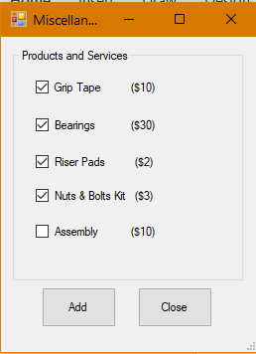

Hitting Reset and then adding Grip Tape and Assembly to show that Assembly does not get charged taxes.

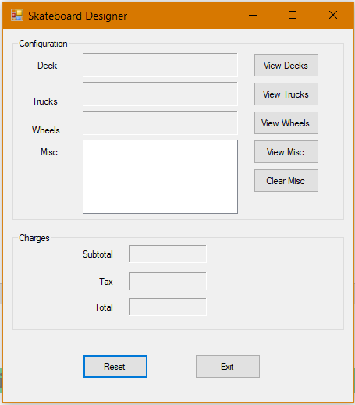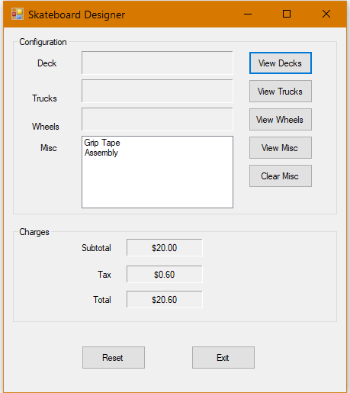

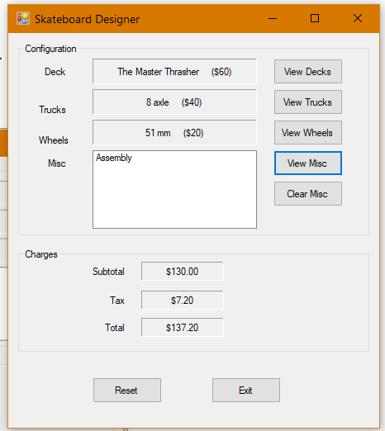

I created 2 modules. One for storing most of the global variables and another for the string variables and their functions:

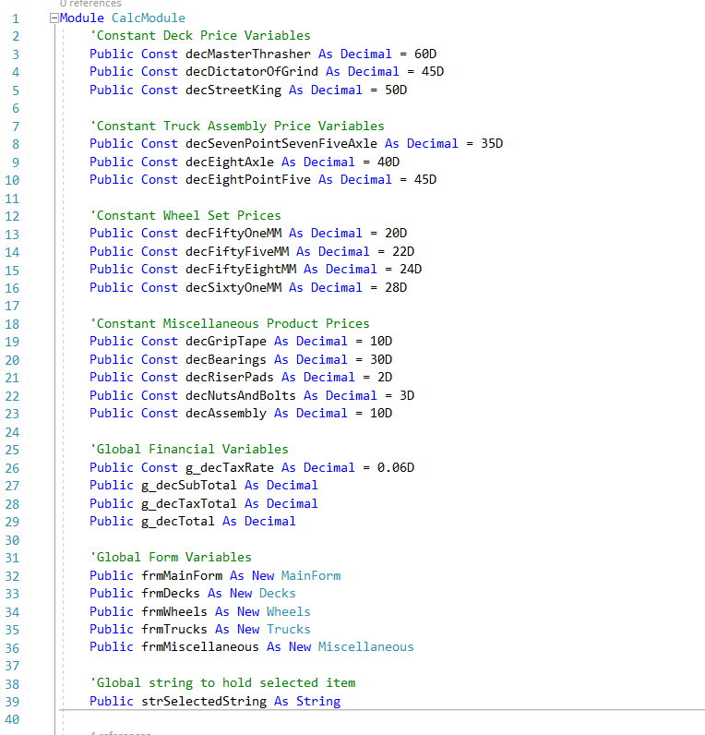

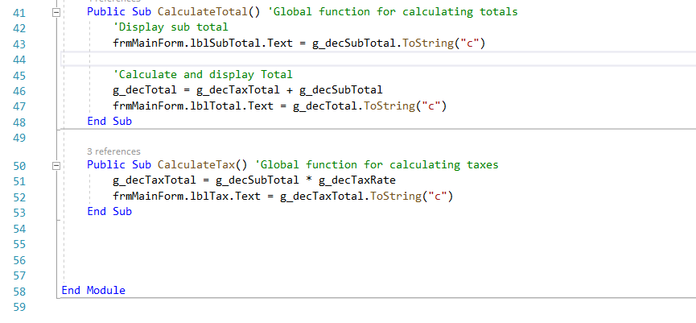

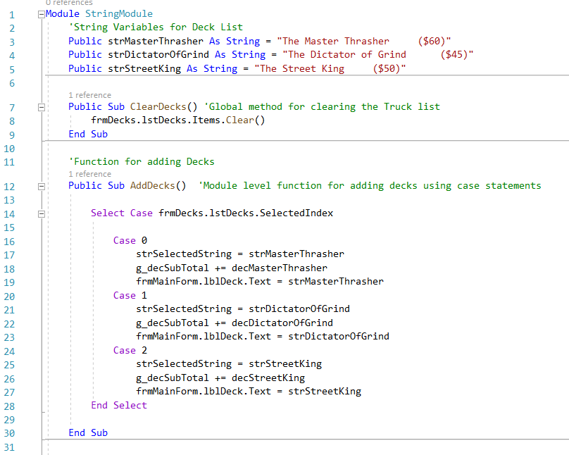

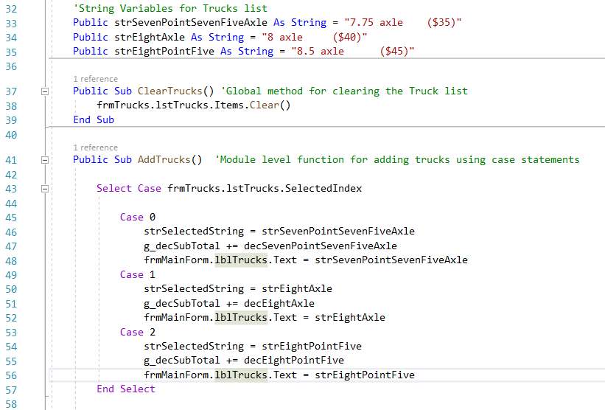

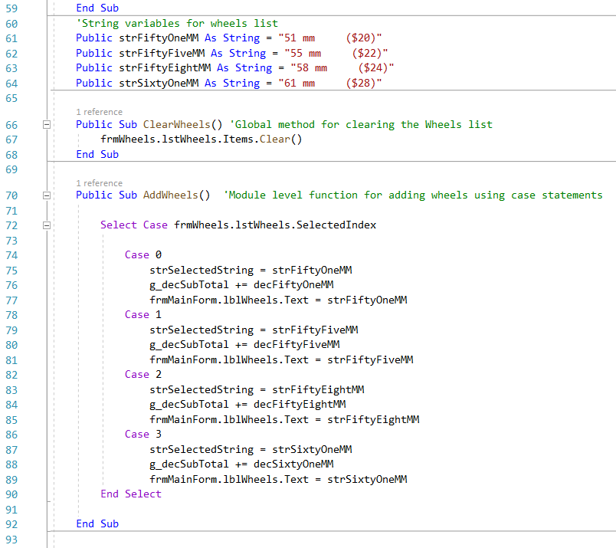

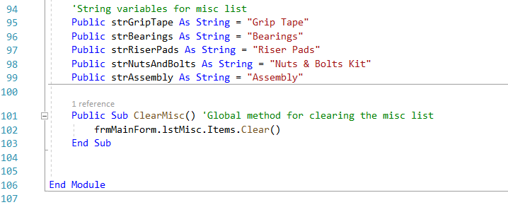

MainForm

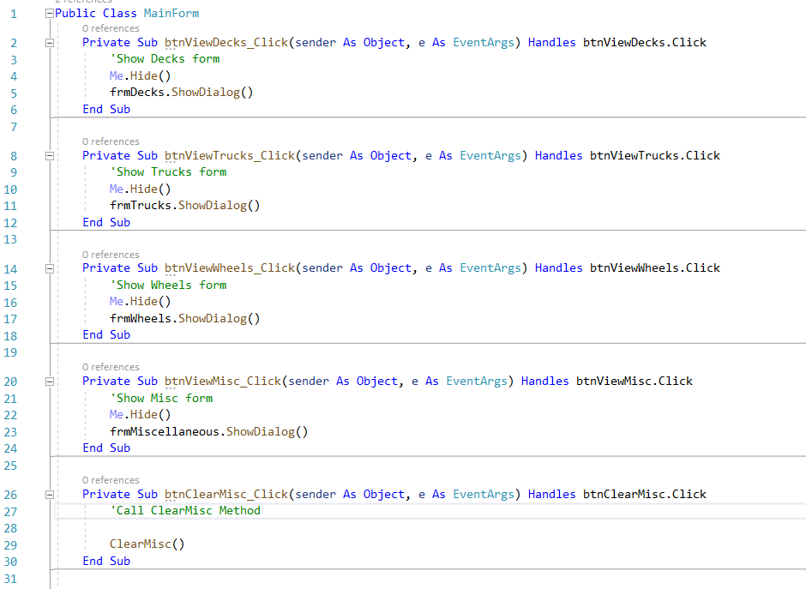

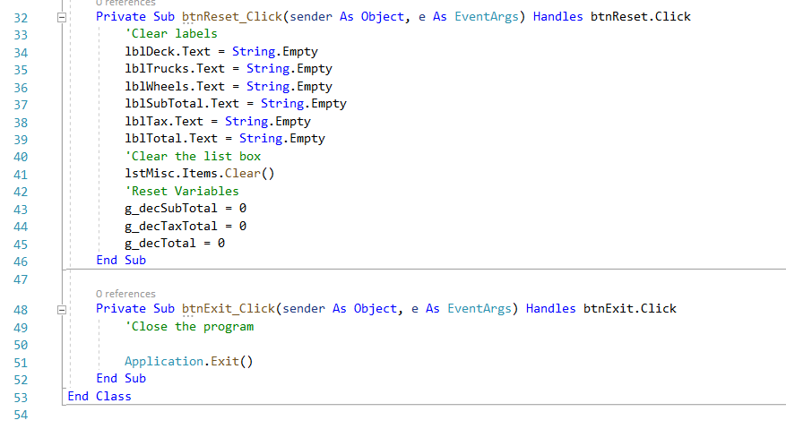

Decks

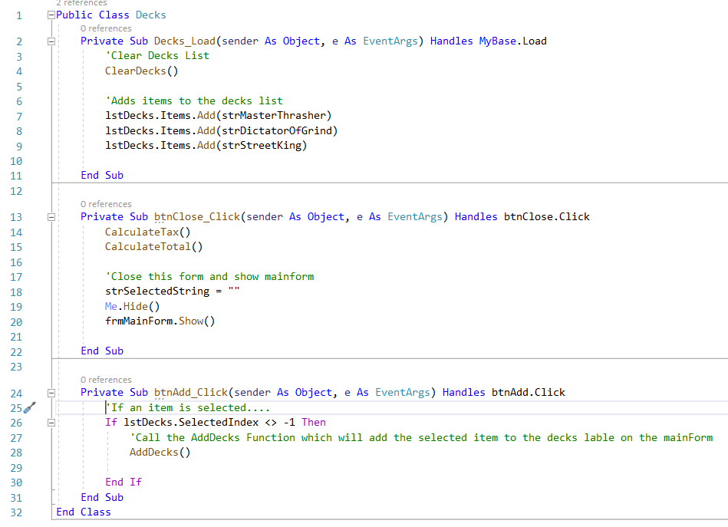

Trucks

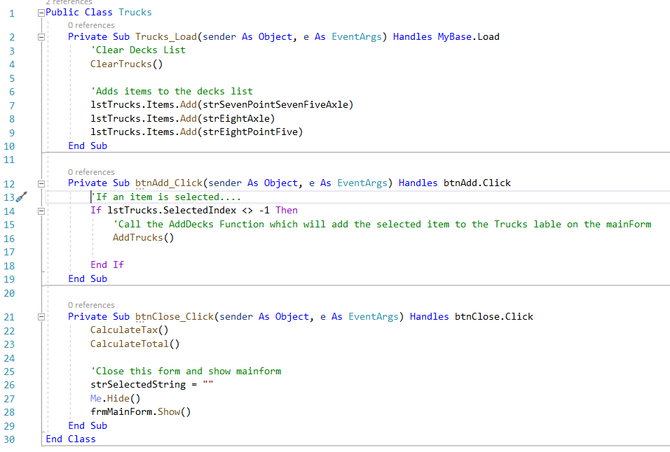

Wheels

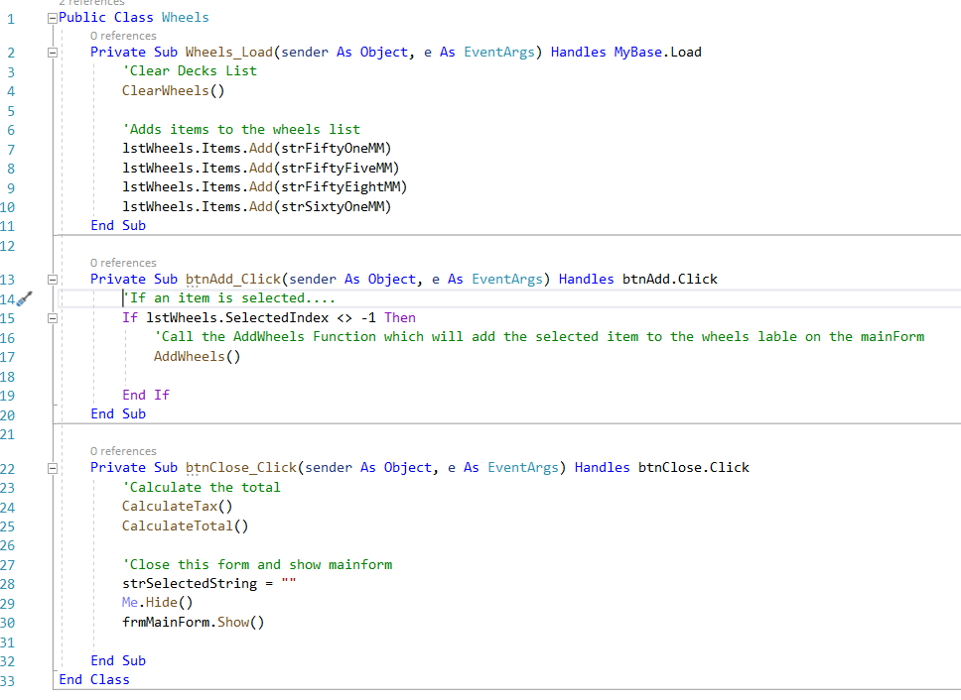

Miscellaneous

