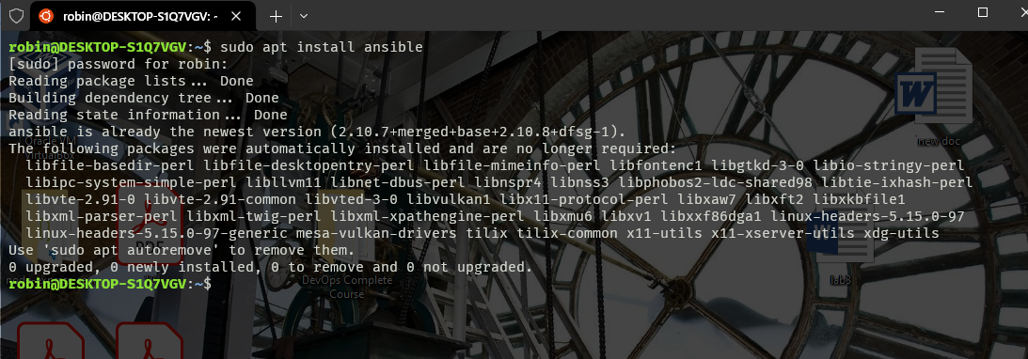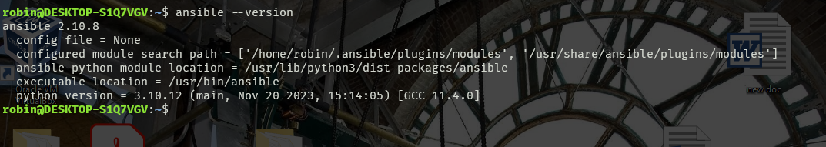

SHA256:L0MQKP8vOcP3Tj0+UaiPQYdVEBDmEUncl+BgVsDD8Z8 robin@DESKTOP-S1Q7VGV