Connecting to private Ec2 Instances using Systems Manager

Projects Descriptions:
- Leverage the Power of AWS Systems Manager:
Use AWS Systems Manager to establish connections between instances in the private subnet without the need for a keypair
- Utilize the Architecture From Our Previous Project:
Incorporate the architecture we previously built. For reference, please check our previous post: Previous Project Post: https://www.linkedin.com/posts/rogmer-bulaclac_project-file-activity-7144285021472796672-Cvm4?utm_source=share&utm_medium=member_desktop
- Reference Links for This Project:
- https://docs.aws.amazon.com/prescriptive-guidance/latest/patterns/connect-to-an-amazon-ec2-instance-by-using-session-manager.html
- https://dev.to/aws-builders/connecting-to-private-ec2-instances-using-systems-manager-a-hands-on-guide-33m
- Creation of Instances, IAM Roles, and VPC Endpoints Using Terraform:
In this project, utilize Terraform to create instances, IAM roles, and VPC endpoints.

Prerequiestes:
- AWS Acccount
- AWS ACCESS KEY and SECRET ACCESS KEY with administrator ACCESS
- Terraform Must be Installed
- GIT must be Installed
- Text Editor

Instructions:
- Clone project repository:
git clone -b terraform https://github.com/robudexIT/awsdevopsproject.git
- cd to terraform project directory:
cd awsdevopsproject/terraform/vpcpeering/
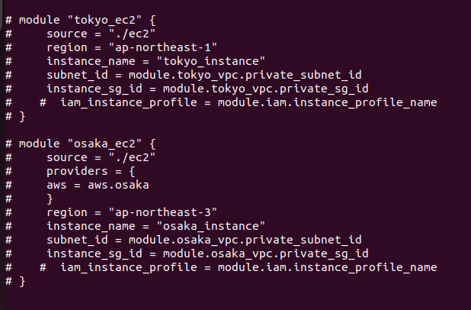
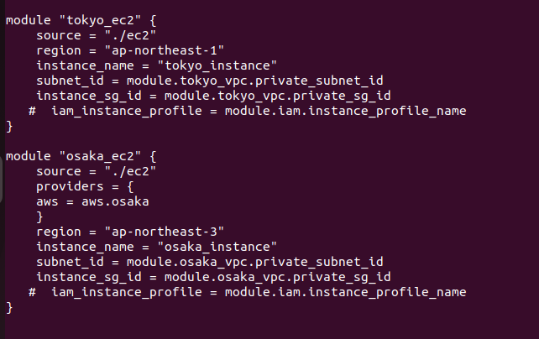
- Open awsdevopsproject/terraform/vpcpeering/main.tf with your chosen text editor. Uncomment the tokyo_ec2 and osaka_ec2 modules, and save the file.
4. Run these commands:
MUST BE LIKE THIS
REMOVE THIS
- terraform init
- terraform validate
- terraform plan
- terraform apply – auto-approve
5. When Terraform completes its execution, open the AWS console in two separate tabs. In one tab, navigate to the Tokyo region, and in the other tab, navigate to the Osaka region. Once there, go to the EC2 section in each region and verify if the instance’s have been successfully created.

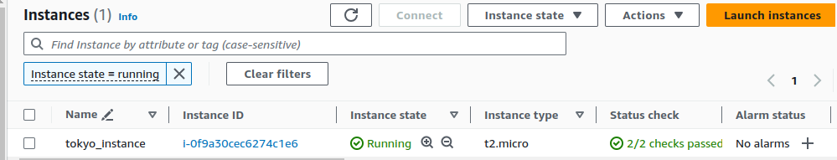
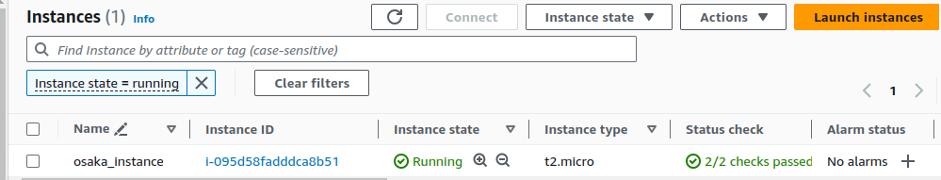

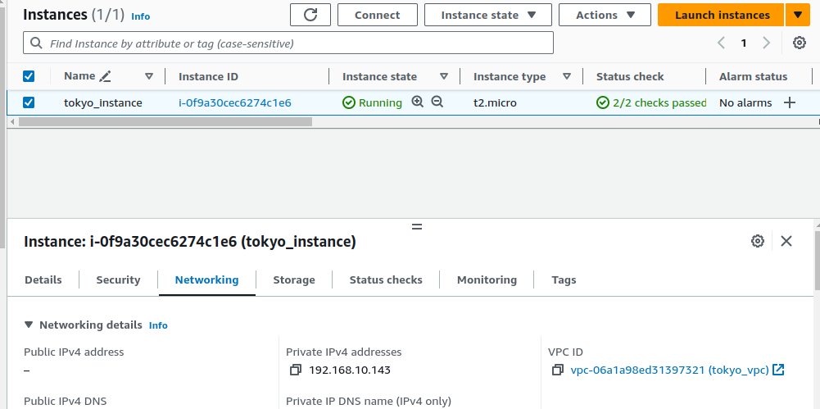
6. Navigate to 'Instance,' then click on 'Networking.' Verify that no public IP is assigned and confirm that the public DNS remains unset

7. Click the connect button the select Session Manager.

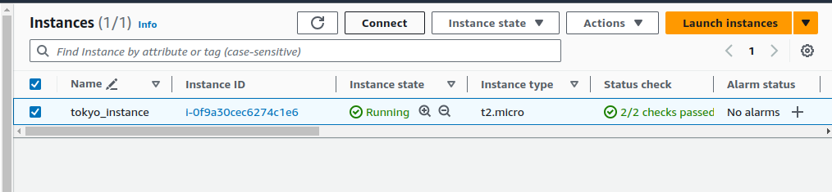
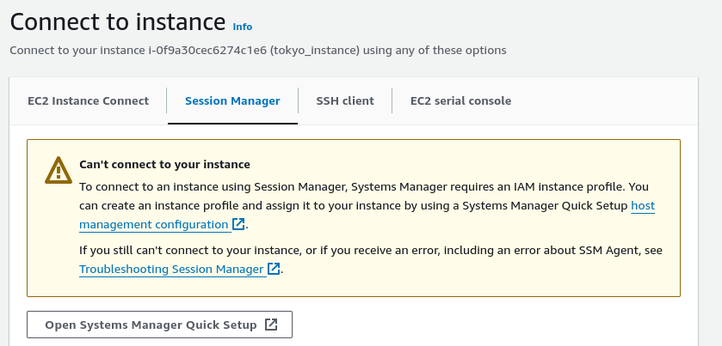
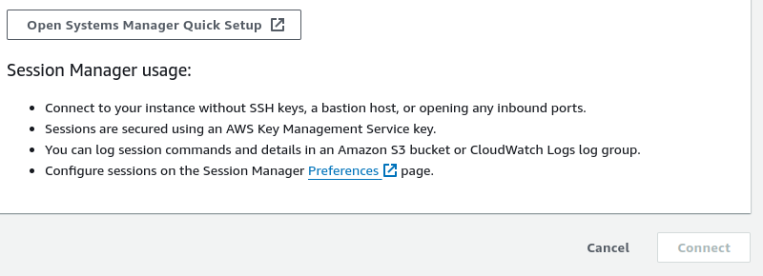
As you notice, the connect button is disable
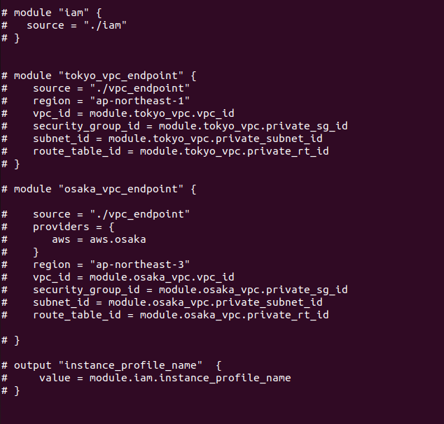
8. Reopen awsdevopsproject/terraform/vpcpeering/main.tf with your chosen text editor. Uncomment the iam, tokyo_vpc_endpoint, and osaka_vpc_endpoint modules, and save the file.
REMOVE THIS
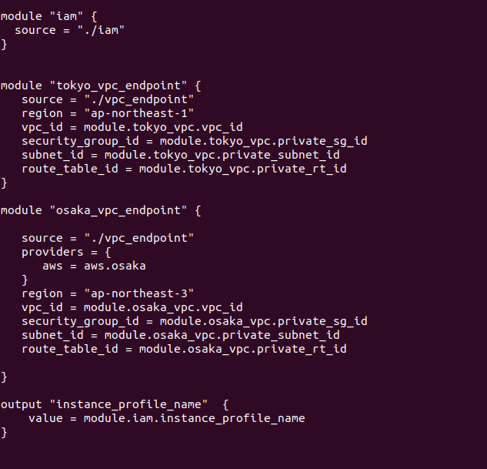
MUST BE LIKE THIS

9. Run these commands:
- terraform init
- terraform validate
- terraform plan
- terraform apply – auto-approve

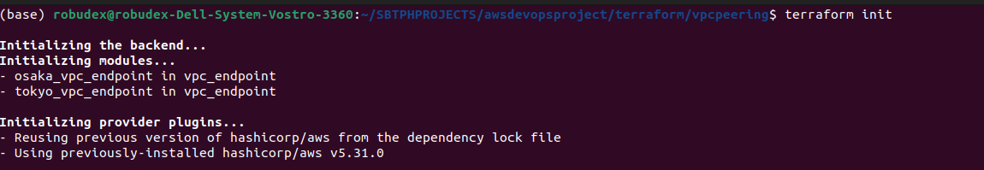
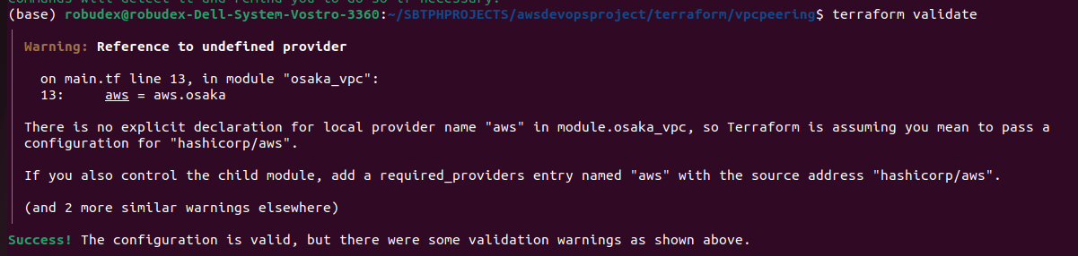

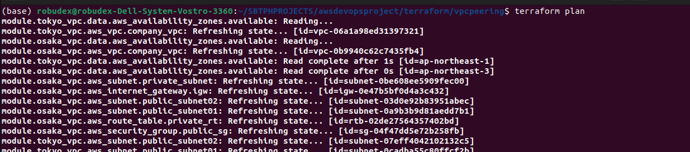
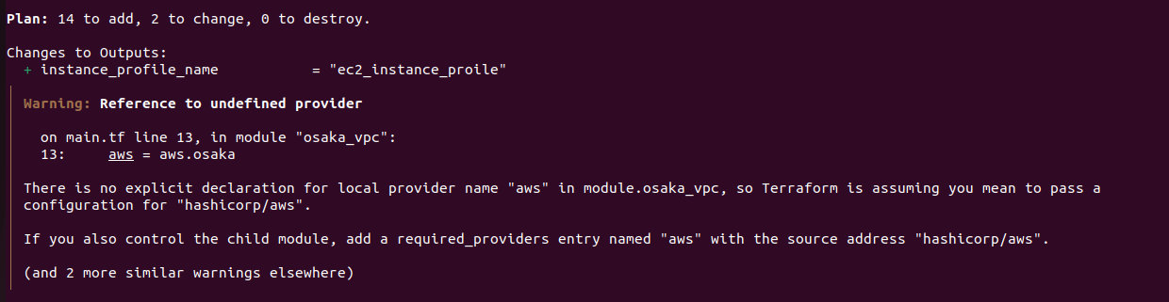
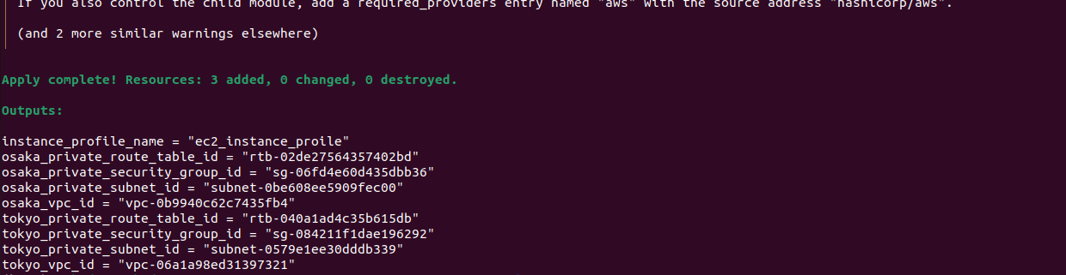
10. When Terraform completes its execution, open the AWS console in two separate tabs. In one tab, navigate to the Tokyo region, and in the other tab, navigate to the Osaka region. Once there, go to the EC2 section in each region. Then Modify IAM role

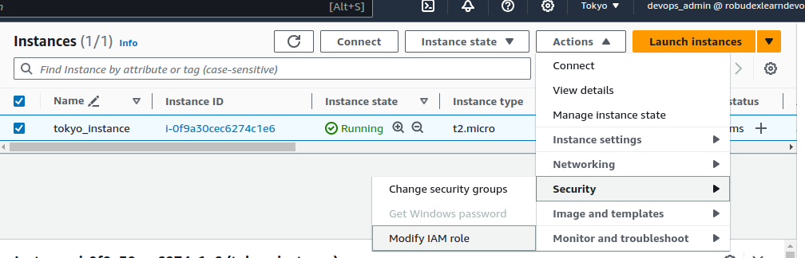

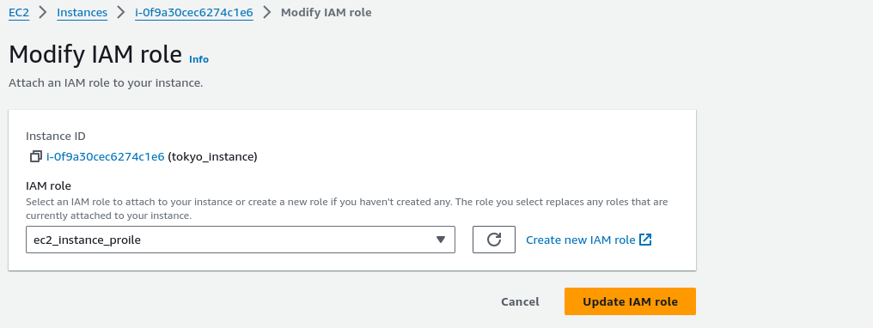
Click connect
Select Session Manager-> Click Connect
Note: Sometimes, the newly updated IAM Role may take some time to take effect. If you don't see a similar result on the screenshot below, refresh the page until it appears as shown in the screenshot.
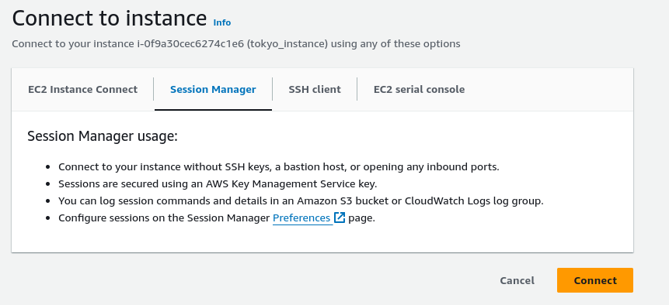
Do similar steps on Osaka Region EC2 Instance.

11. Testing connectivy and Install packages like httpd

Instance Tokyo and Osaksa Instance type (ifconfig)
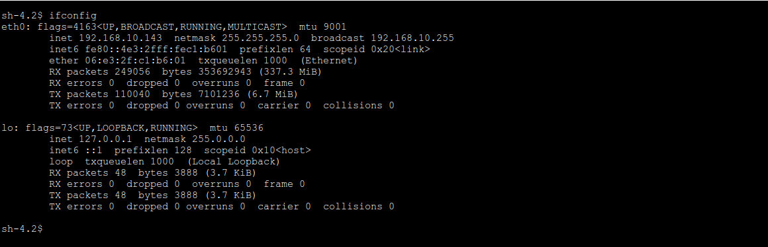
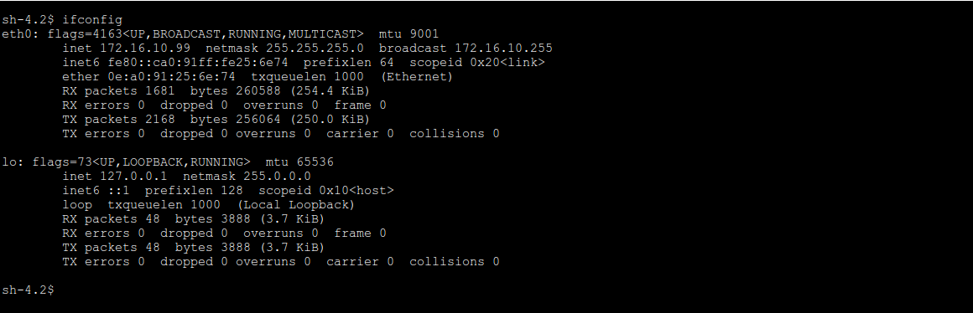
Now, ping the IP address of the Osaka instance from the Tokyo instance, and vice versa
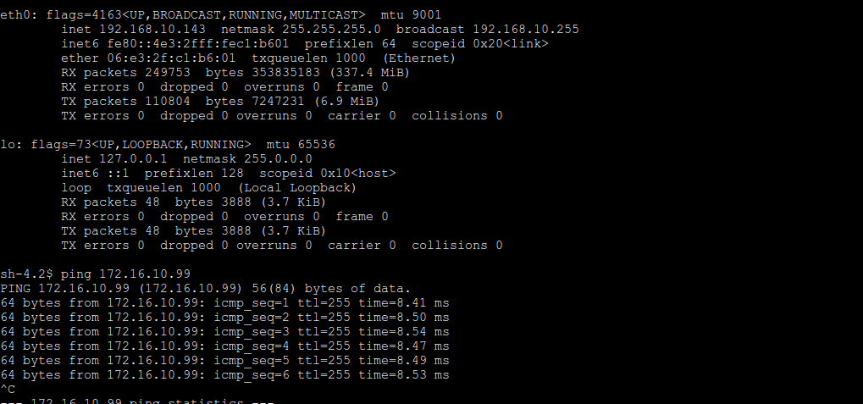
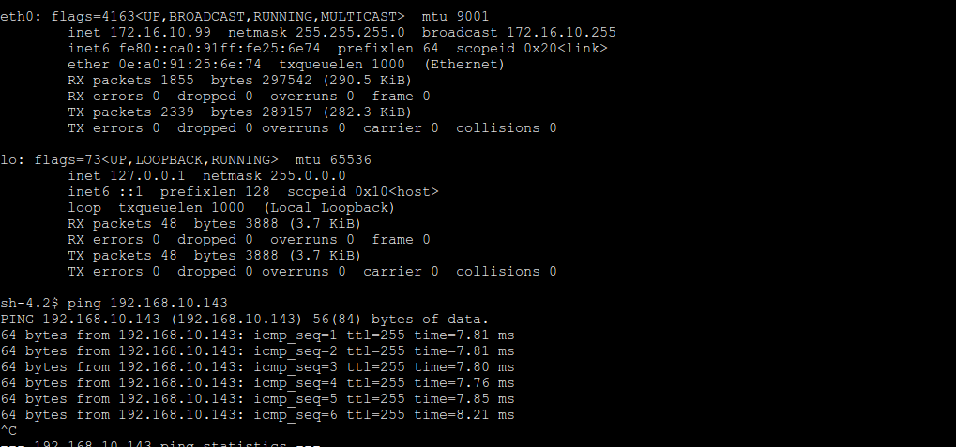
Now Let’s try to install httpd package

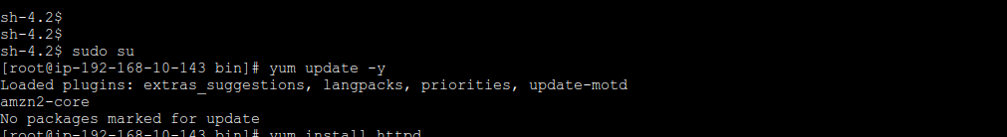
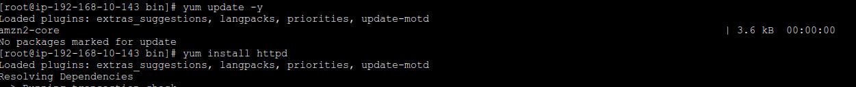
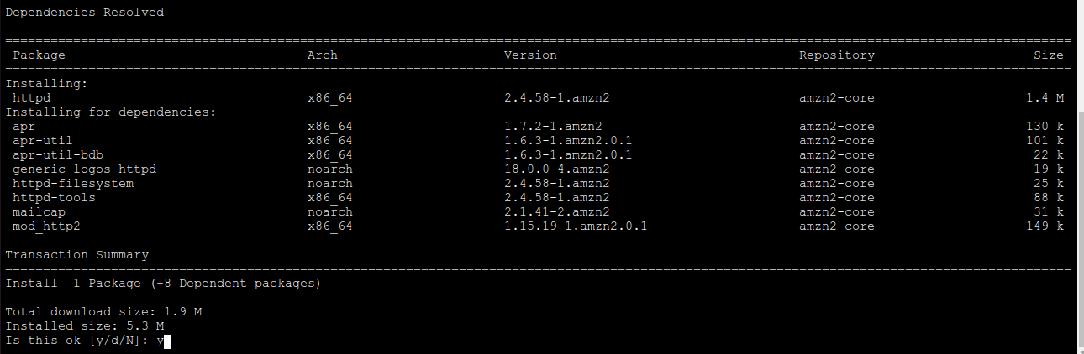
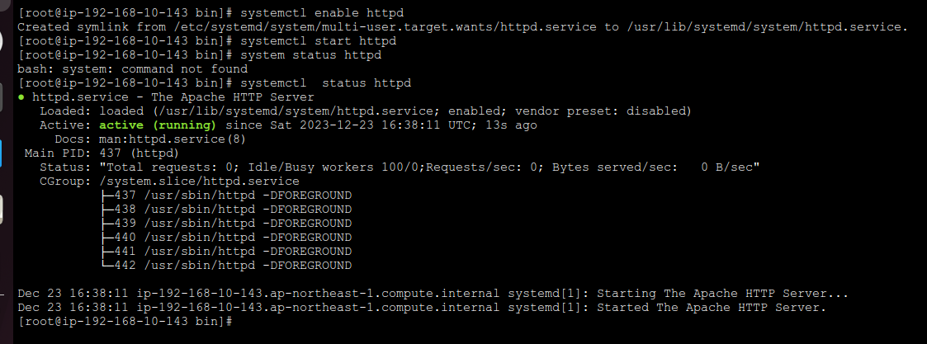

12. This concludes the project. Once done, don't forget to terminate all resources created by Terraform. In your terminal, type the command:
- terraform destroy -auto-approve

