WEB APP – SINGLE SERVER TO ELASTIC EVOLUTION (Adding Custom and Loadbalancer SSL Termination)

Last project final result of the last project we build. If you not yet done the project , here the link: https://www.linkedin.com/posts/rogmer-bulaclac_project-file-activity-7146604589822148608-EigB?utm_source=share&utm_medium=member_desktop

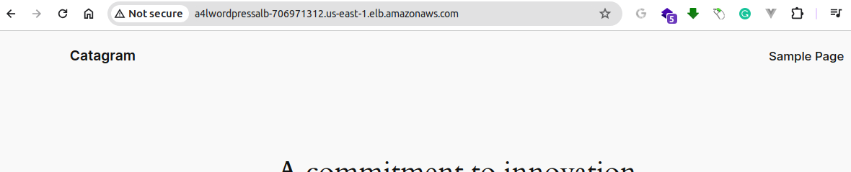
NOT SECURE AND NO CUSTOM DOMAIN

The project is indeed working, but no custom domain and no secure yet

Objectives:
- Generate SSL Certificate:
- Install SSL Certificate on Load Balancer
- Configure Security Group for Load Balancer
- Update DNS Settings at GoDaddy
- Verify SSL Configuration

Instructions:

- Generate SSL Certificate:

- Navigate to AWS Certificate Manager (ACM).
- Select "Request a certificate" and choose "Request a public certificate." Ensure you have a valid domain name, such as (robudexdevops.com).
- Under "Domain names," enter your fully qualified domain name (e.g., *.robudexdevops.com).
- Add tags (Key: Name, Value: MyAppCert) and click "Request."
- You now have a Certificate ID, but the status is "Pending validation."
- Click on your Certificate ID and copy the CNAME name.

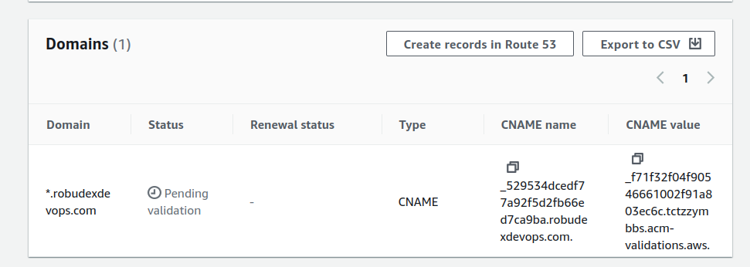

- Open your GoDaddy account and navigate to DNS Management.
- Under DNS Records, click "Add New Record."
- Select Type: CNAME.
- For Name, paste your CNAME here but remove the trailing domain name. For example, if your CNAME is _sldfoajlajr85.robudexdevops.com, enter only _sldfoajlajr85.
- For Value, copy the CNAME value but remove the trailing dot (.).

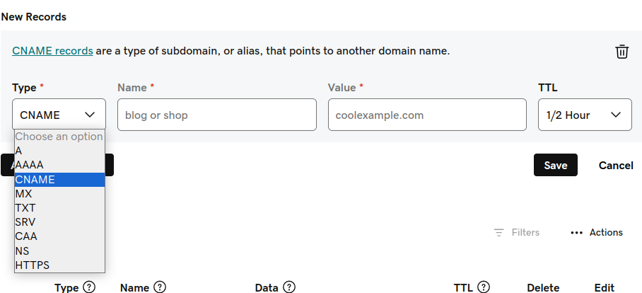

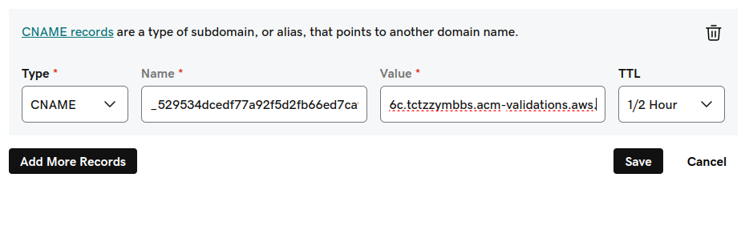
CERTIFICATE CNAME name and value HERE

- The request for a certificate may take some time. If the status is now available, we can proceed to the next steps. Otherwise, we'll need to wait.

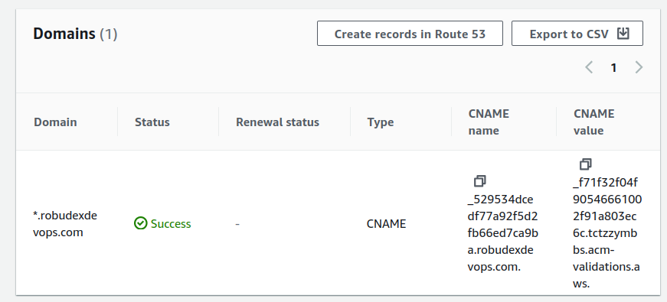
Wait Until Certifacte is verified before proceeding...

2. Install SSL Certificate on Load Balancer

- Select the Loadbalancer

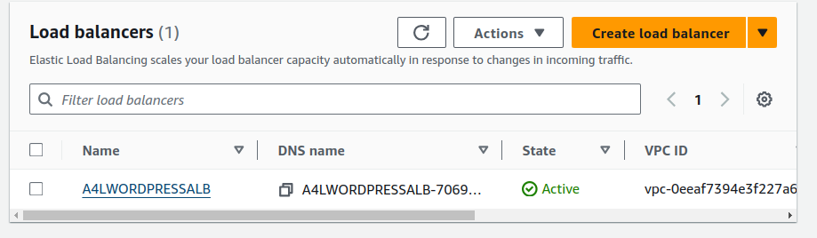

- Goto Listeners and rules and Click Add listener button

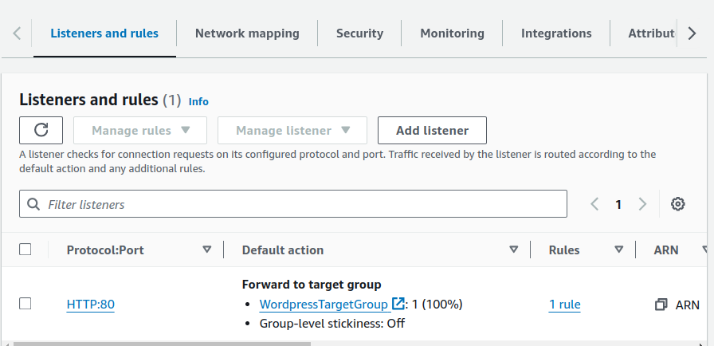

- Select HTTPS Protocol, for Routing actions, Select Forward to targroups choose the WordpressTargetGroup

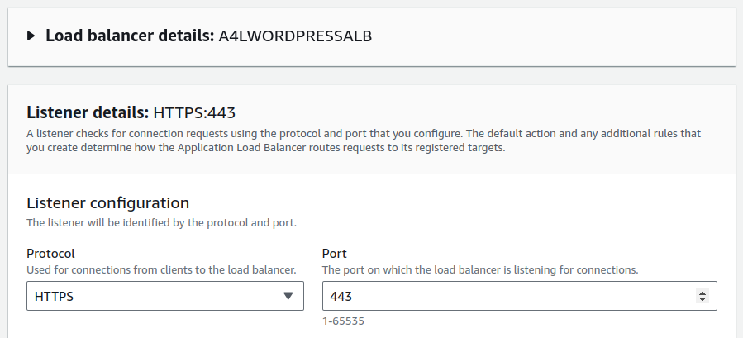

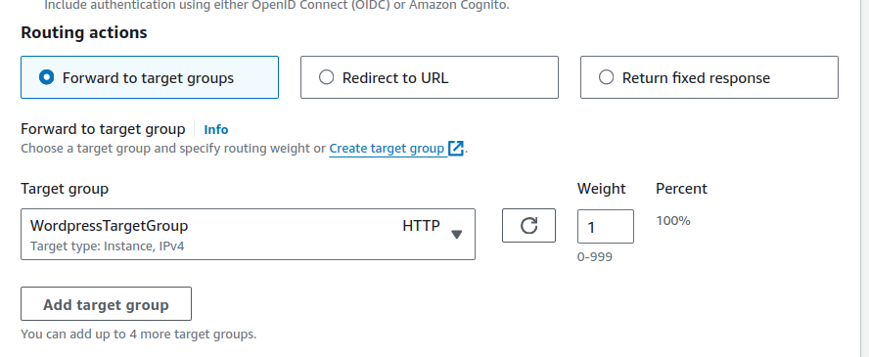

- Goto Secure listener settings from Certificate (from ACM) Select your certificate. Then Click Add button

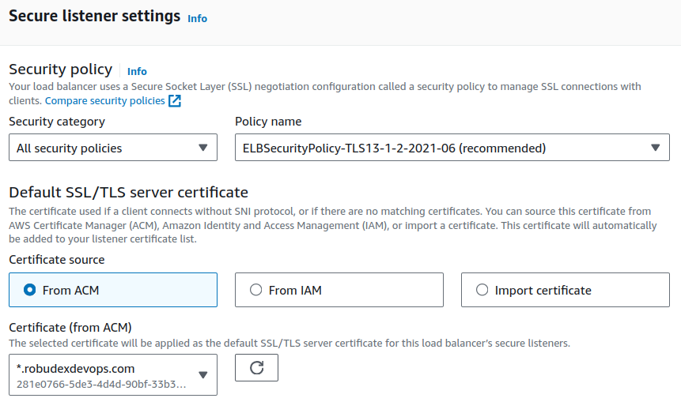
Your Certifacate here...

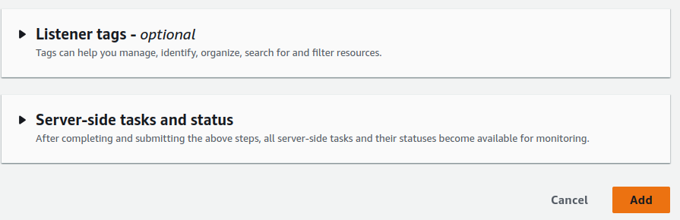

- On the Listeners and rules (HTTPS:443) added but not yet reachable

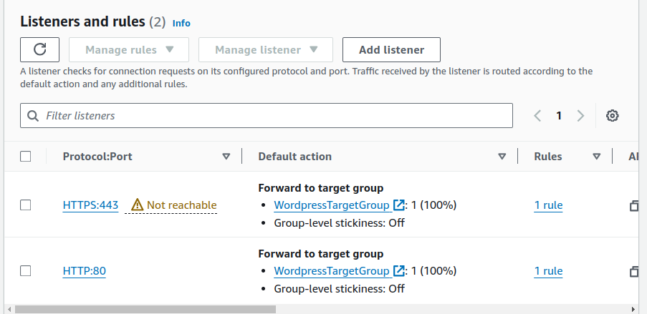
NOT YET REACHABLE

3. Configure Security Group for Load Balancer

- Select Load Balancer Security Group and add 443 on the inbound rules

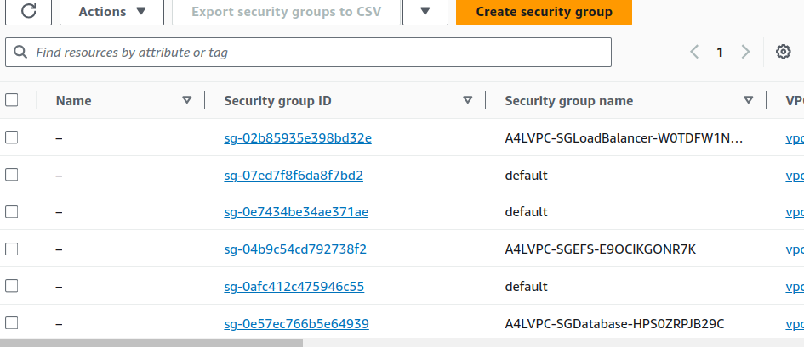

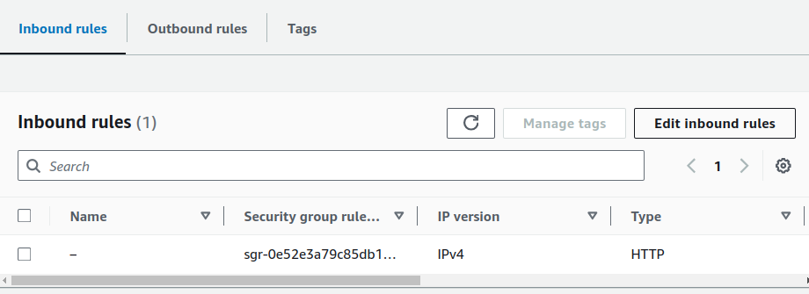

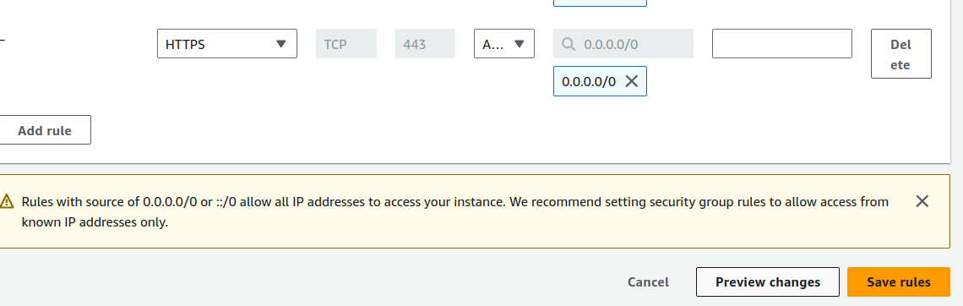
ADD THIS RULE

- Goto Load Balancer Listeners and rules again and notice is now reachable
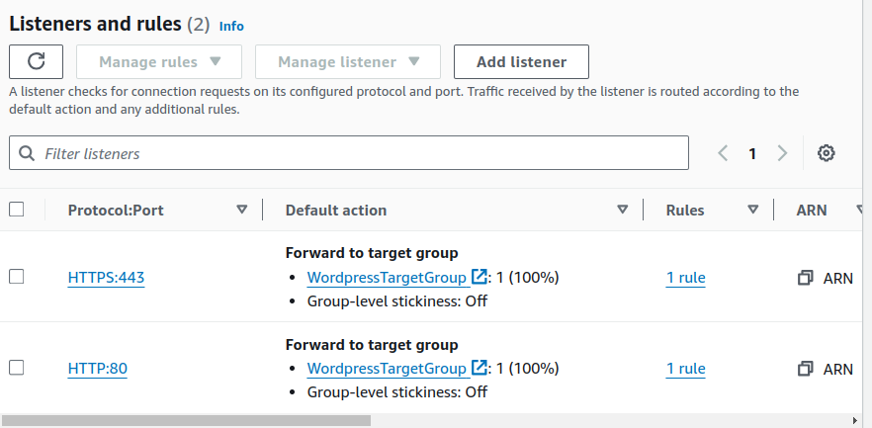
IT REACHABLE NOW....
4. Update DNS Settings at GoDaddy

- Create CNAME records with
Name: wordpress
Value: LoadBalancer Domain name

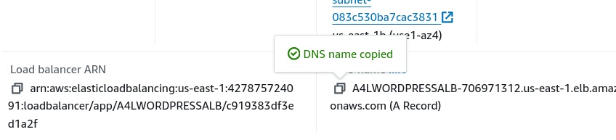

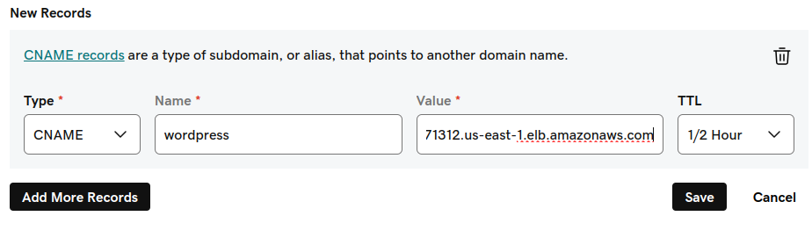
YOUR LOADBALANCER DNS HERE
5. Verify SSL Configuration

- goto web browser and (https://wordpress.YOURDOMAIN) eg https://wordpress.robudexdevops.com
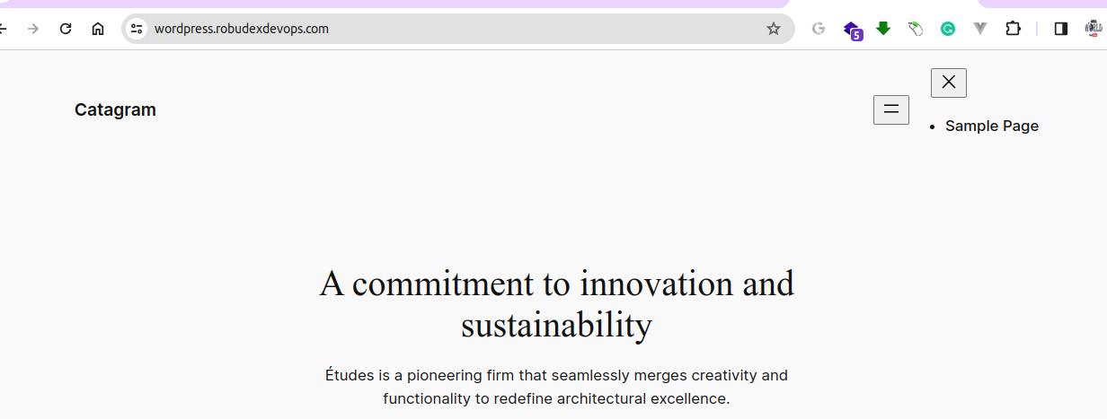
WITH CUSTOM DOMAIN AND SECURE

