WEB APP – SINGLE SERVER TO ELASTIC EVOLUTION (Final Stage) BY ADRIAN CANTRILL

Note: The project instructions are detailed in Adrian's GitHub repository.

Project Link Source: https://github.com/acantril/learn-cantrill-io-labs/tree/master/aws-elastic-wordpress-evolution

In this section, we construct the Final Stage of the project, unifying all the elements we've learned from previous stages and infusing it with adaptability.

Objectives:

- Offload the Database from the WordPress instance by migrating it to an RDS instance. This ensures that in the event of an instance crash, the database can survive, or vice versa.
- Offload the wp-content from the WordPress instance by migrating it to an AWS EFS. This ensures that in the event of an instance crash, the application media and UI can survive.

- Incorporating autoscaling and a load balancer into the project

Instructions:

- Log in to your AWS Console. Ensure that your account has Administrator Access..
- Copy and paste the following link into your browser https://console.aws.amazon.com/cloudformation/home?region=us-east-1#/stacks/quickcreate?templateURL=https://learn-cantrill-labs.s3.amazonaws.com/aws-elastic-wordpress-evolution/A4LVPC.yaml&stackName=A4LVPC.

This CloudFormation template will create the infrastructure for our WordPress app. Click "I acknowledge that AWS CloudFormation might create IAM resources," then click "Create stack." Wait for the stack to move into the "CREATE_COMPLETE" state before continuing.

- Download the CloudFormation template from this link:
https://github.com/robudexIT/awsdevopsproject/blob/cloudformation/cloudformation/wordpress/wordpress_complete.yaml

Note: You can skip step 2 if you already created the stack

This CloudFormation template contains the same instructions as in Stage 4

4. Stage4 Instructions Cloudformation:

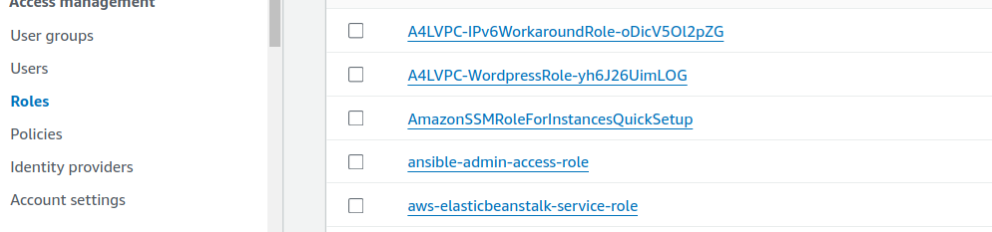
- Goto https://us-east-1.console.aws.amazon.com/iam/home?region=us-east-1#/roles and look for A4LVPC-WordpressRole Roles and click it.

- Copy the Instance Profile Name to your notes

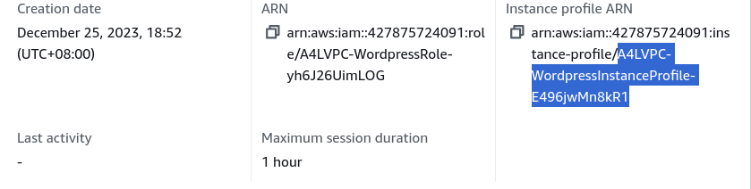
Copy only the highlighted text

- Goto Cloudformation and create stack:

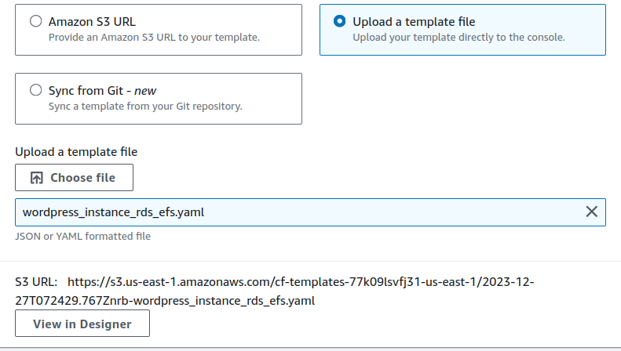
This file is downloaded from steps 3

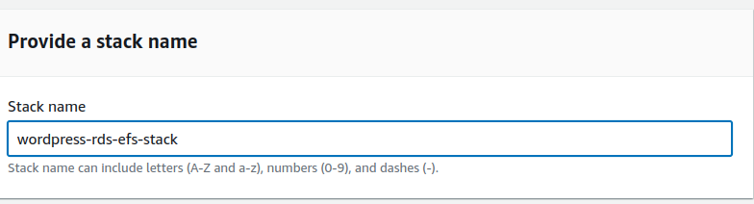
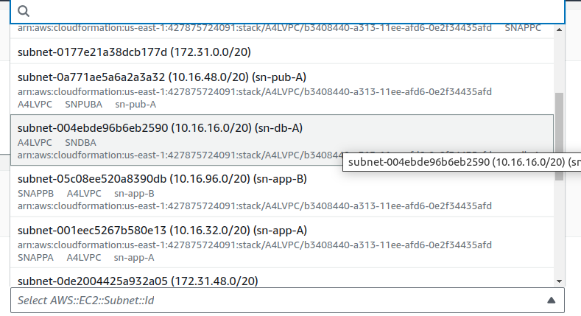
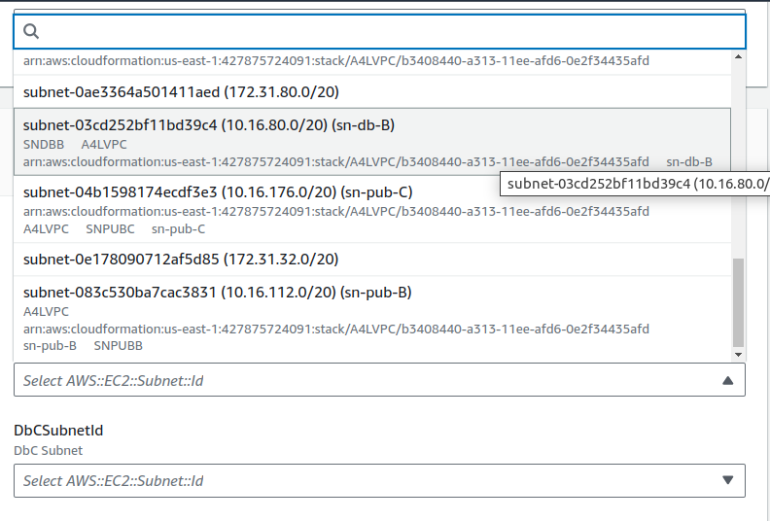
DbASubnetId
DbBSubnetId
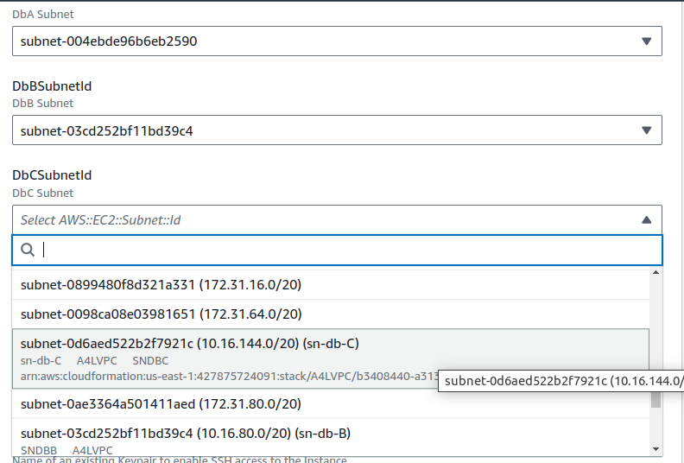
DbCSubnetId
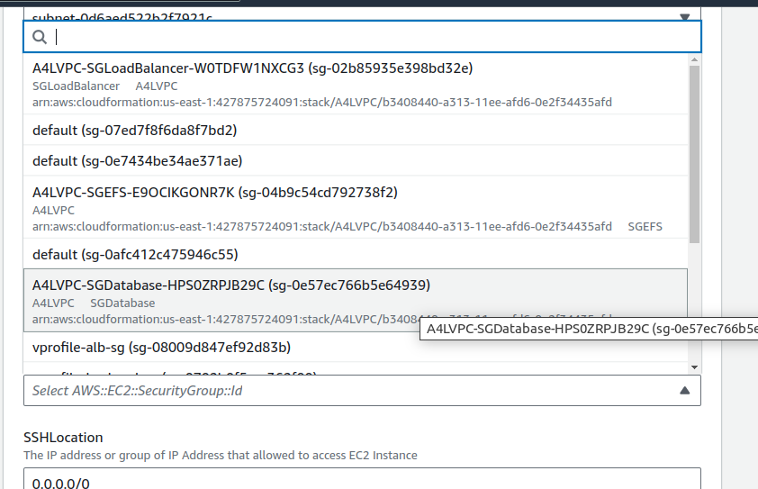
RdsSecurityGroupID
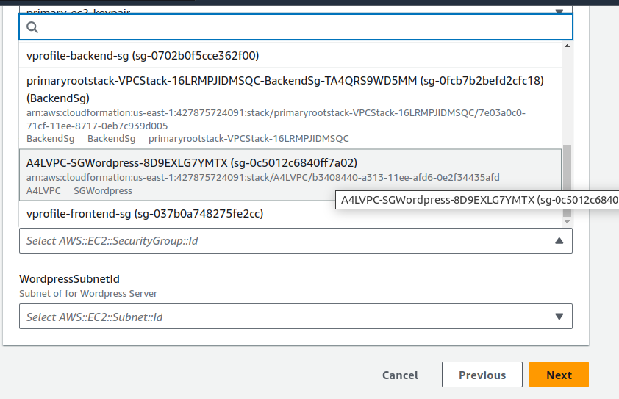
WordpressSecurityGroupID

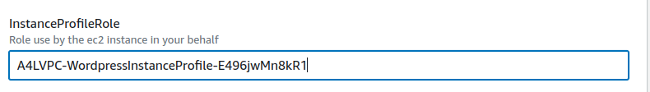

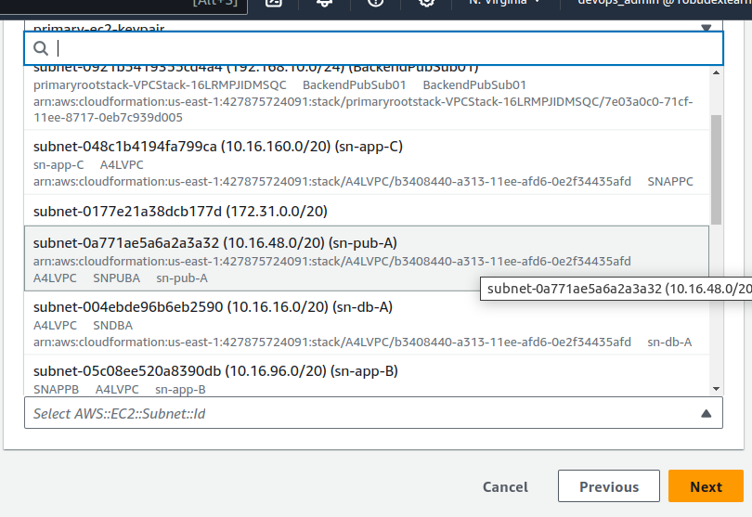
WordpressASubnetId

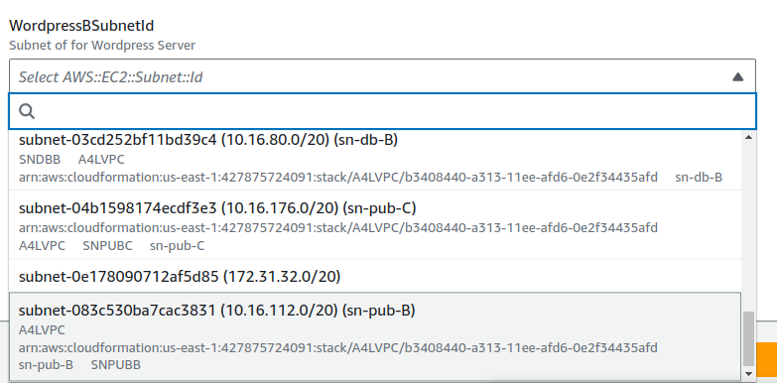
WordpressBSubnetId

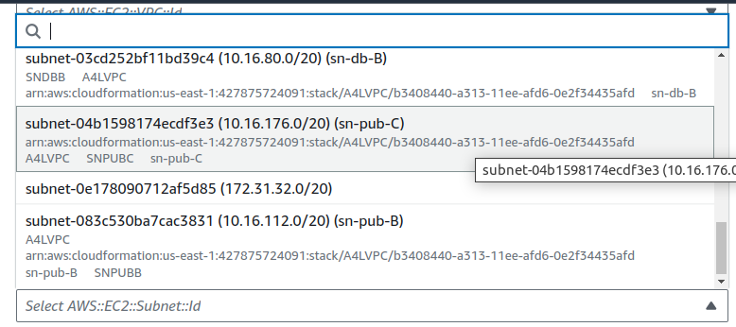
WordpressBSubnetId

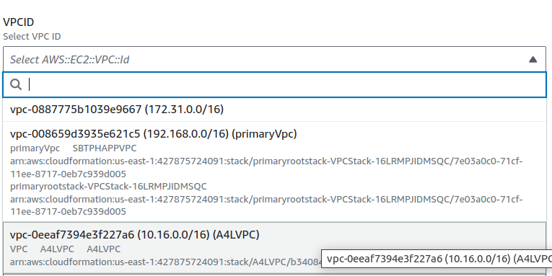

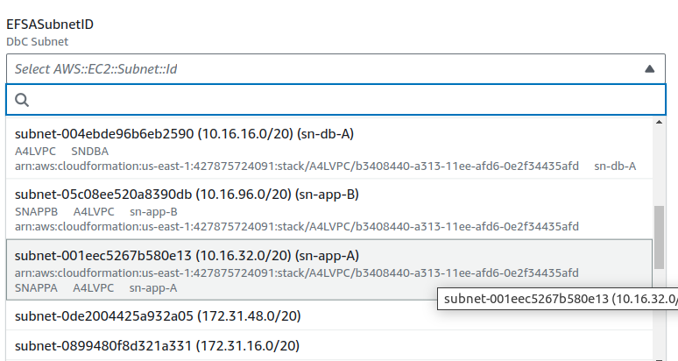
EFSASubnetID

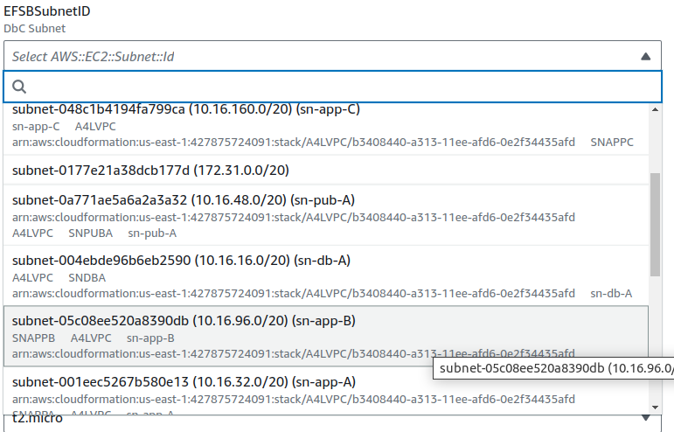
EFSBSubnetID
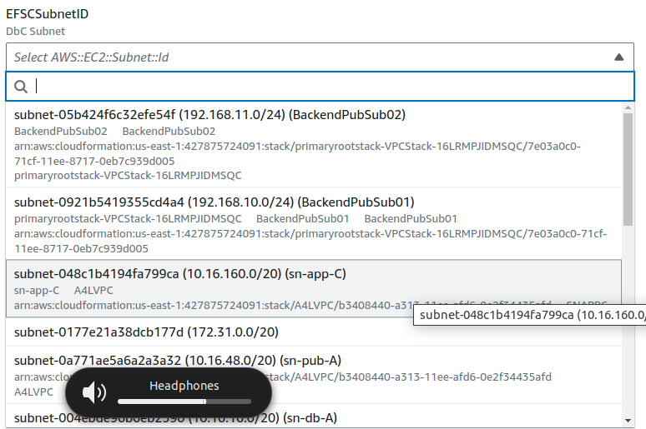
EFSCSubnetID

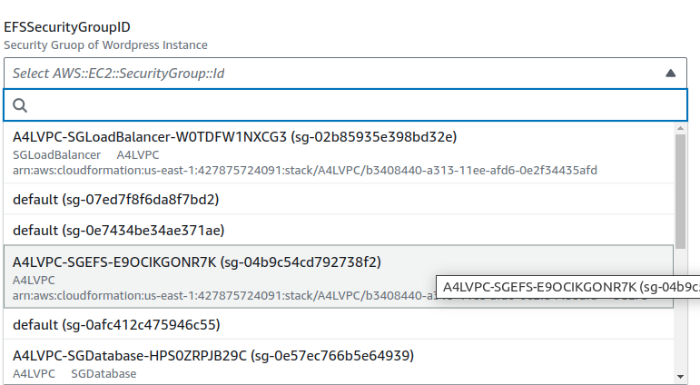
EFSSecurityGroupId

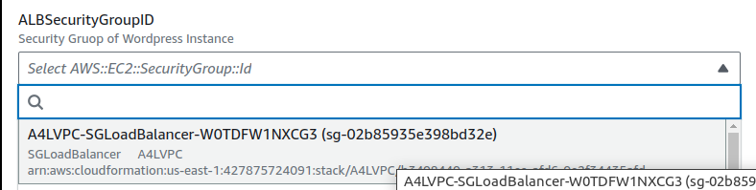

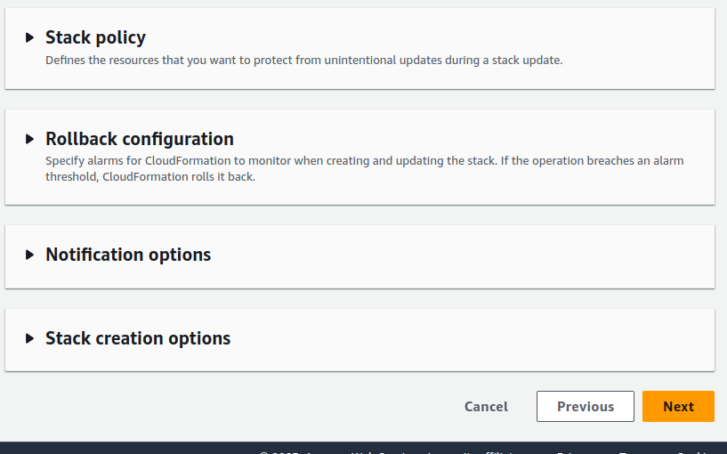

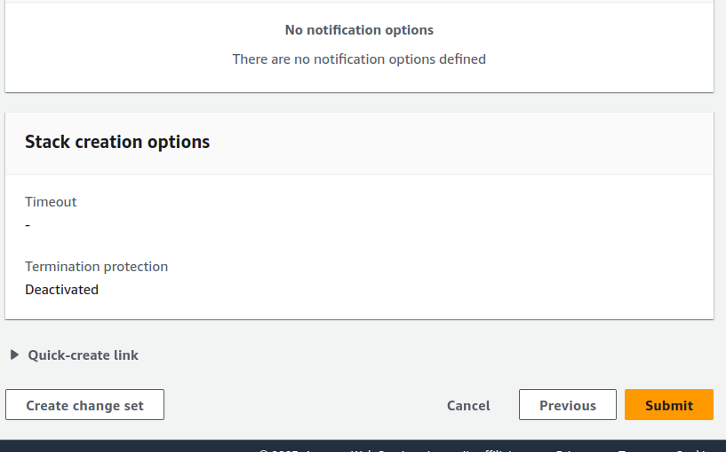

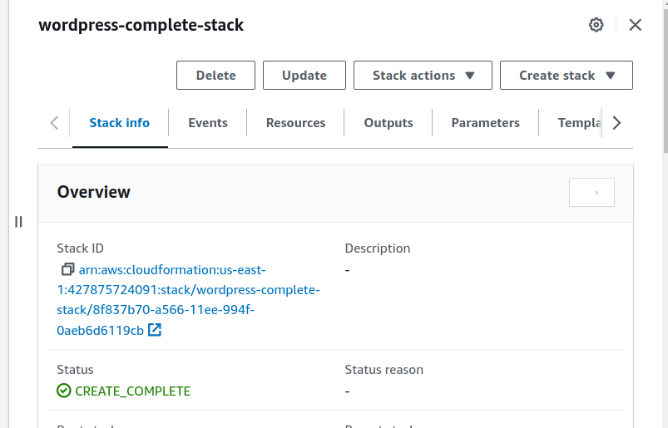

- Go to https://console.aws.amazon.com/ec2/v2/home?region=us-east-1#Instances:sort=desc:tag:Name
- Select the Wordpress Instance and copy the Public IP Address and paste it to browser address bar
- If this page will appear that means the wordpress setup is successful

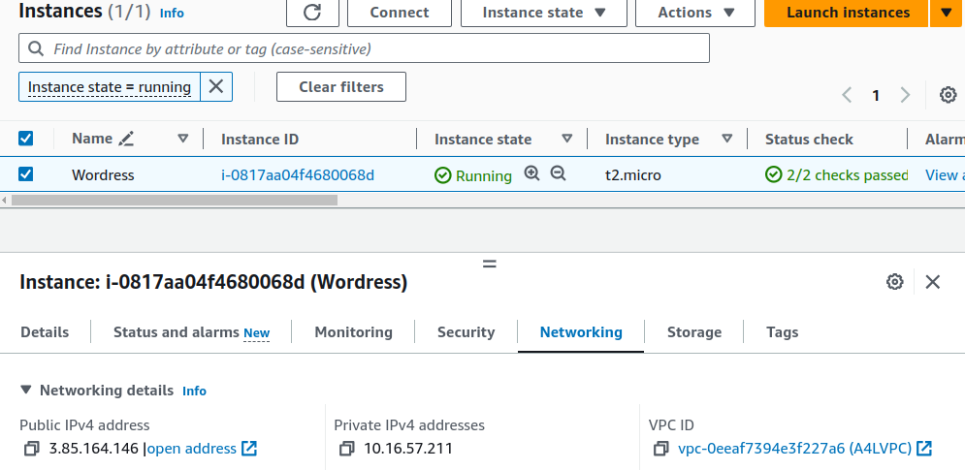

Paste this Public Ip Address to Browser

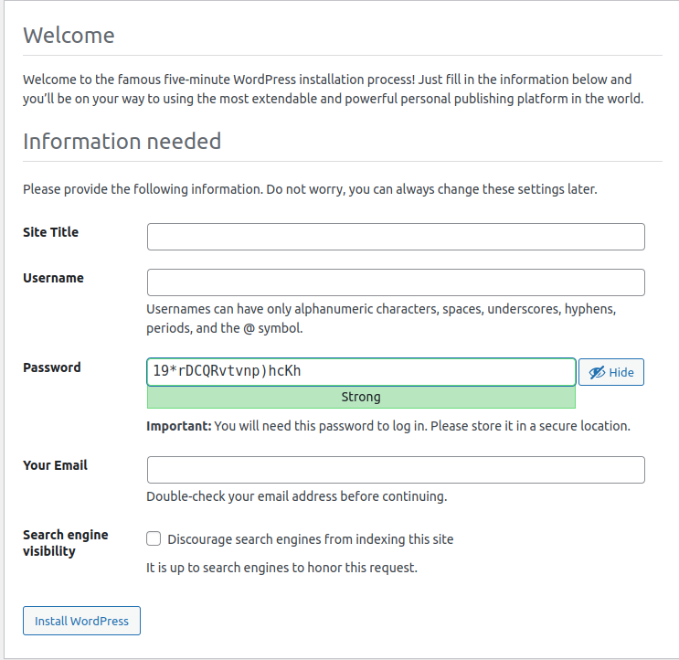

- Let Perform Initial Configuration and make a post

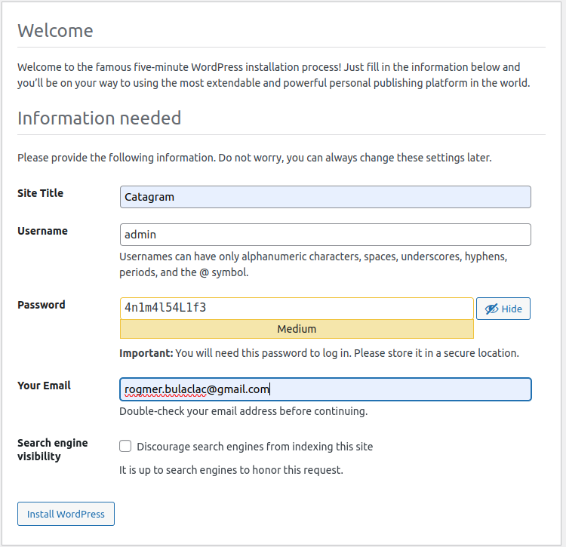

Click This

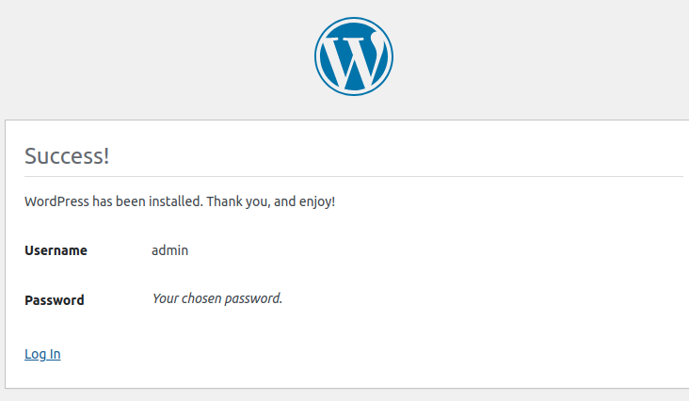

Click This

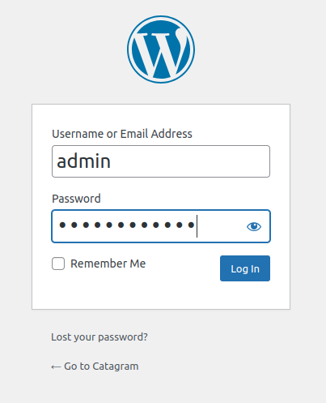

Login User and Password here:

- Click Posts in the menu on the left
- Select Hello World! Click Bulk Actions and select Move to Trash Click Apply
- Click Add New
- If you see any popups close them down
- For title The Best Animal(s)!
- Click the + under the title, select Gallery Click Upload
- Select some animal pictures.... if you dont have any use google images to download some Upload them
- Click Publish
- Click Publish Click view Post

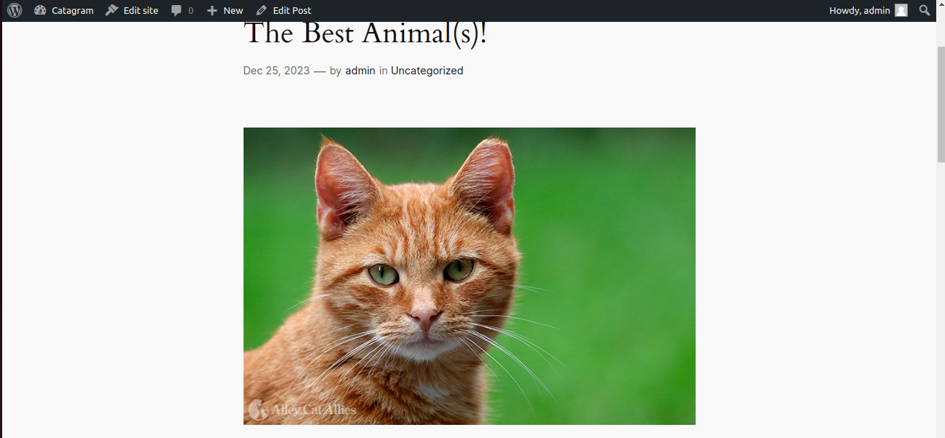

- Now that our Initial Wordpress Setup was done and uploads some photos. Its time change our AutoScaling Health Check to ELB. Open the wordpress_complete.yaml locate the WordpressASG resource, on the HealthCheckType, check the value from EC2 to ELB

Note: Initially, we set the WordpressASG HealthCheckType to EC2 due to our initial setup. Setting it to ELB during creation would result in continuous termination of instances because the ASG relies on ELB health checks. Since WordPress is not yet set up, the ELB Target Group would mark the instance as unhealthy. This is because checking the instance at the / path would return HTTP error codes 404 or 500

- Go to Cloudformaton, select wordpress-complete-stack and Click Update

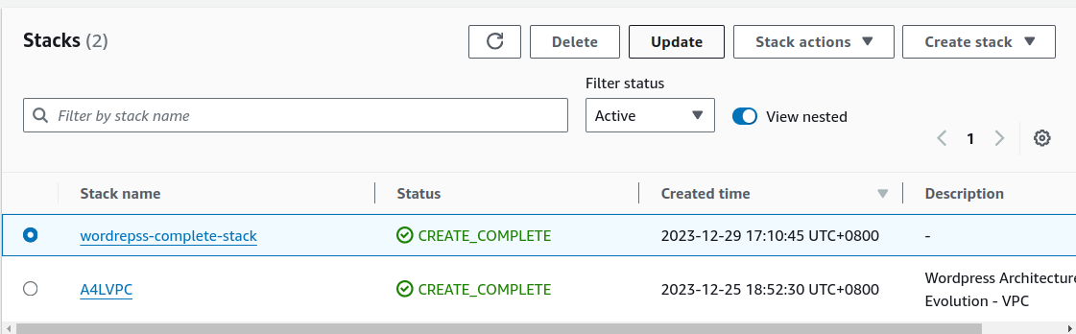

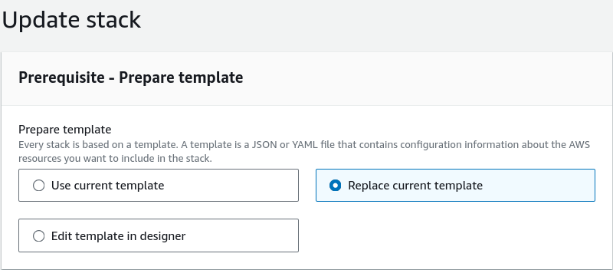
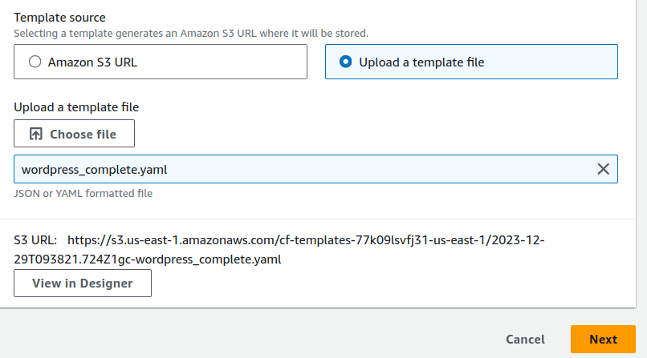

- As observed in the change set preview, please note that the action will only modify the WordpressASG
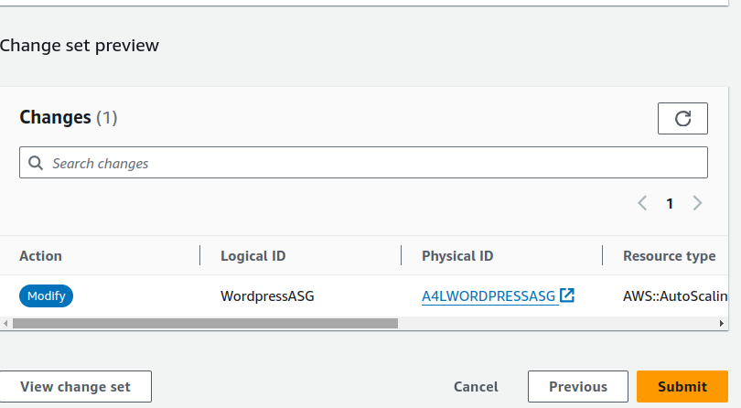

- Wait Until Stack Update is compete

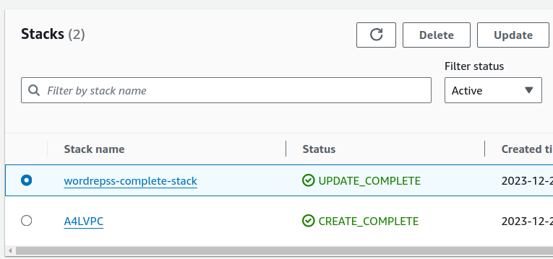

- Let check the ASG Health Check if it is updated

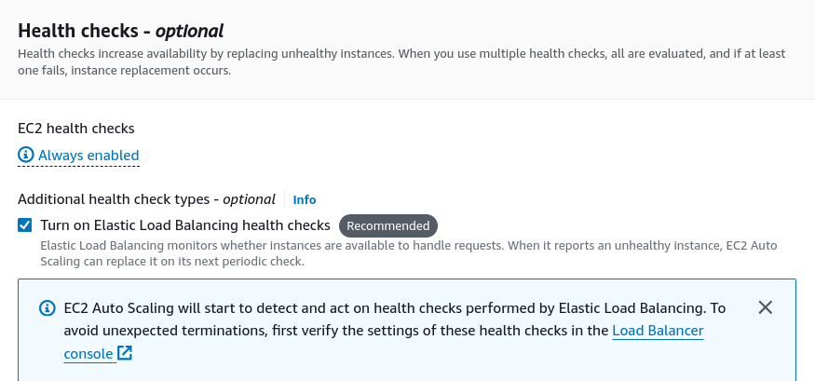

- Lets do our first test, Let terminate the existing instance

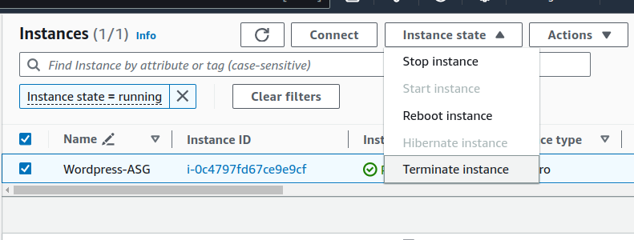

- After several minutes, the Auto Scaling Group (ASG) detected the change and launched a new instance in accordance with its capacity settings

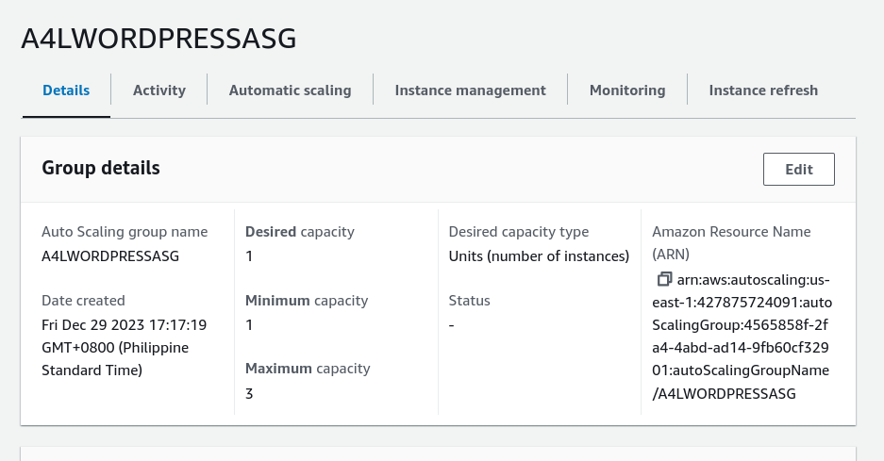

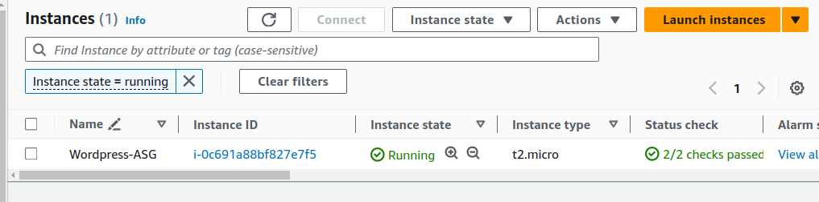

Let's check the Load Balancer to ensure it functions as expected. Navigate to EC2, select "Load Balancers," and click on "A4WORDRESSALB.

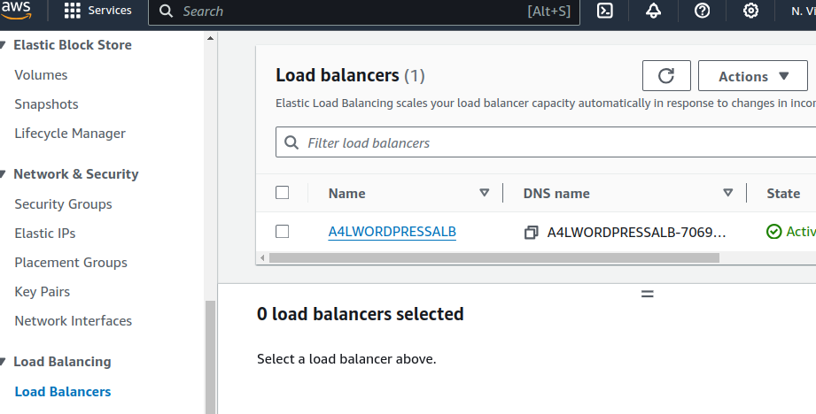
Paste this to browser

- Copy the DNS name and paste to web browser:

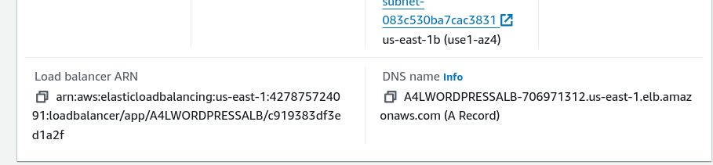

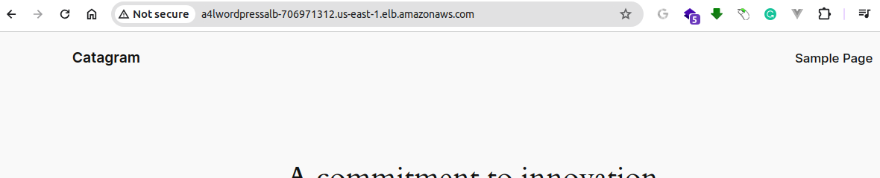

- Scroll Down and click the Post you Initially created

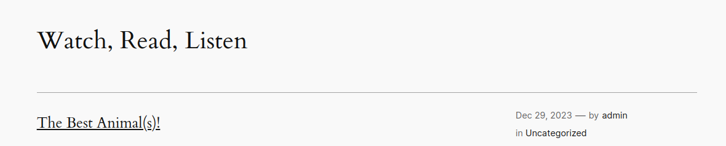

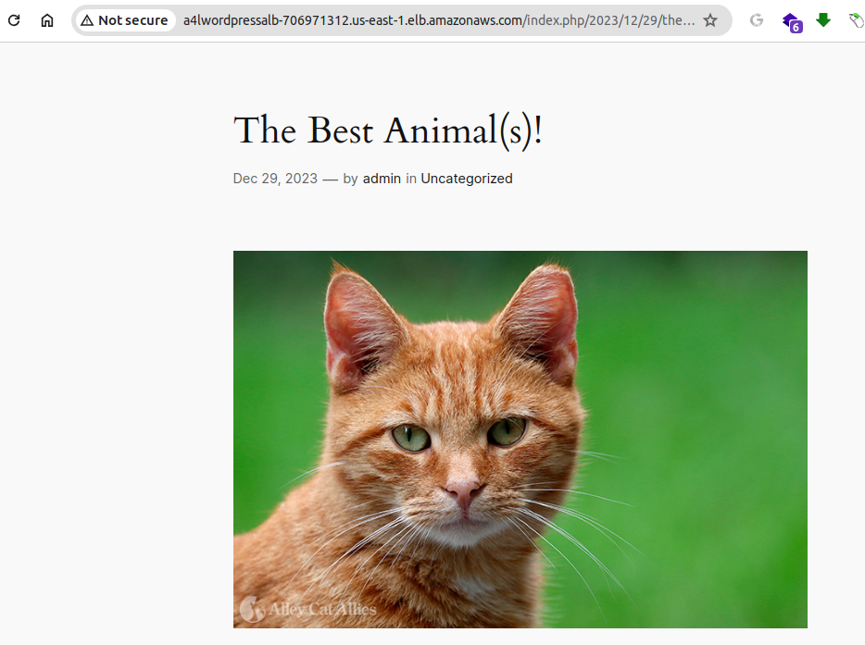

As you can see, the our LoadBalancer is working....

- Now, let's shift our attention to the elasticity and scalability of our project. Connect to the instance, and let's put stress on the CPU

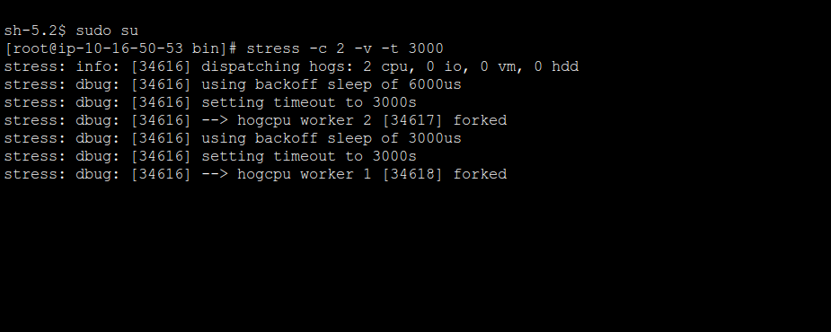
Stress command

Goto Cloudwatch and Select WordpressHIGHCPU Alarm

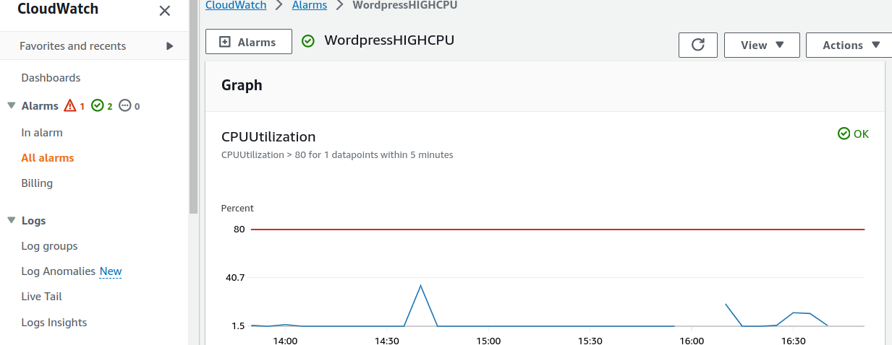
it triggers an alarm when it surpasses this threshold

- After several minutes, it transitions from "OK" to "In Alarm," prompting our Auto Scaling Group (ASG) to detect the change and spawn a new instance to respond to the increased demands

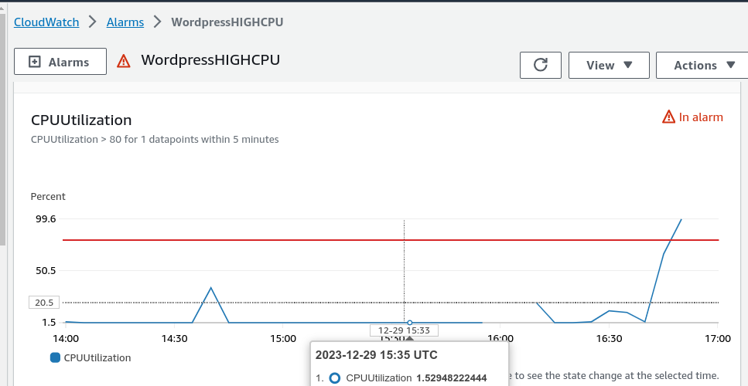
it surpasses the threshold

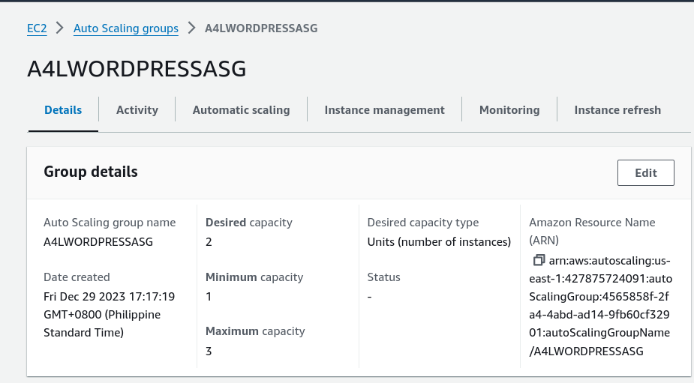
Adjusted the Desired capacity into 2

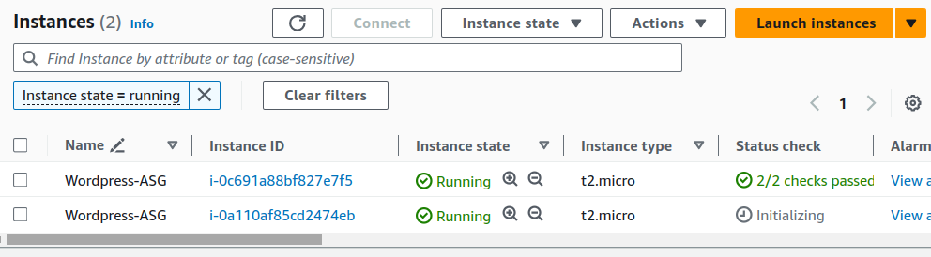
New spanning new instance

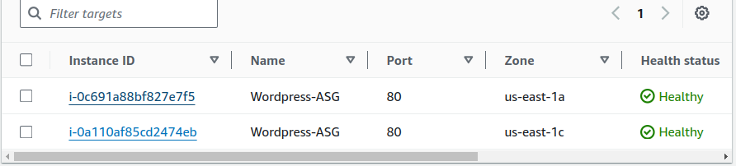

- Lets stop the stress command

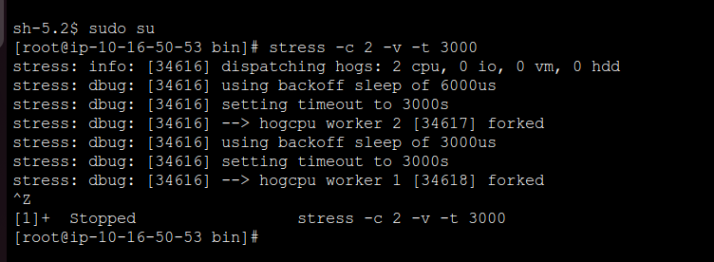

- Goto Cloudwatch and Select WordpressLOWCPU Alarm

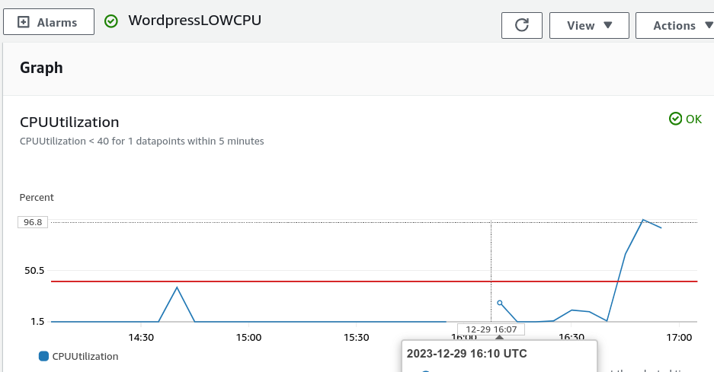

- After several minutes, it change from OK to In alarm, and our ASG detects it that there is no high cpu demand, so it terminate intances leave only number instance base on the scalling capacity settings

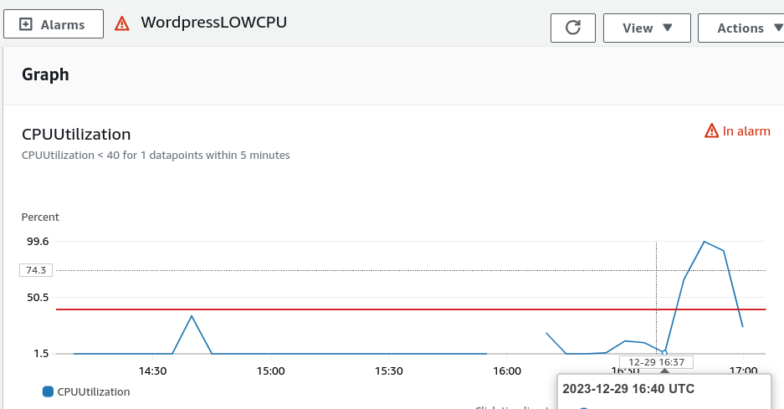
it falls to this threshold

Adjust Desired Capacity back to 1

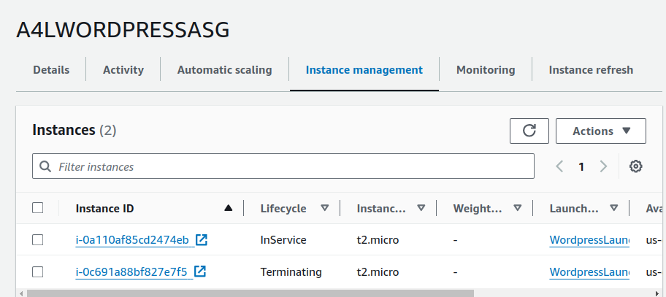
One Instance is terminating

Draining before it will terminated
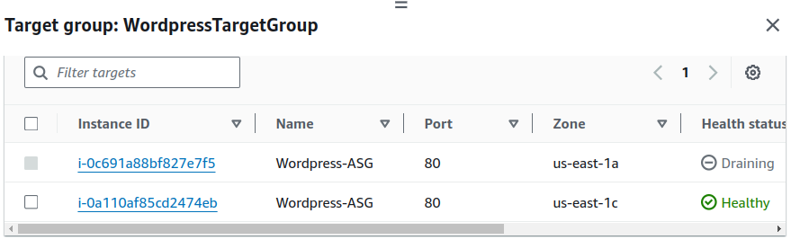

Thats Conclude the Final Stage or the Stage 5 .....
Stage 6 is about Cleanup, since we build this project using Cloudformation, Deleting our project is easy.

First Delete worpress-complete-stack when its done
Delete the A4VPC stack

