WEB APP – SINGLE SERVER TO ELASTIC EVOLUTION (STAGE 1) BY ADRIAN CANTRILL

Note: The project instructions are detailed in Adrian's GitHub repository.

Project Link Source: https://github.com/acantril/learn-cantrill-io-labs/tree/master/aws-elastic-wordpress-evolution

In this section, I will only build Stage 1 of the project, and I will use CloudFormation as part of my DevOps practice.

Instructions:

- Log in to your AWS Console. Ensure that your account has Administrator Access..
- Copy and paste the following link into your browser https://console.aws.amazon.com/cloudformation/home?region=us-east-1#/stacks/quickcreate?templateURL=https://learn-cantrill-labs.s3.amazonaws.com/aws-elastic-wordpress-evolution/A4LVPC.yaml&stackName=A4LVPC.

This CloudFormation template will create the infrastructure for our WordPress app. Click "I acknowledge that AWS CloudFormation might create IAM resources," then click "Create stack." Wait for the stack to move into the "CREATE_COMPLETE" state before continuing.

- Download the CloudFormation template from this link:
https://github.com/robudexIT/awsdevopsproject/blob/cloudformation/cloudformation/wordpress/wordpress_instance.yaml

This CloudFormation template contains the same instructions as in Stage 1

Note: I used String type for the 5 parameters because CloudFormation currently doesn't support SecureString. Although it can be achieved using Custom Resource with Lambda or AWS Secrets Manager, for simplicity, I'm sticking to Parameter Store for now..

4. Stage1 Instructions Cloudformation:

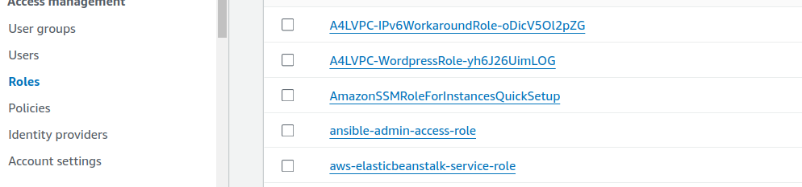
- Goto https://us-east-1.console.aws.amazon.com/iam/home?region=us-east-1#/roles and look for A4LVPC-WordpressRole Roles and click it.

- Copy the Instance Profile Name to your notes

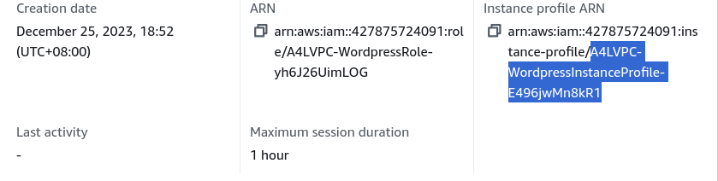
Copy only the highlighted text

- Goto Cloudformation and create stack:

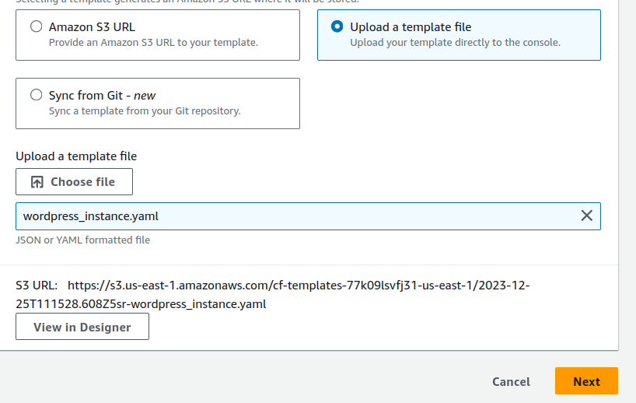
This file is downloaded from steps 3

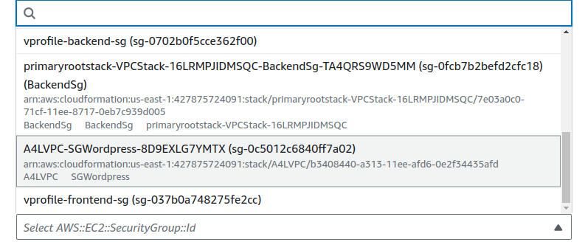
Select This

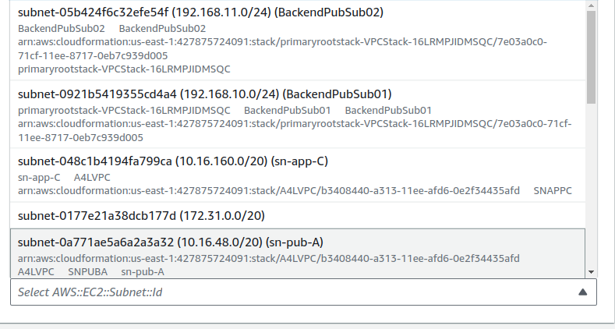
Select This

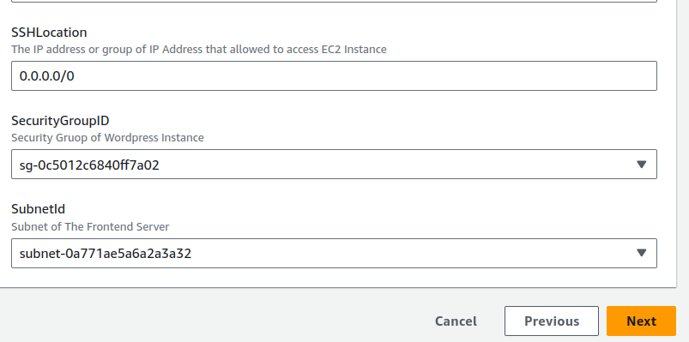

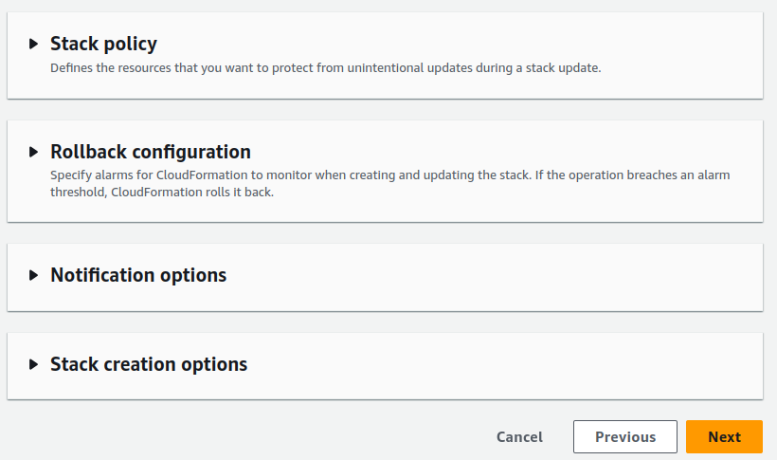

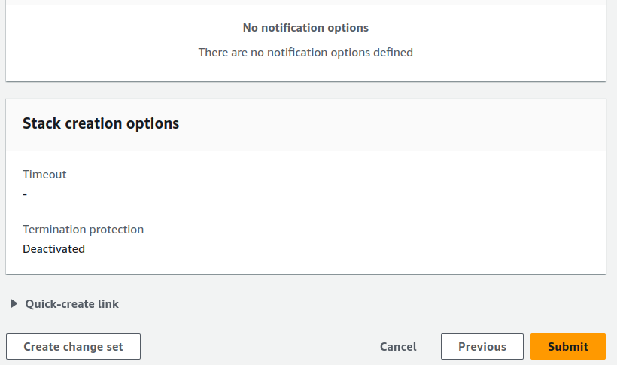

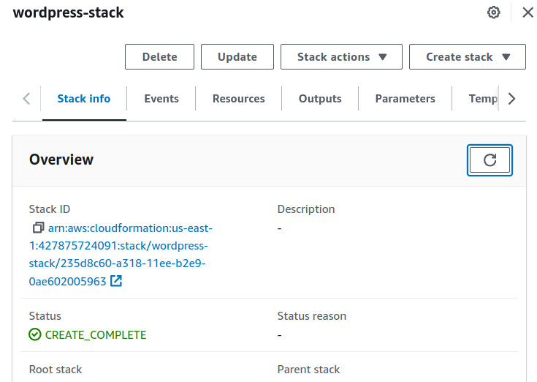
Wait Until Wordpress-stack compelete

- Go to https://console.aws.amazon.com/ec2/v2/home?region=us-east-1#Instances:sort=desc:tag:Name
- Select the Wordpress Instance and copy the Public IP Address and paste it to browser address bar
- If this page will appear that means the wordpress setup is successful

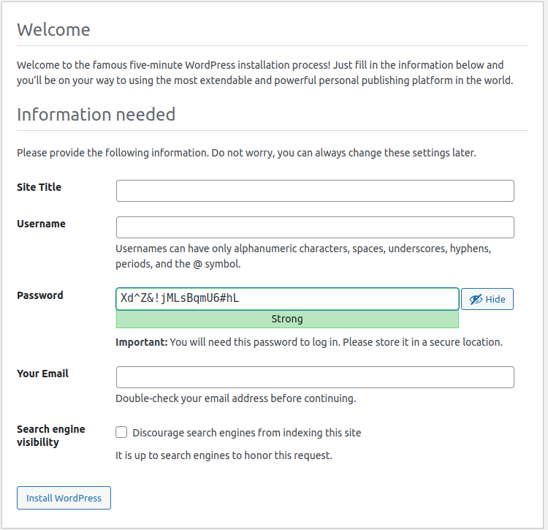

- Let Perform Initial Configuration and make a post
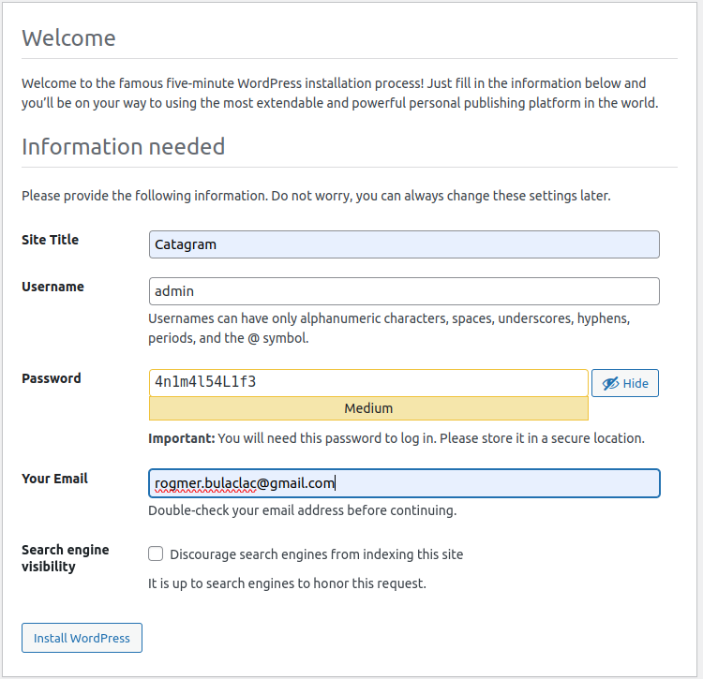
Click This

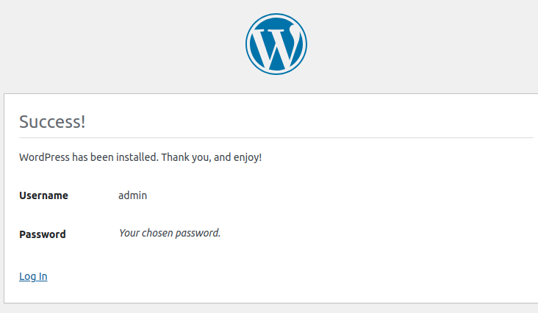
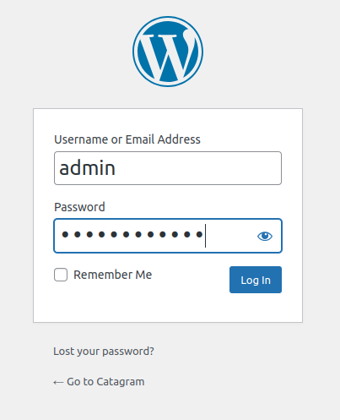
Click This

Login User and Password here:

- Click Posts in the menu on the left
- Select Hello World! Click Bulk Actions and select Move to Trash Click Apply
- Click Add New
- If you see any popups close them down
- For title The Best Animal(s)!
- Click the + under the title, select Gallery Click Upload
- Select some animal pictures.... if you dont have any use google images to download some Upload them
- Click Publish
- Click Publish Click view Post

Final Result:

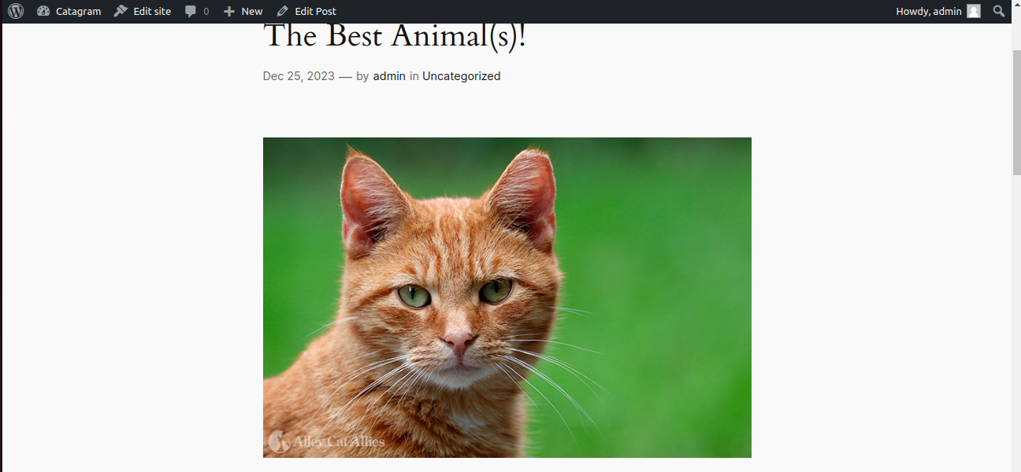

Thats Conclude the Stage 1.....
You can delete the the wordpress-stack.. dont delete the A4LVPC we will need it in Stage 2

