Cross-Regional VPC Peering: A Secure and Efficient Cloud Network
Infrastructure with Terraform

Project Architecture:

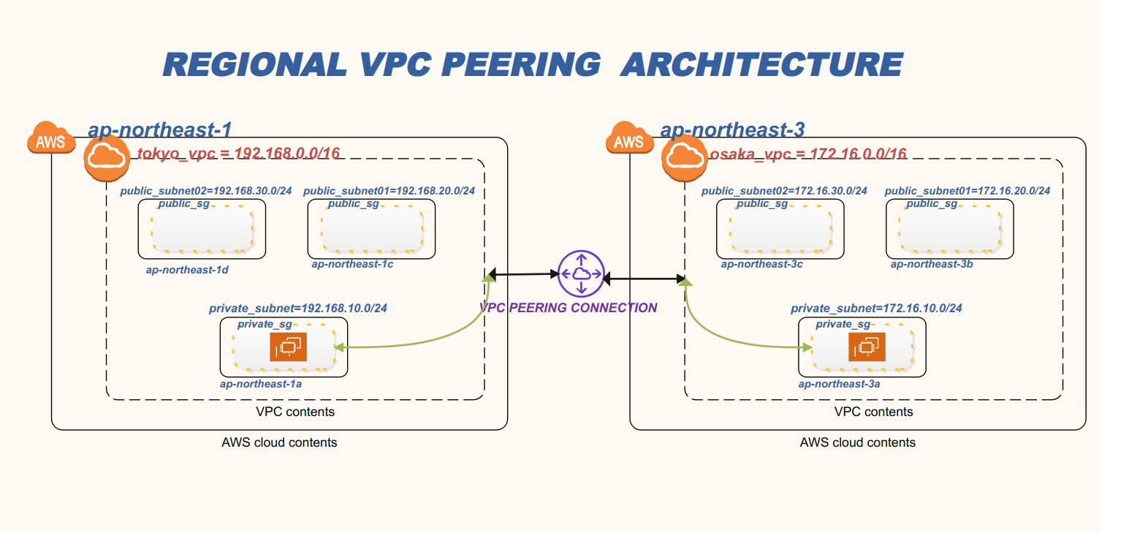

Project Descriptions:
- This project will create the architecture above using Terraform

Prerequiestes:
- AWS Account
- AWS ACCESS KEY and SECRET ACCESS KEY with administrator ACCESS
- Terraform Must be Installed
- GIT Must be Installed

Instructions:
- clone project repository :
git clone -b terraform https://github.com/robudexIT/awsdevopsproject.git
- cd to terraform project directory:
cd awsdevopsproject/terraform/vpcpeering/
- Run these commands
- terraform init
- terraform validate
- terraform plan
- terraform apply -auto-approve

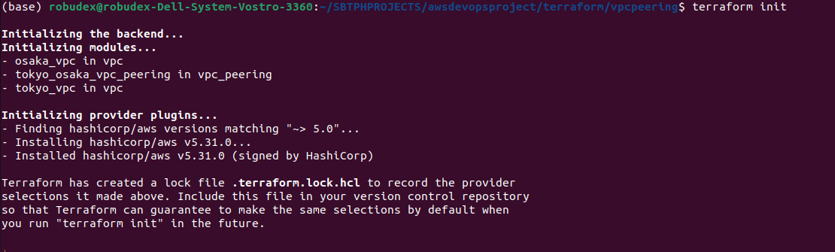
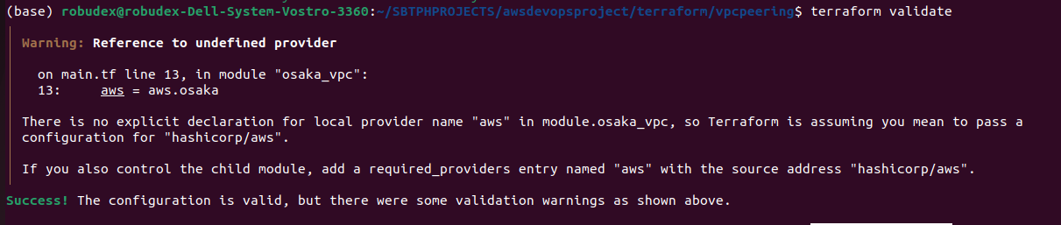

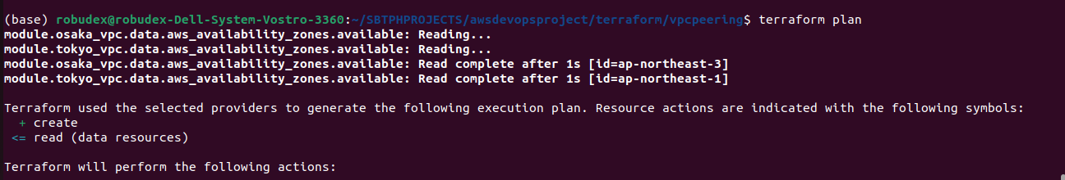

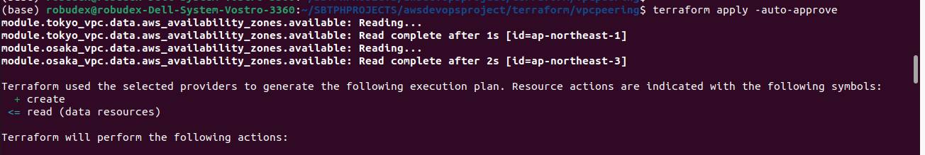


4. When Terraform completes its execution, it creates the following AWS services and resources based on the configurations defined in your Terraform files

- 2 VPCS one for Tokyo Region and one for Osaka Region
- Each VPC Contains:
- 3 Subnets (Two Public and One Private)
- One public routing table with associations to two public subnets.
- One public routing table with associations to one subnet.
- 2 Security Groups (One Public and One Private)
- VPC Connection between two VPCs
- Internet Gateway

5. Open the AWS console in two separate tabs. In one tab, navigate to the Tokyo region, and in the other tab, navigate to the Osaka region. Once there, go to the VPC section in each region and verify if the VPCs have been successfully created.

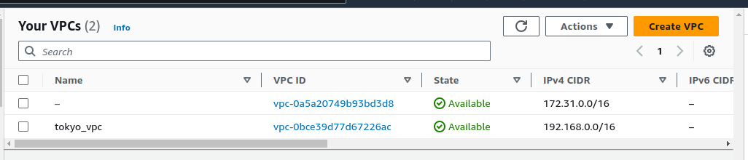

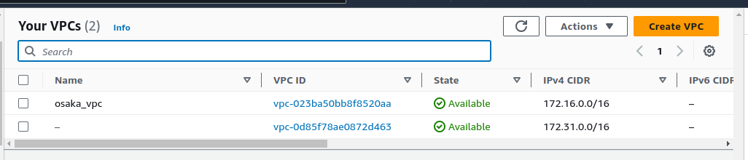

6. Verify the Following resources in each region.

FOR TOKYO REGION
3 subnets created
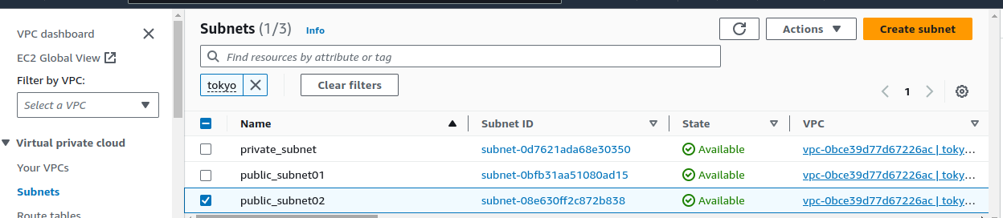
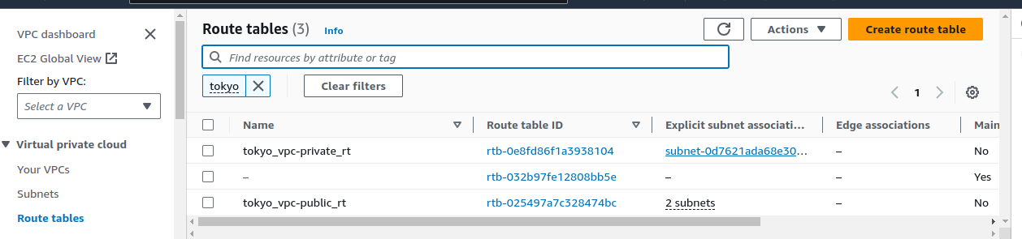
Public and Private routing table created

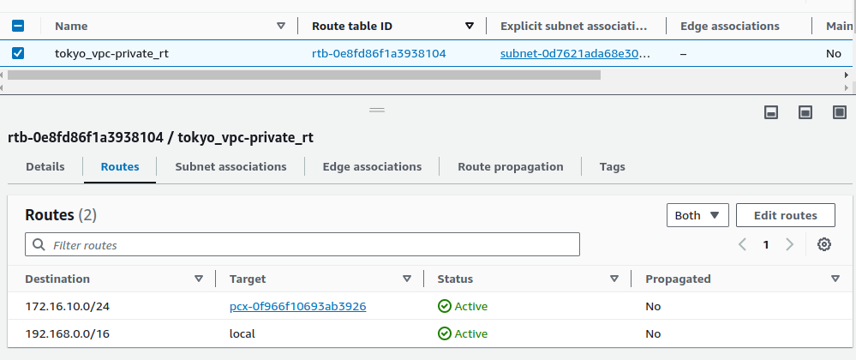
Private Routing Table has Destination route of 172.16.10.0/24 with VPC Peering Connection ID as Target

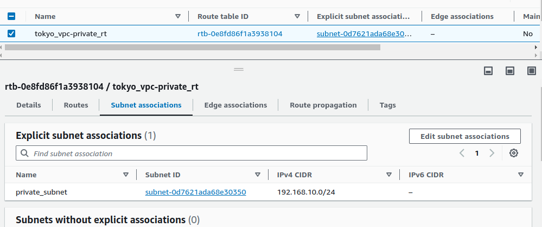

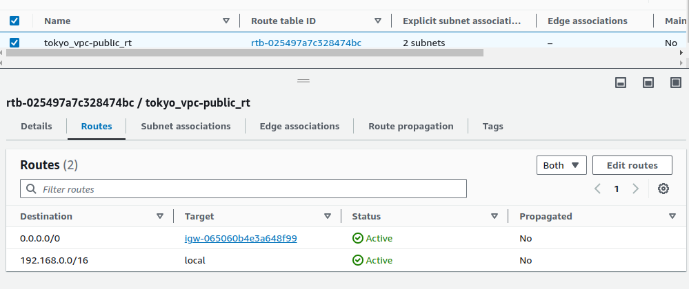
Public Routing Table with a route to the internet

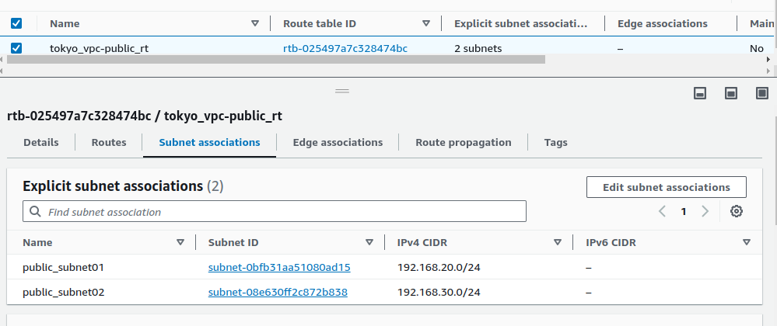

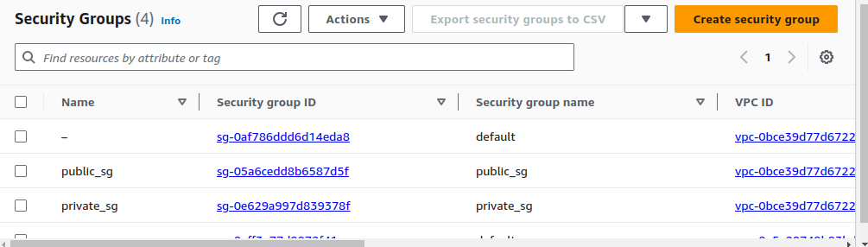
Select the 'private_sg,' then click on 'Inbound rules' to ensure that a rule allowing traffic from the subnet in the OSAKA region has been added.

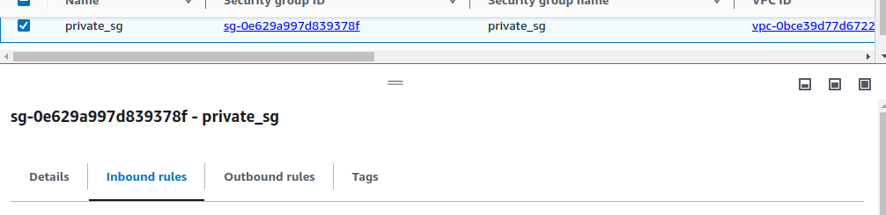

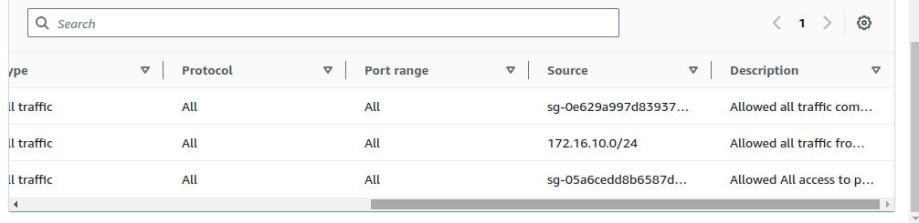
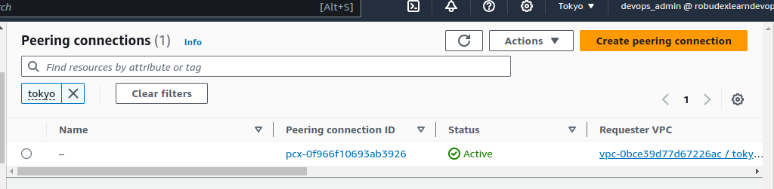
VPC PEERING Successfully created

7. Do the same on the OSAKA REGION

8. Once you’ve done, dont forget to delete your project. Goto the terminal and type the command:
- terraform destroy -auto-approve

