WEB APP – SINGLE SERVER TO ELASTIC EVOLUTION (STAGE 3) BY ADRIAN CANTRILL

Note: The project instructions are detailed in Adrian's GitHub repository.

Project Link Source: https://github.com/acantril/learn-cantrill-io-labs/tree/master/aws-elastic-wordpress-evolution

In this section, we build Stage 3, skipping Stage 2 because it only involves refactoring the Stage 1, which is already covered in my initial CloudFormation templates.

Objectives:
- Offload the Database from the WordPress instance by migrating it to an RDS instance. This ensures that in the event of an instance crash, the database can survive, or vice versa.
- This practice is also necessary to enable scaling for both the WordPress app and the database without affecting each other.

Instructions:

- Log in to your AWS Console. Ensure that your account has Administrator Access..
- Copy and paste the following link into your browser https://console.aws.amazon.com/cloudformation/home?region=us-east-1#/stacks/quickcreate?templateURL=https://learn-cantrill-labs.s3.amazonaws.com/aws-elastic-wordpress-evolution/A4LVPC.yaml&stackName=A4LVPC.

This CloudFormation template will create the infrastructure for our WordPress app. Click "I acknowledge that AWS CloudFormation might create IAM resources," then click "Create stack." Wait for the stack to move into the "CREATE_COMPLETE" state before continuing.

- Download the CloudFormation template from this link:
https://github.com/robudexIT/awsdevopsproject/blob/cloudformation/cloudformation/wordpress/wordpress_instance_rds.yaml

This CloudFormation template contains the same instructions as in Stage 3

4. Stage3 Instructions Cloudformation:

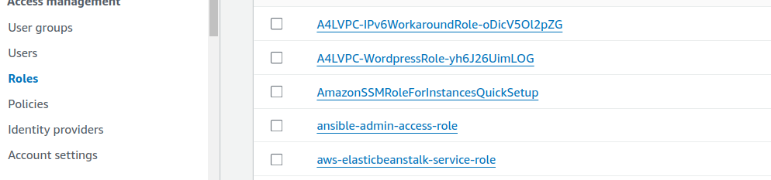
- Goto https://us-east-1.console.aws.amazon.com/iam/home?region=us-east-1#/roles and look for A4LVPC-WordpressRole Roles and click it.

- Copy the Instance Profile Name to your notes

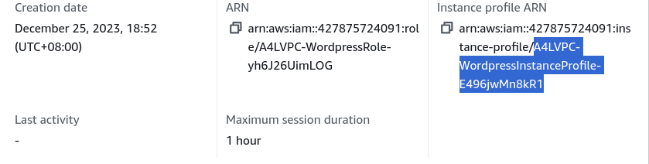
Copy only the highlighted text

- Goto Cloudformation and create stack:

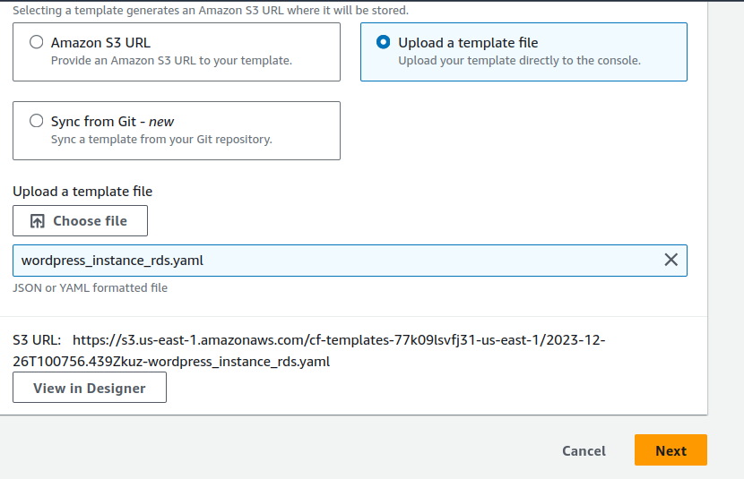
This file is downloaded from steps 3

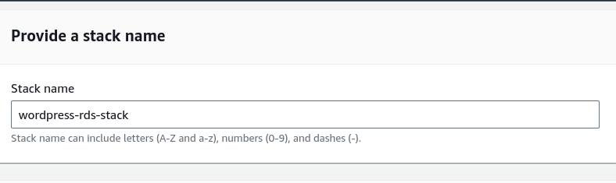
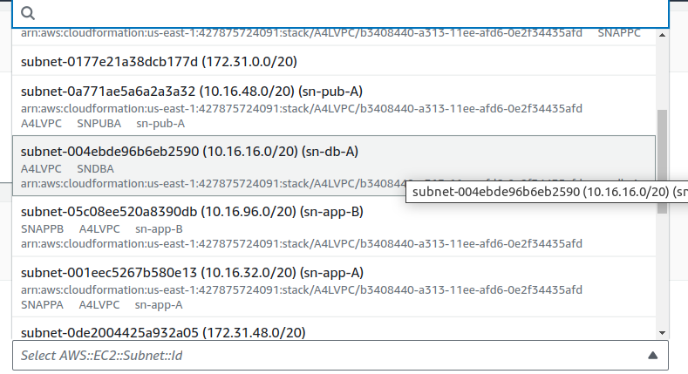
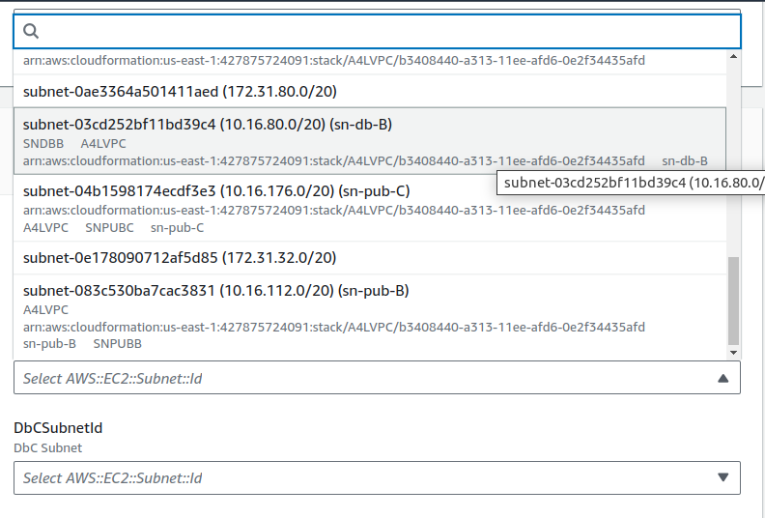
DbASubnetId
DbBSubnetId
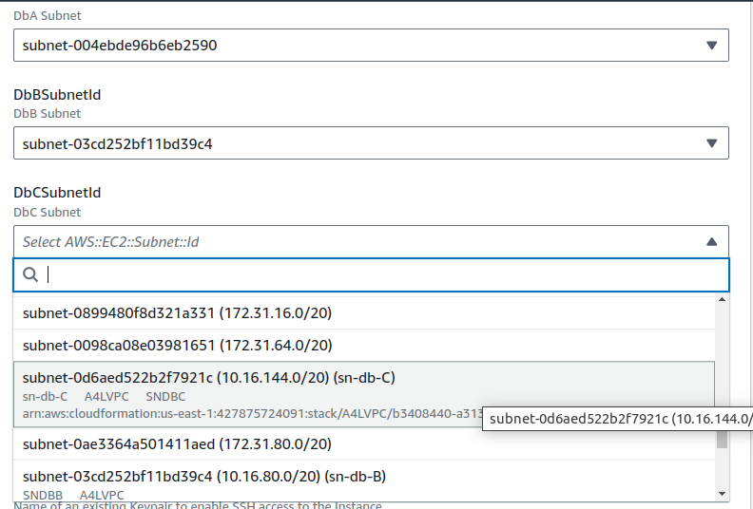
DbCSubnetId
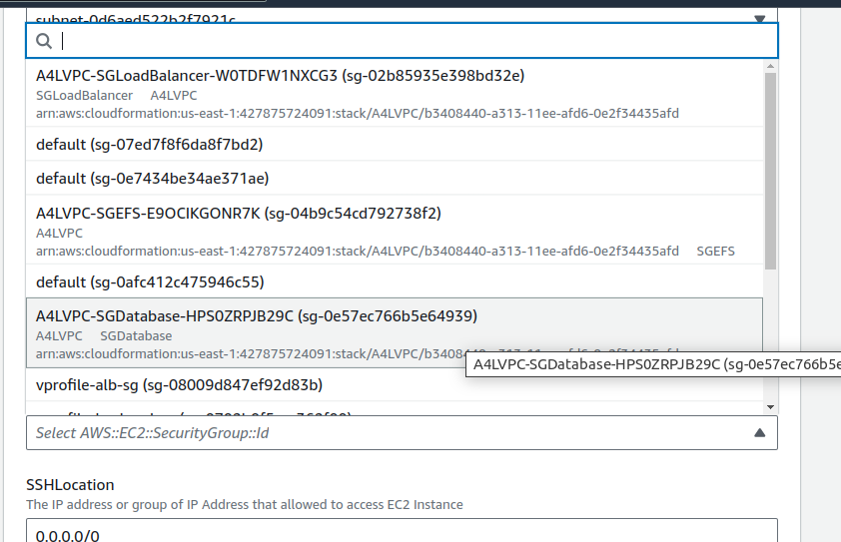
RdsSecurityGroupID
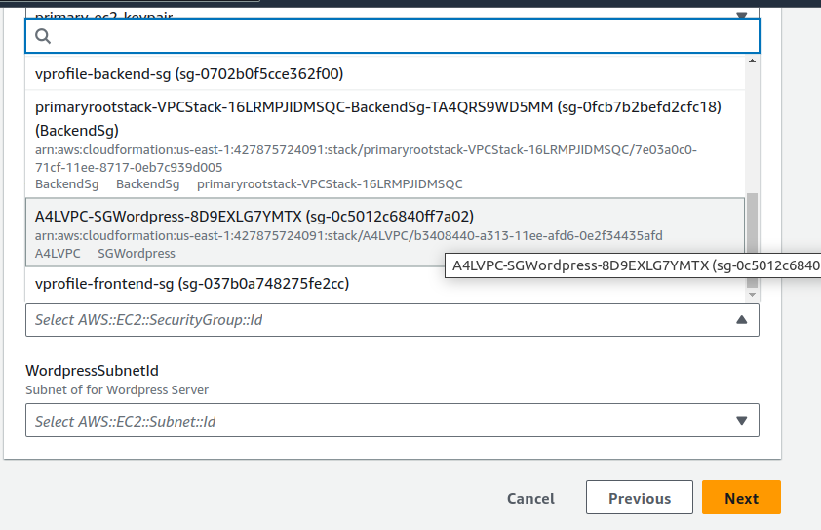
WordpressSecurityGroupID

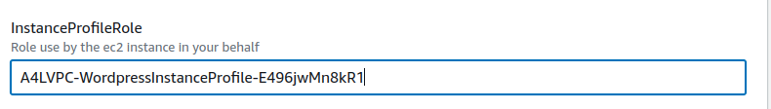

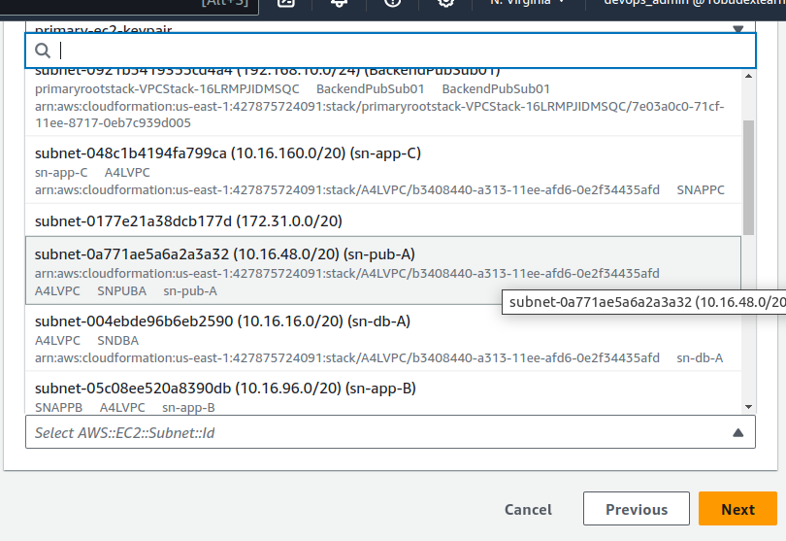
WordpressSubnetId

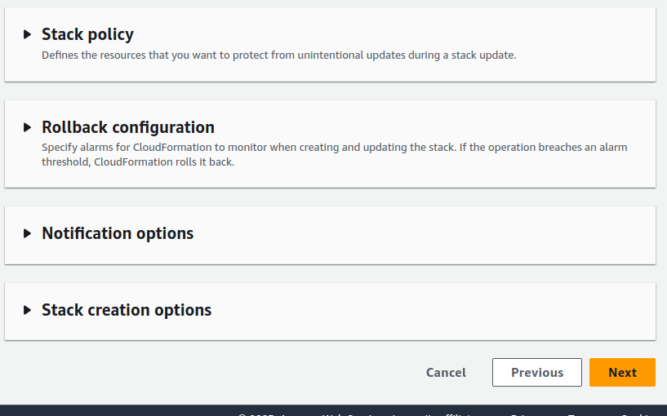
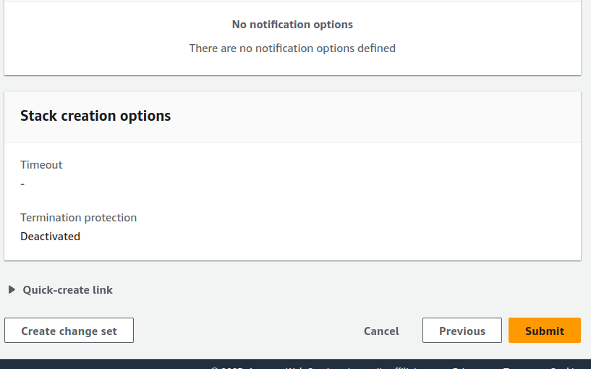

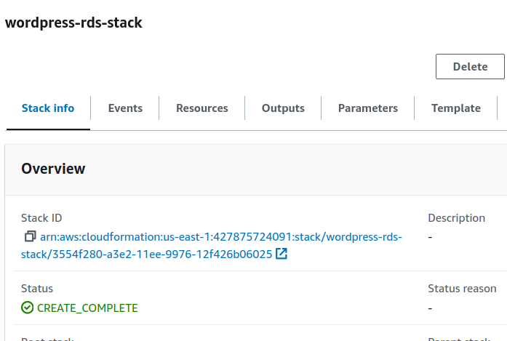
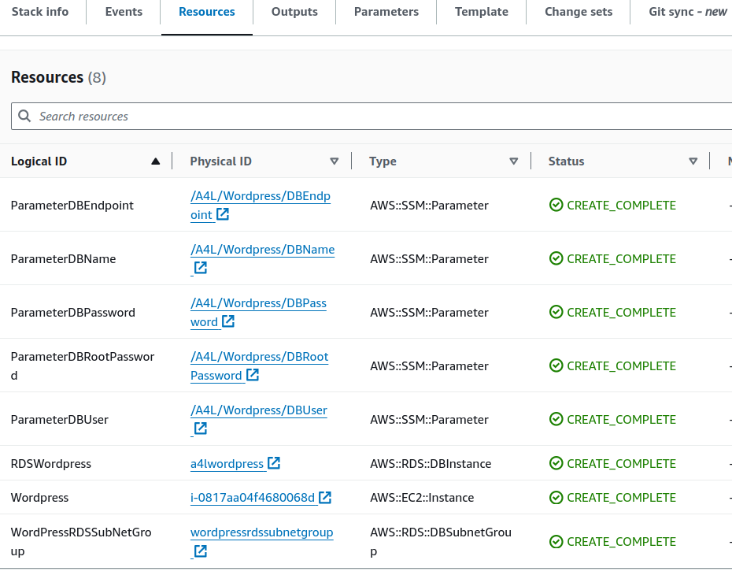

- Check If the RDS Instance is created successfully.
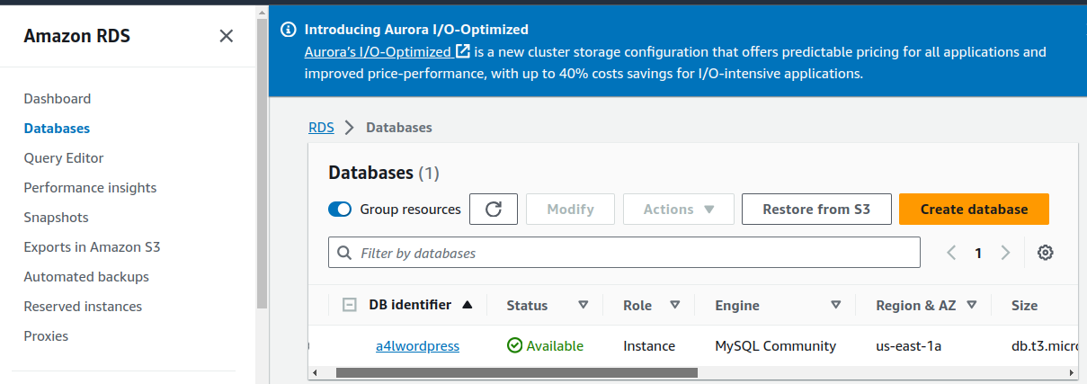

- Go to https://console.aws.amazon.com/ec2/v2/home?region=us-east-1#Instances:sort=desc:tag:Name
- Select the Wordpress Instance and copy the Public IP Address and paste it to browser address bar
- If this page will appear that means the wordpress setup is successful

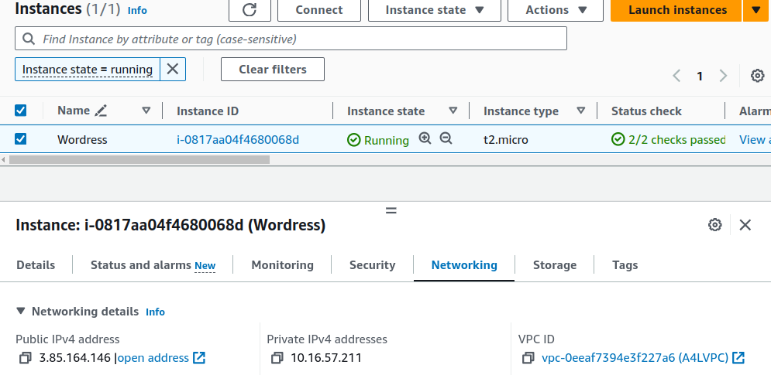

Paste this Public Ip Address to Browser
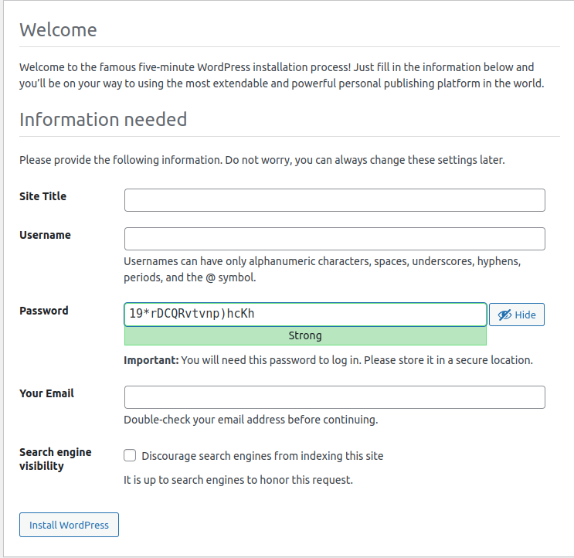

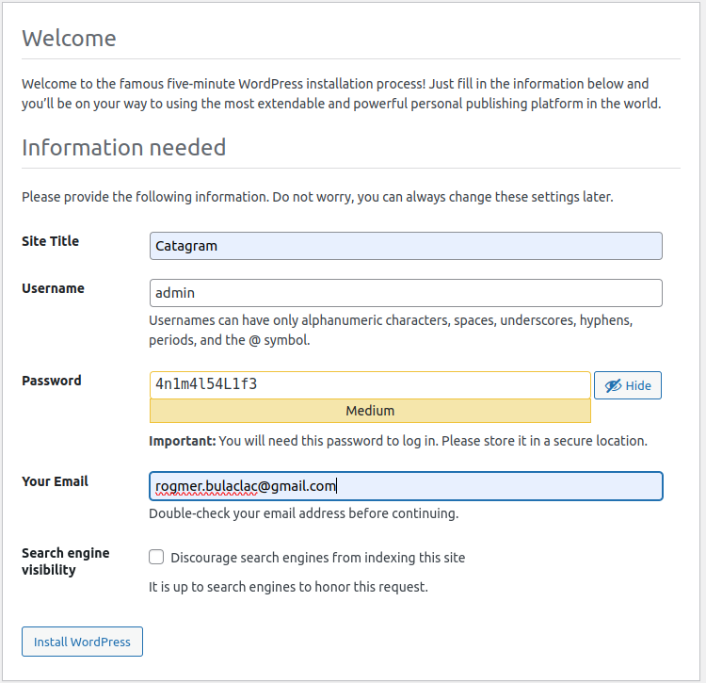
- Let Perform Initial Configuration and make a post

Click This
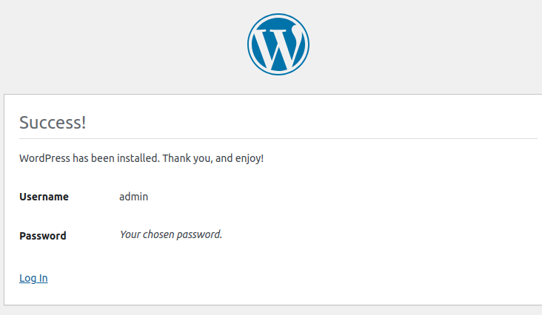
Click This
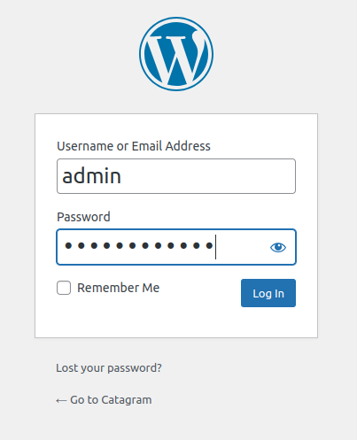

Login User and Password here:

- Click Posts in the menu on the left
- Select Hello World! Click Bulk Actions and select Move to Trash Click Apply
- Click Add New
- If you see any popups close them down
- For title The Best Animal(s)!
- Click the + under the title, select Gallery Click Upload
- Select some animal pictures.... if you dont have any use google images to download some Upload them
- Click Publish
- Click Publish Click view Post

Final Result:

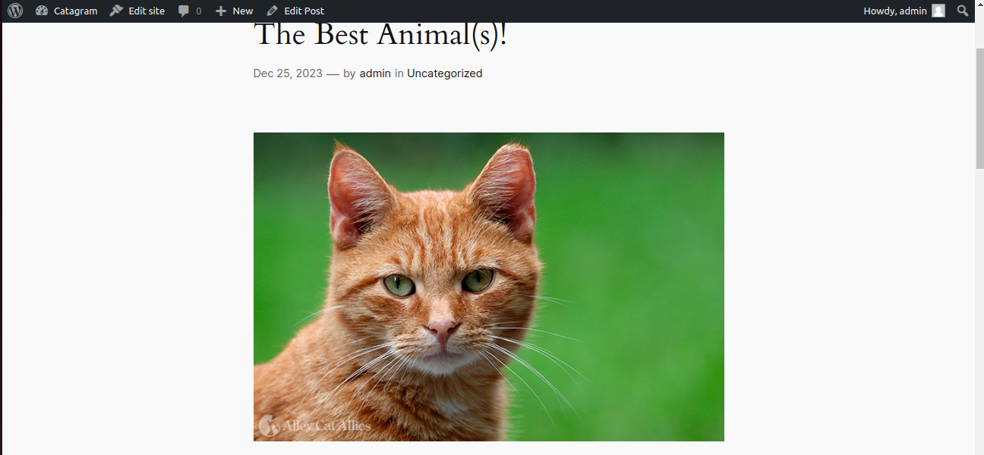

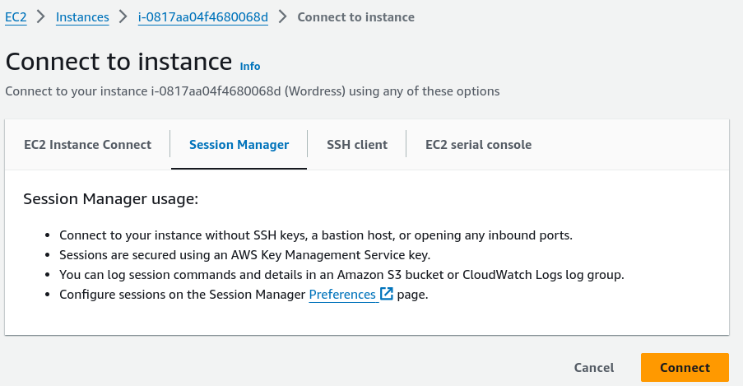
- Let's log in to our instance to ensure that no MariaDB/MySQL database is installed:
Click This

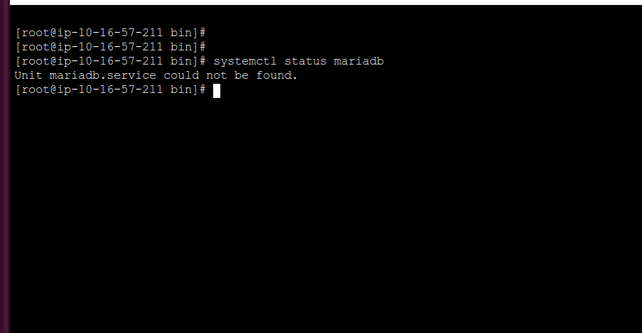
NO database Installed Confirm

- Log in to the RDS instance to make sure the WordPress database was installed successfully.

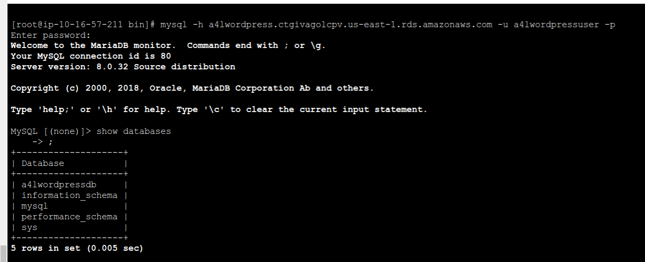
Database credentials is located in Parameter Store
Wordpress Db
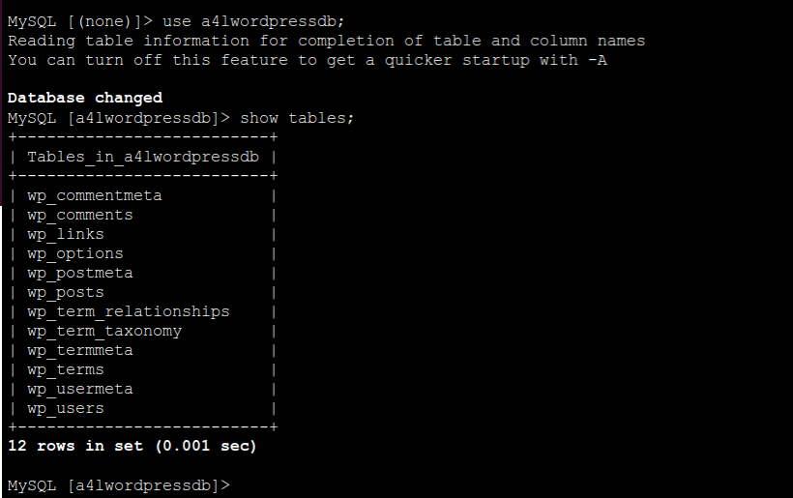
Wordpress Tables

Thats Conclude the Stage 3.....
You can delete the the wordpress-stack.. dont delete the A4LVPC we will need it in Stage 4

