Project Title: Resume Challenge on AWS
Project Source: https://cloudresumechallenge.dev/docs/the-challenge/aws/
Project Repo:

Project Architecure:

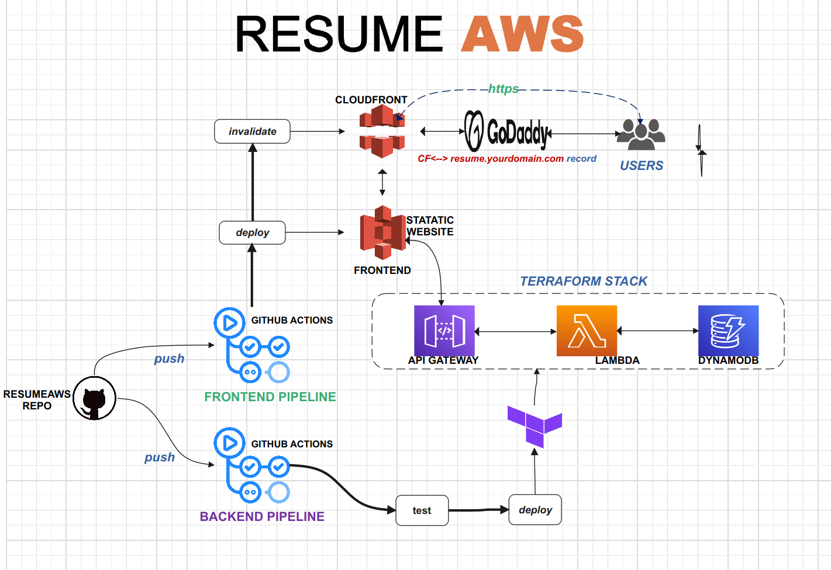
Project Summary:
- Overview: This project focuses on building a Simple WebApps project while applying DevOps principles throughout its Software Development Life Cycle (SDLC).
- Frontend Deployment: Frontend development involves HTML, CSS, and JavaScript. The application will be deployed to an S3 static website with CloudFront for content delivery.
- Custom Domain Setup: Custom domain configuration will be handled using GoDaddy.com for seamless access to the deployed application.
- Backend Development: The backend architecture will utilize AWS Serverless services, employing API Gateway, Lambda Functions, and DynamoDB. Infrastructure provisioning will be managed using Terraform.
- Testing : Testing will be conducted using Pytest because Lambda functions us Python
- Source Code Management: GitHub will serve as the source code repository, facilitating collaborative development and version control.
- CI/CD Pipeline: GitHub Actions will be employed to automate Continuous Integration and Continuous Deployment (CI/CD) processes.

Project Details:
- This is my project structure below. (some files are irrelevant I highlight only the files that are being used)

├── backend
│ ├── a.out
│ ├── backend_github_ctions.yaml
│ ├── hello.c
│ ├── __init__.py
│ ├── lambda_code
│ │ ├── index.py – this file will be deploy on our lambda function
│ │ └── __init__.py
│ ├── requirements.txt - this file content the python package need on this project
│ ├── resume-ai.tf
│ ├── resumecf.yaml
│ ├── resume.yaml
│ ├── terraform
│ │ ├── resume.tf - this file contain our backend infrastructure
│ │ └── variable.tf -
│ └── test_code.py – this file contain our python test code
└── frontend - all files in this folder will be uploaded to our S3 bucket
├── index.html
└── myresume_photos.jpg

My CICD pipelines are place in the hidden directory .github cd to it and type tree command as well

└── workflows
├── resume_backend_pipeline.yml - this file is our code for backend pipeline
└── resume_frontend_pipeline.yml - this file is our code for frontend pipeline

2. I Create S3 Bucket name robudex-resume, enable static website hosting and turn the Block all public access off (this will serve as my frontend of my app)

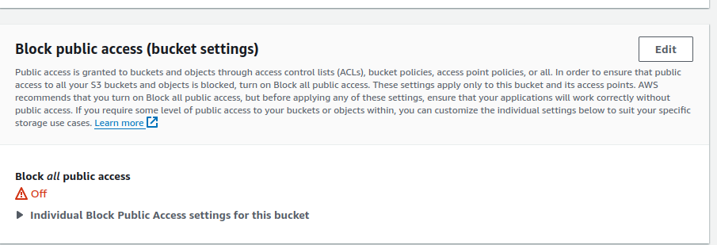

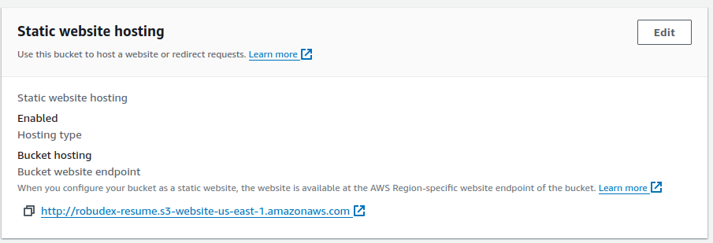

3. Because I plan to use a custom domain I needs Certificate to make this happen. I request certificte to AWS Certificte Manager (ACM)

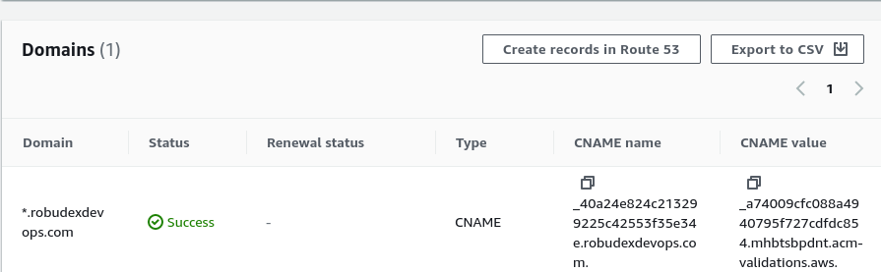

I Add this CNAME records to my godaddy DNS Records and wait for the status to Success.



4.Next I Created Cloudfront Distribution with the S3 bucket that I created earlier is my origin. Because I want the Origin access can only be access by the Cloudfront I set Origin access control settings (which is by the way its recommended).
- For Alternate domain name (CNAME) I used my choosen domain name: resumeaws.robudexdevops.com
- For Custom SSL certificate, I Choose the Certificate that I created
- I set also my Default root Object to index.html
- For the Viewer Setting, I set Redirect HTTP to HTTPS

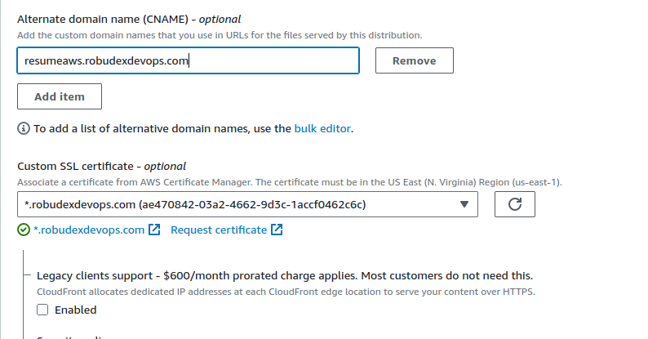
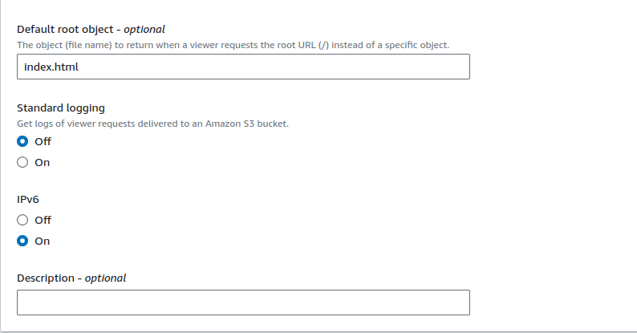
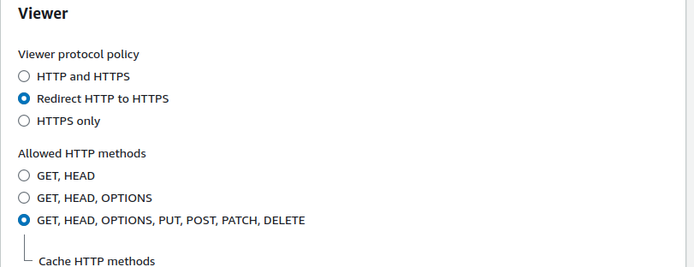

5. After the Cloudfront Distribution creatation is done.
- I Click my Distribution ID,
- Goto Origins and click edit
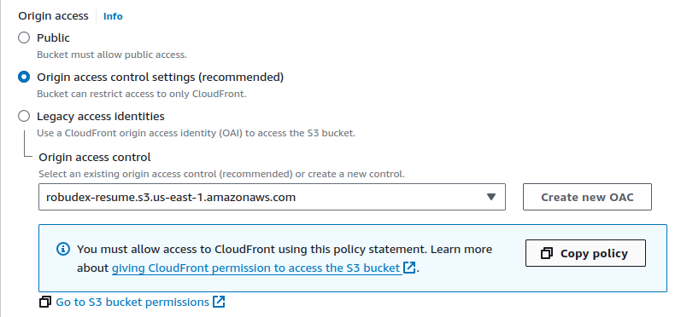
- On the origin Access I copy the policy , go to my S3 Bucket policy and paste the policy there

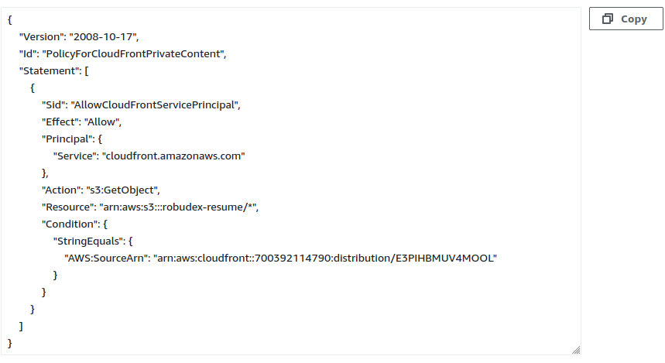

6. Updating my godaddy.com account to point resumeaws.robudexdevops.com to my cloudfront
- Under My robudexdevops.com domain I created CNAME records
resumeaws --> ${MY_CLOUDFRONT_DOMAIN}
- setup Forwading
http://resumeaws.robudexdevops.com --> redirect 301

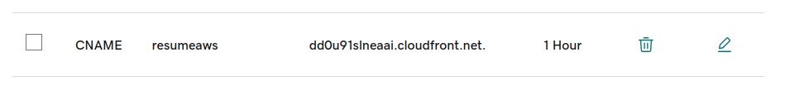
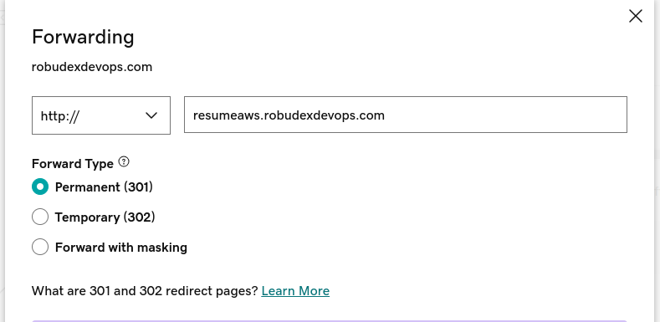

7. Now that my frontend is set. Its time to build the backend
A. For my lambda sdffunction, it is located in backend/lambda_code/ it contains:
- index.py – the source code.
- index.zip – the package that will use by terraform for creating lambda.

B. Build backend Infrastrucure using Terraform

- I cd to my backend/terraform project folder (which contain all codes for my backend infrastructure)
- resume.tf is the file where the aws services are declared to be created
- And run nesssary commands to build the infrastructure (terraform init, terrafrom fmt, terraform validate, terraform plan and terraform apply)
- When terraform finish creating the infrastructure, I copy the newly API Endpoint created on the output append it /resumeaws to the end.
- Open the frontend/index.html and udpate the API endpoint on the javascript section of the file.
- Upload the update index.html file to S3 bucket

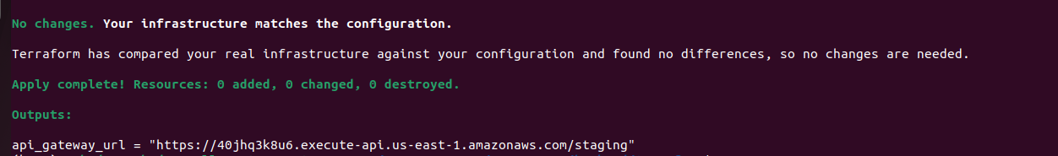

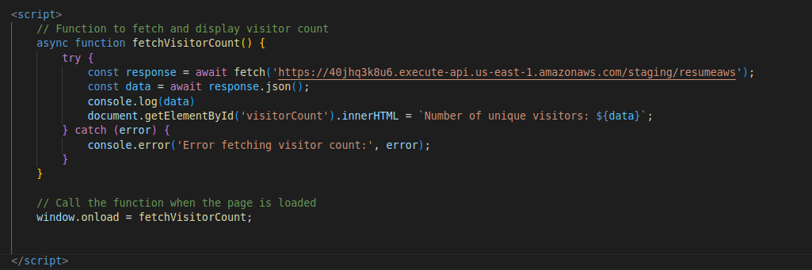

8 Time Test the App. I open the browser the paste my resumeaws.robudexdevops.com
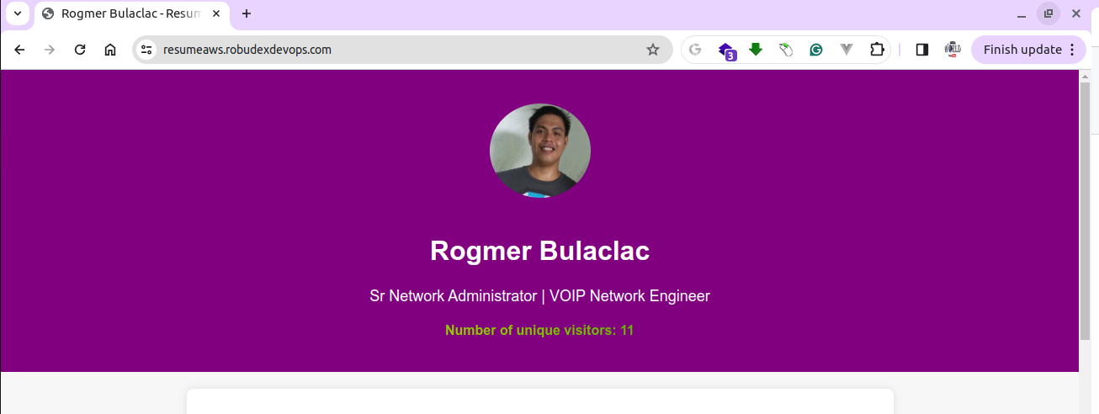

And its working!! with https secure connections. Great!! Its time to build the last piece the most fun one Setup Github Repo upload codes and create CICD pipelines

9. Enable my project repo to use git
- git init
- git add .
- git commit -m “First Comment”
- git checkout -b main
- git branch -d master
Note: (I create branch called main and delete my branch because github now is using main branch as master branch)

10. Creating Github Repo
- On my
- On the Github I created new repository called resume-aws, copy this code

git remote add origin git@github.com:robudexIT/resume-aws.git
git branch -M main
git push -u origin main

11. Add the origin to my project repo and push it to github
- git remote add origin git@github.com:robudexIT/resume-aws.git
- git push -u origin main.

12. Now that all are set. Its time to create CICD using github actions.
- On my project I created .github/workflows directories (mkdir .github/workflows) cd to it (cd .github/workflows) and created two files
- resume_backend_pipeline.yml -> pipeine for my backend
- resume_frontend_pipeline.yml -> pipeline for my frontend

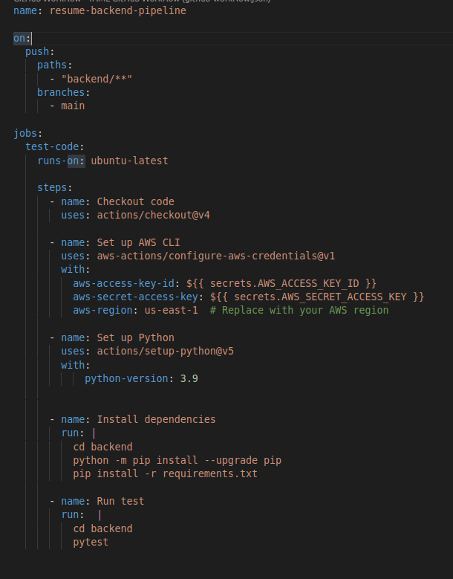
resume_backend_pipeline.yml

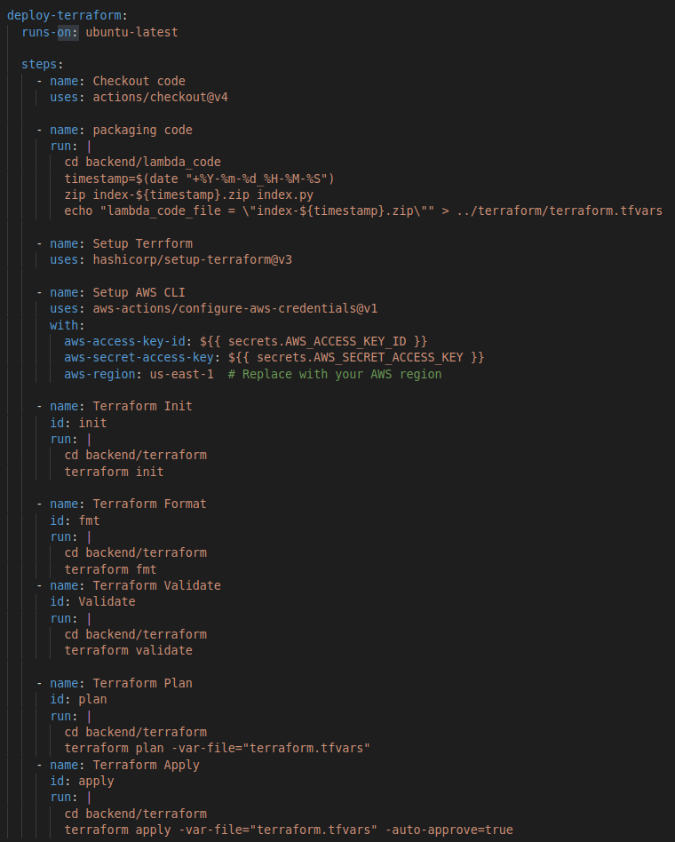

resume_frontend_pipeline.yml
