PROJECT ARCHITECTURE:
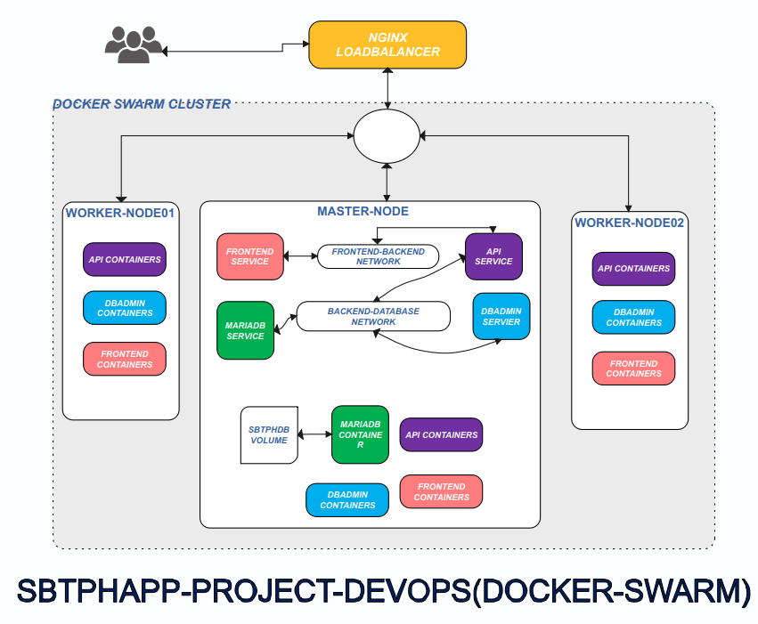

PROJECT DESCRIPTION:

In this project, we will build a Docker Swarm cluster consisting of 1 Master Node and 2 Worker Nodes. We'll deploy our 'sbtphapp' application on this cluster. Additionally, we will add NGINX to act as a load balancer. This project will be deployed on the Digital Ocean Cloud Provider. I chose Digital Ocean because it offers $200 of free credit for 2 months, which is ample for building and completing this project.

PROJECT REQUIREMENTS:
- Digital Ocean Accounts – for Servers
- DockerHub Account – for storing the docker image

SETUP INSTRUCTIONS:
- On Your Digital Ocean account, 4 Droplets with:
- OPERATING SYSTEM => Ubuntu Server 20.04
- SHARED CPU
- Regular Disk type: SSD
- 4GB/2CPU
- Authentication Method => Password => Type your choosen password

2. Name your 4 Droplets, and click Create Droplet

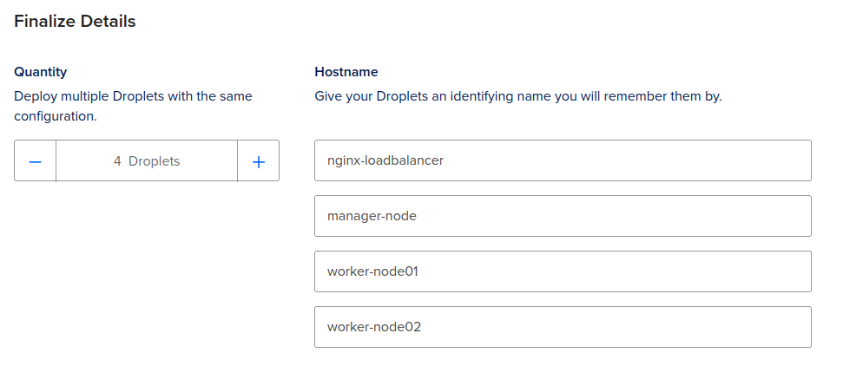
3. Once the Droplets are created, it's time to install the Docker engine on the manager node, worker node 01, and worker node 02, and Nginx on the Nginx load balancer droplet. SSH into these four droplets.

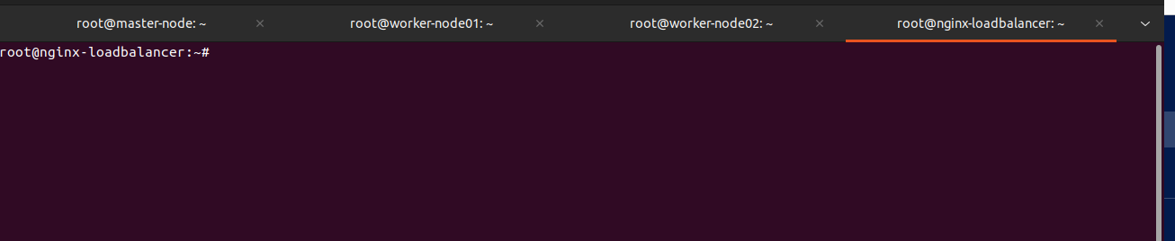

4. Installing docker engines on manager-node, worker-node01 and worker-node02:

Commands:

for pkg in docker.io docker-doc docker-compose docker-compose-v2 podman-docker containerd runc; do sudo apt-get remove $pkg; done

sudo apt-get update -y

sudo apt-get install ca-certificates curl gnupg -y
sudo install -m 0755 -d /etc/apt/keyrings

curl -fsSL https://download.docker.com/linux/ubuntu/gpg | sudo gpg --dearmor -o /etc/apt/keyrings/docker.gpg

sudo chmod a+r /etc/apt/keyrings/docker.gpg
echo \ "deb [arch=$(dpkg --print-architecture) signed-by=/etc/apt/keyrings/docker.gpg] https://download.docker.com/linux/ubuntu \ $(. /etc/os-release && echo "$VERSION_CODENAME") stable" | \
sudo tee /etc/apt/sources.list.d/docker.list > /dev/null
sudo apt-get update – ysudo apt-get install docker-ce docker-ce-cli containerd.io docker-buildx-plugin docker-compose-plugin -y

4. On master-node, get eth0 (Public IP) and type this command: (Make sure replace it without Public IP)

docker swarm init --advertise-addr {MANAGER-ETHO-PUBLIC-IP}

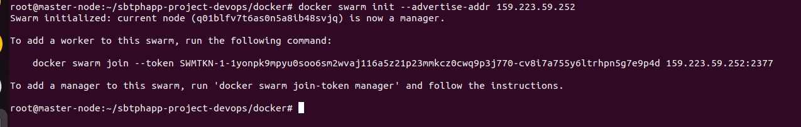
On worker-node01 and worker-node02, paste this command: docker swarm join –token *****

On master-node , check if two workers nodes are successfully joined:

docker node ls

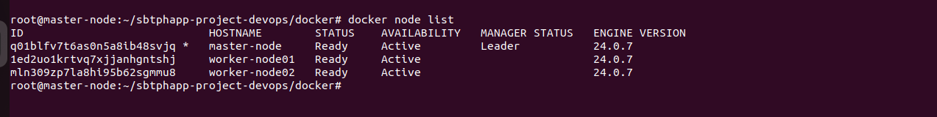

5. On master-node clone this github repo:

git clone -b docker https://github.com/robudexIT/sbtphapp-project-devops.git

6. cd to sbtphapp-project-devops/docker, get your nginx-loadbalancer server public ip and run this command: (make sure you replace it your nginx-loadbalancer server ip before running the command)

find frontend/dist/js/* -type f -exec sed -E -i 's/\b([0-9]{1,3}\.){3}[0-9]{1,3}:8081\b/YOUR_NGINX_LOADBALANCER_PUBLIC_IP_HERE:8081/g' {} +

7. Run this commnd:

docker compose build

8. Login to your docker hub account, check the docker images created, tag the images and push it to your docker hub.

docker login
docker images
docker tag docker-api:latest {YOURDOCKERHUBUSERNAME}/sbtphapi:latest
docker tag docker-frontend:latest {YOURDOCKERHUBUSERNAME}/sbtphapp:latest
docker push {YOURDOCKERHUBUSERNAME}/sbtphapi:latest
docker push {YOURDOCKERHUBUSERNAME}/sbtphapp:latest

9. On the master-node, create docker overlay network

docker network create -d overlay frontend-backend
docker network create -d overlay backend-database

10. On the master-node create mariadb service, check if mariadb service was created, check if which Node mariabdb container is running

docker service create --detach=true --name mariadb --network backend-database \
--env-file ./env/db.env \
--mount type=volume,source=sbtphdb,target=/var/lib/mysql \
--mount type=bind,source=$(pwd)/database,target=/docker-entrypoint-initdb.d \
--publish 3307:3306 mariadb

docker service ls

docker service ps mariadb

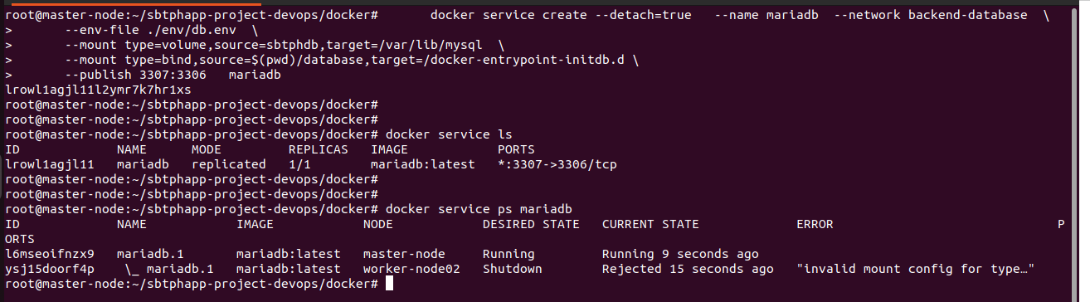

11. On master-node create api service, check if api service was created, check if which Node api container is running. (Make sure your replace it with your docker hub username account

docker service create --name api --env-file ./env/api.env \
--network backend-database -p 8081:80 --replicas=5 \
{YOUR-DOCKER-HUB-USER}/sbtphapi

docker service ls

docker service ps api
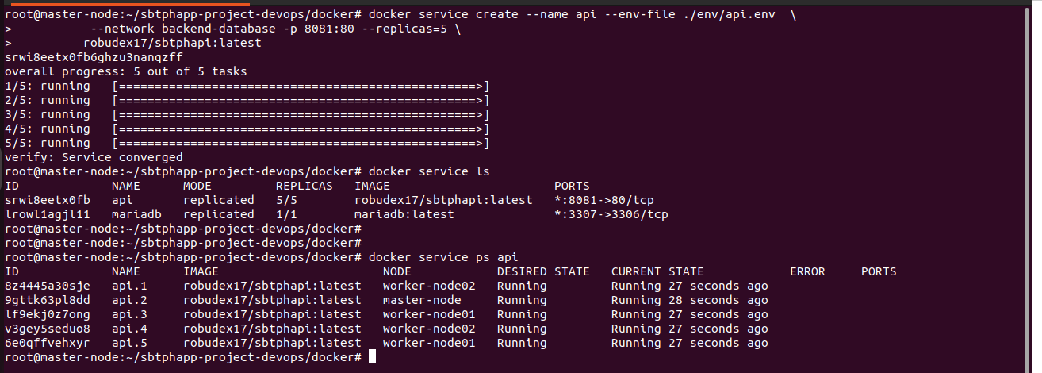

12. On master-node create frontend service, check if frontend service was created, check if which Node frontend container is running. (Make sure your replace it with your docker hub username account

docker service create --name frontend \
--network frontend-backend -p 8082:80 --replicas=5 \
{YOUR-DOCKER-HUB-USER}/sbtphapp:latest

docker service ls

docker service ps frontend

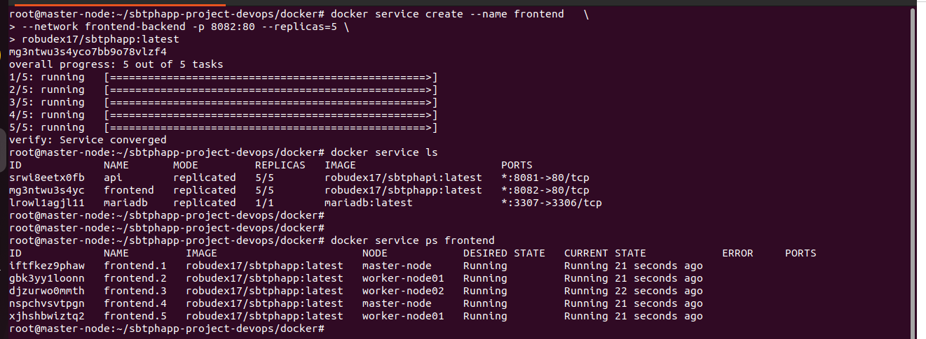

12. On master-node create dbadmin service, check if dbadmin service was created, check if which Node dbadmin container is running.

docker service create --name dbadmin --network backend-database --env-file ./env/admin.env -p 8083:80 phpmyadmin

docker service ls

docker service ps dbadmin

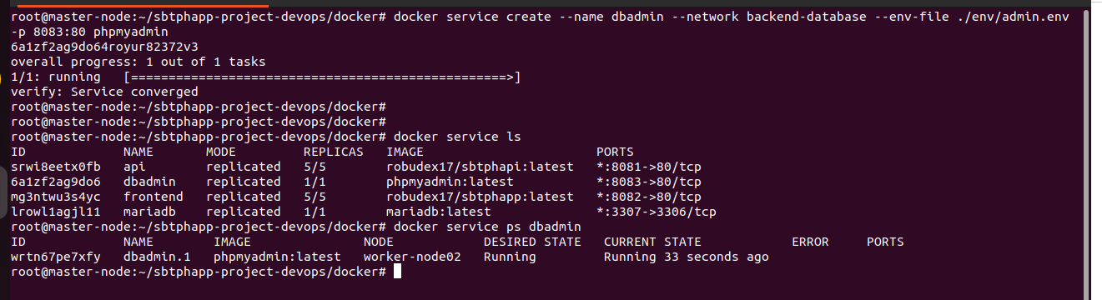

13. On nginx-loadbancer, inginx

sudo apt update

sudo apt-get install nginx

14. Create /etc/nginx/conf.d/load-balancer.conf file and paste this config below: (Make sure you update the ip address on the upstream directives:

upstream frontend {
server {MASTER-NODE-IP-HERE}:8082;
server {WORKER-NODE01-IP-HERE}:8082;
server {WORKER-NODE02-IP-HERE}:8082;
# Add more Swarm nodes as needed
}

upstream backend {
server {MASTER-NODE-IP-HERE}:8081;
server {WORKER-NODE01-IP-HERE}:8081;
server {WORKER-NODE02-IP-HERE}:8081;

# Add more servers as needed
}

upstream phpmyadmin {
server {MASTER-NODE-IP-HERE}:8083;
server {WORKER-NODE01-IP-HERE}:8083;
server {WORKER-NODE02-IP-HERE}:8083;

# Add more servers as needed
}

server {
listen 8082;
server_name yourdomain.com;

location / {
proxy_pass http://frontend;
proxy_set_header Host $host;
proxy_set_header X-Real-IP $remote_addr;
proxy_set_header X-Forwarded-For $proxy_add_x_forwarded_for;
proxy_set_header X-Forwarded-Proto $scheme;
}
}

server {
listen 8081;
server_name yourdomain.com;

location / {
proxy_pass http://backend;
proxy_set_header Host $host;
proxy_set_header X-Real-IP $remote_addr;
proxy_set_header X-Forwarded-For $proxy_add_x_forwarded_for;
proxy_set_header X-Forwarded-Proto $scheme;
}
}

server {
listen 8083;
server_name yourdomain.com;

location / {
proxy_pass http://phpmyadmin;
proxy_set_header Host $host;
proxy_set_header X-Real-IP $remote_addr;
proxy_set_header X-Forwarded-For $proxy_add_x_forwarded_for;
proxy_set_header X-Forwarded-Proto $scheme;
}
}

14. Restart nginx service
nginx -t
systemctl reload nginx
systemctl restart nginx

TESTING THE APP: Get the nginx-loadbalancer ip address

For Api Testing:

http://{NGINX-LOADBALANCER-IP}:8081/sbtph_api/api/active.php

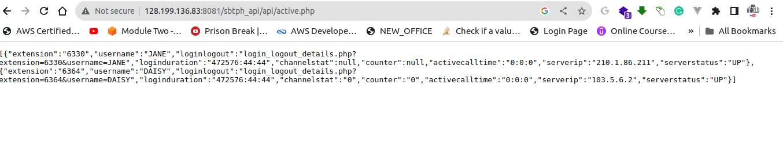
For Frontend Testing:

http://{NGINX-LOADBALANCER-IP}:8082/sbtph_app/login

Extension: 6336
Secret: 99999

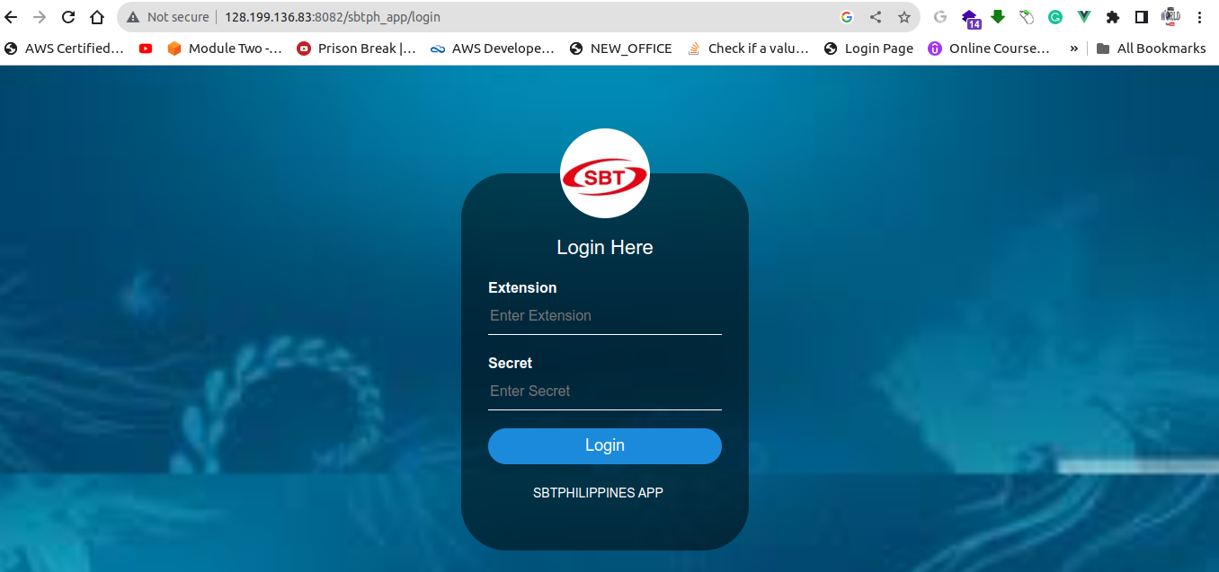

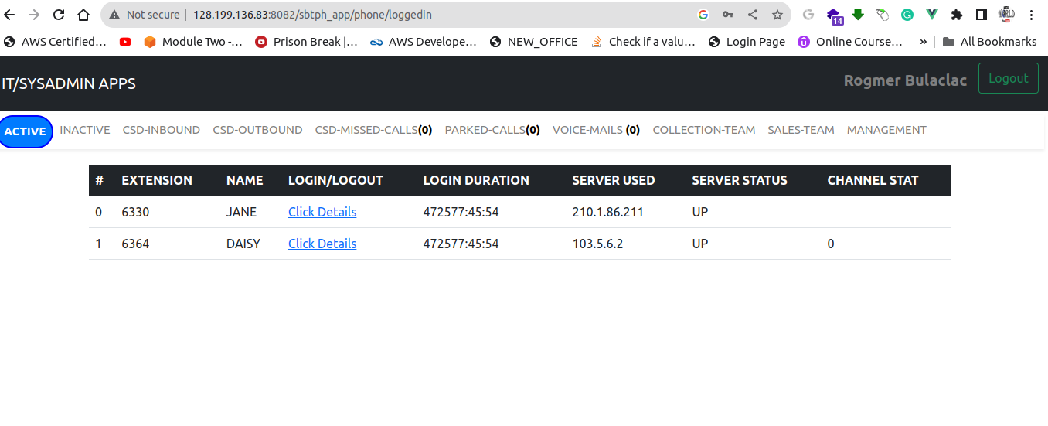

For dbadmin Testing:

http://{NGINX-LOADBALANCER-IP}:8083

