Project Title:JAVA APP CICD USING GITHUB ACTIONS

ProjectRepo:https://github.com/robudexIT/shopping_cart

Notes:The Java application use in this project is clone from this github repository: https://github.com/shashirajraja/shopping-cart.git.

Project Architecture:

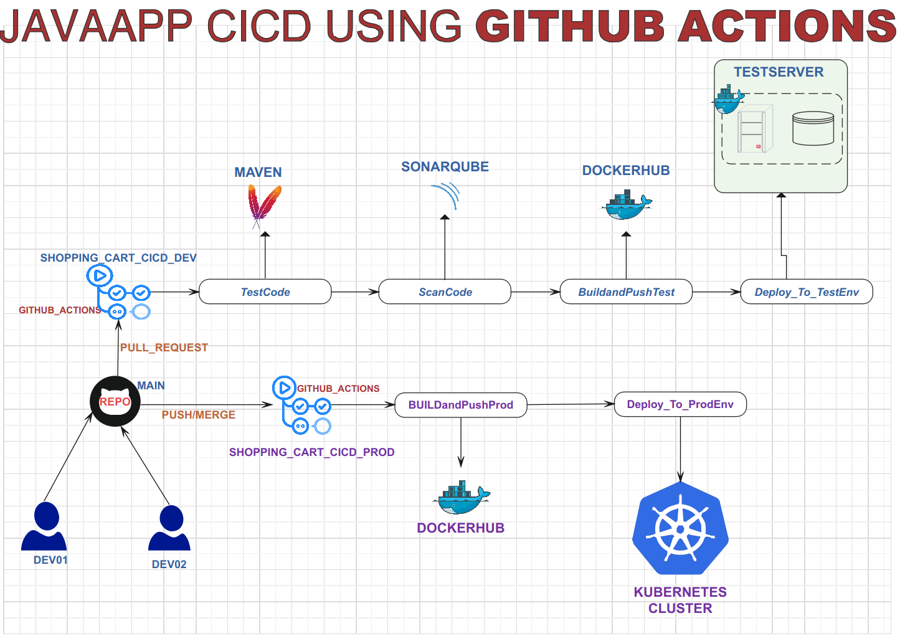

DEV03
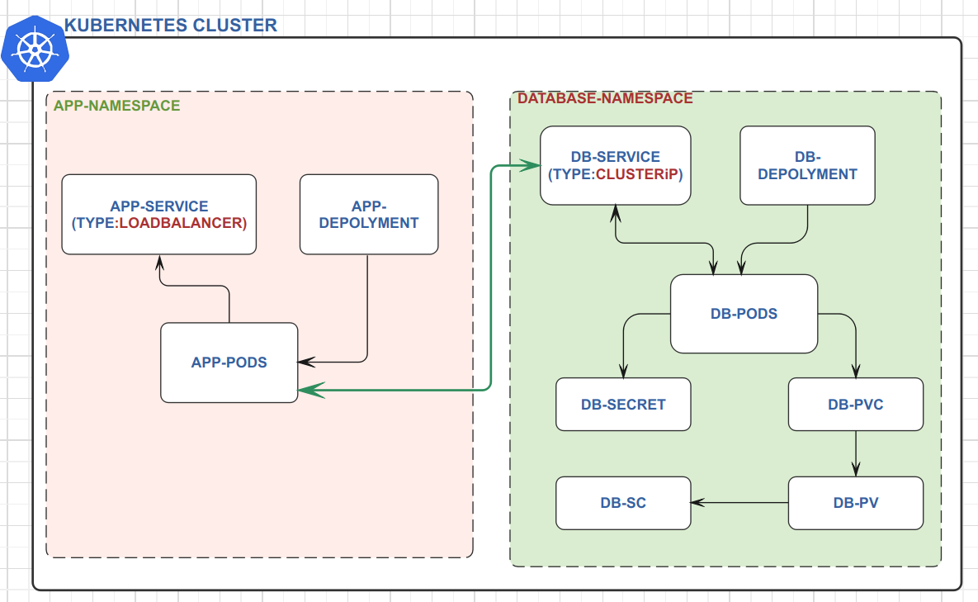
Kubernetes Cluster Architecture:

Project Overview:

- Workflow Structure: The project utilizes two GitHub workflows or pipelines: one dedicated to the development/test environment and the other to the production environment.

- Development/Test Pipeline:

- This pipeline is triggered by pull requests to the main branch.
- It executes the following steps:
- Running tests using Maven.
- Performing additional code analysis using SonarQube.
- Building a Docker image for the test environment.
- Pushing the Docker image to DockerHub.
- Deploying the Docker image to the test environment.

3. Production Pipeline:

- This pipeline is triggered by merges or pushes to the main branch.
- It includes a manual approval step.
- Upon approval, the pipeline:
- Builds and pushes the production Docker image with prod tag.
- Deploys the production image to the production environment.

4. Branch Protection: Direct pushes to the main branch are prohibited to maintain code integrity and ensure changes go through the proper workflow.

5. Team Structure:
- The project team consists of three members:
- Dev01: Responsible for updating the code by initiating pull requests.
- Dev02:Authorized to review and merge code changes.
- Dev03: Responsible for granting manual approval in the CI/CD production pipeline.

6. Test Environment:
- Hosted on a single server running Docker Engine.
- Infrastructure provided by Digital Ocean.

7.Production Environment:
- Utilizes a Kubernetes cluster.
- Infrastructure provided by Digital Ocean.

Project Flow of Execution:

- Create 3 github Users
robudex17 - Dev01:
- Role: Initiates pull requests.
- Responsibilities: Updating code and initiating pull requests for review
robudexIT - Dev02:
- Role: Responsible for merging and pushing changes to the main branch.
- Responsibilities: Reviews pull requests and merges approved changes into the main branch.
robudex2023 - Dev03:
- Role: Responsible for approving or rejecting changes in the production workflow.
- Responsibilities: Manually approves changes in the CI/CD production pipeline or requests adjustments if necessary.

Then I clone https://github.com/shashirajraja/shopping-cart.git java webapps project, create DockerFile and Kubernetes manifiests and push it to my Dev02 users.

Current project tree. Shown below

├── databases
├── Dockerfile – this file will dockerirze the shopping-cart apps
├── kubernetes - this folder contain my kubernetes manifest
├── LICENSE
├── pom.xml
├── README.md
├── src
└── WebContent

Kubernetes Manifest
├── application
│ ├── shopping-cart-app-deployment.yaml
│ └── shopping-cart-app-service.yaml
├── database
│ ├── shopping-cart-db-deploment.yaml
│ ├── shopping-cart-db-service.yaml
│ ├── shopping-cart-pv.yaml
│ ├── shopping-cart-secrets.yaml
│ └── storage-class.yaml

2.On the test server, I created the latest MySQL Docker container and restored the database of the project using these commands.
- cd /root
- git clone https://github.com/robudexIT/shopping_cart.git
- mkdir /root/mysqldb

- docker run --name shopping-cart-db -v /root/mysqldb:/var/lib/mysql -e MYSQL_ROOT_PASSWORD=password123 -e MYSQL_DATABASE=shopping-cart -d mysql:latest
- docker exec -i shopping-cart-db sh -c 'exec mysql -uroot -ppassword123 shopping-cart' < /root/shopping_cart/databases/mysql_query.sql

Then check if database was properly restore by these commands:
- docker exec -it shopping-cart-db bash
- mysql -uroot -ppassword123
- show databases;
- use shopping-cart;
- show tables;

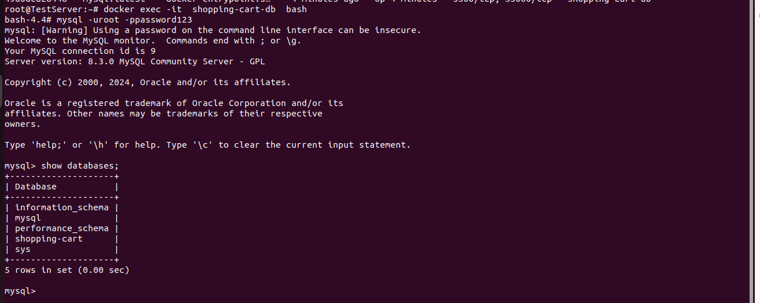
Succesfully Added
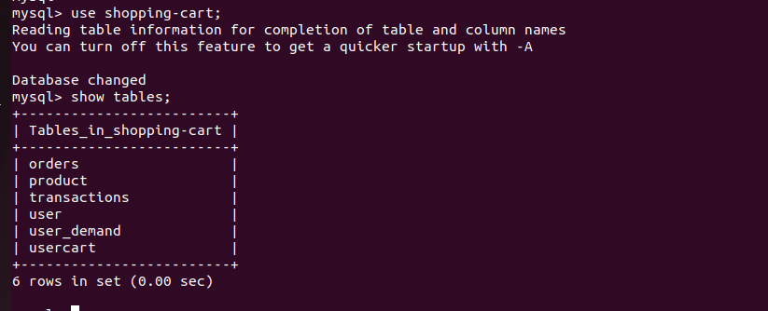

3. On My Kubernetes Cluster I Create Mysql Deployment and Service

Note: I will utilize one of my Kubernetes nodes' storage in a PersistentVolume, ensuring that MySQL deploys on that node. This will be achieved by adding a label to the node and using this label in the deployment. Here are the commands:

- kubectl get nodes

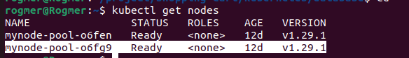
- kubectl label nodes mynode-pool-o6fg9 nodetype=database
- kubectl get node mynode-pool-o6fg9 --show-labels
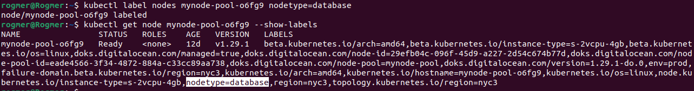
LABEL ADDED

I like the separation between the app and the database so I created namespace
- kubectl create namespace database-namespace
- kubectl create namespace app-namespace

Clone git https://github.com/robudexIT/shopping_cart.git and Navigate (cd) to shopping-cart/kubernetes/database and run the command in order
- kubectl apply -f storage-class.yaml -n database-namespace
- kubectl apply -f shopping-cart-pv.yaml -n database-namespace
- kubectl apply -f shopping-cart-pvc.yaml -n database-namespace
- kubectl apply -f shopping-cart-db-deploment.yaml -n database-namespace
- kubectl apply -f shopping-cart-db-service.yaml -n database-namespace

Verify Kubernetes Objects
- kubectl get namespace
- kubectl get sc -n database-namespace
- kubectl get pv -n database-namespace
- kubectl get pvc -n database-namespace
- kubectl get deployment -n database-namespace
- kubectl get service -n database-namespace
- kubectl get pods -n database-namespace

4. Restore shopping-cart database to shopping-cart-mysql pod with commands
- kubectl get pods -n database-namespace
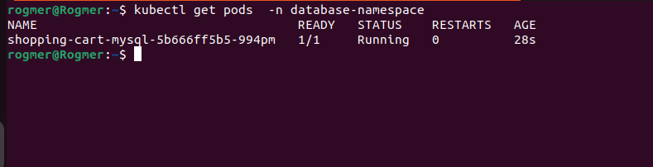

- kubectl cp shopping_cart/databases/mysql_query.sql shopping-cart-mysql-5b666ff5b5-994pm:/tmp --namespace database-namespace
- kubectl exec -it shopping-cart-mysql-5b666ff5b5-994pm -n database-namespace -- bash -c 'mysql -u root -ppassword123 shopping-cart < /tmp/mysql_query.sql'
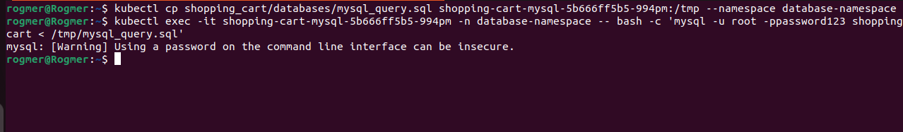

- kubectl exec -it shopping-cart-mysql-5b666ff5b5-994pm -n database-namespace – bash
- mysql -uroot -ppassword123
- show databases;
- use shopping-cart;
- show tables;
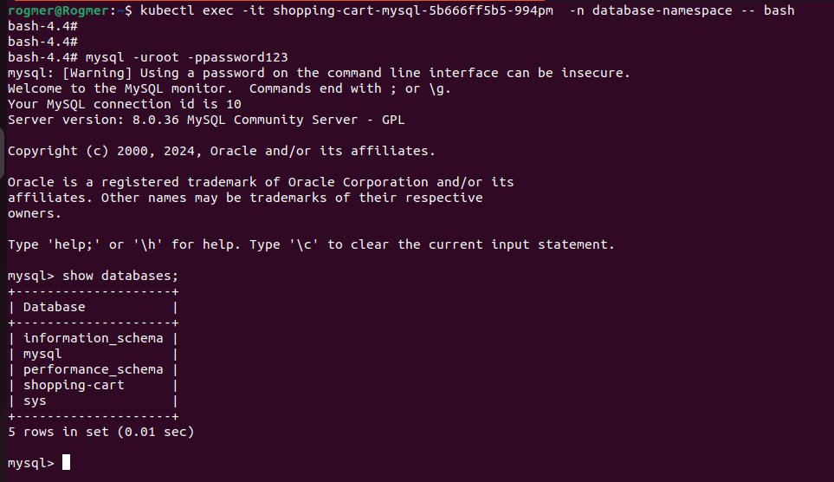
Successfully Added
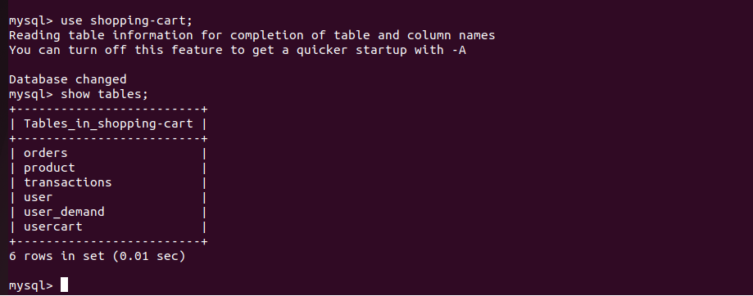
Successfully Added

5. Now that the MySQL databases are installed on the test server and in the Kubernetes cluster, it's time to set up the DockerHub repository, SonarQube (organization, project, quality gates and token).

DockerHub:

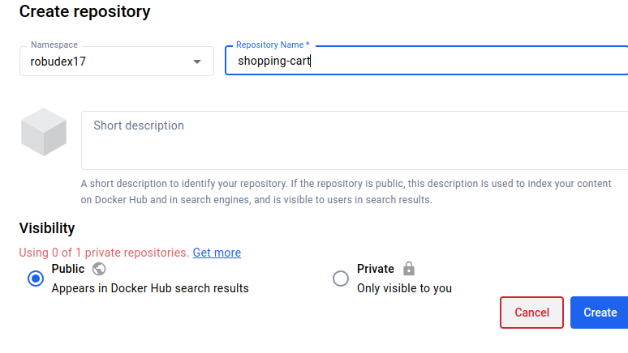

Sonarqube Organization and Project
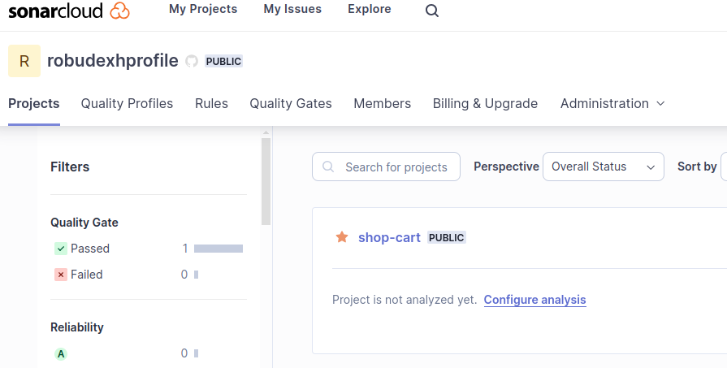

Quality Gates have been added with the name "shop_cart_gate". I have configured it to be less restrictive setting coverage to 0.0% and duplicated lines to 10.0%. Please note that this configuration is not recommended and is solely for demonstration purposes.
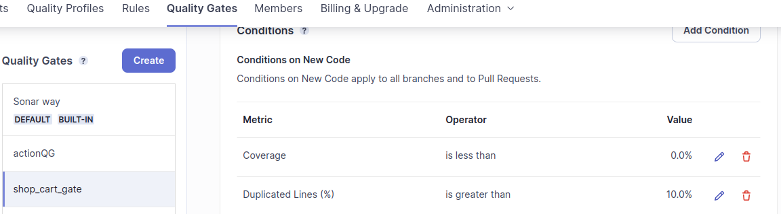

ADD THESE ONLY TWO METRICS

Add Token

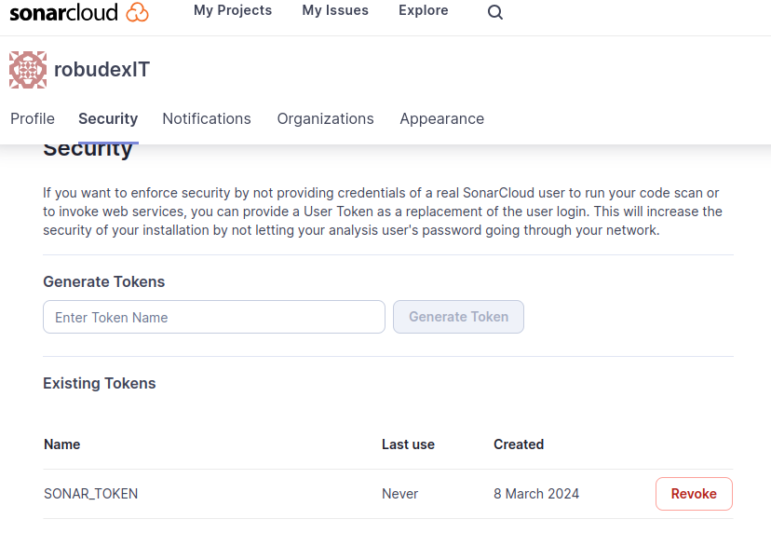

6. Configure Repo Settings, Add Production Environment, Secrets And Github Workflows/Pipelines

Add Dev01 and Dev03 as Collaborators:
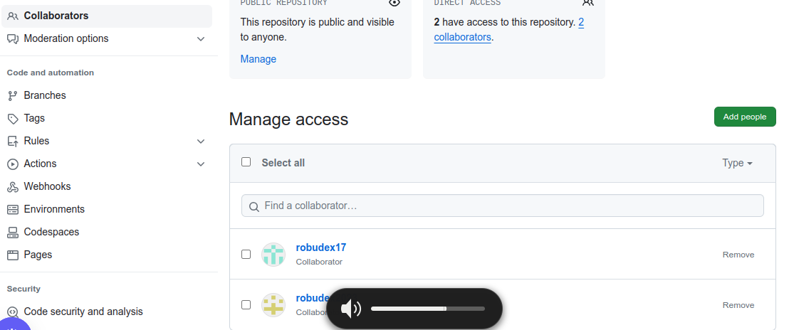
ADD DEV01 AND DEV03 AS COLLABORATORS
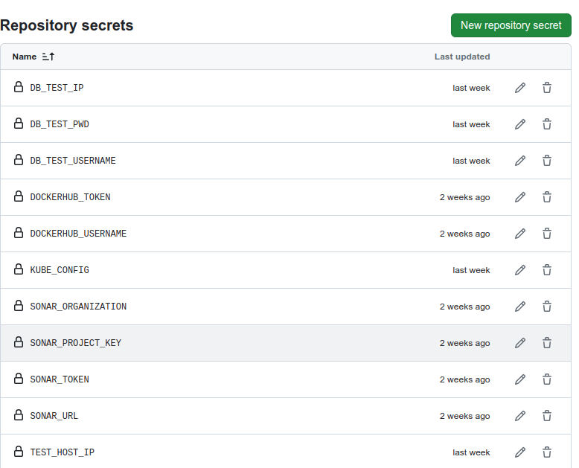
Next I add the secrets and production environment. (Settings-> Security>Secrets and Variables->Actions)

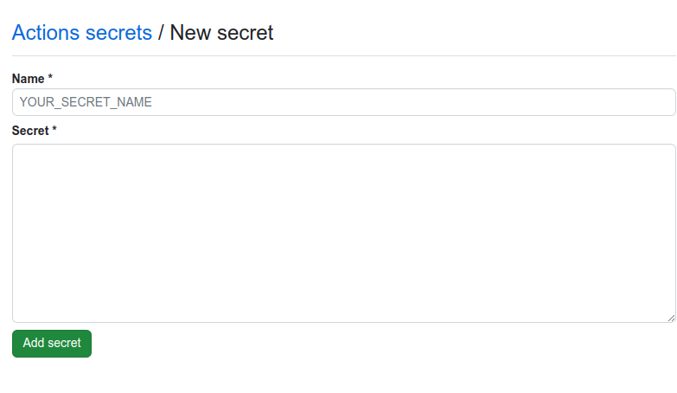

These are secrets that I added

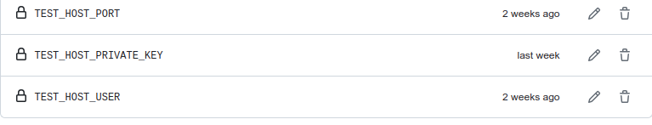

DB_TEST_IP - mysql docker container IP Address running on Test Server.
You can get docker containter ip address by (docker inspect <container-name>/container-id)

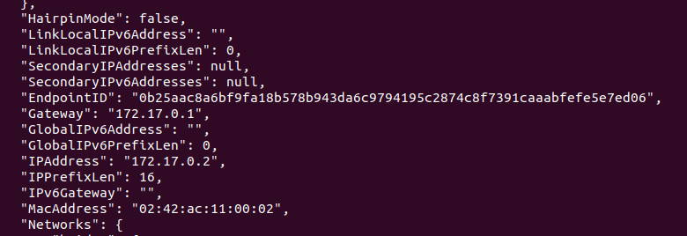
MYSQL CONTAINTER IP ADDRESS

DB_TEST_PWD - mysql docker container password running on Test Server

DB_TEST_USERNAME - mysql docker container root user running on Test Server

DOCKERHUB_USERNAME – dockerhub username

DOCKERHUB_TOKEN – dockerhub password

KUBE_CONFIG – kubernetes cluster configuration you can get this in .kube/config

SONAR_ORGANIZATION – your sonarqube organization on this project
SONAR_PROJECT_KEY – your sonarqube project key
SONAR_TOKEN - your sonarqube token
SONAR_URL – sonarqube url (https://sonarcloud.io)

TEST_HOST_IP – IP address of the Test Server
TEST_HOST_PORT – Test Server SSH port

TEST_HOST_PRIVATE_KEY - Test Server Private Key
You can generate key using (ssh-keygen).
TEST_HOST_USER – Test Server User (root)
Create Production Environment and Add Dev03 as reviewer. Production pipeline will not run without the approval of Dev03
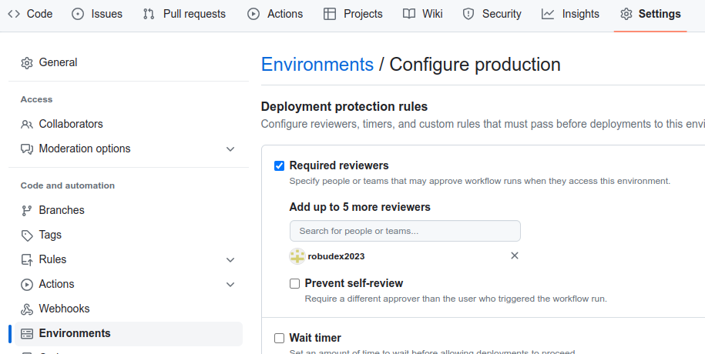
ADD DEV03 USER

Production Environment Secrets

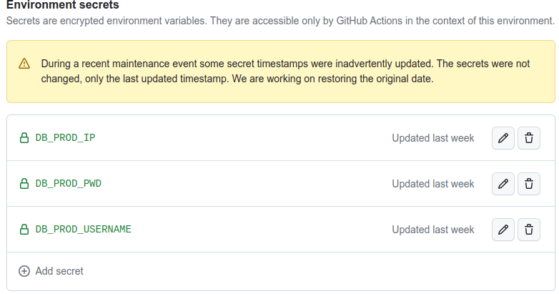
DB_PROD_IP – mysql Pod IP address in kubernets cluster
DB_PROD_USERNAME – mysql Pod username in kubernetes cluster
DB_PROD_PWD– mysql Pod password in kubernetes cluster

Creating Test/Dev Pipelines:
- Now that All secrets and environment are setup its time to create Pipelines

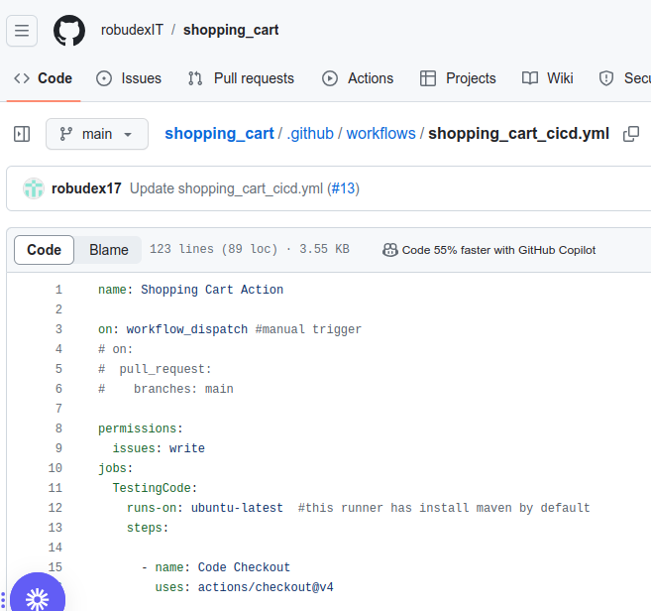
On My Dev02 shopping_cart repo, I created new blank workflow name it shopping_cart_cicd.yml
SET TO MANUL TRIGGER INTIALLY

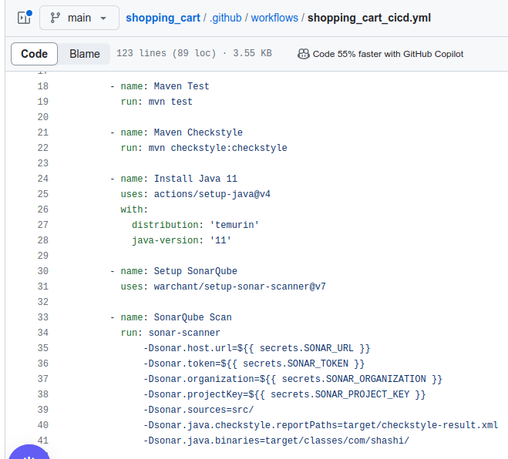

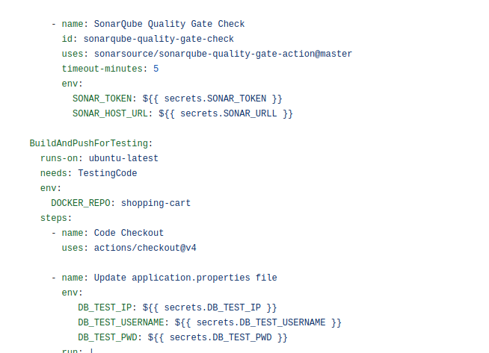

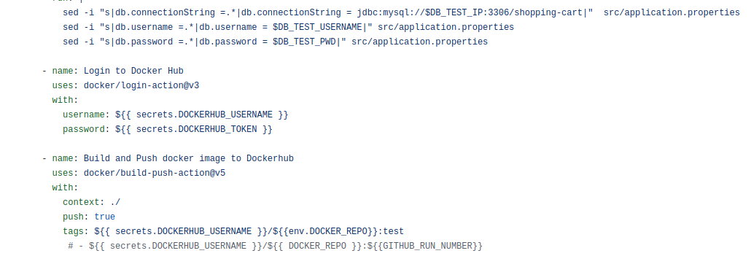

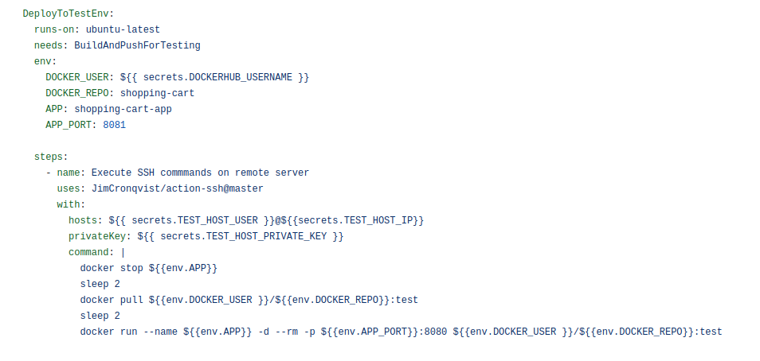

Creating Production Pipelines:On My Dev02 shopping_cart repo, I created new blank workflow name it shopping_cart_cicd_production.yml

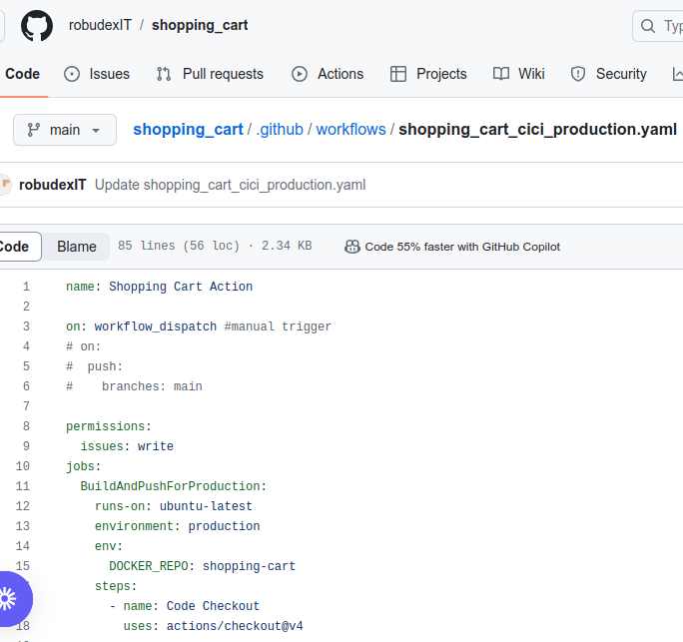
SET TO MANUL TRIGGER INTIALLY
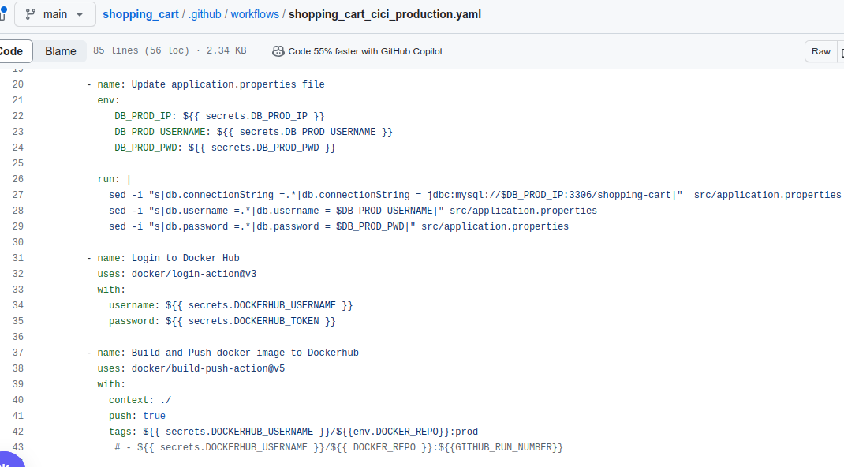

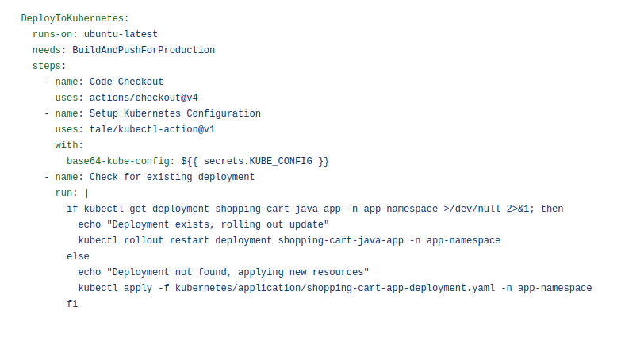

As you notice, I tempoary set the two pipelines to manual trigger (workflow_dispatch) to avoid running the pipeline because it is not ready yet.

Create Branch Rules for main branch. Settings -> Branches
Check the Option Seen below:
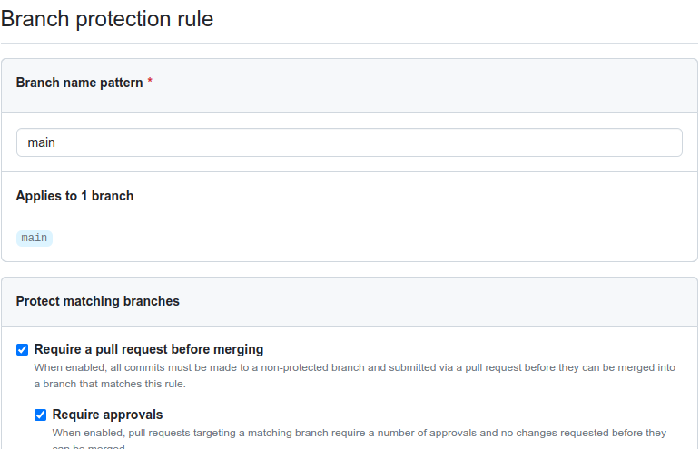

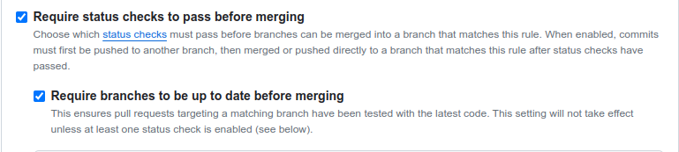
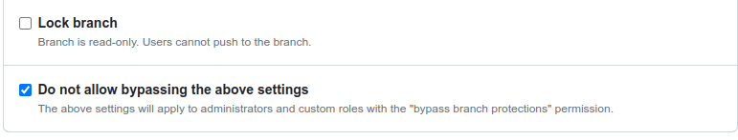

On Settings-> General-> Pull Requests

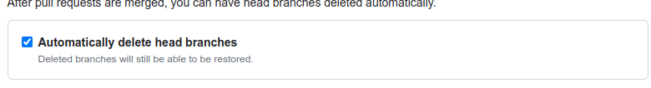

7. Now All are Set, Its time to test.

On Dev01-> I Update shopping_cart_cicd.yml from workflow_dispatch to pull_request

As you can see. It cannot directly push to main to make some changes. Click Propose changes, Description and create pull request

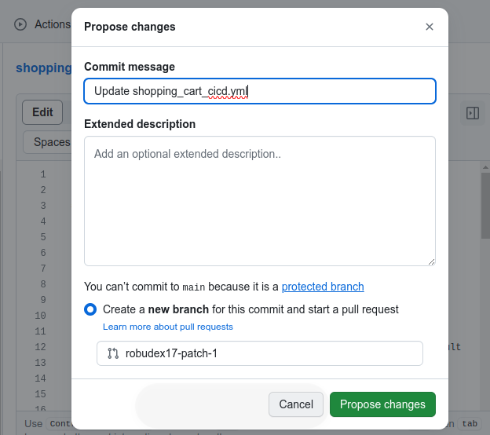

CLICK THIS

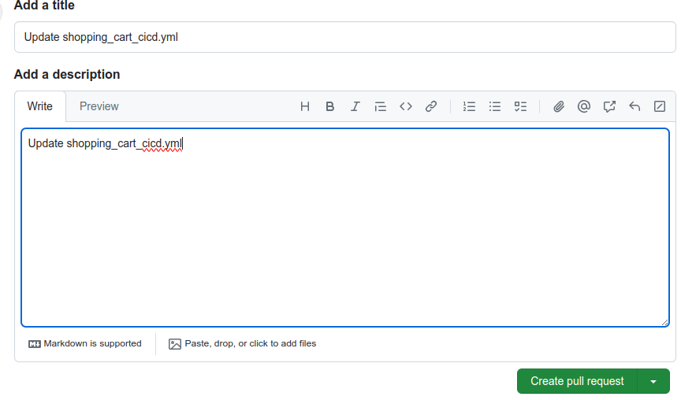
ADD SOME MEANINGFUL DESCRIPTION
Goto Dev02 Account and check the Pull Request and Approved it

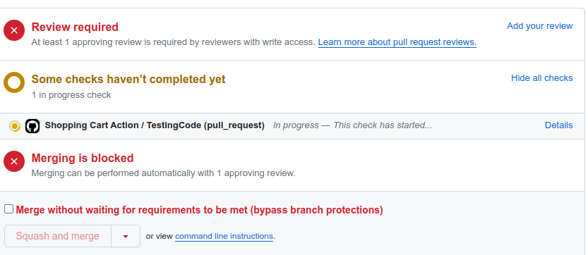
CLICK THIS
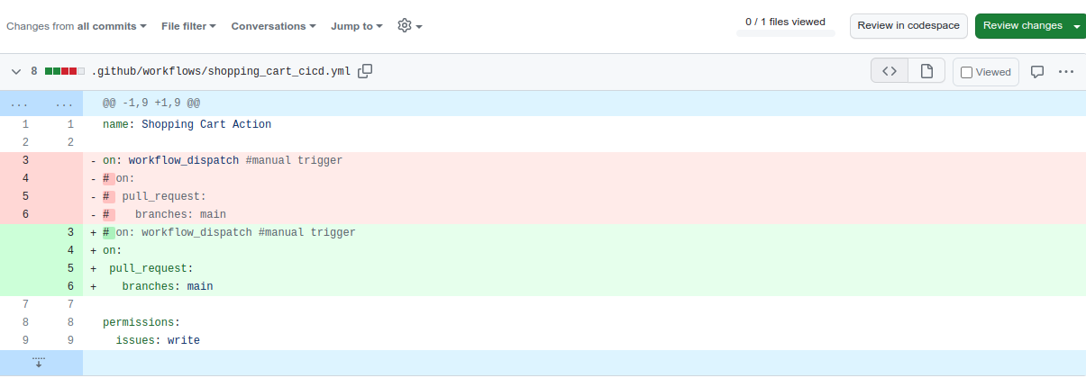
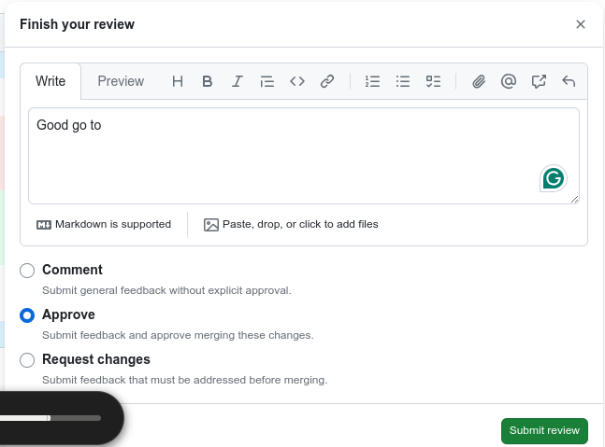
CLICK THIS
MAKE SOME REVIEW COMMENT

Goto Actions and see that the shopping_cart_cicd execute successfully.

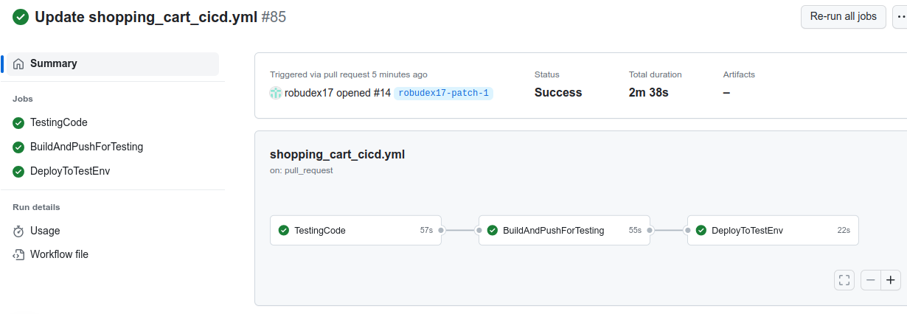
TEST PIPELINE SUCCESSFULLY RUN

Java Webapp is successfully install in Test Server

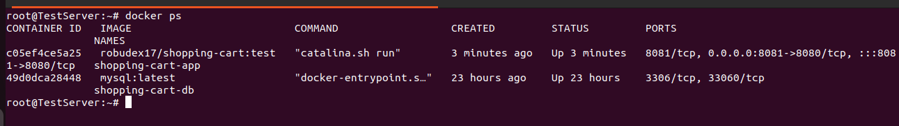


Paste Test Server Public ip and 8081 port
TEST SERVER PUBLIC IP AND PORT

After ensuring the successful deployment on the Test Env, it's time to merge the changes into the main branch. To do so, Dev02 should navigate to the Pull Requests section, select the relevant pull request, and opt for the "Squash and Merge" option. This action condenses all commits from the feature branch into a single commit before merging them into the main branch.

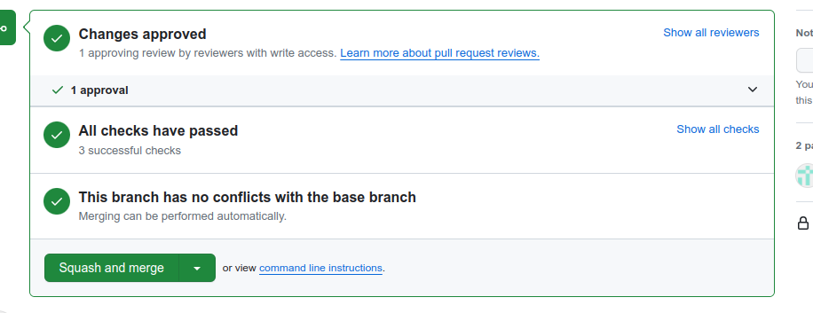
CLICK THIS

Notice that the change .github/workflows/shopping_cart_cicd.yml has been merge to main branch

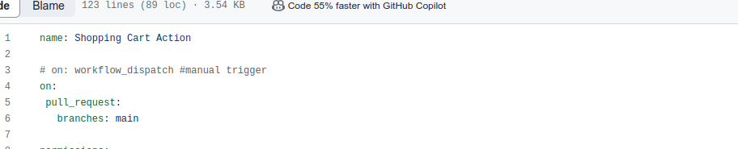
UPDATED CODE AFTER MERGE

Now Its time to update the .github/workflows/shopping_cart_cici_production.yaml as well from workflow_dispatch to push. On Dev01 change the file and create pull request. Then approve the Pull request on the Dev02 Account.

Note that the shopping_cart_cicd pipeline executes because another pull request has been initiated. Please wait for the pipeline execution to finish before merging it into the main branch.

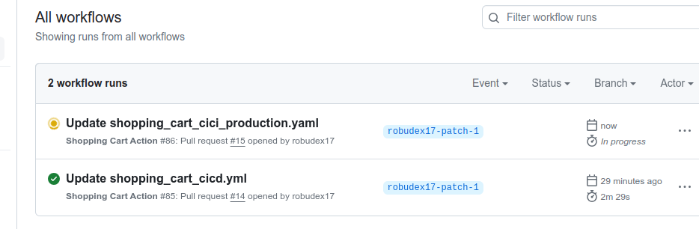
Now because there is a merge or a push in the main branch production pipeline execute
TEST PIPELINE START RUNNING AFTER PULL REQUEST
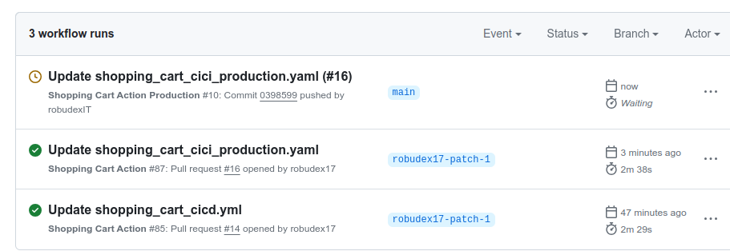
PRODUCTION PIPELINE RUNNING AFTER MERGE AND WAIT FOR MANUAL APPROVAL

Click the workflow and notice it requires approval

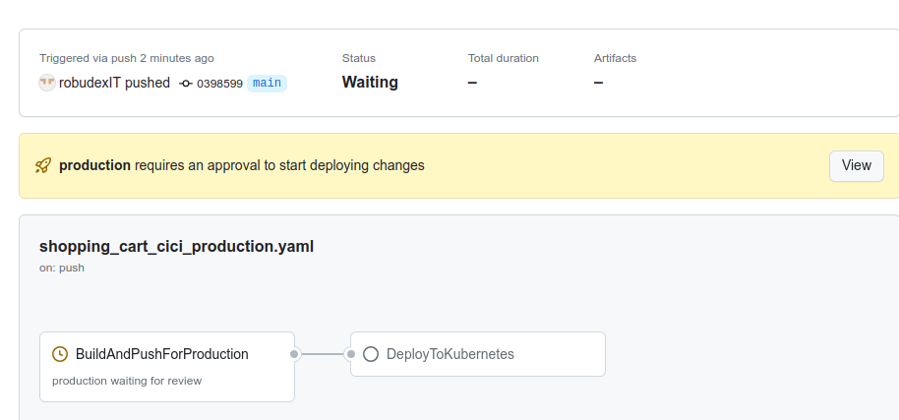
NEED APPPROVAL TO START
NEED APPPROVAL TO START
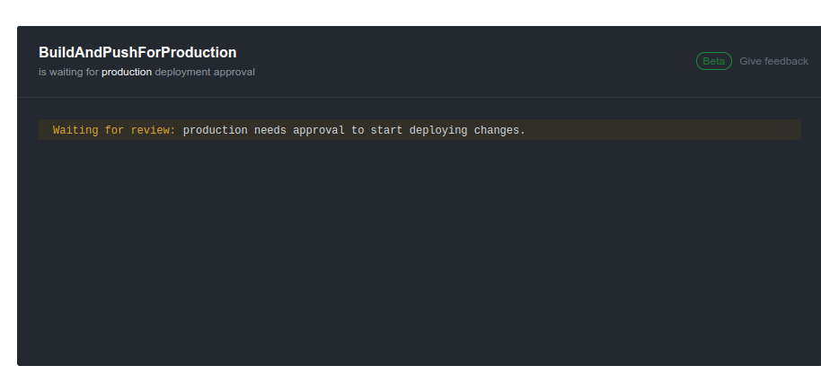

Given that I've configured Dev03 to solely approve or reject the pipeline execution, it won't initiate or conclude without Dev03's approval. Please proceed to Dev03 and provide approval.

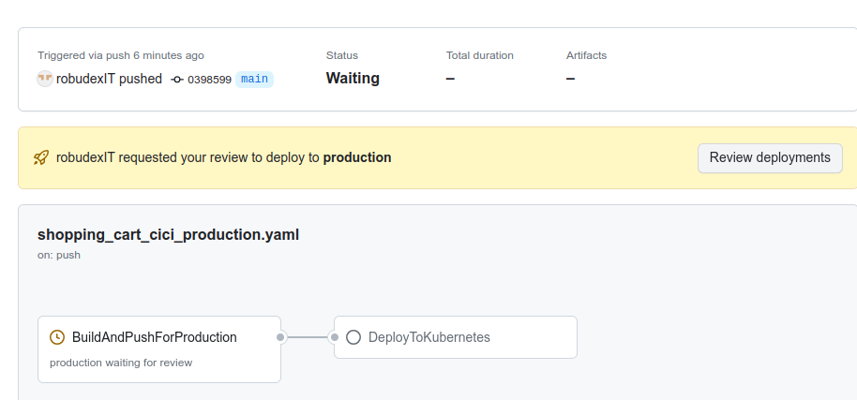
CLICK THIS

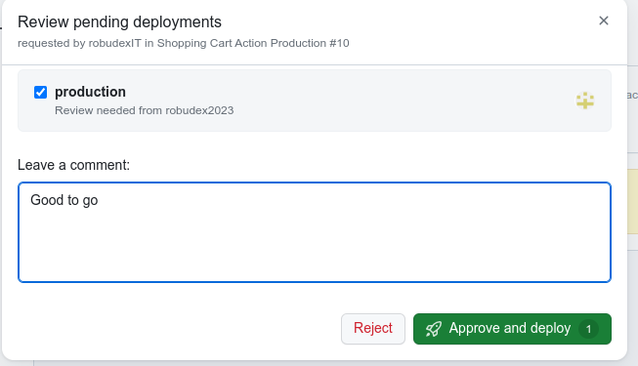
CLICK THIS
ADD USEFUL COMMENT

Production pipeline Start executing...

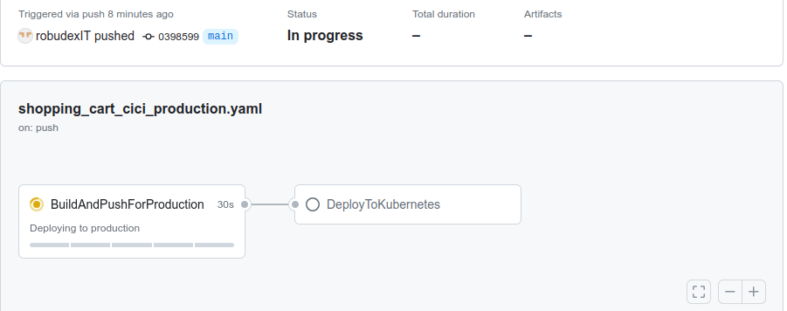
PRODUCTION PIPELINE START EXECUTING

Production pipeline Done.. Check Kubernetes cluster

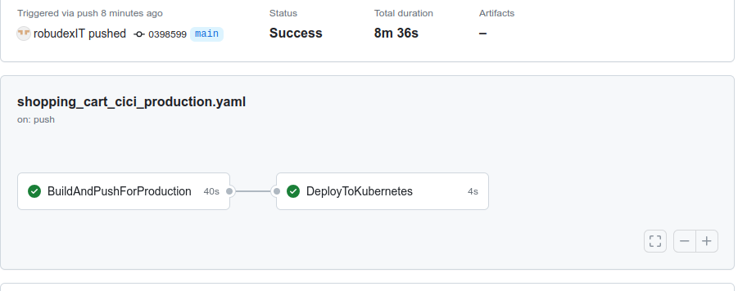
PRODUCTION PIPELINE RUNS SUCCESSFULLY

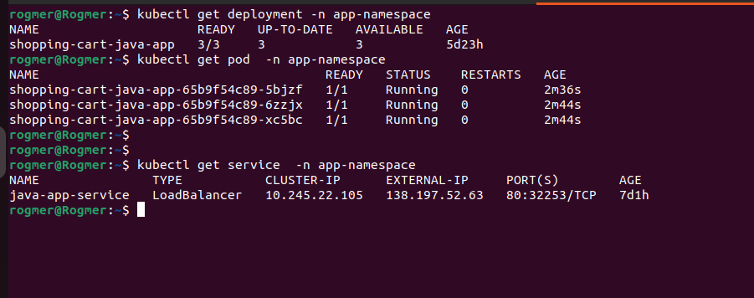

KUBERNETES SERVICE LOADBALANCER PUBLIC IP
Paste the EXTERNAL-IP to browser

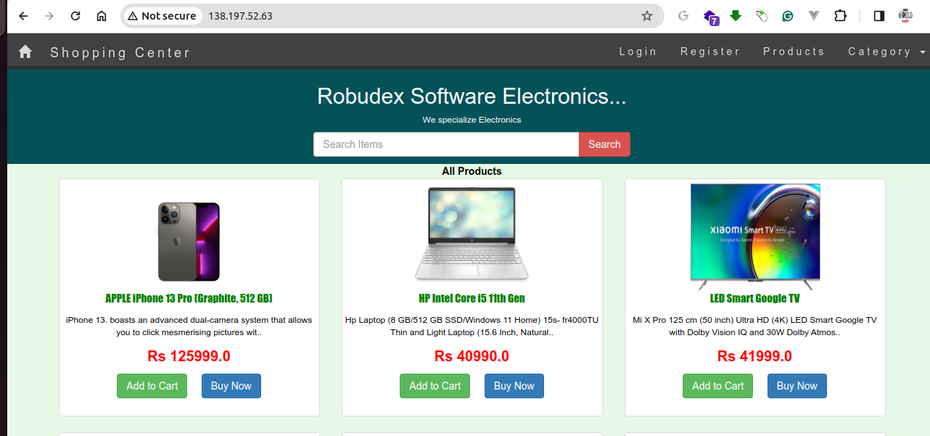

The production environment in the Kubernetes cluster is operational. Now, it's time to implement some code changes, create a pull request, merge it into the main branch, and ultimately, approve the production pipeline.

The flow will start in..

Dev01 --> make code change then make pull request
Dev02 --> Approve the pull request and then merge to main
Dev03 --> Approve the production pipeline execution.

Since I am not a java developer I will change only the header bg color to purple in WebContent/header.jsp file.

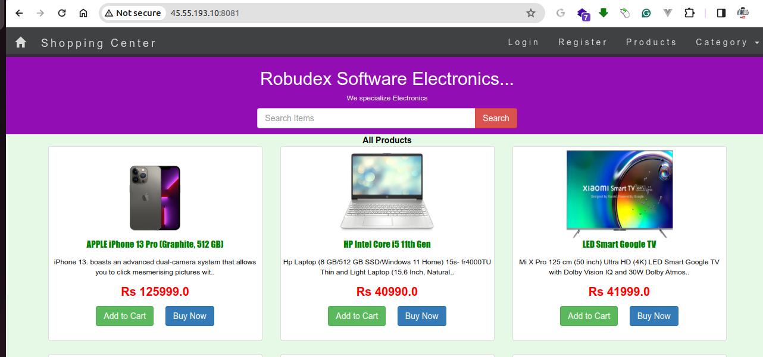
Test Server Code Update
TEST SERVER PUBLIC IP AND PORT
KUBERNETES SERVICE LOADBALANCER PUBLIC IP

Production Server Code Update:



Now Let check our sonarqube acccount. Under Your Organization, Click the shop-cart project, Click the pull_request. And see that result is passed.

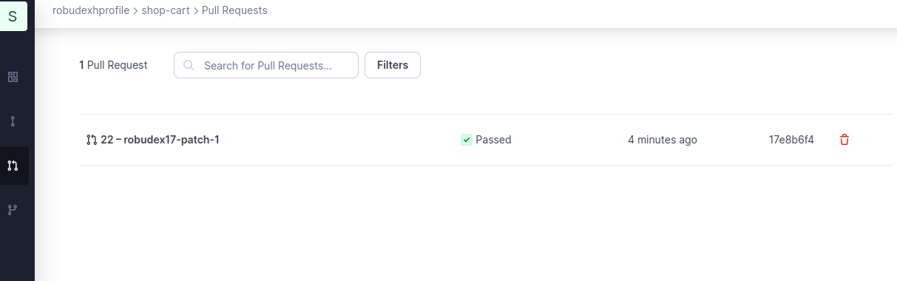
IT PASSED ON QUALITY GATE METRICS
CLICK THIS

Lets Adust the Quality Gate And Re-run the Test Pipeline. (Note that we expect failure execution this time )

ADJUST QUALITY GATE METRICS TO PURPOSELY FAILED THE PIPELINE

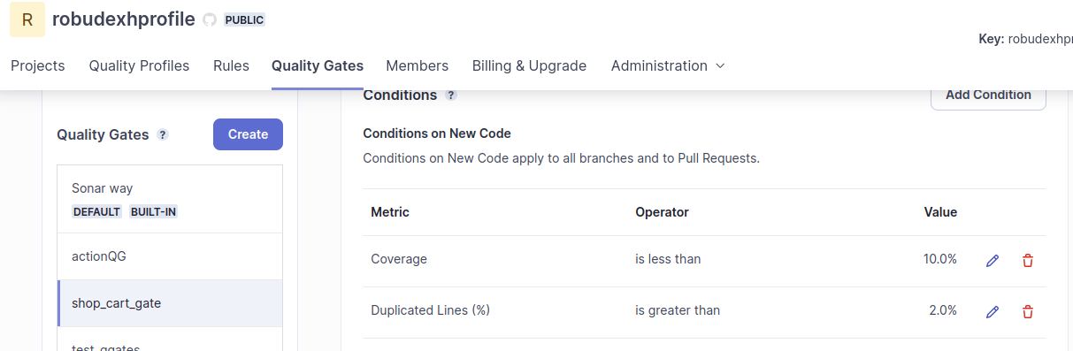

Click the Latest workfows of TEST Pipeline and Re-rull all jobs
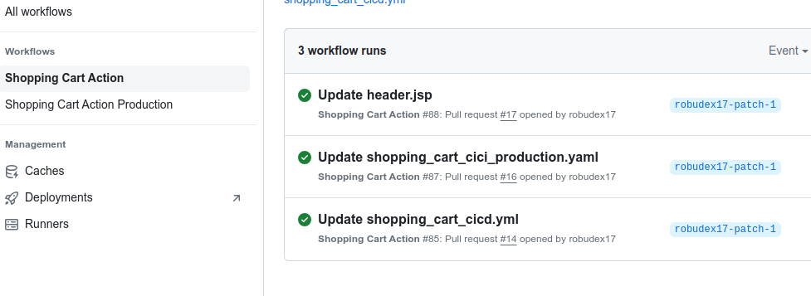
SELECT THE LATEST WORKFLOW JOB
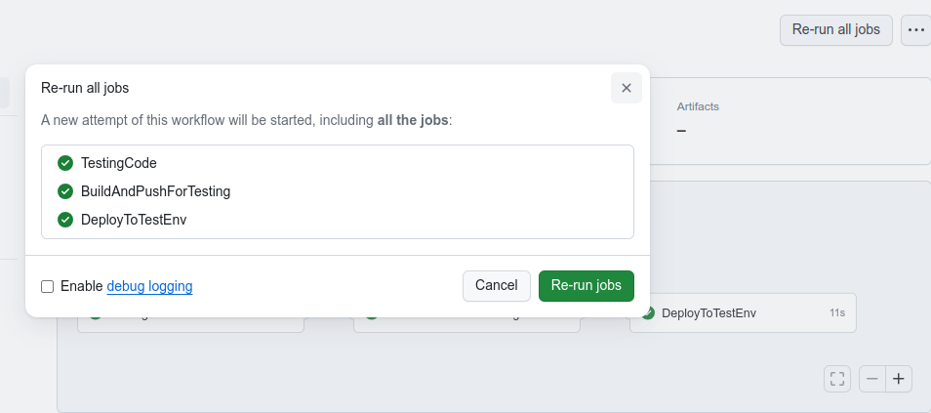
CLICK THIS

And indeed the pipeline fails.

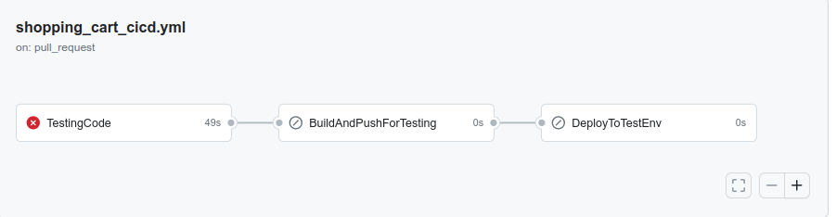
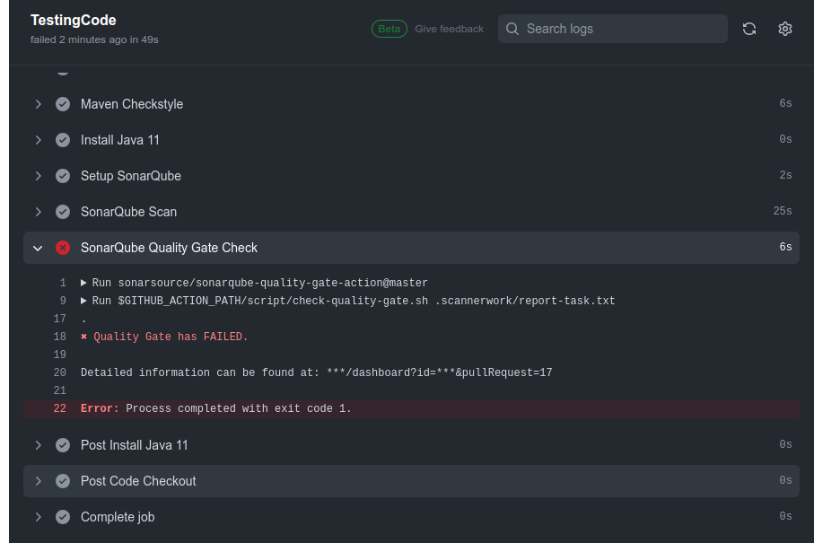
IT FAILED BECAUSE IT DOEST NOT PASS IN QUALITY GATES METRICS

On SonarQube:

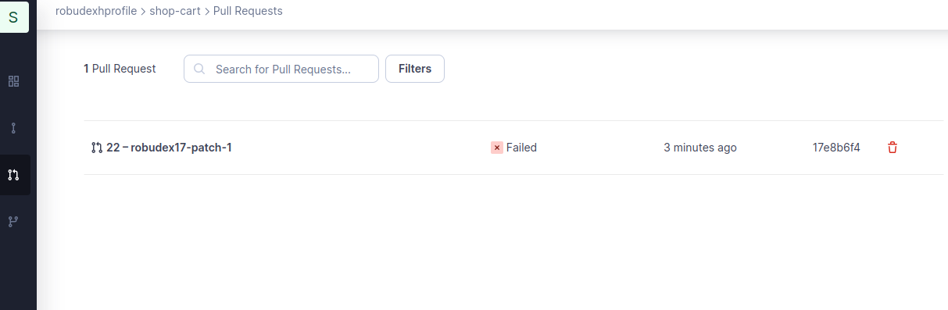
CLICK THIS
IT FAILED BECAUSE IT DOEST NOT PASS IN QUALITY GATES METRICS

Lets back the sonar_cart_gate Metrics to less restrictive again ang re-run the Test Pipeline. To make it passed again.

THAT CONCLUDE THE DOCUMENTAION...THANK YOU

