Team K.A.R. Project 2: HW 7

# Finalized Problem Area

**Description**:

Relationships between students and teachers are important to learning and teaching. However, the process for developing those relationships are difficult and time-consuming, especially in large classrooms typical in public schools. We want to create a way for teachers to develop relationships with their students easily and effectively.

**Mission**: Enhance the learning and teaching experience through the development of strong relationships between teachers and students.

**Populations**: K12 students and teachers in public middle schools

# Data Collection Plan

**Stakeholders:** Teachers and guidance counselors at public middle schools

**Collection Plan:** We will be conducting contextual inquiry at a local public middle school, as well as conducting historical interviews with teachers and guidance counselors.

**Stakeholder**: Students at public middle schools.

**Collection Plan:** We will be conducting contextual inquiry and classroom observations at a local public middle school. We were able to ask quick questions during the class but we were not allowed to talk to them in depth. Parent permission forms would be required in order to conduct In-depth interviews with children.

### SCHOOL VISIT PLAN

Goals for School Visit: build insights about middle school classroom dynamics, especially for teacher-student relationships.

[Demographics for Putnam Ave Upper Middle School:](http://profiles.doe.mass.edu/accountability/report/school.aspx?linkid=31&orgcode=00490310&):

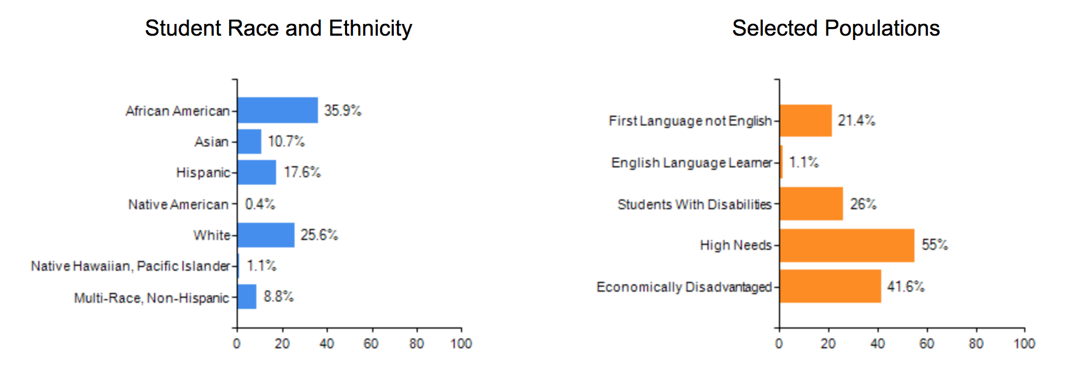

**Questions for teachers**:

1. Are you comfortable answering questions? What is your name? What year and subject do you teach?
2. What are the biggest challenges you face in your job?
3. Why did you decide to be a teacher?
4. What’s the favorite part of your job?
5. When do you feel like you are most effective as a teacher? What encourages this aspect of your teaching? And what obstructs this aspect of your teaching?
6. What are the barriers to forming relationships with students?
7. How did you develop the strongest relationship with students? What are specific tactics that you would recommend to new teachers?
8. How many of your students do you feel like you have a real connection/know as well as you would like to? Do you feel like there is a disconnect between teachers and students?
9. What are some scenarios where you think there is opportunity to build relationships with your students?
10. Do you think relationship between students and teacher affect student academic outcomes?

**Questions for students (not in front of teachers)**:

1. What is your name? What grade are you in?
2. What do you like/dislike about school?
3. What is your favorite thing about your teacher? OR Who’s your favorite teacher? Why?
4. What’s your favorite subject in school? What do you like about that subject?
5. Do you feel respected by your teacher? What makes you feel this way? OR Do you feel respected in the classroom? What makes you feel this way?
6. Have you raised your hand in class this week? Which classes do you raise your hand in more? Why?
7. If you do not understand something, what do you do?
8. In class, do you ever talk about your life outside of class with your teacher?
9. Do you engage with your teacher outside of class? How? (i.e. during lunch time, early in the morning, quick chat after school?)
10. Do you feel like you have a personal relationship with your teacher? What makes you feel this way?

# List of Sources

**School Name:** Putnam Avenue Upper Middle School

**Grades:** Middle School (6th - 8th)

**Teacher/Staff Contact Information:**

Mirko Chardin (Principal): [mchardin@cpsd.us](mailto:mchardin@cpsd.us)

Maisha Rounds (Principal Intern & HGSE student): [maisha_rounds@gse.harvard.edu](mailto:maisha_rounds@gse.harvard.edu)

Emily Petrow (7th grade social studies) [epetrow@cpsd.us](mailto:epetrow@cpsd.us.edu)

Mr. Cutler (7th grade Math teacher) [kcutler@cpsd.u](mailto:kcutler@cpsd.us.edu)s

Mr.Ahmed (Adjustment Counselor) [jahmed@cpsd.us](mailto:jahmed@cpsd.us.edu)

**Group 1**

Demographic Information:

* Emily Petrow
* 7th grade Social Studies Teacher

Method: Historical Interview

Most interesting observation + interpretation: Students “work for people they care about or people who care about them” - establishing the relationship between teacher and students is really important.

**Group 2**

Demographic Information:

* Mr. Cutler
* 7th grade Math Teacher

Method: Historical Interview

Most interesting observation + interpretation:

There are moments of student shut down and in those moments “I wish I knew more” to “empathize or sympathize with them”. There is definitely a room for growth and improvement in terms of handling the teacher-student relationship.

**Group 3**

Demographic Information:

* Ms. Walsh
* 8th grade ELA Teacher

Method: Class Observation

Most interesting observation + interpretation:

Phones and laptops out in class and is frequently used - technology isn’t something foreign to the classroom nowadays.

**Group 4**

Demographic Information:

* 6th grade Science Teacher

Method: Classroom Observation. The class was watching a movie so we were able to ask teachers and students an brief questions.

Most interesting observation + interpretation:

The teacher was young and extremely approachable, making students comfortable enough to speak casually with the teacher and participate actively in class - hiring with intentionality allows younger teachers who might connect better with younger students into the classroom. Such diversity also encourages the breadth and depth of the teaching staff in connecting with the students.

**Group 5**

Demographic Information:

* Mr. Hoquee
* 8th grade Math Teacher

Method: Class Observation

Most interesting observation + interpretation:

The teacher knew everyone by first name and the students were eager to participate by raising their hands - apart from knowledge, there definitely seemed to be a “I feel comfortable with the teacher” factor that encourages the students to go beyond expectation

**Group 6**

Demographic Information:

* Mr. Ahmed
* Adjustment Counselor (1 of 2 for 250 students)

Method: Historical Interview in his office.

Most interesting observation + interpretation:

The relationship between teachers and counselors (administration) is important to make sharing comfortable - there exists a need for an overall solution to capture both types of relationships.

**Group 7**

Demographic Information:

* Mr.Cutler and Mr.Godfrey
* 6th grade Math Teachers

Method: Classroom Observation

Most interesting observation + interpretation: Two teachers in the room allowed for more personal attention. While one teacher was at the board, the other was available to work with students 1:1. Teacher was also very encouraging and fist bumping students and telling them to “Keep it up!”

# Insights

Insight 1: Teachers collaborate and communicate with each other and other staff in order to understand their students better.

* Student support team meetings are held monthly between teachers and guidance counselors organically when a situation requires teacher knowledge.
* Teaching teams within grade levels meet weekly for professional development and discuss individual students when necessary

Insight 2: Extroverted kids dominate classroom dynamics and teacher’s attention.

* Two boys in 6th grade science had a lot of energy, moved around, play-fought while a video was being shown. Teacher had to remove them from classroom and speak to them.
* Three boys in 6th grade science competed against each other in the wildlife simulator

Insight 3: Classroom dynamics cause shy kids to withdraw into themselves, making it difficult to understand their social emotional state and thus restricting teachers from building relationships with them.

* In 6th grade science, when the class environment was boisterous (i.e. kids shouting across the classroom to each other, boys wrestling, child acting out), the shy children would withdraw into themselves, making it difficult to gauge what they were experiencing/learning.

Insight 4: Teachers need to understand the child’s perspective, both to understand their need for agency and respect as well as to identify changes in behavior.

* Changes in behavior may signal something else going on in a child’s life (new meds, family situation etc.).
* The environment of a classroom or school should match the aesthetic needs of a child to respect a child’s world.
* Guidance counselor: “Teachers talking down to students is unhelpful”
* Teacher needs to see bigger picture and make decisions that benefit the child but also understand the child’s perspective.
* Teachers need to understand kids’ desire to have agency and choice.
* Science Teacher: “Their mood changes very often”.
* Students need to feel like there’s an equal relationship and feel respected/valued.

Insight 5: Students use technology in the classroom to learn.

* Students in 6th grade math were working on laptops, on variety of sites (IXL, google, word doc)
* In 6th grade science students were playing a wildlife simulator with elements that had been gamified.

Insight 6: Choice of pedagogy affects student-teacher interactions in the classroom.

* Sage on stage model did not encourage student-teacher interaction.
* Teacher would work on overhead project on an example question while students followed along on their own worksheets.
* Team teaching allowed for more individual attention. In the math classroom, one teacher was at the board explaining a problem while another teacher was sitting next to a student and working directly with him.
* While students were working on writing a short essay based on a reading, the teacher was walking around and checking in with students individually.

Insight 7: Individual student-teacher interactions are important when developing relationships.

* For new teachers, advice would be to check in with students and ask questions often.
* Mr.G fist bumped a student and encouraged him to “Keep going!”
* Teachers called students by their names.
* Advisory blocks are chances for teachers to work with a smaller group of students (~15).
* Activities, clubs, and sports are good opportunities to develop relationships with students outside of the classroom.

Insight 8: Teachers are extremely pressed for time which affects their teaching capability.

* Teachers said that there are 20 students per class with wide range of academic ability
* Each teacher taught four classes.
* Teachers said that they were most effective at teaching when fully prepared.

Insight 9: Relationships between students and teachers affect student performance and teacher satisfaction.

* 6th grader: “Math is my favorite subject because I like the math teacher.”
* Teacher: “Students will work harder for teachers they care about.”
* Teacher: “I believe better relationships lead to better academic outcomes.”
* Teachers’ favorite part of teaching was seeing growth in students.

**Affinity Diagram:**

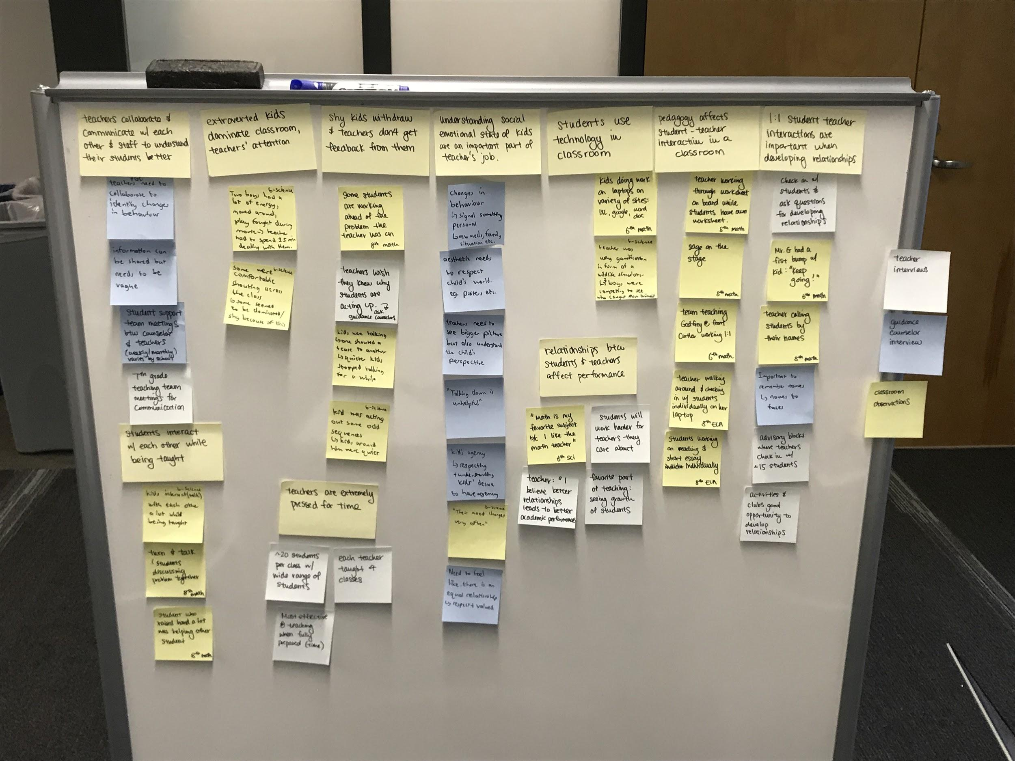

# Project Brief

**Goals:** Enhance teacher-student interactions and relationships in order to improve both the teacher’s and the student’s experience.

**Audience:** Middle school students (6th-8th grade) and their teachers who realize the importance of establishing improved relationships between teachers and students. The attributes of the students include a desire to have fun and express themselves, and the ability and the general worldview of 12-14 year old Americans. The attributes of the teachers include the aspiration to improve the lives of their students and see the impact that they make, the need to balance their own conception of what is best for the child with the child’s conception of their own world, and the ability of a trained professional.

**Principles:**

There are 3 key constraints that we must keep in mind for a successful production of this product:

First and foremost, our design must be youth-friendly in terms of aesthetics and vocabulary, and easily-accessible, intuitive & usable so that the students can comfortably interact with the app in a way that is congruous with how they usually interact with their environment and technology.

Second, our design must contain different UIs for different target groups so that it can *efficiently* address different problems and goals for the different target groups. In each case the design of the UI needs to be based both on the the goals of each group, as well as the attributes that were listed in the audience section above.

Third, our design must respect the privacy and confidentiality rights of our target users. We must be particularly mindful that these rights and restrictions are more extensive in the case of children and thus we must ensure that our app does not infringe upon these rights.

**Scenario:**

A 7th grade female student recently lost her grandmother when she passed away last week. She has difficulty focusing in class and even at home, where she is constantly reminded of the absence of her grandmother. These challenging personal circumstances make it difficult for the student to interact with her peers and teachers. However because of a new app that her and her teacher have been using, they have created a strong personal relationship and the teacher is able to both identify the reason for her change in behavior, as well as implement a solution that is relevant to the student’s life. Because of this, the student is better able to deal with her personal circumstances and her academic performance is improved. The teacher’s sense of satisfaction is also greater as they have a deeper connection with the student and can see the difference that their involvement has made.