Final Research Paper Figures

Caelin Randall-Scott

March 16, 2019

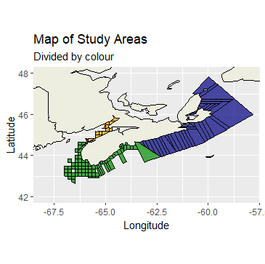

Figure 1: This map shows where the three study areas (North, South and Fundy) are divided.

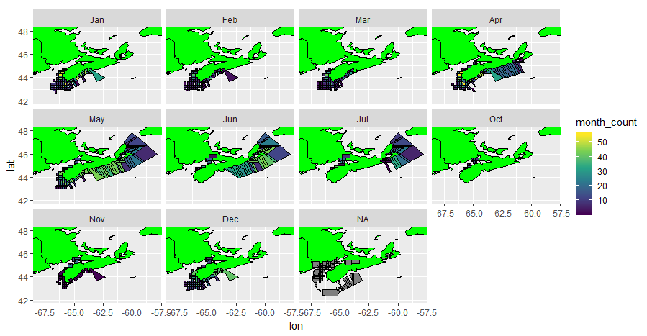

Figugre 2: This figure shows the monthy distribution of bottom temperatures recorded.

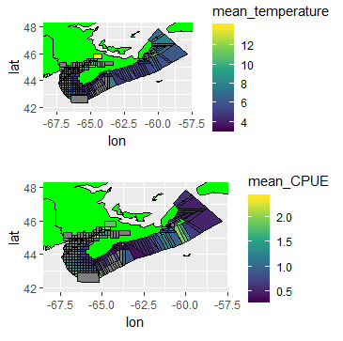

Figure 3: This figure highlights the mean temperature and CPUE over the ten years where data was collected.