An Example Markdown Bibliography

Caelin Randall-Scott

March 7th, 2019

According to Hobday et al. (2016), MHW’s last for at least five days.

Lobsters are known to enjoy hot water, on occasion (Le Bris et al. 2018).

Mills et al. (2013)

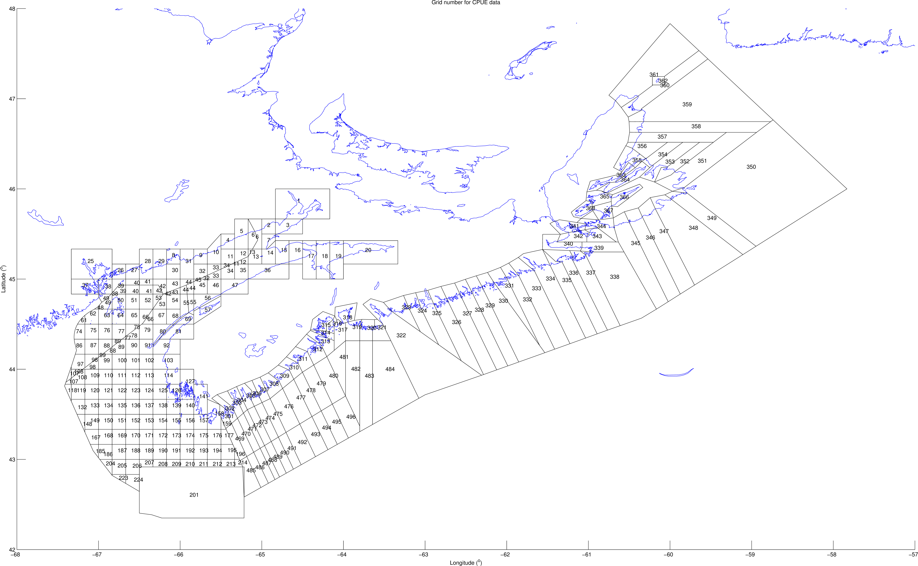

Figure 1: The study area.

## R Markdown

This is an R Markdown document. Markdown is a simple formatting syntax for authoring HTML, PDF, and MS Word documents. For more details on using R Markdown see <http://rmarkdown.rstudio.com>.

When you click the **Knit** button a document will be generated that includes both content as well as the output of any embedded R code chunks within the document. You can embed an R code chunk like this:

summary(cars)

## speed dist   
## Min. : 4.0 Min. : 2.00   
## 1st Qu.:12.0 1st Qu.: 26.00   
## Median :15.0 Median : 36.00   
## Mean :15.4 Mean : 42.98   
## 3rd Qu.:19.0 3rd Qu.: 56.00   
## Max. :25.0 Max. :120.00

## Including Plots

You can also embed plots, for example:



Note that the echo = FALSE parameter was added to the code chunk to prevent printing of the R code that generated the plot.

# Literature Cited

Hobday, Alistair J, Lisa V Alexander, Sarah E Perkins, Dan A Smale, Sandra C Straub, Eric CJ Oliver, Jessica A Benthuysen, et al. 2016. “A Hierarchical Approach to Defining Marine Heatwaves.” *Progress in Oceanography* 141. Elsevier: 227–38.

Le Bris, Arnault, Katherine E Mills, Richard A Wahle, Yong Chen, Michael A Alexander, Andrew J Allyn, Justin G Schuetz, James D Scott, and Andrew J Pershing. 2018. “Climate Vulnerability and Resilience in the Most Valuable North American Fishery.” *Proceedings of the National Academy of Sciences* 115 (8). National Acad Sciences: 1831–6.

Mills, Katherine E, Andrew J Pershing, Curtis J Brown, Yong Chen, Fu-Sung Chiang, Daniel S Holland, Sigrid Lehuta, et al. 2013. “Fisheries Management in a Changing Climate: Lessons from the 2012 Ocean Heat Wave in the Northwest Atlantic.” *Oceanography* 26 (2). JSTOR: 191–95.