Example of markdown

Calisa Staniforth

2019-03-07

According to Hobday et al. (2016), MHWs last for at least five days.

Lobsters are known to enjoy hot water, on occasion (Le Bris et al. 2018).

A study conducted by Campbell, Noakes, and Elner (1991) showed that lobster increase off the coast of Halifax was correlated to a rise in SST.

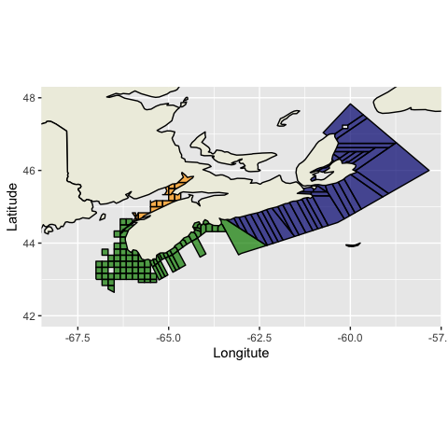

Figure 1:the study area.

# References

Campbell, A, DJ Noakes, and RW Elner. 1991. “Temperature and Lobster, Homarus Americanus, Yield Relationships.” *Canadian Journal of Fisheries and Aquatic Sciences* 48 (11). NRC Research Press: 2073–82.

Hobday, Alistair J, Lisa V Alexander, Sarah E Perkins, Dan A Smale, Sandra C Straub, Eric CJ Oliver, Jessica A Benthuysen, et al. 2016. “A Hierarchical Approach to Defining Marine Heatwaves.” *Progress in Oceanography* 141. Elsevier: 227–38.

Le Bris, Arnault, Katherine E Mills, Richard A Wahle, Yong Chen, Michael A Alexander, Andrew J Allyn, Justin G Schuetz, James D Scott, and Andrew J Pershing. 2018. “Climate Vulnerability and Resilience in the Most Valuable North American Fishery.” *Proceedings of the National Academy of Sciences* 115 (8). National Acad Sciences: 1831–6.