An example markdown file

Robert Schlegel

07/03/2019

According to Hobday et al. (2016), MHWs last for at least five days.

Lobsters are known to enjoy hot water, on occasion (Le Bris et al. 2018).

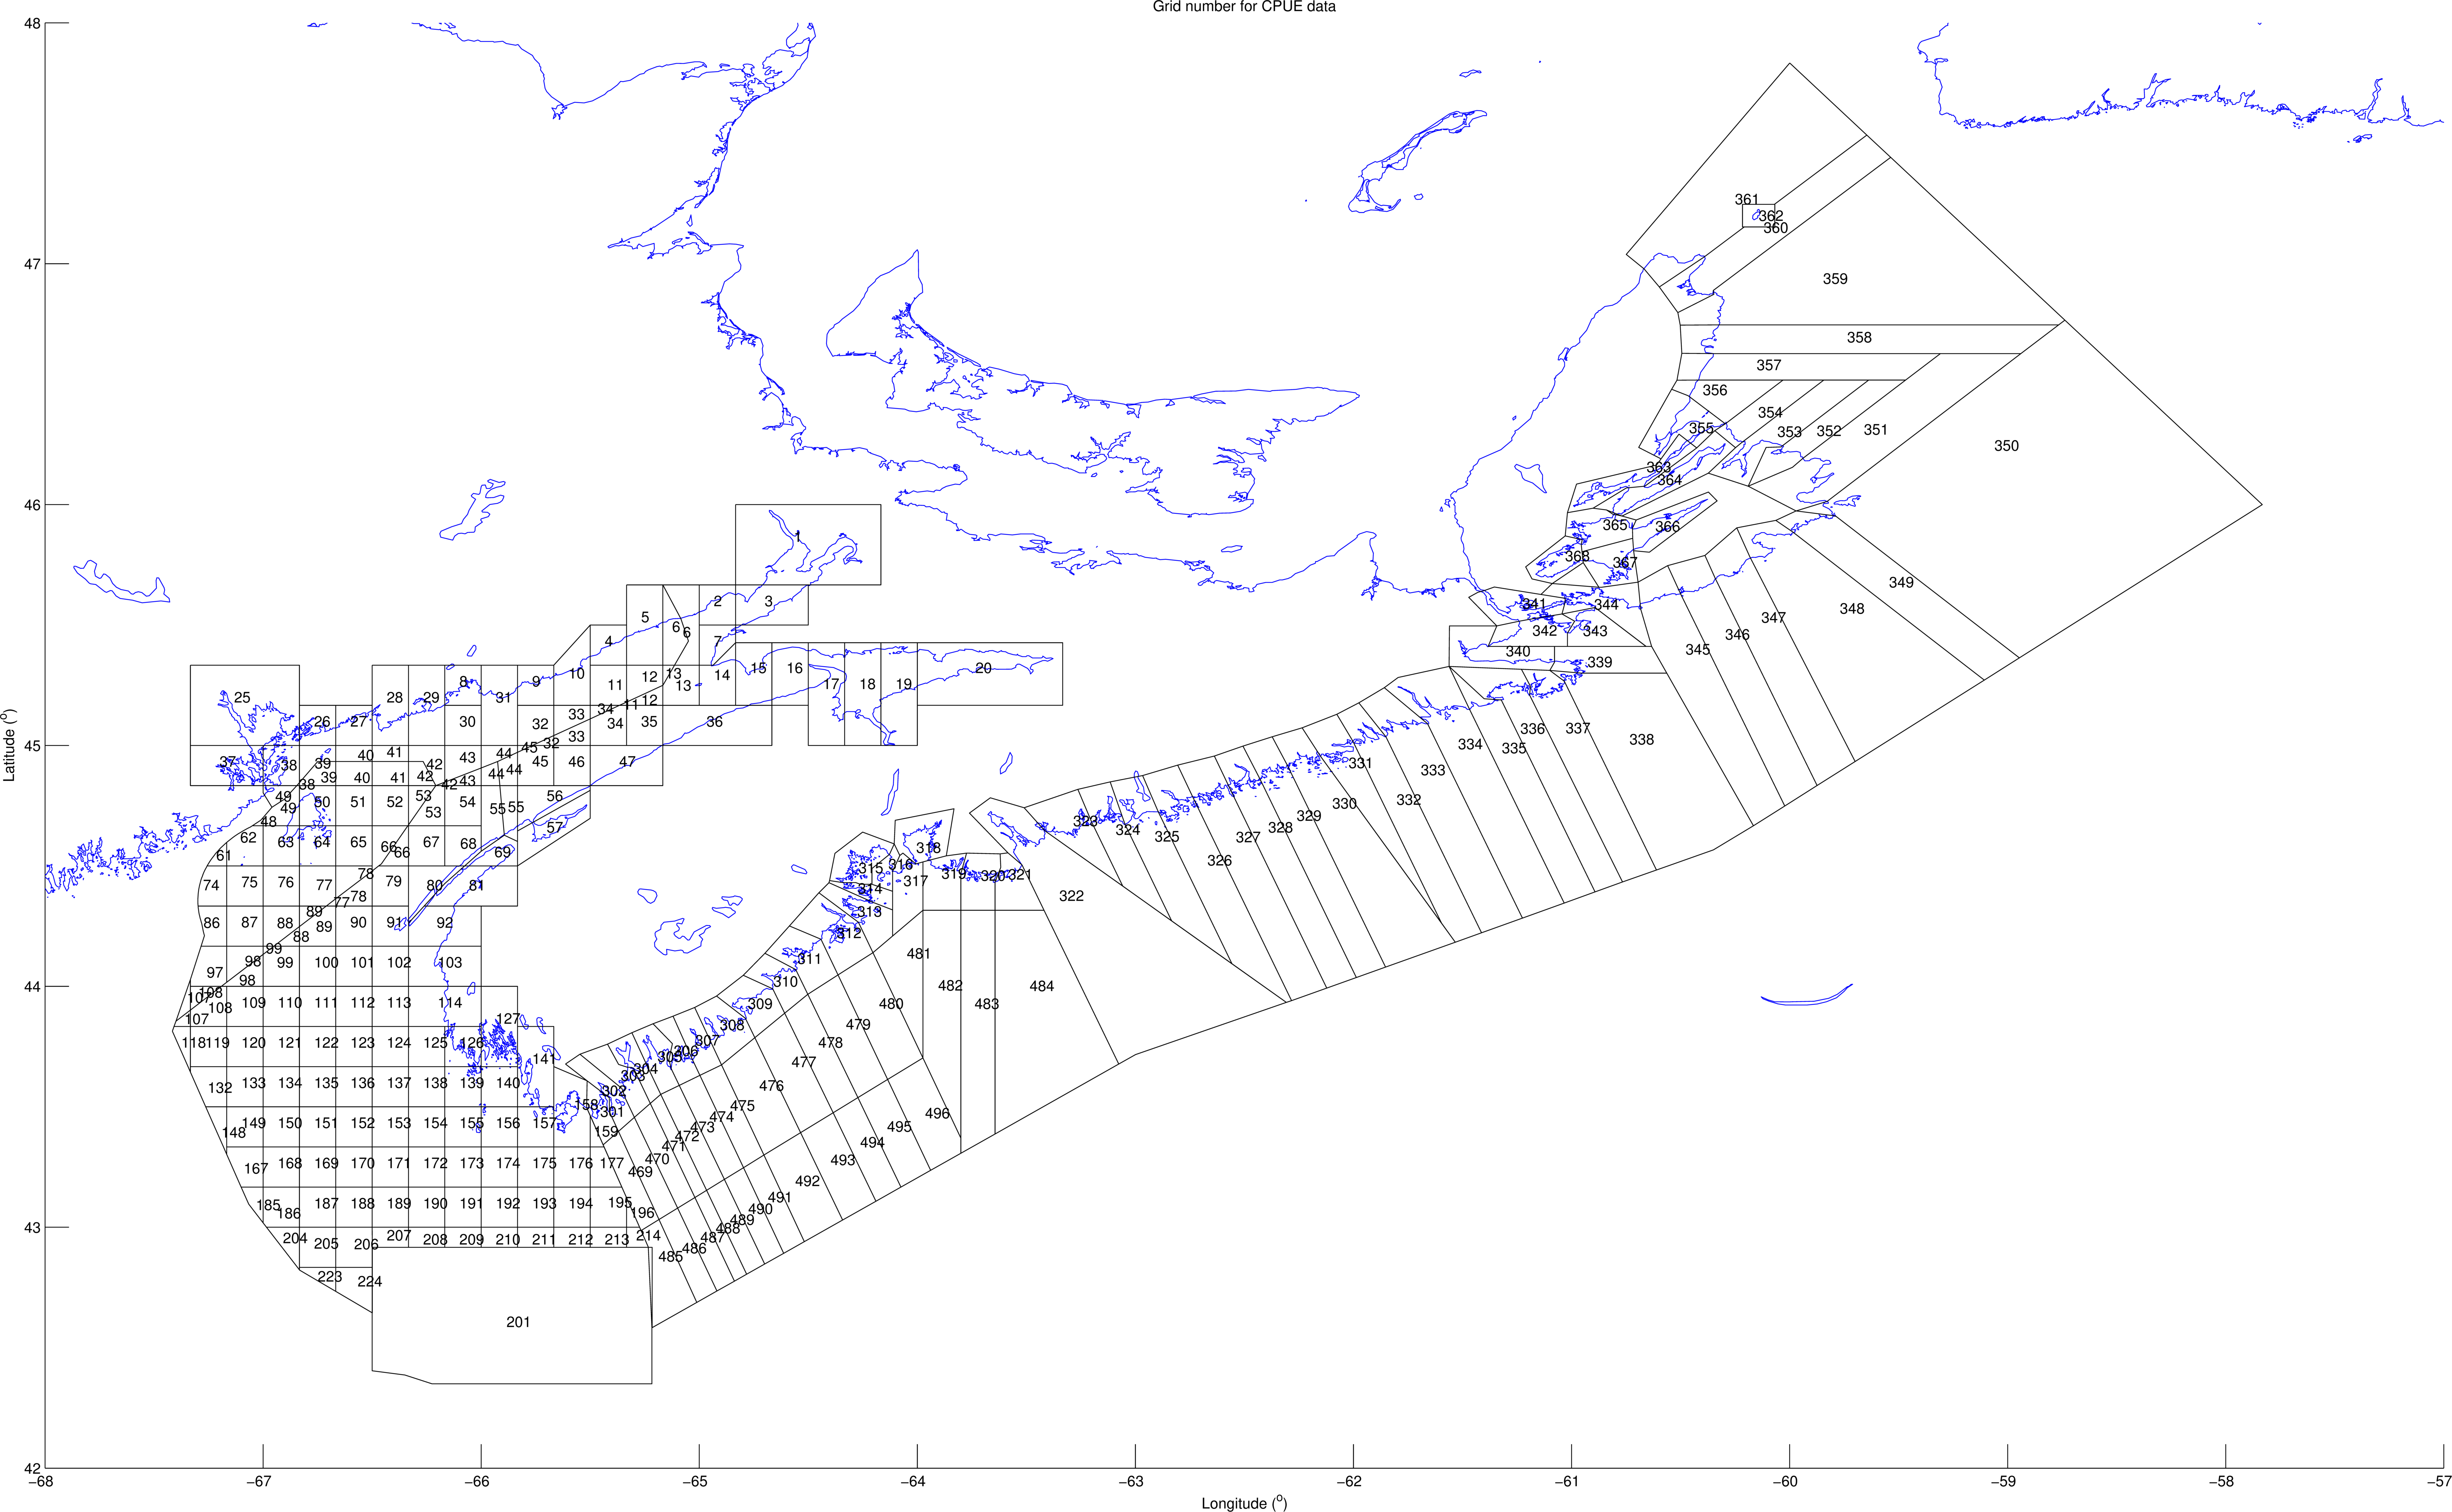

Figure 1: The study area.

# References

Hobday, Alistair J, Lisa V Alexander, Sarah E Perkins, Dan A Smale, Sandra C Straub, Eric CJ Oliver, Jessica A Benthuysen, et al. 2016. “A Hierarchical Approach to Defining Marine Heatwaves.” *Progress in Oceanography* 141. Elsevier: 227–38.

Le Bris, Arnault, Katherine E Mills, Richard A Wahle, Yong Chen, Michael A Alexander, Andrew J Allyn, Justin G Schuetz, James D Scott, and Andrew J Pershing. 2018. “Climate *Vulnerability* and Resilience in the Most Valuable North American Fishery.” *Proceedings of the National Academy of Sciences* 115 (8). National Acad Sciences: 1831–6.