SYNAPSE
Stratospheric Balloon Mission
Launch: Mid-September

TASK DOCUMENT
Payload SW Integration

Task Deadline: 5 July
Responsible: Mirel, Violeta
Mission: SYNAPSE
Document Version: 1.0
Status: DRAFT

CLASSIFICATION: INTERNAL

Table of Contents

1. Scope
This document covers the software integration of the Raspberry Pi 5 and the Akida BrainChip neuromorphic chip for the SYNAPSE payload. It includes the physical connection setup, environment configuration, inference pipeline development, camera integration, and performance benchmarking.

1.1 Objectives
- Set up the Raspberry Pi — Akida hardware and software stack.
- Run inference on the Akida chip using EuroSAT satellite images.
- Develop and validate a full pipeline: image capture → segmentation → inference.
- Benchmark performance under realistic conditions.
- Iterate the model based on real conditions.

1.2 Out of Scope
- Payload hardware assembly (covered by hardware task).

2. Requirements

2.1 Functional Requirements
- The system shall run inference on the Akida chip.
- The inference pipeline shall classify 64x64 image patches from segmented satellite images.
- The system shall segment large images into 64x64 patches before inference.
- The full pipeline (capture → segment → infer) shall be implemented.

2.2 Non-Functional Requirements
- Inference time per image and per full batch shall be measured and documented.
- The pipeline shall be tested with real satellite images photographed from a screen (realistic conditions) and various satellite images.

3. Implementation

3.1 Implementation Steps
- Test inference on Akida: classify 100 EuroSAT images saved locally on the Raspberry Pi. Measure classification accuracy and time. Then test on all images and record total inference time.
- Download a large satellite image from the internet. Run the segmentation script on it. Classify the resulting patches. Measure time and performance.
- Integrate the camera: configure it to capture images and save them to the Raspberry Pi automatically.
- Develop the segmentation script: split large images into 64x64 patches.
- Photograph satellite images from a screen and run the full pipeline (segmentation → inference). Record performance parameters.
- Iterate the model taking into account the most realistic operating conditions.

3.2 Physical Setup — Raspberry Pi & Akida Connection
Connect the Raspberry Pi to a laptop via UART using the red USB communication module. Wire connections as shown in the images below.

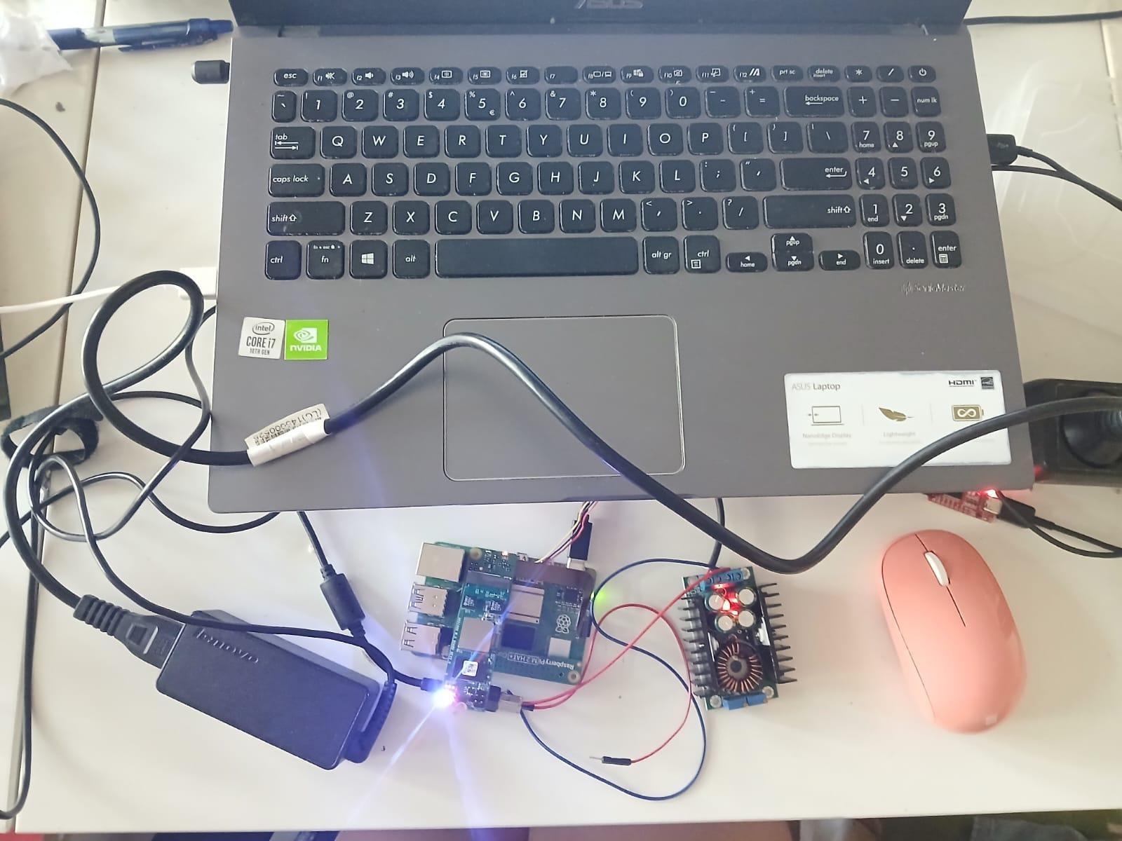
Physical wiring — Raspberry Pi to UART module (1/3)
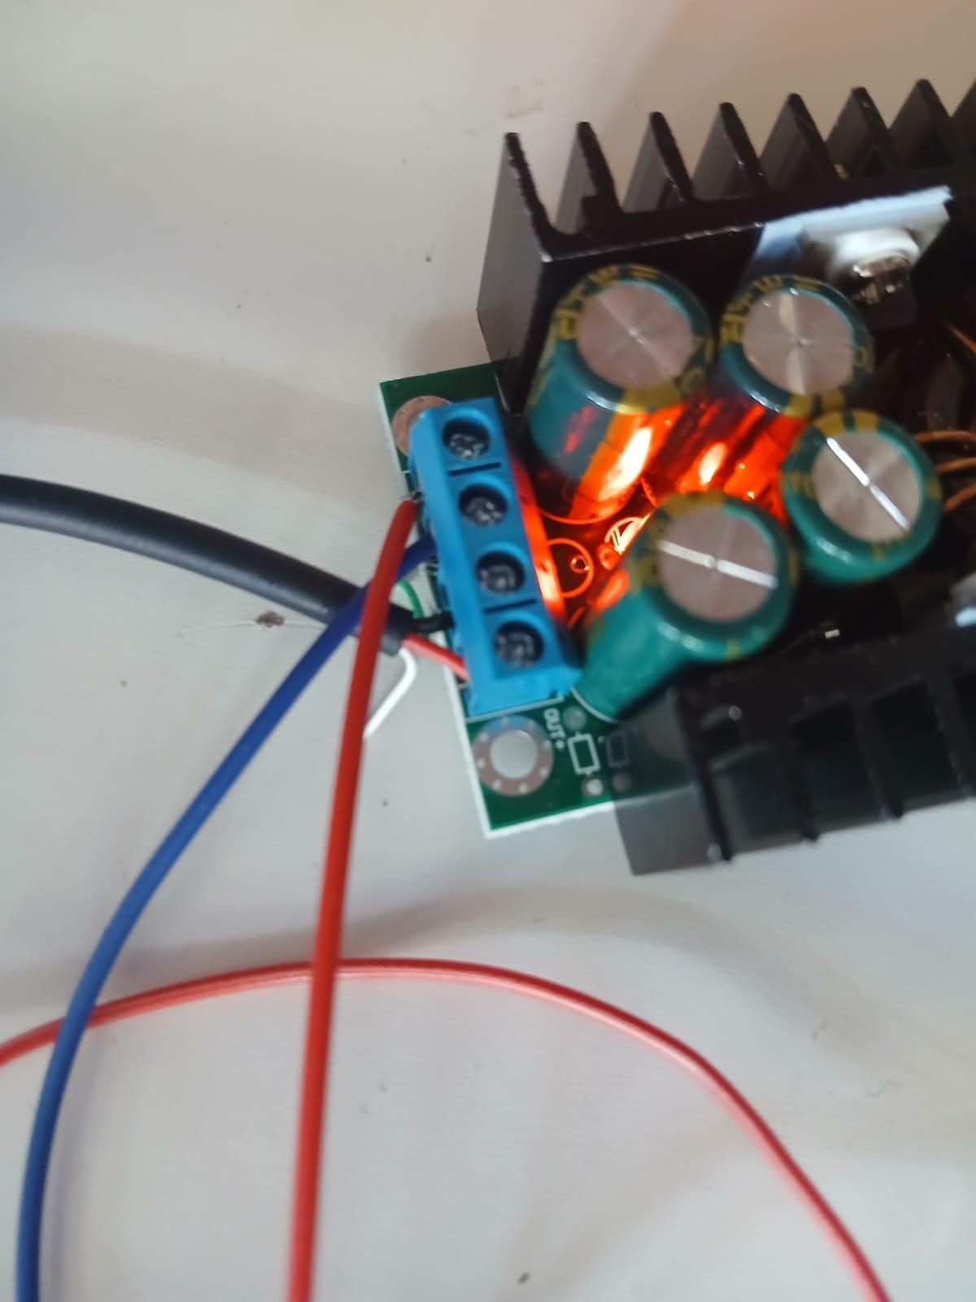
Physical wiring — Raspberry Pi to UART module (2/3)
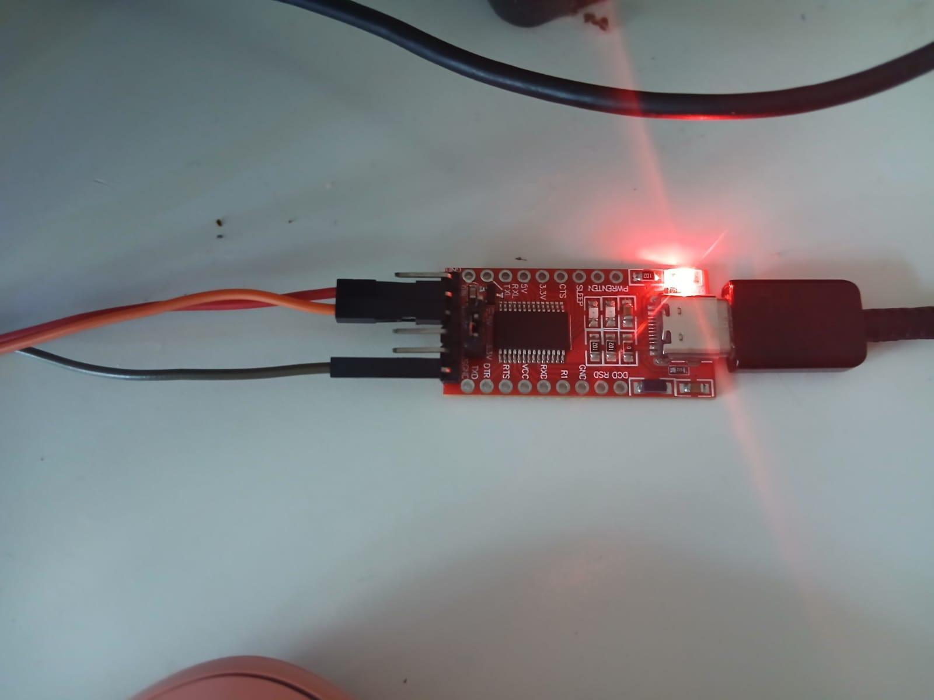
Physical wiring — Raspberry Pi to UART module (3/3)
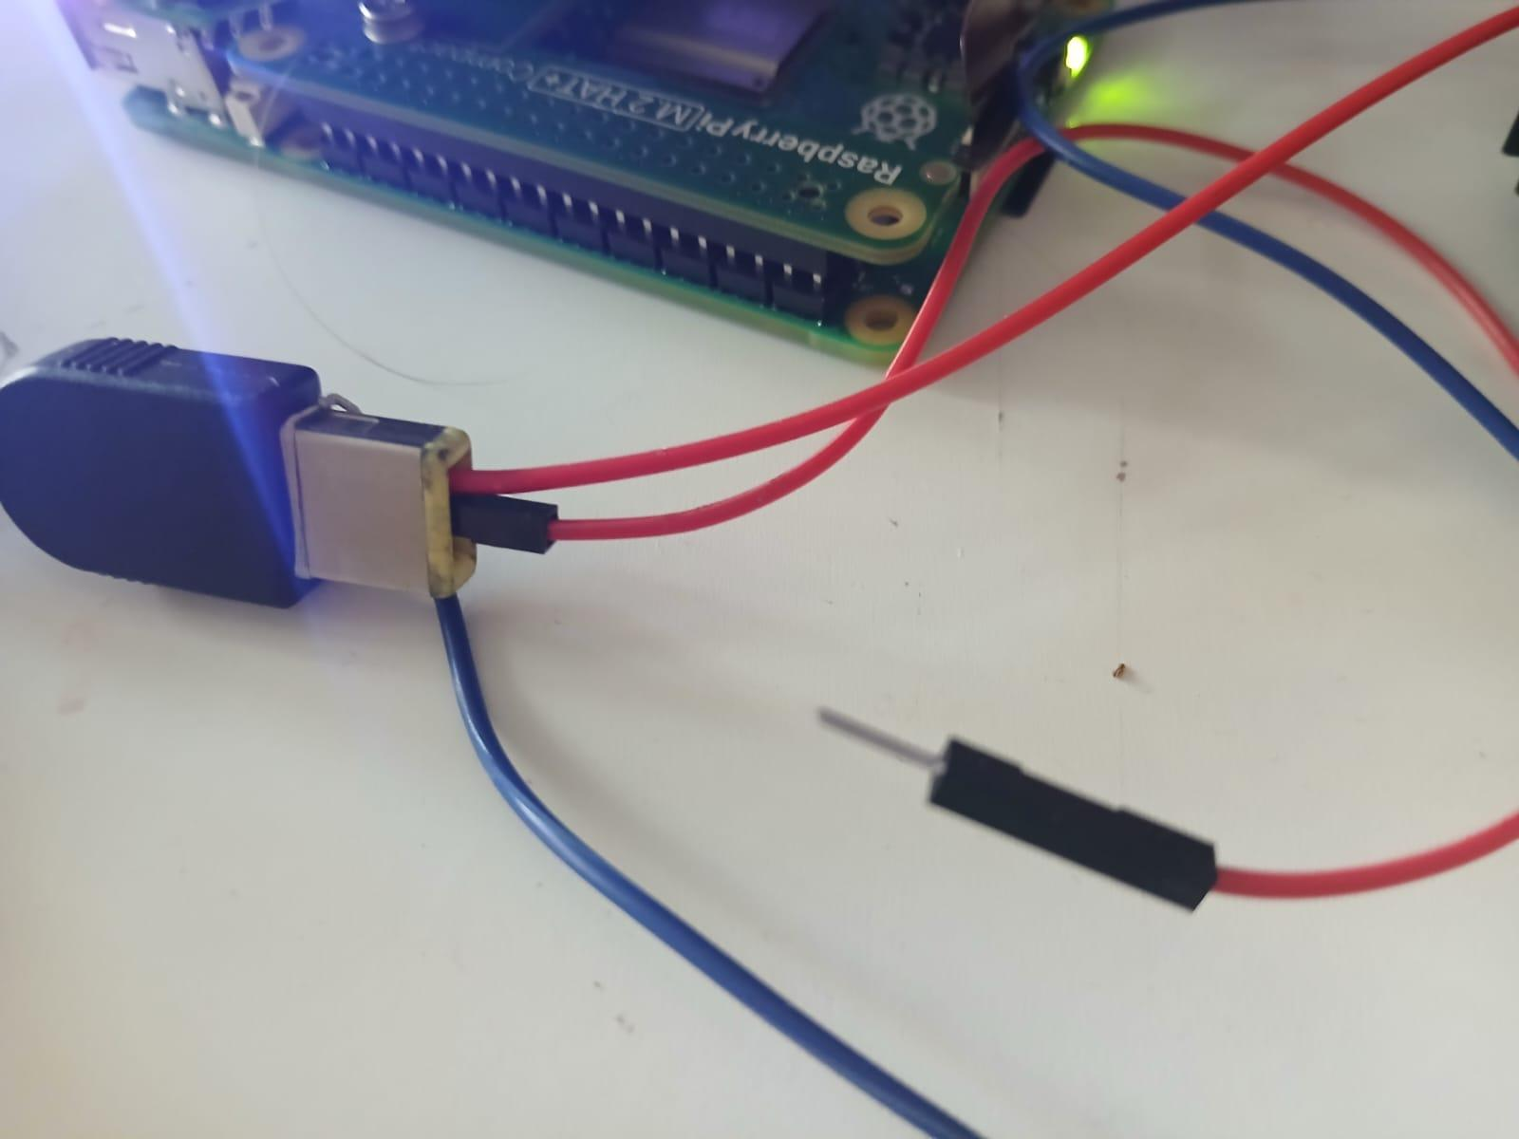
Raspberry Pi and Akida board assembled

3.3 Driver Installation & Serial Connection (UART)

Step 1 — Install UART driver
Download and install the VCP driver for the red USB communication module:
FTDI VCP Drivers: https://ftdichip.com/drivers/vcp-drivers/
Run the setup executable, install, then restart the laptop.

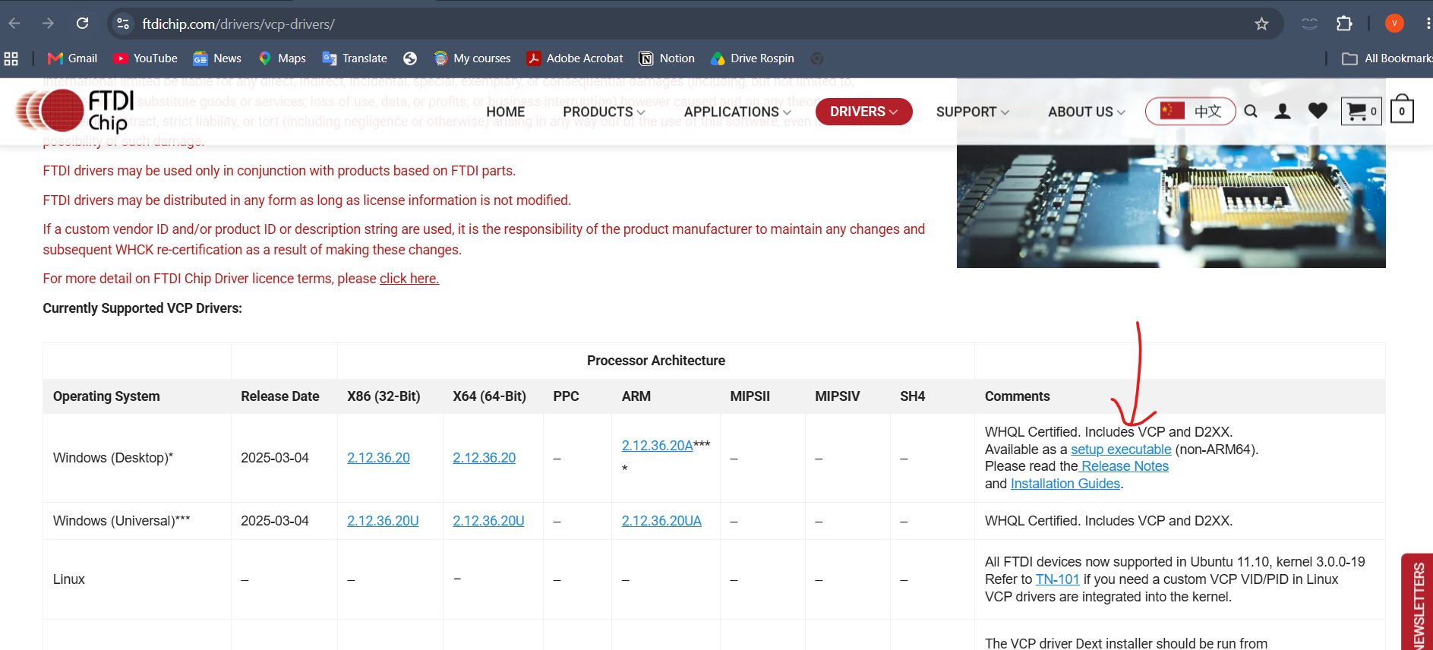
Driver installation — setup executable

Step 2 — Identify COM port
Connect the red module via USB. Open Device Manager and note the COM port number under Ports:

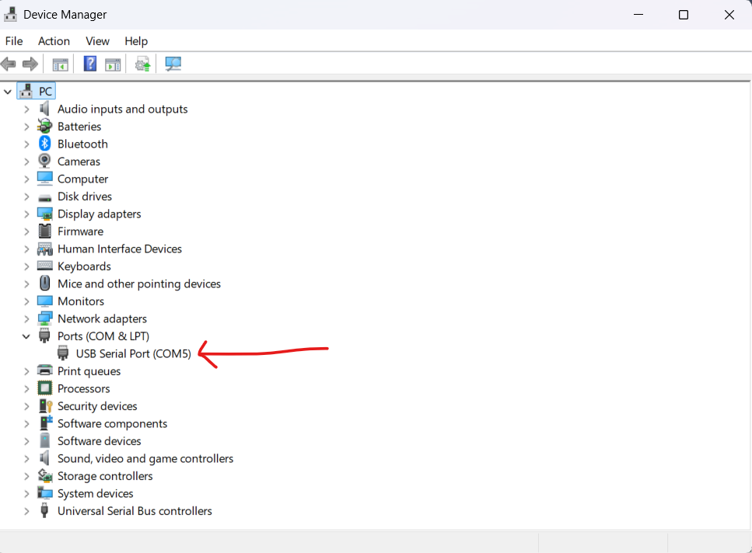
Device Manager — COM port identification

Step 3 — Connect via PuTTY
Download PuTTY: https://putty.org/index.html
Open PuTTY and configure as follows: Connection type: Serial | Speed (Baud rate): 115200 | Serial line: COM5 (or your identified port).

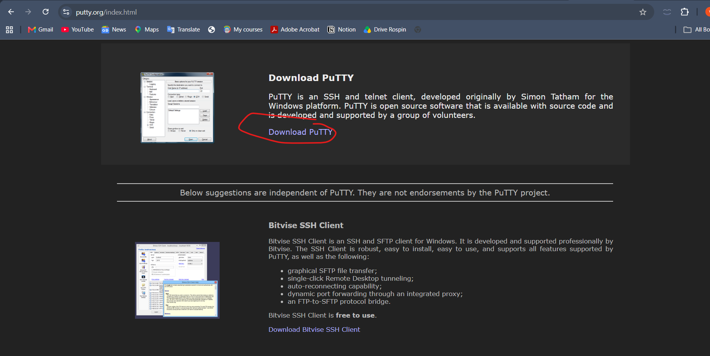
PuTTY configuration

Connect the wires from the Raspberry Pi to the red module while the Pi is powered on. You should now have a serial terminal.

Login credentials:
Hostname: synapse2025
Password: synapse2025

Step 4 — WiFi connection
Connect to the WiFi hotspot using the following command:
sudo nmcli dev wifi connect "My" password "violetamihai"
WiFi hotspot credentials: SSID: My | Password: violetamihai (rename phone hotspot accordingly if needed).

3.4 Akida Driver & Docker Environment

Step 1 — Load Akida kernel module
Run the following each time the Raspberry Pi boots:
cd ~/akida-setup/akida_dw_edma
sudo insmod ./akida-pcie.ko

Step 2 — Verify Akida device
ls -l /dev/akida*
Expected output:
crw------- 1 root root 10, 260 Jun 9 00:57 /dev/akida0

Step 3 — Dockerfile
Create the Dockerfile on the Raspberry Pi:
nano ~/akida-setup/test-simple-program/Dockerfile
Content:
FROM ubuntu:22.04
RUN apt update && apt install -y python3 python3-pip
RUN pip3 install akida==2.16.1 numpy==1.26.4 Pillow
WORKDIR /data
Save with Ctrl+X → Y → Enter, then build the image:
sudo docker build -t akida-image ~/akida-setup/test-simple-program/

Step 4 — Start the container
sudo docker run -it --device=/dev/akida0 -v /home/synapse2025/Desktop/akida_sample:/data akida-image

Step 5 — Transfer images to Pi
From Windows laptop, copy images to the Raspberry Pi:
scp -r "C:\Users\Violeta\Desktop\Synapse\subsystems\payload\images" synapse2025@192.168.137.189:/home/synapse2025/Desktop/akida_sample/

3.5 Startup Checklist (Every Session)
Follow these steps each time the Raspberry Pi is powered on:
- Load the Akida kernel module:
cd ~/akida-setup/akida_dw_edma
sudo insmod ./akida-pcie.ko
- Verify the device exists:
ls /dev/akida*
- Start the Docker container:
sudo docker run -it --device=/dev/akida0 -v /home/synapse2025/Desktop/akida_sample:/data akida-image

Inside the container
Run inference on a single image:
python3 /data/infer.py
Run inference on all images:
python3 /data/infer_all.py
Exit the container:
exit

Key files
- /home/synapse2025/Desktop/akida_sample/infer.py — inference on a single image
- /home/synapse2025/Desktop/akida_sample/infer_all.py — inference on all images across 10 classes
- ~/akida-setup/test-simple-program/Dockerfile — Docker container recipe

Note: files in /data/ inside the container map directly to /home/synapse2025/Desktop/akida_sample/ on the Pi. Scripts edited on the Pi are immediately visible in the container. Docker only needs to be rebuilt if the Dockerfile changes.

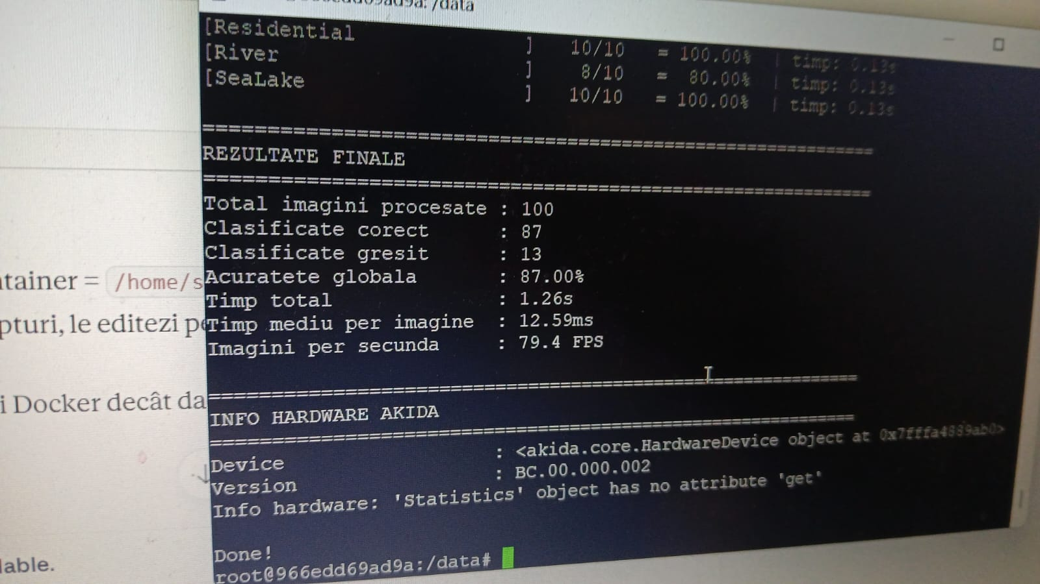
Performances

3.6 Performance Results
[Fill in inference results as tests are completed.]

Test | Images | Time (total) | Notes
EuroSAT — 100 images | 100 | [TBD]
EuroSAT — full dataset | [TBD] | [TBD]
Large image — segmented | [TBD] | [TBD]
Full pipeline (screen photo) | [TBD] | [TBD] | Real conditions

4. Risks and Mitigation
ID | Risk | Probability | Impact | Mitigation
RSK-01 | Akida kernel module fails to load after reboot | Medium | High | Load kernel module manually each session (sudo insmod ./akida-pcie.ko). Document startup checklist clearly.
RSK-02 | Docker container loses access to /dev/akida0 | Medium | High | Always pass --device=/dev/akida0 flag when starting container. Verify device exists before running container.
RSK-03 | Inference performance insufficient for real-time pipeline | Medium | Critical | Benchmark early (Section 3.1). Iterate model and segmentation parameters if needed (Section 3.5).
RSK-04 | Camera integration fails or produces incompatible image format | Low | Medium | Test camera save pipeline independently before integrating with segmentation + inference scripts.
RSK-05 | WiFi credentials change or hotspot unavailable during setup | Low | Medium | Document current credentials. Fallback: use UART/USB connection as alternative access method.

4.1 Additional Notes
[Any additional risk observations or mitigation actions not captured in the table above.]

