Algonquin College

Assignment #1:

My Favourite Movie Web Page

Robyn Estes

LIB 2024

Professor Huthaifa Abderahman

February 10, 2023

Table of Contents

Introduction

*1*

Coding Elements

*2*

Coding Process

*3-5*

Conclusion

*6*

Introduction

For this assignment, our task was to create a webpage using HTML code that described our favourite movie, and included elements such as the best or funniest line from the movie, a brief description of the plot and how we would describe it to try and entice someone to watch it. We were also asked to include a rating, a note to self, and a list of cast members.

I chose the movie “The Grand Budapest Hotel”, one of my very favourite movies. Using elements of HTML code, which are listed below, I was able to create a small webpage which contained all of the items requested for the movie blog post. I have also included screenshots and explanations of the code.

*Page 1*

Coding Elements

<div> = Division used to contain a section for easy organisation.

<link> = Used to attach a link to an image.

<section> = Used to section off part of the HTML for easy organisation.

<p> = Used for inserting text.

<b> = Used to bold text.

<h> = Used for adding headers.

<br> = Used for a break within text.

<img> = Used to insert an image.

<header> = Used to define the header of the webpage.

<footer> = Used to define the footer of the webpage.

<mark> = Used to highlight text.

<progress> = Adds progress bar to indicate ratings.

<meta> = Defines metadata of the HTML document.

<ul> = Creates an unorganised list.

<li> = Creates list item.

*Page 2*

Coding Process

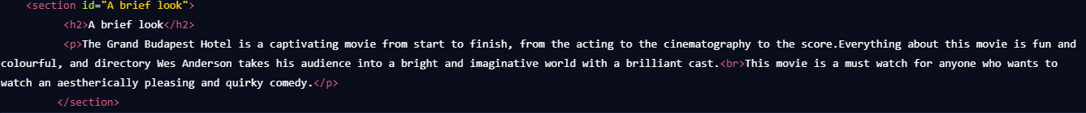

This is the “a brief look section”. This section contains a head and paragraph, which is giving a brief overview of the movie with a break in the paragraph.



This part contains a head and paragraph, and was used for the “best line” of the webpage.

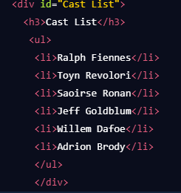

Contains an unordered list of cast members of the movie.

*Page 3*



The footer contains bolded text that is marked, for the “note to self” section.

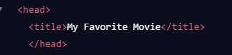

This is the head, which contains the title of the webpage.

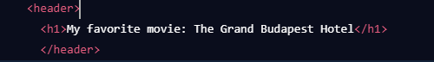

The header of the page contains the physical text title of the webpage.

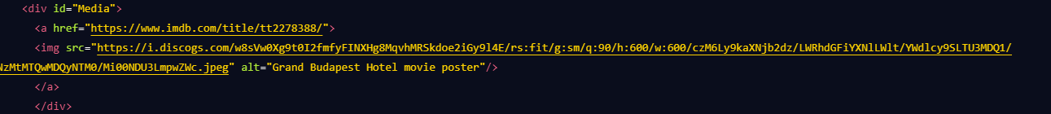

This is the image which has a link attached to it, in this case it links to the IMDB page for this movie.

*Page 4*

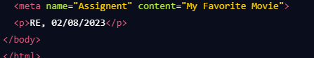

This shows the metadata for the web page, as well as my initials and date.

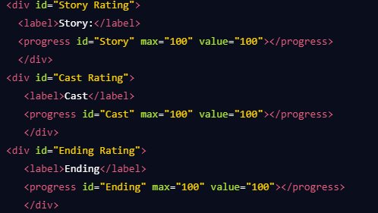

This shows the progress bar for story, cast, and ending ratings, all of which are set at value 100.

*Page 5*

Conclusion

For this assignment I was able to create a webpage using the HTML resources taught in class and information found online. It was a good assignment as it taught me how to create a webpage and use the basics of HTML, as well as how to apply them in a practical setting. I enjoyed getting first hand practice at using HTML to create a web page, and to see the outcome of my coding. It was important to me to create clean and well organised code that was organised in a way that made sense and looked presentable.

*Page 6*