

Zex™

User Manual
Part No: LSZ0100

http://www.lightsoft.co.uk/zex

This electronic version of the manual is designed to be viewed in at least 256 colours and preferably ‘Thousands’ or better. For printing, set the page size to “A4”

LSZ0100 – Zex™ User Manual
©LSG 2006.

www: http://www.lightsoft.co.uk
Email: support@lightsoft.co.uk (This is NOT FUNCTIONAL anymore)

Revision 1.0 June 2006

Although the author and Lightsoft have made a reasonable effort to ensure the accuracy of the information herein, they assume no responsibility for errors or omissions. The information in this manual is distributed “As Is,” without warranty of any kind. Neither Lightsoft nor the author shall be liable to any person or entity for any special, indirect, incidental, or consequential damages, including without limitation lost revenues or lost profits, that may result (or that are alleged to result) from the use of these materials. In other words, use this information at your own risk.

Any trademarks, service marks, product names or named features that appear in this manual are assumed to be the property of their respective owners.

Installation And Requirements
Macintosh
Windows
Zex Support
What is Zex?
Quick Start
Tutorial And Training
Game
Game Controls
Starting The Game
Difficulty Levels
Ship Systems and Control
Thrust
Combat Mode
Cruise Mode
Instrument Panel
Damage Repair Systems (DRS)
Weapons
CANNONS [SPACEBAR]
LASERS [L]
TASERS [L]
REAR FITTED LASERS [L]
MISSILES [M] [P]
Electronic Counter Measures (ECM)
360 Degrees Targeting
Ships Hold
Additional Equipment
Navigation Computer
Flight Computer
Trade Computer
Ejection Pods [E]
Flatpack ships.
Fast Dock
Other Equipment
Flying
Refueling
Motherships
Lighting
Command and Control
Promotion
Commanding other pilots
Galactic Map
Motherships:
Planets
Warpholes
Galactic Trading
To Trade:
Score Summary Screen
Sample Strategy Guide
Tactics & Tips
Designers Notes
FAQ and Problems
Speed Tips
Cheats
Changing Where Zex Saves Games
Credits

Installation And Requirements

Macintosh
Zex requires an Apple Macintosh™ computer running Mac OS X version 10.3.9 or later. Drag the Zex folder to somewhere on your hard disk; we would suggest your ‘Applications’ folder. Then double click the application called "Zex" to run the game.

Windows
On Windows Zex will run on Windows 98™ or later. After download, double click the ‘zex.exe’ file to extract the game; this will produce a folder called ‘LSG-Zex’. Open the folder then double click the application called Zex to run the game.

Zex Support
If you have a problem with Zex, first, check with this manual.

If that fails to answer your question please try the on-line Zex pages at:
http://www.lightsoft.co.uk/zex/
and the Lightsoft forums at:
http://www.lightsoft.co.uk/phpBB2/

If you still haven’t found the answer to your problem please feel free to email us at:
support@lightsoft.co.uk
Where we’ll answer your question as quickly as possible.

If you think you have found a bug, please first check for an updated version Zex at:
http://www.lightsoft.co.uk/zex/

If you are running the latest version of Zex then please contact us via email as above. Please be sure to give as much information as possible as follows:

Macintosh Users:
Please send us a system profiler report and a crash log along with a description of the problem and how to go about reproducing it. This will help us diagnose your problem as quickly as possible.

Crash logs can be found in ~/Library/Logs/CrashReporter. So for example if your name is stu, then the path to a Zex crash log would be:
/Users/stu/Library/Logs/CrashReporter/Zex.crash.log

A System Profiler report can be generated from the Apple Menu – if you select ‘About This Mac’ and then click the ‘More Info’ button, System Profiler will open from where you can save a report.

Windows Users:
Please send us your PC model, OS version and the file ‘Stderr.txt’ found in the LSG-Zex folder along with a description of the problem and how to go about reproducing it. This will help us diagnose your problem as quickly as possible.

What is Zex?
Zex is a space based role palying game presented in a retro-style.

The R'Mparians have invaded our Solar System and are trying to deplete our defences to the point we can no longer defend ourselves against them.

In a last ditch effort a secret ship known as Zex was designed and built from captured alien hardware. Disguised as a R'Mparian vessel, it was sent through a warphole into the R'Mparian galaxy, along with a few Earth Motherships.

As the game starts, you find yourself in command of Zex as a lowly Ensign. Your job is to force a retreat of the R'Mparians and secure a peaceful future for Mother Earth.

Not an easy task, and not a task accomplished in a few minutes!

Of course, you may want to just work on improving your rank, making money, a little bit of pirating or generally just exploring the galaxy. It’s up to you.

Quick Start
Before starting the game we strongly suggest you run through the tutorial and maybe a training mission or two.

Launch the game and wait until you get to the main screen.

Tutorial And Training
Adjust the music and sound volumes then select "New Game". From the next screen select the difficulty rating as "Training" and then “Tutorial”. Follow the Tutorial through – it teaches you how to fly Zex, how to use weapons and how to dock with Motherships – all vital elements of the game.

After the Tutorial, we would strongly suggest you run through the first training mission just to get a feel for how enemies behave and fight.

Game
When you have finished training, you’ll return to the main menu screen.
Select “New Game” and from the next screen select the difficulty rating as "Space Cadet" – this is the easiest level of play.

You will find yourself in the heart of the Alpha Quadrant of the R'Mparian Galaxy. Bring up the Galactic Map by pressing [G]. Your position is shown as a flashing white square. Find a nearby Earth Mothership (indicated as a small green square) and click on it. This will set a course for the Mothership. Press [G] again to leave the map and return to the main game screen. On your radar (the oval instrument at the bottom of the screen) will be a green line, or vector, showing which way to fly to the Mothership; follow it. When very close to the Mothership, hit [D] and dock.

When docked, click on "Trade" and wait until you are connected to GalaNet. Next click on TradeNet and select an item to buy. Now you can launch, bring up the Galactic Map again, find another Mothership you think will offer a higher price for the thing you just bought (hint: check the Motherships supply route and nearby planets), set a course for it by clicking on it... and that should get you started.

When you have a good number of credits, you might want to consider getting on with what you are supposed to be doing; forcing the surrender of R’Mparian Motherships and ruling the galaxy. Unfortunately there's no quick guide for that.

Game Controls
All controls are configured from within Zex (available from the main game screen).
The mouse is not used as a game controller in Zex but is used to control the pointer on various game screens - for example when docked at a Mothership.

The default keyboard layout:
Forward Thrust Up arrow Key
Reverse Thrust Down arrow Key
Turn Left Left arrow key
Turn Right Right arrow key
Fire Cannon Space
Fire Laser L
Fire Missile M
Toggle Combat/Cruise thrust V
Retro Thrust T (When fitted)
Select Missile Pylon P
Radar Range Select R
Request Dock D
Manual Eject E
Tab Shockwave
W Warp jump

Show Ship Status Screens /
Pause/Resume Game ESC
Increase Music Volume ]
Decrease Music Volume [
Increase Sound Volume =
Decrease Sound Volume -
Camera Zoom In Z
Camera Zoom Out X
Change Camera Mode C
Full Screen/Windowed Mode F1

Toggle Instrument Panel I
Display Galactic Map G
Command and Control K

Note that in this manual, default keys are indicated in square brackets [].

Starting The Game
Launch the game and wait until the main screen is displayed. (You can "click through" the intro screens if you like.)

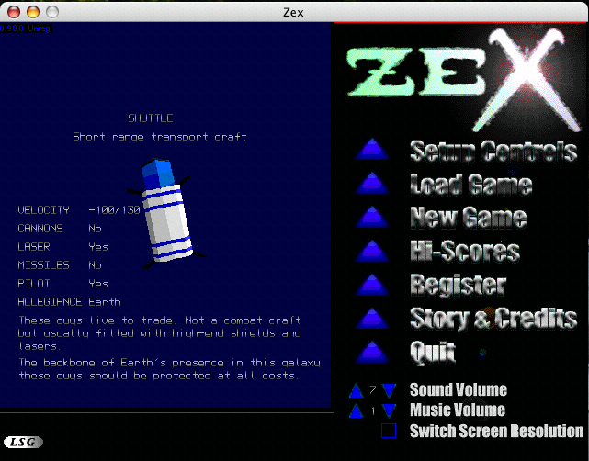

Down the right of the main screen are the following options:

Setup Controls | Click here to configure your game controller for Zex
Load Game | Allows you to load in a previously saved game
New Game | Starts a new game.
Hi-Scores | Displays the current high score table.
Story & Credits | Displays the background story and Zex's credits.
Quit | Quits the game.
Sound Volume | Adjust the sound volume by clicking the up/down arrows.
Music Volume | Adjust the music volume by clicking the up/down arrows.
Switch Screen Resolution | Allows Zex to switch your monitor to the best resolution to fill the screen.

Select New Game to start a new game.

The Game can be paused at any time by hitting the Pause key [ESC by default]. This will overlay a small selection dialog with the following options:
Resume Hit this or ESC to resume the game.
Abort Click this to quit the current game and return to the main screen.

When docked at a Mothership, the following options are available:
Rest | If you get tired, you need to sleep.
Leave Dock | Leave the Mothership
Show Status | Show current status of ships systems - the same as when in flight with the "/" key
Trade | Log on via electronic data link to GalaNet where you can buy and sell weapons, fuel, equipment and commodities
Save Game | Save the current game
Quit | End the current game and return to the main menu

Difficulty Levels
Zex has three difficulty levels; Space Cadet, Zexician and Master Zexician.

Space Cadet really makes life easy for you. No one would publicly admit to playing Zex on this level.

Zexician – this is the level the game is designed to be played at.

Master Zexician – OK, this is hard. Even the guys at LSG have trouble on this level of play.

Various parameters are set as the result of the difficulty level; for example how many Human Motherships are present at the start of the game, how much profit you make on trades, weapon and shield strengths, how easy it is to get promoted etc.

In addition on the Space Cadet level, the game freezes whilst you are viewing the Galactic Map. On the Zexician levels time continues whilst the Galactic Map is displayed.

Game Display

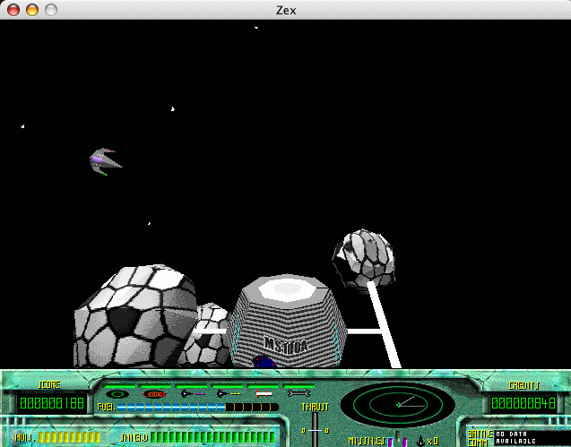
The display is split into two parts. The top part contains the main camera view and overlaid scrolling message area. The lower part is the instrument panel and shows various system status and navigation information. The instrument panel can be toggled on and off with the [I] key by default.

The main display has three controls associated with it. The view can be zoomed in [Z] or out [X] and the camera view angle can be changed [C] through two modes - top down or locked to Zex's rotation. In this latter case the right of the radar display indicates "forward".

The message area contains up to 7 lines of age sensitive text. The older a message, the dimmer it becomes. New messages appear at the bottom of the area and call signs of other ships precede the message where necessary. For example "SS01:" indicates this message was transmitted by the ship with the call sign SS01.

Ship Systems and Control

Thrust
Zex uses a high quality super conducting ceramic radial engine. It offers extremely high levels of acceleration depending on availability of a gravity. A lightweight ceramic disk is cooled to about 70K and spun using an electromagnet driven by high frequency and high current pulses. Objects directly above this disk lose weight; hence the engine is in the base of the hull. The amount of thrust produced cannot be altered (but see Cruise Mode below). Direction of thrust is controlled by rotating the engine. Fuel consumption is directly proportional to thrust, but do note that even at no thrust some fuel is consumed to keep the engine idle and provide power for ships systems. Raw fuel is converted to electric current via a Zorkner and Webb standard convertor unit.

Combat Mode
Even though the engine is not a linear device, for convenience the Orientation and Control System (O.R.C.S.) normally regulates the thrust to provide linear output. This method of rapidly pulsing the thrust on and off limits the forward and reverse velocities to 360 Galactic Units/second (GUs) forward and 100GUs reverse. This results in smooth and fast power delivery in normal situations at the expense of fuel.

Cruise Mode
In this mode, toggled with the [V] key, the pilot has direct control of the thrust, which is either on or off; there is little linearity in this mode above about +-20GUs (below which, again the ORCS regulates thrust to achieve precision). Maximum forward velocity in this mode is limited to just over 1000 GUs.
This is a high speed mode for longer distance journeys at the expense of acceleration.

Note that in this mode, though the engine only uses fuel when accelerating or decelerating, vast quantities of fuel can be consumed by the shields fending off the impacts of space dust. The optimum cruising speed is just under 900GUs which offers a balance between high speed and shield power needs.

When switching down from Cruise to Combat mode the ORCS will try to immediately slow the ship before switching thrust modes. A good pilot will slow to about 360GU/s before switching from Cruise to Combat thrust mode; doing otherwise will severely strain the engine. However, combat is combat and this "emergency stop" behaviour can be used to gain a tactical advantage. Nothing slows from 1000 to 360 GU/s like Zex!

Instrument Panel
The Instrument panel positioned at the bottom of the display provides navigation and ships systems status information.

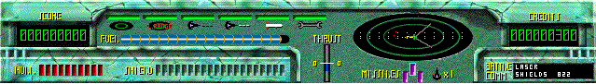

Along the top is a series of six lights known as the Central Warning Panel, or CWP; these indicate the status of the following systems (from left to right): Radar, Long Range Radar, Cannon, Laser, Missiles, Damage Control A green light indicates the system is functional, a red light indicates damaged.

Below the CWP is the fuel display, which shows how much fuel is remaining.

Below the fuel display is the Hull and Shields indicators. The shields will change colour according to current status and audible warnings are generated if hull damage is likely.

To the right is the thrust indicator which can indicate negative and positive values.

Above the thrust indicator is the Radar Display [R]. This provides navigational and orientation information. Zex is always positioned in the center of the display, any objects within the radar scan range are displayed relative to Zex. The radar has two ranges - short and long. The long range display displays approximately four times the range of the short range but uses more energy.

Navigation information to target or destination is displayed via a vector from the center of the radar display (see Navigation Computer). The angle of the line indicates in which direction to fly, the length of the line indicates the distance. The longer the line, the further the distance.

To the right of the radar display is a display of how many credits has been earned (via electronic bounty payments), and below that the missile pylons status display which indicates the state of each of the three missile pylons and which one is currently armed.

The display Panel can be toggled on or off using the [I] key by default. When off, minimal instrumentation is overlaid at the bottom of the screen.

Damage Repair Systems (DRS)
Zex contains a highly sophisticated repair system that is capable of repairing all ships systems apart from the hull. Damage to the hull is repairable when docked (generally for quite a serious fee). Rumors of an auto hull repair unit are unsubstantiated as of this time.

The Damage Repair System will repair ships systems in a priority order ranging from missiles at the highest level (assuming at least one missile is fitted) to the Radar system at the lowest priority. Most DRS's consume large quantities of fuel when in operation; the Bell and Williams being the (expensive) exception with its self contained power supply.

Damaged systems are indicated by a red light on the CWP. As a system is repaired the light associated with that system will turn green.

The DRS itself can become damaged. In this case it will try to repair itself as a priority task above weapons systems.

DRS's require power to operate and as such drain the ships fuel system whilst actively repairing.

The DRS is also linked to the On Board Computer (OBC). This unit monitors additional ships systems as well as maintaining communications links. Messages from the OBC are displayed in the message area of the display.

Status Screen A useful screen is the status screen [/] (see picture on next page). This will show all fitted equipment and its status including equipment you lost in battle. Also shown is your current score, credits, and current time. Pressing [/] a second time brings up the "Hold" display, showing what cargo you are carrying. Pressing [/] a third time returns you to the main display.

Status Screen
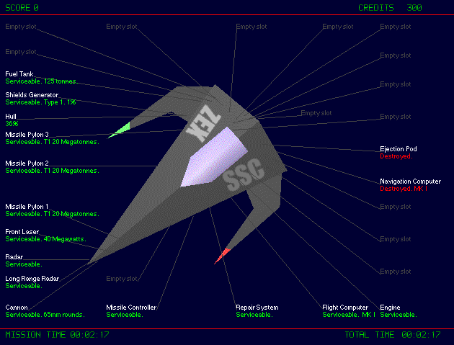

Weapons

Weapons come in three basic varieties; shells, missiles and energy devices. Most come in different classes where a class 1 item is less powerful than say a class 3. Generally the higher the class the more destructive the weapon is and the further it will fire. For example a level 1 laser has a range of about 500 metres, whereas a level three laser may reach as far as 3 or 4 kilometres.

CANNONS [SPACEBAR]
These are the bread and butter weapon. Unlike other more powerful weapons, cannons are completely non-discriminatory. You can shoot anything with a cannon. As long as the cannons are not damaged, then you can fire. Zex as standard is fitted with a 65mm armor piercing cannon. Upgrades are available in 120 and 200mm forms. Cannons should still fire in the advent of a power outage; for example should you run out of fuel.

LASERS [L]
More advanced and generally more powerful than cannons, lasers must have a target to fire at. Lasers will only target enemy objects. They will not target infrastructure or friendly ships. Lasers come equipped with targeting mechanisms; the better the laser the wider the targeting (or "capture") angle. A level 1 laser typically has a capture angle of +/-10 degrees; larger lasers have wider capture angles.

Lasers require huge amounts of energy; generally taken from the engine into a large storage capacitor. Hence most lasers use fuel and have a definite firing rate, or Pulse Repetition Frequency (PRF); also note that lasers are inoperative if the ship has run out of fuel. Some more expensive types of laser have their own power supply.

A variety of lasers have been noted, ranging from 40 Megawatts, which is the Zex standard fitting, up to about 300 Megawatts. The most "useful" are said to be Triridium™ based units.

Unlike in the olden days, Zex's laser will not overheat under normal circumstances.

TASERS [L]
Typically found only on alien Motherships, these are what you really want. A Taser is a laser with twin beams. The power of each beam is similar to an equivalent laser BUT the capture angle of a Taser is typically +/-80 degrees or greater. At more than twice the price of the equivalent laser big tasers are expensive but devastating when surrounded by hoards of enemies.

REAR FITTED LASERS [L]
Perform similar to the normal lasers but fire in the opposite direction. An upgrade to the targeting system (360 degree targeting) is required before the rear laser will function. Rear lasers typically come in lower power ratings than main lasers.

MISSILES [M] [P]
These powerful weapons are limited in supply and typically command a high price when available. Beware of cheap prices!

Missiles, like lasers are targeted weapons, but a missile selects its target after it has been fired. This means a missile will always fire straight ahead but will immediately try to acquire and lock on to a valid target. If no target is found, the missile will fly onwards and eventually explode.

If you are in the unfortunate position of looking at the wrong end of a missile, the only reasonable defence (in the absence of ECM) is another missile, which hopefully will target the missile coming towards you. There have been some unsubstantiated rumors of pilots outmaneuvering a missile.

The on-board computer will issue an vocal warning if it detects a missile being fired at you.

There are at least three types of missiles that can be fitted to Zex, ranging from 20 Mega Tonnes up to 140. Missiles can be bought at all fine weapons establishments.

Zex can carry a maximum of three missiles at any one time on three under-belly pylons. Missile types are indicated on the pylon indicators as different colours. The armed missile; i.e. that which would fire were the missile trigger pressed, is outlined in light blue. A different pylon can be selected via a push switch [P]. Immediately a missile is fired, the missile controller will auto select the next available pylon.

Missile jams are rare, but if one does happen, the next missile will fire assuming the ship has more than one missile available. A worse form of malfunction is the missile that fires, but just sits there going nowhere! This is typically attributed to buggy missile software.

Missiles will not target infrastructure or friendly forces. However, missiles in flight may severely damage or destroy any object that gets in-between the missile and its target!

Important: When attacking an alien Mothership, higher class missiles have more chance of getting through the Motherships shields.

Note: Be aware that the optimum speed for a low-end missile in flight is about 900 GUs and when launched a missile will immediately adjust its speed to this value. The problem comes when Zex is travelling faster than 900 GU's (possible in Cruise Thrust [V key]). In this case you will launch the missile, the missile will immediately slow and you will drive straight into it! Not good.

Electronic Counter Measures (ECM)
This unit is designed to work in conjunction with the ships computer to detect and attempt to destroy incoming missiles.

360 Degrees Targeting
This item is needed for rear lasers.

Ships Hold
Zex can carry up to four cargo containers. You may buy cargo when docked for trading purposes, or ships you destroy may have been carrying cargo. In this case you can fly over the cargo to pick it up. Cargo containers will last about 10 to 20 seconds in open space before being destroyed.

You can list your cargo by pressing the [/] key twice. This screen also allows you to jettison cargo should you need to.

Additional Equipment

Navigation Computer
This unit will display vectors overlaid on the main radar display to various items of interest; mainly items you've selected on the Galactic Map and Motherships. A MKI computer does not discriminate between types of Motherships, a MKII does.

In the event of a failure of the Nav Computer, switching to long range radar can be helpful.
All Nav Computers can detect and warn of abnormal magnetic variations; typically present around asteroids or large herds of space cows.

Flight Computer
Responsible for controlling Zex's attitude, damping, rate of turn and to a certain extent acceleration (and deceleration). As far as is known there is only one type; without it the ship is far less "damped" and controllable. A damaged Flight Computer may result in the ship becoming fixed in a certain orientation making flight extremely difficult.

The Flight Computer is also known as ORientation Control Systems or ORCS.

Trade Computer
These handy little boxes will usually get you a discount on GalaNet at any Mothership and are necessary to translate protocols between Zex and Alien Motherships. Generally considered to be well worth the investment especially before purchasing anything involving a major cash outlay.

Ejection Pods [E]
Ejection pods provide a "last ditch" chance to save your skin. These will both take you to safety whilst setting the ships' auto destruct mechanism so as not to fall into the wrong hands.

Two types of ejection pod are in existence. The standard unit is rather cheap and cheerful whereas the Fosset unit has a hardened shell making it supposedly indestructible.

A typical series of events during ejection is:
a). The pod sets the ship to auto destruct.
b). The pod ejects (taking you with it).
c). A course to the nearest Mothership is computed.
d). The pod accelerates to high speed until close to the Mothership which is guaranteed (by mutual treaty between earth and the aliens) to dock the pod safely.

Note: if there are no Motherships in the vicinity the pod will be unable to eject.

On arrival at a Mothership, a new ship with minimal kit will be supplied by Command. Your credits will be reduced by 30% to subsidize the new ship and your promotion rating (see below) will be adversely affected!

Note that an Ejection Pod is not fitted as standard to the replacement ship!

Ejection will lose you everything and is not guaranteed to save your skin. A shaky treaty is in effect which makes it a heinous offence to destroy ejection pods; at the very least a fine is imposed. However targeted weapons such as lasers know nothing of such laws and some aliens (and Humans!) are specifically known to enjoy destroying ejection pods.

Flatpack ships.
These amazing units are complete ships stored in a container no bigger than about 25 centimeters. In times of dire emergency via some clever temporal trickery it will effectively auto assemble itself in a few nanoseconds just before your current ship is destroyed.

You and nearly all ancillary items fitted to the original ship will be transferred to the new ship although some items may be lost. Word on the street is that it's always the expensive items that vanish!

Fast Dock
A complex temporal manipulation unit that can effectively speed up the docking with a Mothership considerably. It basically puts the pilot to sleep during the docking procedure; you don't actually dock any quicker -- it just seems like it!

Other Equipment
We suspect much alien equipment can be fitted to Zex; this manual only details those items Command has tested.

Flying
Zex is inherently unstable. The advantage to this is that the craft is always "just on the edge" of rolling over, so maneuvers can be executed with very little delay between pilot input and craft response even in the presence of an atmosphere. The ORientation Control Systems (ORCS) is entirely responsible for maintaining Zex at any given attitude demanded by the pilot. The downside is if the flight computers fail, Zex will lose much of its agility. In the event of main flight computer damage a secondary system will maintain the current orientation .

The pilot has no control over roll. Roll is computed as a function of yaw input, atmospheric density (if any) and speed and will always give the best turn rate for any combination of these variables.

Thrust is an important factor in flying and maneuvering Zex. Thanks to its lightweight design and high thrust delta values from its engine, Zex can out-accelerate most craft. Reverse thrust is limited to 0.45 of maximum forward thrust for structural reasons.

Refueling
Zex needs fuel to convert to electric current for its engine and ship systems. Fuel is used constantly. Failure of the fuel system, or running out of fuel will leave Zex stranded.

Zex can be refuelled at alien fuel dumps. The procedure involves simply flying over the refuel area at very low speed - ideally zero thrust. The fuel system will emit a short tone every second whilst refuelling is taking place. Zex cannot be over fuelled.

Space Cows - These organic creatures are pretty much harmless, mainly sitting around just munching space dust. Space cows however, are full of a material Zex is able to convert to fuel by flying through them although be warned: strong shields are require. Flying through a Space Cow will certainly annoy the 'cow which will indicate its disdain with a loud roar. The 'cow may also try to damage you in some way; being somewhat annoyed at you sticking your nose into its insides!

Should you run out of fuel, your only recourses are:
a). Somehow find fuel.
b). Eject and suffer the consequences.
c). Pray some pirate comes along and destroys your ship before you run out of oxygen.

Motherships
Motherships hold all sorts of goodies you can buy and add to your ship and these are the only places you can get your hull repaired. As your experience increases, more items will become available.

Most Motherships contain on-line trading centers connected to GalaNet. Here you can sell most anything currently fitted to your ship and buy ships’ items via CombatNet. You can also buy and sell commodities through TradeNet (see Galactic Trading).

When connected to CombatNet clicking on items when browsing will provide useful information. Some items are only available on Motherships of a certain allegiance and/or when you reach a certain rank. Note that there may be other users buying and selling items so the items available may change as you browse.

GalaNet charges you 30 credits per minute whilst on-line; this charge can be somewhat reduced if you have a trade computer fitted to your ship.

If there are problems with the network at the time you try to connect, either wait a while and try again, or find another Mothership. Network problems can be caused by Mothership damage, or simply too many people trying to connect at the same time.

Motherships have a power rating and consume power. If the power level is too low on a Mothership (because of a recent battle) then some mothership services may become unavailable; for example docking or access to GalaNet.

Ultimately, your job is to damage Alien Motherships so badly they surrender. High powered weapons along with some experienced subordinates are highly recommended. An Alien Mothership will assume you are an alien craft and will not fire on you unless you fire on it first. Alien Mothership crew seem to assume the "Three strikes and you're out!" rule. If you shoot an alien Mothership more than twice, it will know it was no accident and do all in its power to destroy you. Be aware that Motherships typically hold fighters in reserve to be launched when under attack, so not only will you have the Motherships lasers to worry about, but probably a bunch of Alien fighters as well.

See Command and Control below for more information.

Docking with a Mothership is simply a case of flying close and sending a docking request signal [D].
(The tutorial shows you how to dock with a Mothership. You can select Tutorial by first selecting "New Game" then selecting "Tutorial".

When Zex sends a dock request signal it will relax all flight control mechanisms in anticipation of the Mothership's tractor beam. You can cancel the docking request any time. Cancelling the docking request automatically re-engages the flight control mechanisms. During engagement with the tractor beam nearly all ship's controls are inoperational (including weapons) but as an added bonus you are protected from all weapons.

The fastest way of docking is to get a docking computer! The second fastest way is to approach parallel to the Mothership from top left. When you are just left of center send your dock request.

When you dock you will be charged a docking fee or "toll". This is to pay for the energy and time required to dock your ship and if you can't afford the toll, the Mothership will not dock you. Finally, if a Mothership is docking another ship, you'll just have to wait your turn.

Ejection pods are never charged a docking fee (this is taken into account in their price) and hence will always dock.

Lighting
The lighting in Zex varies between bright and dark. The lighting available is not linked to the real game time which is based on Earth's 24 hours. Lights-out in most Motherships is between 8 and 9 P.M. Earth time.

Command and Control
You start the game as a lowly Ensign. All pilots have some rank and you can command pilots of a lower rank. Unfortunately the lowest rank for a pilot is Ensign, so until you achieve your first promotion you're very much on your own.

Promotion
Promotion is achieved by doing good things; destroying alien ships for example. When docked you'll see a status panel in lower right of the screen. One of the items here is your current promotion points; for example 50/500 means you have earned 50 promotion points and you need 500 to get promoted. As you get further up the promotion ladder it gets progressively harder to get promoted, but that's life. You can also view your status in-ship via the status key [/].

Promotion points are lost for doing bad things; shooting your own Motherships and destroying escape capsules are the most common. Again, life's tough.

Commanding other pilots
To commandeer another pilot, press the Command & Control key [K]. The action will freeze and a dialog appears.
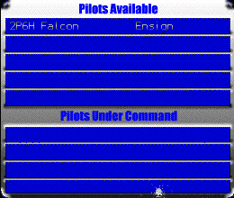

In the top part will be listed up to five available pilots with their call signs and rank. If you see one with a lower rank than you, you can click on it. The pilot will move to the Pilots Under Command area of the dialog.

Clicking on a pilot under your command displays a list of available orders for that pilot as a blue strip at the top of your screen.

When you select a command (by pressing a number key), the message will be sent to the pilot and when he's able he will reply and comply.

You are allowed to control up to four pilots at any one time. You can send commands to pilots you already command by pressing the [K] key. The command dialog box pops up again. In the lower part is a list of pilots under you control. Select one with the mouse, and again the blue strip appears from where you can send the command.

Galactic Map
The Galactic Map [G] shows where you are in relation to planets and Motherships. Note that the game continues to run whilst you are viewing the galactic map apart from if the difficulty is set to Space Cadet.
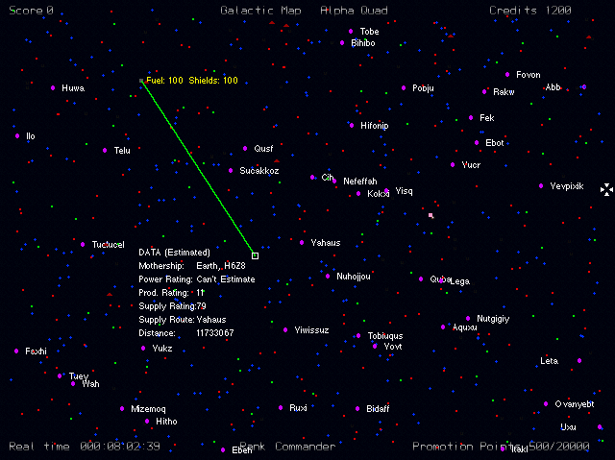

Your Nav computer is responsible for generating the map of your current quadrant. Human Motherships are shown as green squares. Alien Motherships as red squares. Inhabited planets as purple circles along with their name. Uninhabited planets as small blue squares. The warphole to the next quadrant is shown as a pink square. Unknown items are shown as a small "U" and supply depots as flashing triangles. Finally, Zex is shown as a small flashing square with current fuel and shield readouts.

Clicking on an item will:
a). Insert that item into your navigation computer. It will now appear on the radar as a green vector.
b). Display information about that item as follows:

Motherships:
Power Rating - how much power the Mothership has; this affects its ability to manufacture ships and recharge its shields. Both Human and Alien Motherships manufacture a variety of ships; mainly fighters and traders.

Production Rating - how quickly it can manufacture ships; based on power and supply ratings.

Supply Rating - a useful indication of what prices are likely to be like; a lower supply rating means few traders visit this Mothership, and hence prices are likely to be higher in general.

Supply Route - The closest inhabited planet to this Mothership; this can give you an idea of what type of items will be stocked.

Distance – The distance from the Mothership to your current location.

If you have not visited the Mothership then some of the data will be estimated; if you have visited then the data will be known to your On Board Computer (O.B.C.) and the data will be shown.

Planets
Planet Name: The name of the planet. All planets have names.

Inhabited: Yes or No.

Type: Agricultural or Technological. An agricultural planet turns out raw materials (foodstuffs, ores etc.) cheaper than a technological planet. Hence Motherships near an agricultural planet should have cheaper prices for these kind of goods; whereas Motherships near technological planets will have higher prices for raw materials, but be cheaper for technology based items, such as machinery or computer parts.

Class: On a scale of 1 to 10 how advanced is this planet.

GNP: Gross National Product; how much can the planet produce in one year; the higher this number, the cheaper the prices on Motherships supplied by this planet.

Distance: The distance from your current location to the planet.

Warpholes
The R'Mparian galaxy is split into four Quadrants; Alpha, Beta, Gamma and Delta. Connecting the four quadrants are Warpholes shown on the galactic map as a blue square. The R'Mparians charge a large toll for travel through the warphole.

Life is said to get harder as you proceed through the quadrants.

Galactic Trading
You can trade when docked. Zex can carry up to four cargo containers and Motherships carry over eighty different items to trade in; each with specific rules regarding their prices. There is no randomness about trading in Zex; all you need to become a good trader is to learn what sells, and where. The data from the Galactic Map (see above) can give you a good idea of what’s likely to be available and in demand at a given Mothership.

Trading in Zex is carried out on-line via TradeNet, a subsidiary of GalaNet; the company that runs all on-line transaction processing Galaxy-wide. GalaNet, being corporate types, charge you for the privilege; 30 credits per minute. This charge applies not only to trading cargo, but also when buying or selling combat items on CombatNet.

To Trade:
Dock at a Mothership, then select "Trade". Your terminal will attempt to connect with GalaNet - this may take a few seconds. Finally you'll get the GalaNet main screen, click on TradeNet. The following screen will appear.
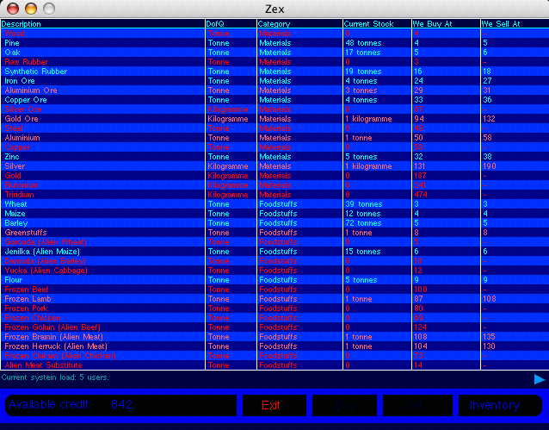
Like most things in Zex, this screen is updated in real time; as prices change (because other users are buying and selling), the page is updated.

The “Description” column list the generic description of the stock. The “DofQ” column indicates the unit of measurement for the stock. GalaNet categorizes stocks, which is what the “Category” column indicates; some people specialize in a specific category - tech stocks for example. “Current Stocks” shows you how much of that item is available right now. Finally, “We Buy At” and “We Sell At” columns shows the current prices.

At the bottom of the screen, the Current system load shows you how many people are on-line at this moment in time; including yourself. The more users on-line, the more active will be the screen. The blue arrow on the right can be clicked to move to the next screen of stock.

GalaNet very generously colour code the items, according to stock level. When a stock exceeds given threshold points its colour changes as follows: Yellow - too much stock, the price is probably dropping. Red - not enough stock; probably expensive right now.

To buy an item, click on it then click on the buy button at the bottom of the screen.

To sell an item, click on Inventory; this will list items in your hold. Again select an item then click on Sell.

To leave, click on Exit.

Prices are set according to the following rules:
1. Is the Mothership on a good or poor supply route? Motherships close to inhabited planets normally have good supply ratings; those further away have poorer supply ratings.

2. The attributes of the supplying planet(s) are taken into account.

3. The attributes of the various "goods" are taken into account. For example, Guinness™ may command a high price on Alien Motherships, as they do not produce it. But do R’Mparians like Guinness? Other attributes for an item include “Where does the item come from?”, “Do R’Mparians like it?”, “Do humans like it?” etc.

4. The amount of stock available. More stock means cheaper buying prices and higher selling prices.

5. Other attributes are taken into account - for example, is the item illegal?

Note that trading is normally available between 0800 and 1700 hours. The trading network is closed outside of these hours.

Score Summary Screen
This screen is shown when either the game ends or you dock. The figures on the left refer to the game played so far in total, the figures on the right are the details for the current session (i.e. since you loaded a game, or started a new game). Note that it is entirely possible for the credits for the current session to show negative!

Sample Strategy Guide
Initially you need to build up your credits via trading and bounties to buy better equipment. Next you should concentrate on getting promoted by actively seeking out alien ships to destroy whilst building up your credits. When promoted, search out three or four subordinates and commandeer them.

Pick a weak alien Mothership - low supply and production rating (this will generally mean it has a low power rating), and with your team try to make it surrender. The game is won when it is decided there is no way the aliens can recover; at which point they will offer surrender. You can refuse it to completely obliterate them - up to you.

Alternatively, you may just want to wander around, seeing what's what. It's a big Galaxy!

Tactics & Tips

Shields recharge quicker at lower thrust levels as there is more power available to the shields. All systems consume power so if you really don't need long range radar, turn it off.

Systems will not be damaged if shields have some charge - if you hear the screeching of hull damage it may be wise to get out of the action.

Class 1 missiles are cheap - use them.

If the Nav computer is damaged or lost in battle, long range radar can help you find Motherships.

Attacking ships head-on can be a bad idea. Getting rammed is seriously bad for your health. Try to get behind alien ships, 'specially larger ones (probably armed with missiles).

Be aware that the sight of an alien ejecting does not necessarily mean the pilot has really ejected! For example:
A) The pilot may have faked it to make you believe the ship will no longer fire.
B) There may be more than one crew member on-board alien ships, certainly the larger ones.

If the pilot of an alien ship really has ejected, the ship will go out of control. These are dangerous objects and should be destroyed if at all possible to avoid being rammed.

Look after your hull! You should avoid using Flatpacks wherever possible. When you do use one, some equipment from your old ship will be lost, and some of it may well be expensive; hull repairs (when docked) are preferable to buying Flatpacks.

Ejecting loses you everything, but will save your skin. When you eventually dock with a Mothership after ejecting, be sure to buy any specialist equipment you may have been using before launching!

Ejection pods have a limited rate of turn. If you eject too close to a Mothership, the ejection pod may never get to it; it’ll just fly around it in a large circle! Rumor has it that later software has fixed this problem.

Don't run out of fuel! Sounds obvious but it happens all too easily; get hold of a fuel maximizer.

Sound: the direction of sounds may give away needed information.

Designers Notes
Zex simulates a galaxy where you play a game. Unfortunately the sim doesn't know it's a game! Whilst we have tried hard to control the difficulty, it may be that you start the game, a powerful Mothership is close by which generates a powerful Phoenix which kamikaze's you at 1200GU's. And little old you gets your butt kicked big time. End of story.

In this situation it's important to bear in mind that you are going into the middle of a war with literally nothing. Zilch. Zero squared. The sim is running thousands of earth ships against thousands of alien ships continuously (and does an accelerated run before the game starts to get everything up to speed). You start with nothing but the galaxy starts in the middle of a war. Next time, use long range radar to find somewhere to hide; somewhere safe, quickly. Hanging outside an Earth Mothership is generally safe. Any R’Mparians will be dealt with by the Mothership’s defences. Figure your strategy from there.

Don't expect an easy ride - the game may take you many months to play - some days it'll be easy, and others not so. Save often and keep a Flatpack handy for insurance!

FAQ and Problems

Problem: I get no space dust displayed.
Answer: Your machine is struggling to run Zex. Dust is only displayed if the processor has some spare time. The faster the processor the more dust you'll get (up to a reasonable limit).

Question: Can I get a frames per second (FPS) reading?
Answer: Yes. First make sure you have at least one pilot under your command. Press [K] to show the Command and Control Dialog, select a pilot you command so the blue banner appears at the top of the screen. Now press the [9] key. (It's an unlisted command). The FPS will be displayed top left. Issue the same command to remove the FPS readout.

Note: You can only do this once you get promoted from Ensign, as you need to command a pilot.

Speed Tips

If Zex seems to be running slowly, try the following options to improve game speed .

1. Zoom the camera further in [Z key by default]. This gives Zex less objects to draw.

2. Turn the music volume down to Zero from Zex's main screen. This will stop Zex playing music and give your CPU more time to deal with the game.

3. If you have more than one monitor, try running the game on an alternative screen. You may find one is faster than the other.

Cheats
Cheats in Zex?!? No way! ;-) No really, there aren’t any.

Changing Where Zex Saves Games
Should you wish to change the directory Zex saves games to you can use a text editor to create a file called ‘save_file_path.txt’ within Zex’s ‘P’ folder.

The contents of the file should be a single line that specifies the full path to where you want the game to save to; for example:

"/Users/rob/Zex Saved Stuff"

Credits

Zex 2005 People

Written by Stuart Ball and Robert Probin.

Additional programming and graphics: Claire Probin, Ian Dennis.

Incredibly Brave Development Testers: George Palmer & Tony Park.

Zex web site: Jessica Ball.

Zex is dedicated to Fluffy

Zex is brought to you by the colour indigo.

